Newton’s Laws of Motion

**OBJECTIVES**

1. Students should be able to recognize the Laws of Motion by their general name:

a. First Law of Motion

b. Second Law of Motion

c. Third Law of Motion

2. Students should be able to state how forces affect motion (*forces cause motion*).

3. Students should be able to distinguish between an unbalanced force and a balanced force.

4. Students should be able to state that friction is an opposing force.

**Introductory ACTIVITIES**

1. Demonstration of friction [trick with small piece of paper] (*opposing forces*)

2. Balanced vs. Unbalanced Forces using a ping pong ball

1. **Stationary ball to moving ball** and vice versa (***inertia***)
2. Use a tennis ball or golf ball or ping pong ball. Show the ball at rest.
3. Roll the ball lightly and let it come to a stop.

Discuss Forces:

Net Force produce acceleration

Unbalanced force

Balanced Force … constant speed (“no net force”

1. **Acceleration of thrown ball** depends on force (***f = m x a***)

[Throw the ping pong ball with small force at a student. Then throw with a large force.]

1. **“Push and Shove” Competition** (***action/reaction*)**

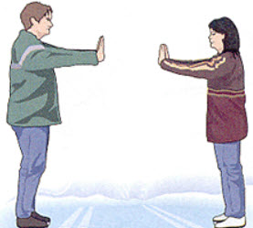

[Mark two lines on floor 50 cm apart. Face opponent and place both feet on foot line. Then place palms against each other. Push until one person moves their feet.]

1. **“Ping Pong” Competition** (*demonstrates all three laws of motion*)

[Have opponent sit on opposite end of the table. Place the ping pong ball in the center and blow until one person gets the ball off their opponents end of the table.]

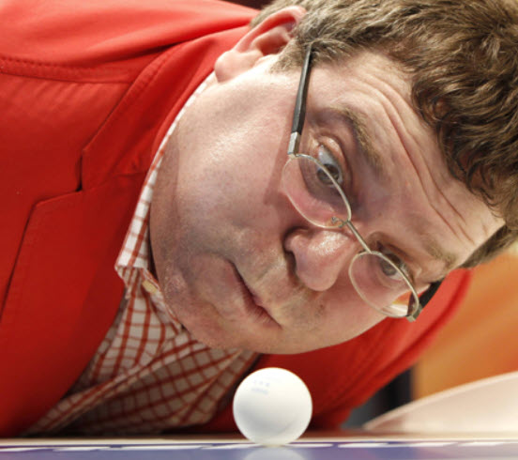 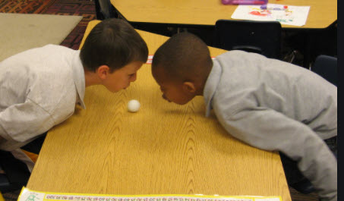

Closure:

Name the unit: *The Nature of Forces and the Laws of Motion*

Give 3 Laws of Motion:

* *First (inertia)*
* *Second (f = m x a)*
* *Third (action/reaction)*

How can forces affect motion?

* *Forces produces motion (unbalanced)*
* *Forces stop motion (balanced)*
* *Forces change direction of motion (unbalanced)*

**HISTORY**

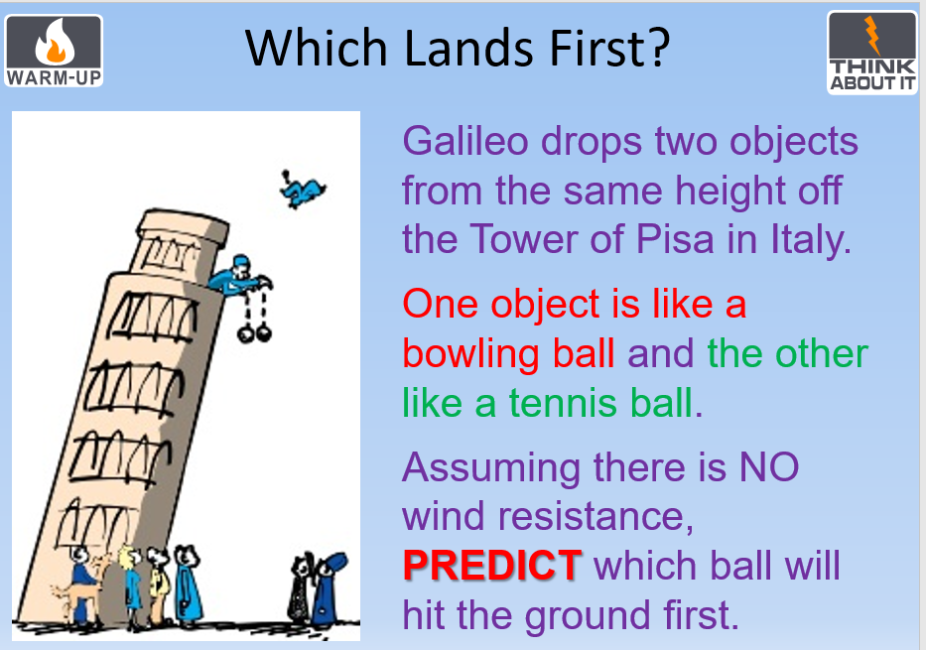

1. **Aristotle** (~300 BC Philosopher, not a scientist) taught:

* Heavier objects fall faster than lighter objects.
* Earth is the center of the universe.
* All motion on earth is straight and linear.

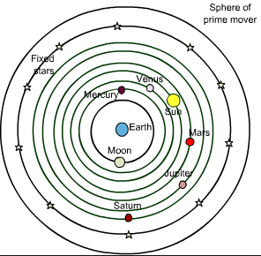 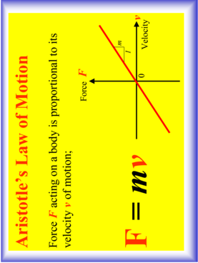

1. **Galileo**

* Used the scientific method / experimentation with supporting evidence.
* Proved (using an inclined plane) that moving objects continue to move unless acted upon by some forces. He called the way objects behaved “Inertia.”

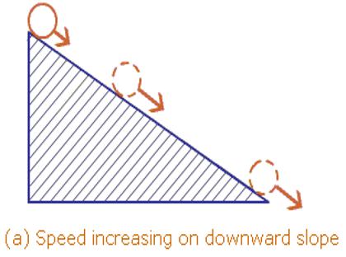 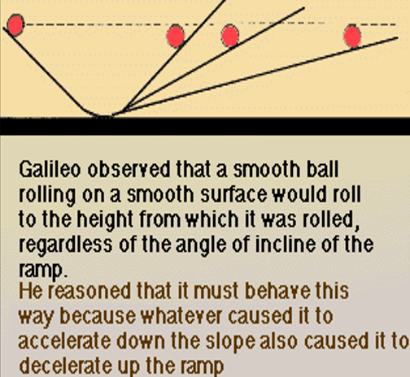

DEMO “Galileo vs. Aristotle” … paper wad vs. tennis ball dropping

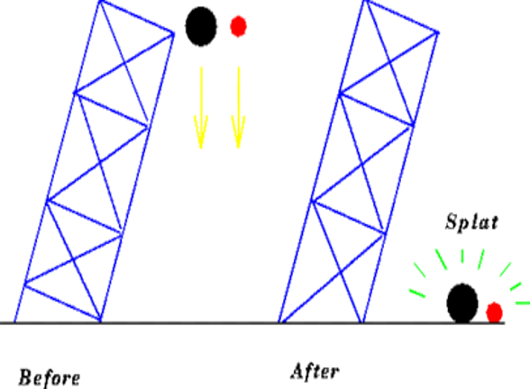

* Galileo proved Aristotle wrong by dropping objects off the leaning tower of Pisa and accounting for air resistance. Heavier objects fell at the same rate as lighter objects due to gravity.
* Used the scientific Method [*experimentation*] to show that objects can demonstrate projectile motion (*objects do not just move in a straight and linear path … as Aristotle claimed*)

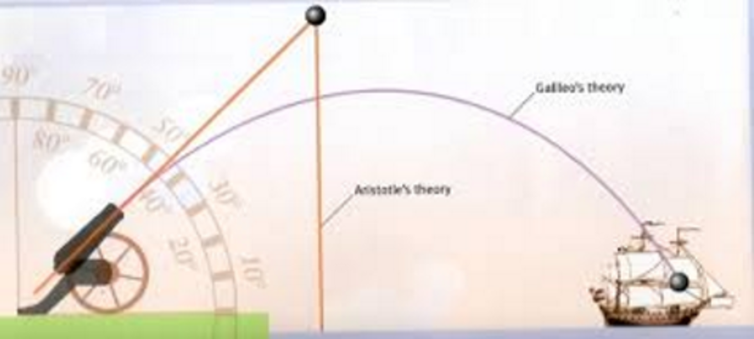

1. **Newton** (1642 – 1727) continued Galileo’s work (died 1642) and became world famous for his three laws of motion.

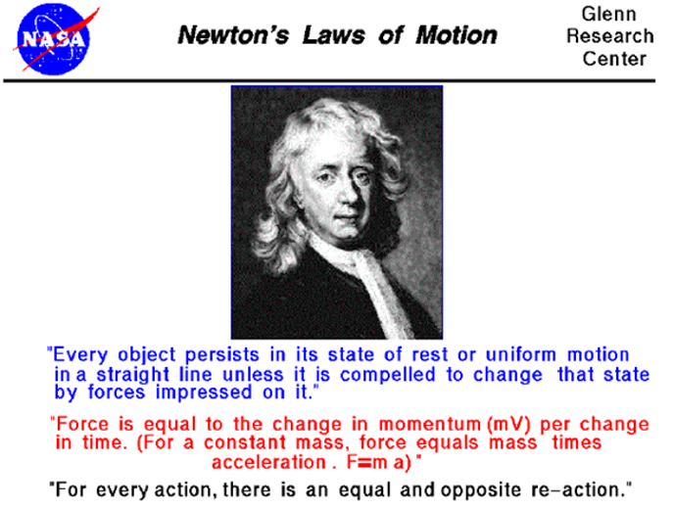

**Newton's first law of motion**

* Newton’s 1st law states that an object at rest will remain at rest and an object in motion will remain in motion at constant velocity unless acted upon by an unbalanced force.
* **Inertia** is the tendency of matter to resist a change in motion.

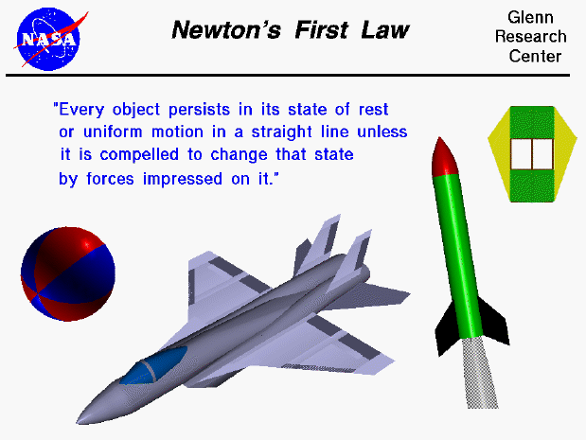

* Slamming on the brakes on an icy road
* Using seat belts in cars to avoid going through the windshield
* Roller coaster or “inertia” bumps – mesenteries inside our abdomen hold organs from hitting the sides of our body
* Going up/down in an elevator and the elevator stops
* **Initial velocity requires more energy than the ensuing constant velocity due to the need to overcome inertia**
* Baseball player hits the ball and begins to run to first base … rounding the bases takes more energy than running to the next base
* See “CAR” Pictures

[**http://somup.com/cFXh00n1kH**](http://somup.com/cFXh00n1kH) **Projectile Motion (0:15)**

* **Showing the cart and ball BOTH moving with constant velocity**
* **Showing the ball moving in a curved path (projectile motion: trajectory)**
* **Newton's 1st Law (inertia**

[**http://somup.com/cFXh0bn1kE**](http://somup.com/cFXh0bn1kE) **Projectile Motion 2 (0:27) similar experiment to above.**

**Forces that OPPOSE MOTION**

Forces applied in the opposite direction to motion:

1. Gravity 🡪 often opposes motion

2. Friction 🡪 a force that always opposes motion, producing negative acceleration or “deceleration”

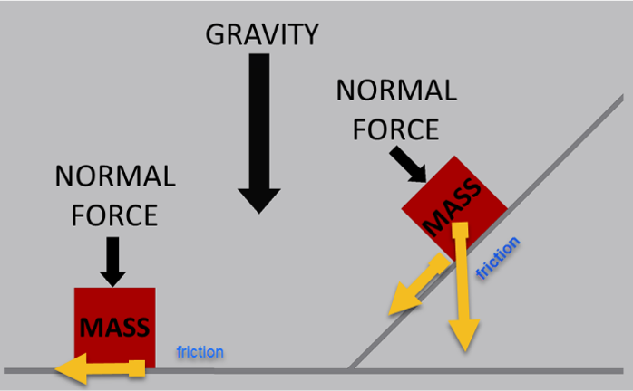

Notice the vectors. We will resolve these vectors using trigonometry.

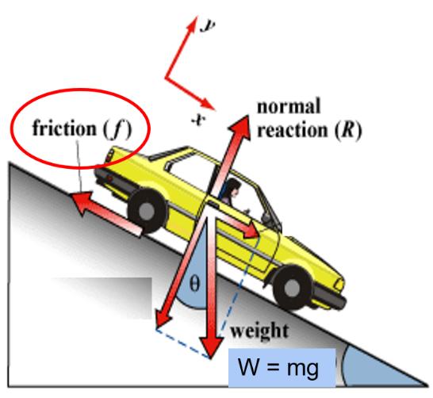 Sin θ = f / W 🡪 f = Wsin θ = mgsin θ

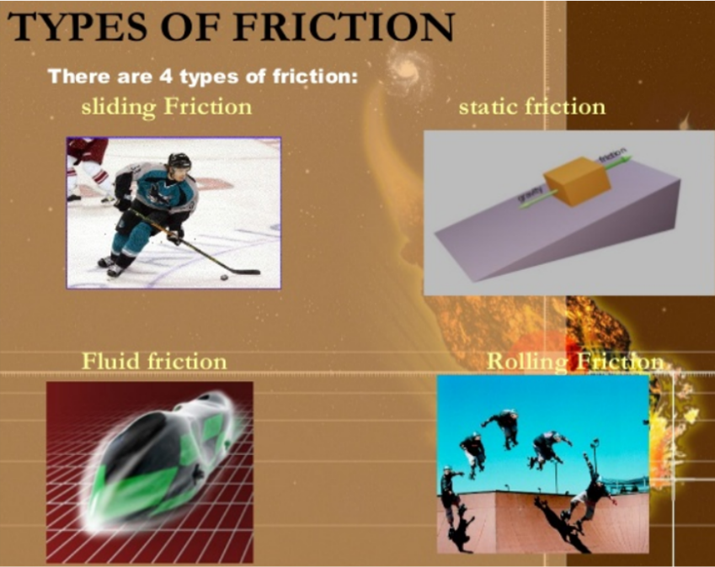

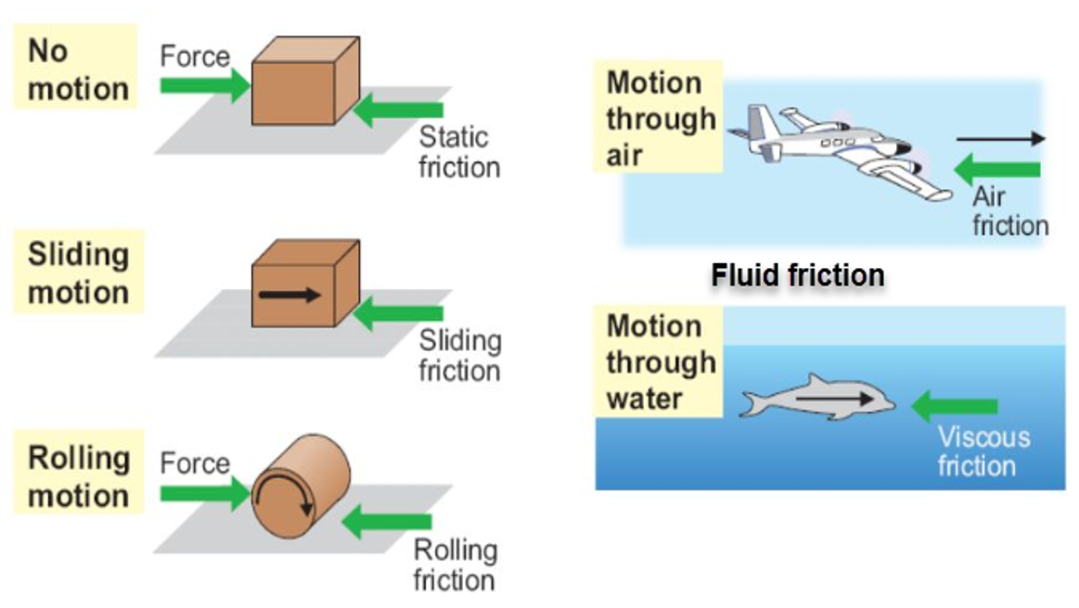

* **Friction lab**: “starting friction” and “sliding friction”

**Newton's second law of motion**

Describes how force, acceleration, and mass are related.

* To overcome inertia, one accelerates or decelerates.
* Force equals mass time acceleration.

*To accelerate a 3 kg mass to 4 m/s/s requires 12 N of force:*

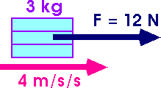

* Racing a grocery cart down the isles – the harder you push, the faster it goes
* Hitting a 0.06 kg tennis ball with a tennis racket versus throwing the ball like a pitcher (thrown about 70 mph vs. hit about 130 mph)

70 mph x 1.6 km/mi = 112 km/hr = 112,000 m/hr x 1 hr/3600 s = 31.1 m/s

Accelerated by the racket for ~0.005 s 🡪 a = (vf – vi) / t

a = 6,220 m/s/s

F = ma (0.06 kg)(6,222 m/s/s) = 373 N

130 mph = 208 km/hr … F = ma (0.06 kg)(11,555 m/s/s) = 693 N

* Tractor pulls or monster trucks use much more force to accelerate than smaller vehicles
* SEE “CAR & VAN” pictures
* **The Legend of the Tortoise and the Hare**

*The Tortoise really wins!*

Can you show using Physics and not logic or guessing how the tortoise can win?

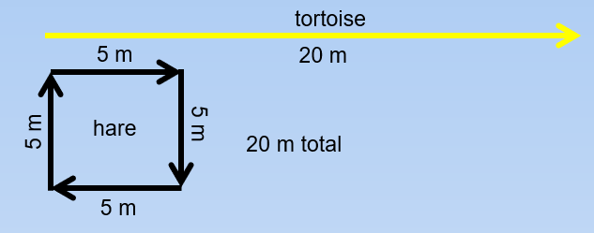

The “hare” has to accelerate & decelerate to almost a stop at FOUR different points versus the “tortoise” only at ONE point. Therefore, the “hare” uses a lot more energy covering the same distance.

*Consider a baseball player running 120 feet straight VERSUS running the bases.*

* **DEMO … Quarter drop**

Place a quarter on the back of your hand.

* SLOWLY move your hand downward. Does the quarter separate from your hand?
* QUICKLY move your hand downward. Does the quarter separate from your hand?

What made the difference?

* **Newton’s 2nd Law of Motion Lab**
* **Force Diagrams Worksheet**

**Newton's third law of motion**

Newton’s third law states that forces always occur in pairs that oppose each other. Every action has an equal and opposite reaction.

DEMO: have students push down on their desks real hard … what happens?

The desk pushes back up with the same amount of force … you know this because there is a mark left on your hand

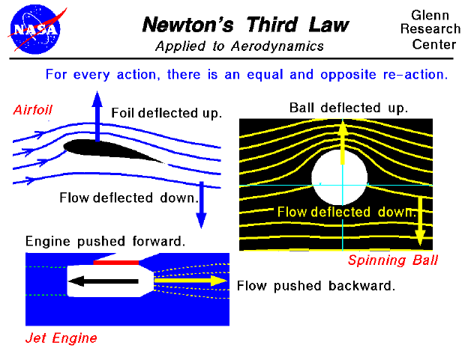

* water sprinkler that spins around (force of water)

<http://somup.com/cFXQqJniFa>

Golf Ball [0:36]

<https://screencast-o-matic.com/watch/cFXQqGYSEq> Golf Ball [0:07]

DEMO: Trust fall

* Ask for a volunteer
* Try with eyes open, then with eyes closed
* Trust fall (person must exert the same amount of force to catch the other)
* Rubber bands stretching and recoiling
* Hitting a nail with a hammer (force of hammer equals force of nail entering wood)

**

Because of Newton’s Third Law, the bat actually bends away and recoils back. The ball also gets indented on the bat side and rebounds back to its normal shape.

* Explain each activity using Newton’s Third Law
* I can’t touch you without you touching me
* Extend your hand and bend your fingers upward
* Inflated balloon against the wall or a chair
* Rubber band stretched between thumb and index finger
* Earth and moon attraction

<http://somup.com/cFXQqpniFy> (4:35)

* Fan cart
* Masses hanging on a string
* Balloon
* Minicar
* Bouncy balls

**REVIEW ACTIVITIES**

<http://somup.com/crhulUqDkV> Inertia Ring; Newton’s Dollar (1:36)

1. Balanced and **unbalanced forces** which relate to motion

* Have students get a partner or two
* Stand at attention with arms at your sides
* Partners hold arms so you cannot extend them
* Try to lift your arms for 60 seconds
* Partners release after 60 seconds

1. FUN Inertia group demo

* Make one or two lines.
* Have everyone line up touching shoulder to shoulder and must stay touching.
* This can be a team competition.
* The first person in line starts by squatting low and crossing their arms as they say:

There’s a bear (*to next person*)

Where? (*next person responds back*)

Over there (*point with arm*)

* Have the groups go until the last person squats and then knock the first person towards the next person and watch the dominoes fall.