Genetics

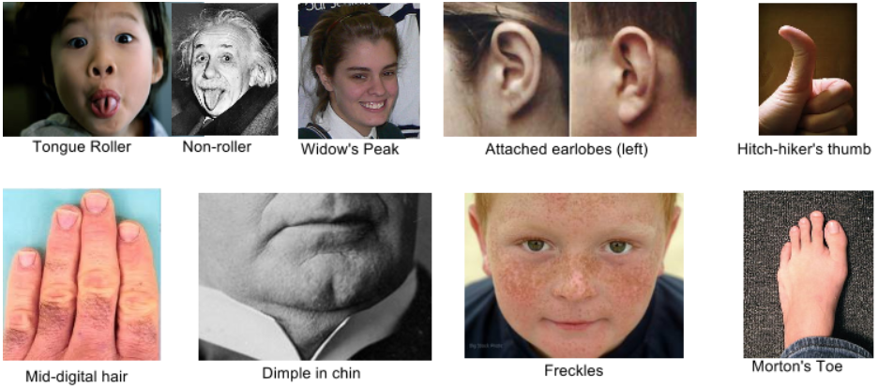

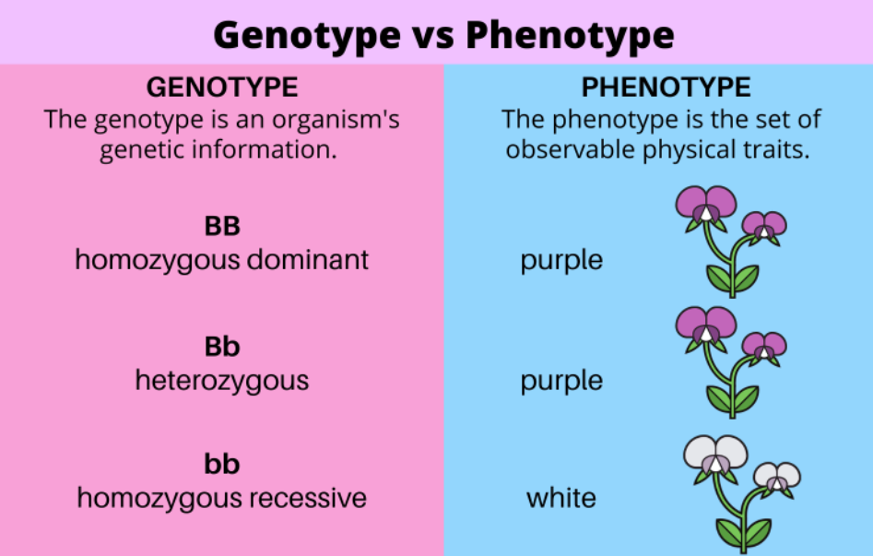

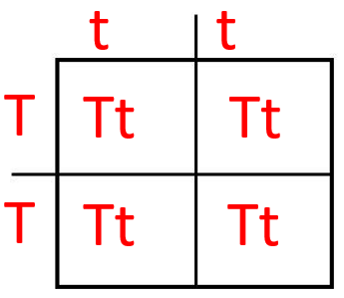

**See** [**https://www.learningctronline.com/courses**](https://www.learningctronline.com/courses) **for Materials and Resources.**

**Topics:**

1. Genetics

**Objectives:**

1. Define genetics and heredity, distinguishing characteristics from traits, genes, and alleles.
2. Describe the history of genetics and Mendel’s role.
3. Delineate the science of heredity in terms of generations (P, F1, F2), differentiating genotype from phenotype.
4. Understand and use the law of segregation to show monohybrid test crosses.
5. Understand and use the law of independent assortment to show dihybrid test crosses.

TAKE NOTE

1. Test Corrections (due before next week’s class)
2. Notes/Study Guide Genetics (1 week)
3. Homework from Text Chapter 12 (1 week)
4. Monohybrid Test Crosses Worksheet
5. Lab Monohybrid Cross Segregation
6. Upcoming (week 16): Semester Exam (Chapters 1-8, 10-16) … due within 10 days after week 16’s class … review test corrections.
7. Week 15 Devotional (<https://www.learningctronline.com/devotional>)

**Text**: Chapter 12: Genes & Heredity pp. 214 – 228

Read the assigned pages in the text.

**Class Notes: PowerPoint or PDF**

**Notes/Study Guide:** Fill in the Chapter 12 Study Guide worksheet to understand the class notes.

**Homework**: (1 week)

* Study Questions (end of the chapter in the text) #1, 4, 8, 10-20 (explain true/false)
* Use a Word document format as follows:
  + Heading: Your name, Chapter in Text, Study Questions
  + Number the appropriate questions you are to answer
  + Write the answer in a complete sentence use the question as the template (do not copy the question, but reword it into a statement that answers the question).
* Use the same document each week by starting a new “Study Question” for a different chapter on the next page.
* Assignments will be “spot checked” during class or submitted via email.

**Lab**: Monohybrid Cross Segregation

* Complete the "Monohybrid Cross Segregation" lab using the lab worksheet provided.
* After completing the Lab worksheet, email it to [learningctronline@gmail.com](mailto:learningctronline@gmail.com) for grading.
* Save document into your LAB folder in the Biology folder on your desktop.

**TEST:** No Quiz this week;

1. Genetics Test after next week’s class.
2. Semester Exam after Genetics Test.

Supplemental Resources (Optional)

1. Genetics Review Quiz
2. Genetics Vocabulary Review

<https://youtu.be/i-0rSv6oxSY> (6:27) The Amoeba Sisters Channel – **Monohybrid Crosses & the Punnett Square**

<https://youtu.be/qIGXTJLrLf8> (8:31) The Amoeba Sisters Channel – **Dihybrid and Two Trait Crosses**