**Sound Waves & Music**

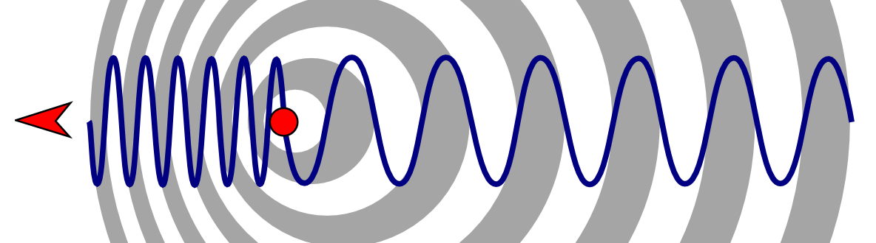

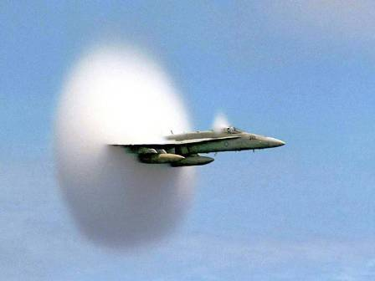

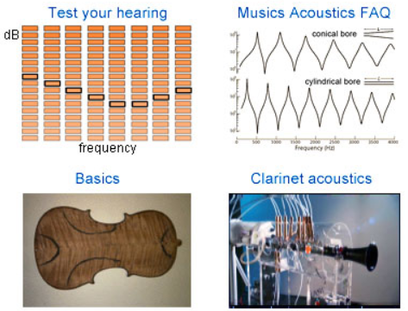

**See** [**https://www.learningctronline.com/courses**](https://www.learningctronline.com/courses) **for Materials and Resources.**

**Topics:**

1. Sound Waves & Music

**Objectives:**

* *Define a wave” and describe three types of mechanical waves, especially contrasting transverse & longitudinal waves.*
* *How are mechanical waves like sound produced, transmitted, and heard?*
* *Define the properties and components of mechanical waves like sound waves (longitudinal, wavelength, amplitude, frequency, period, velocity, compressions, rarefactions) and calculate variables.*
* Recognize and explain behaviors of sound waves (Doppler Effect, refraction, reflection, resonance, and diffraction).
* Distinguish between pure sound, noise, and music. How do musical instruments work?

TAKE NOTE

1. Reading (Hewitt Text)

2. Notes Sound Waves & Music

3. Lab Sound Waves

4. Problem Set: Mechanical & Sound Waves

5. Honors 🡪 Sound Barrier or Sound Production

6. Test Mechanical & Sound Waves

7. Class Song: There’s No Way to Fail

8. Week 27 Devotional (<https://www.learningctronline.com/devotional>)

**Text**: Chapters 25 – 26 Mechanical & Sound Waves (Hewitt)

**Class Notes: Use the Documents provided**

**Homework**:

* Problem Set: Mechanical & Sound Waves
* HONORS 🡪 history of breaking the sound barrier (auto, jet) and problems that were caused or choice a musical topic (voice, instrument) and expound on sound production and propagation.

**Lab**: Sound Waves

* Perform the lab as directed using the worksheet provided.
* Complete all calculations and data, showing work whenever appropriate.
* Conclusions should be answered in complete sentences that convey a complete thought.
* Save the documents into your LAB folder in the Physics folder on your desktop.

**TEST:** Mechanical & Sound Waves

1) the academic integrity policy

* Tests must be completed **WITHOUT** referring to books, notes, the internet, people, or any outside resources.
* Students **MAY** use the approved Periodic Tables, approved Reference Tables, or approved equation (formula) sheet (provided by the teacher) along with calculators and scratch paper.
* A guardian should be proctoring the test. Proctoring means to monitor the following:

2) The test is composed of multiple-choice questions and some problems.

3) There is a **60-minute time limit** on this test.

4) Please have the proctor write the time taken at the top of your answer sheet with their signature or initials.

5) Proctors should NOT be reading the test or engaging students during the test.

6) Do NOT use RED font. Black font is best.

7) NOTE There are additional questions for the HONORS students.

Supplemental Resources (Optional)

<http://somup.com/cbeD3hRA7> PHET Simulation of Transmitting Sound (1:12)

<http://somup.com/cFXoIEnji1> Sonic Boom (2:07)

<http://somup.com/cFXoIHnji6> Examples of Sonic Booms (1:36)

<http://somup.com/cFXoIKnjil> Echo & Reverberation (1:09)

<http://somup.com/cYf3F9iTXa> Standing Waves & Resonance (1:51)

<http://somup.com/cYf3q0iTDy> Sound Waves: Diffraction & Interference (7:21)

<http://somup.com/crnDrkDrtb> Single & Double-Point Source Ripple Tank (0:49)

<http://somup.com/criibpYiqf> Sound Tubes (1:39)

<http://somup.com/crnDrxDrOk> Resonance Boxes with Tuning Forks (1:41)

<http://somup.com/criiFBYi00> C Scale & Single Tuning Fork Demonstration (0:42)

<http://somup.com/c3Vu2cZBWU> Michigan J. Frog (3:06)