# Chapter 9 – DNA, RNA, and Proteins

1. _____ are made of _____.
   1. The _____ wraps around _____ called _____ to form beads on a string or _____.
   2. The chromatin _____ into a fiber and continues to coil around itself.
   3. The condensed and coiled _____ fibers become a section of a _____.
2. Definitions
   1. ____ is a _____ stranded molecule that contains _____ information about function and development of all living things.
   2. A _____ is a segment of _____ that codes for a _____ (polypeptide).
   3. A _____ is a molecule of DNA that contains many genes.
      1. Segments of _____ DNA (strings of _____) that code for various _____ in between non-coding DNA.
      2. Most easily seen during _____ of mitosis.
      3. Formed when DNA compacts into coils around proteins called _____.

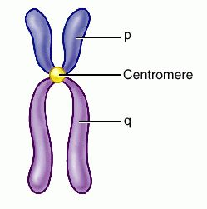

The general shape of an eukaryotic chromosome

p arm 🡪 _____

q arm 🡪 _____

1. History of DNA
   * 1. DNA scientists
        1. Friedrich _____ (Swiss, 1869)
           1. Experimented and isolated a new molecule - _____ - from the cell nucleus.
           2. He determined that nuclein was made up of _____, oxygen, _____ and _____ and there was an unique ratio of phosphorus to nitrogen.
           3. Nuclein, found in the _____, is now known as _____.
           4. He extracted and observed DNA from _____ cells.
           5. Miescher, himself, believed that _____ were the molecules of heredity.
        2. DNA is a double _____
           1. American James D. _____ journeyed to Cambridge University in England, where the more senior Francis _____ was studying protein structure with a technique called X-Ray _____.

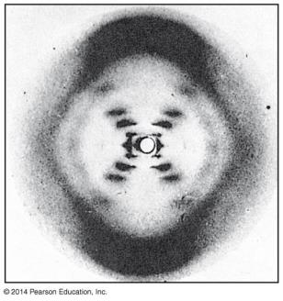

While visiting the laboratory of Maurice _____ at King’s College in London, Watson saw an X-ray image of DNA produced by Wilkins’s colleague, Rosalind _____.

* + - 1. Watson and Crick put it all together
      2. 3-D structure of DNA = _____ _____
      3. Basic components were
      4. _____
      5. _____
      6. _____ bases
      7. Franklin’s X-ray crystallography photos
      8. C_____ Rule (Erwin Chargaff)
      9. A nucleotide:
      10. A _____ base - organic
      11. A _____ 🡪 _____ - organic
      12. _____ group - inorganic
      13. Watson and Crick Model of DNA
          1. A double helix looks like a _____.
          2. Backbone of the ladder

_____

_____ groups

Joined by _____.

* + - * 1. Rungs of the ladder

Two _____ bases that pair across the center of the helix.

Joined by weak _____ bonds

* + 1. Watson and Crick realized that _____ consisted of _____ polynucleotide strands wrapped into a Double _____.
    2. The _____ -_____ backbone is on the outside.
    3. The _____ bases are perpendicular to the backbone in the interior.
    4. Specific pairs of bases give the helix a uniform shape:
    5. _____ pairs with _____, forming _____ hydrogen bonds
    6. _____ pairs with _____, forming _____ hydrogen bonds
    7. Two families of bases:
    8. _____ & _____ are _____
    9. _____ & _____ are _____
  1. Sugar-Phosphate ‘Backbone’ – Covalently bonded
  2. _____ Rule:
  3. # A = # T _____ always pairs with _____
  4. #C ≡ # G _____ always pairs with _____
  5. Structure of DNA

In 1962, the Nobel Prize in Physiology or Medicine was awarded to James D. _____, Francis _____, and Maurice _____.

Rosalind _____ probably would have received the prize as well but for her death from cancer in 1958.

Nobel Prizes are never awarded posthumously.

* + 1. The Watson-Crick Model gave new meaning to the words _____ and _____. It showed:
    2. The structure of _____
    3. How DNA could carry genetic information and _____ it
    4. The _____ information in a chromosome is encoded in the _____ sequence of DNA.

1. DNA R_____
   1. Parameters
      * 1. When does it occur?

* End of _____ (S)
  1. Why does this occur?
* Need to make another _____ of _____ for the _____ cell
  1. How does this occur?
  2. _____ -_____ Replication
  3. Each copy contains one _____ strand and one _____ -synthesized strand.
     1. Steps Involved in DNA in *Semi-Conservative Replication*
* What tells the DNA to do this? _____
  + - * 1. Step 1: _____
        2. Step 2: _____

The DNA is _____ and _____ into _____ strands during the _____ phase of the cell cycle.

When? _____

* + - * 1. Step 3: _____
* Semi-conservative, meaning that the “_____” DNA molecules each consist of one _____ strand and one _____ strand.

1. DNA and RNA are _____ of _____

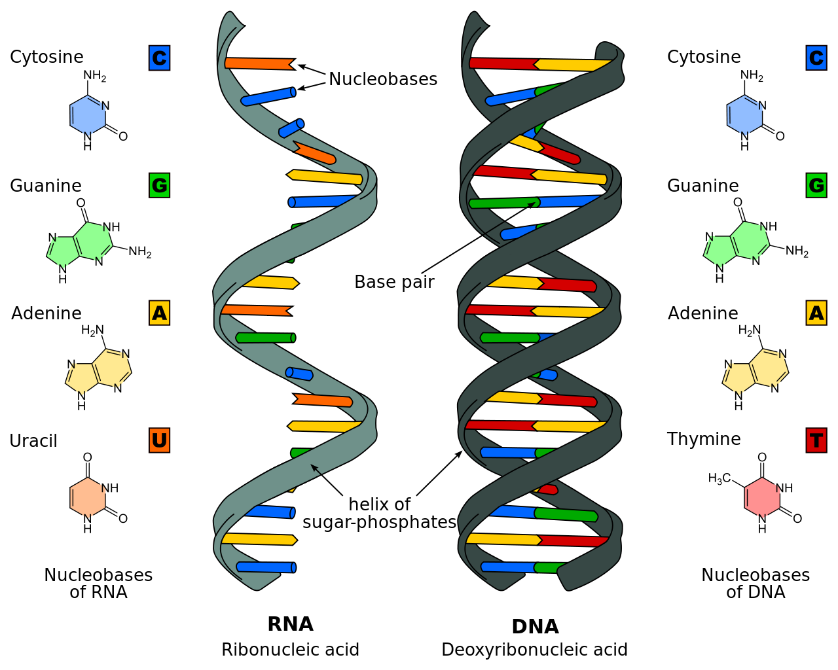

* 1. The full name for DNA is _____ _____, with _____ referring to DNA’s location in the _____ of eukaryotic cells.
  2. _____ (ribonucleic acid) is unlike DNA in that it
  3. uses the sugar _____ (instead of deoxyribose in DNA)

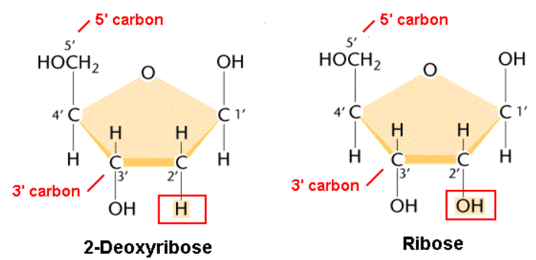

* 1. has a nitrogenous base _____ (U) instead of Thymine (T)
  2. RNA is _____ -stranded; DNA is double-stranded

1. Genes
2. Genes control _____ Traits through the Synthesis of _____
3. DNA specifies _____ by dictating Protein Synthesis
4. _____ are the links between _____ (genetic make-up) and _____ (appearance).
5. The molecular chain of command is from
6. _____ in the _____ to RNA
7. _____ in the _____ to _____
   * + 1. _____ Expression
8. The DNA molecule, with its _____ nitrogenous bases, is the _____ for all _____ that are made in a cell.
9. Genes make up a portion of the _____ strand. A gene is the _____ that controls the production of specific _____, such as _____, structural proteins, etc.
   1. Proteins are the link between _____ and _____ of an organism.
   2. The proteins that are made will determine the _____ of the offspring.
10. Gene Expression:
    1. The process by which _____ directs the _____ of _____.
    2. The expression of genes includes two stages:

* _____ and _____

Protein Synthesis

* 1. Overview

A. _____ contains the _____ information

B. Every _____ of an organism is controlled by _____

C. Genes control _____ Traits through the Synthesis of _____

1. _____ is the synthesis of _____ under the direction of _____.

2. _____ is the synthesis of _____ under the direction of _____.

3. _____ provide the instructions for making specific Proteins.

**Protein synthesis**

C. Genes – Cracking the Code

1. The genetic code was discovered by Marshall _____ and J. Heinrich _____ in 1961.

2. The genetic code was based on _____,sequences of three bases that form a unit of the genetic _____ in DNA that determines a specific _____ _____.

3. Amino acids are used to make _____.

D. Genetic Information written in _____ is _____ into _____ Acid Sequences

1. The sequence of _____ in DNA provides a code for constructing a _____.

a. Protein construction requires a conversion of a _____ sequence to an _____ _____ sequence.

b. _____ rewrites the _____ code into _____, using the same nucleotide “language.”

2. _____ is the process of forming a strand of RNA from a strand of DNA.

a. This process occurs in the _____ (eukaryotic cells).

b. Since prokaryotes do not have a nucleus, the process occurs in their _____.

c. The _____ must make RNA to send to the _____ to tell the _____ how and which proteins to make.

d. The RNA molecule is a faithful copy of a gene’s protein building instructions. This type of RNA is called _____ RNA (_____).

e. An enzyme called RNA _____ catalyzes this reaction.

f. The purpose of transcription is to copy one _____ from the _____ molecule.

II. Transcription

A. Steps of transcription

1. RNA _____ (enzyme) _____ the _____ strands.

a. One strand of DNA is used as a template.

b. New nucleotides are inserted according to the base pairing rules.

c. When transcribing RNA, Adenine pairs with _____; Cytosine pairs with guanine.

d. This continues until the end is reached.

e. As the RNA polymerase moves along the DNA molecule, _____ bonds between the two _____ of _____ are reformed.

f. A _____ stranded _____ molecule has been transcribed.

B. Purpose of Transcription

1. The purpose of transcription is _____ to copy the entire length of the DNA molecule but to copy only small portions – a _____ worth

2. to be sent to the _____ as the instructions for _____ synthesis.

III. Eukaryotic RNA Processing and Editing

* + 1. Once the RNA is transcribed it is not yet ready to be sent out of the _____. It must _____ before it is ready to serve its purpose.
    2. The mRNA is a copy of a _____ section of the DNA
    3. This RNA contains sections called _____ and other sections called _____.
       1. Introns are sequences of _____ bases that are _____ involved in the making of the protein.

1. These need to be _____ of the RNA before the RNA goes to the ribosomes.
   * + 1. _____ are the sequences of nitrogen bases that _____ involved in the making of the protein.
       2. When mRNA is formed, both the _____ from the DNA.
       3. However, the introns are _____ of the RNA while the RNA is still inside the _____.
       4. The remaining exons are _____ by the enzyme _____ to form the final RNA.
       5. Finally, _____ are added to form the final RNA molecule.
          1. The cap and tail help to identify the “_____” of the RNA from the “_____”.
          2. The cap and tail help the ribosome to identify the _____ of the instructions and the _____ of the instructions.
       6. If introns are not needed and will be cut out of the RNA, why are they there in the first place?
          1. When introns are present in genes, it allows a _____ to code for more than one type of _____, depending on which segments are treated as introns and which are treated as exons.
          2. When particular segments are cut out, one type of _____ might result. If different segments are cut out, a different type of protein would result.
     1. mRNA Transcript

* mRNA leaves the nucleus through its _____ and goes to the _____.

IV. The Genetic _____

* + - 1. Overview
      2. Proteins:
         1. Proteins are made by joining together long chains of _____.
         2. The order in which the amino acids are joined determines the type of _____ that is made.
      3. The “language” of mRNA instructions is called the _____ _____.
      4. The genetic code is read _____ at a time.
      5. Each group of three nitrogen bases is called a _____.
      6. A codon is a group of three nitrogen bases that specifies _____.

B. Genetic Information written in _____ is _____ into _____ _____ Sequences

1. The flow of information from _____ to protein is based on a _____ Code.
2. The genetic instructions for the amino acid sequence of a _____ chain (primary structure of a protein) are written in DNA and RNA as a series of non-overlapping three-base “words” called _____.
3. _____ involves switching from the nucleotide “language” to the _____ _____ “language.”
4. Each amino acid is specified by a _____.
   1. _____ codons are possible
   2. Some amino acids have more than _____ possible codon

C. The Genetic Code is the amino acid translations of each of the nucleotide triplets.

1. _____ Nucleotides specify One Amino Acid.
2. Sixty-one codons correspond to amino acids.
3. _____ codes for _____ and signals the _____ of translation.
4. Three “_____” codons signal the _____ of translation.

D. Characteristics of the Genetic Code

1. _____, with more than one codon for some amino acids
2. _____, in that any codon for one amino acid does not code for any other amino acid
3. nearly _____, in that the genetic code is shared by organisms from the simplest bacteria to the most complex plants and animals.

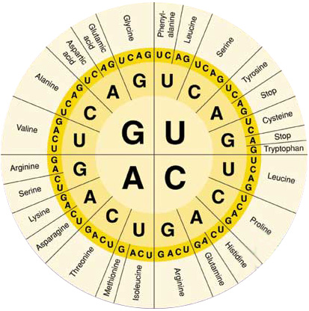

V. Translation

A. Protein Synthesis

1. The synthesis of proteins is called _____.
2. The cell must translate the base sequence of an _____ molecule into the _____ sequence of a protein.
3. The site of translation, or _____, is the _____
4. The _____ facilitates the orderly linking of amino acids into _____.
5. During translation, the cell uses information from _____ to produce _____.

B. _____ RNA Molecules serve as Interpreters during Translation

1. Transfer RNA (_____) molecules function as an interpreter, converting the genetic message of mRNA into the language of proteins.
2. Transfer RNA molecules perform this interpreter task by:
3. picking up the appropriate _____ _____
4. using a special _____ of bases, called an _____, to recognize the appropriate _____ in the mRNA.

C. Transfer RNA

1. The function of tRNA is to _____ amino acids from the _____ amino acid pool to a _____.
2. Transfer RNA molecules are _____ all the same. Each type of tRNA molecule links a particular _____ codon with a particular amino acid.
3. As a tRNA arrives at a ribosome, it carries a _____ amino acid at one end.
4. At the other end is a nucleotide triplet called an _____.
5. These _____ bases are the “ANTICODON”.
6. Each tRNA is used repeatedly to locate a particular _____ _____ and deposit it at the _____.
7. It then _____ the ribosome to go and find another amino acid.

D. Ribosomes build _____

1. Translation occurs on the _____ of the Ribosome:
2. Ribosomes coordinate the _____ of polypeptides
3. Ribosomes have two _____: small and large.
4. Each subunit is composed of _____ RNAs and _____.
5. Ribosomal subunits come together during translation
6. Ribosomes have _____ sites for mRNA and tRNAs.

E. Three steps of translation

1. _____: start codon (AUG)

2. _____: amino acids linked

3. _____: stop codon (UAG, UAA, or UGA)

F. _____ - mRNA Joins the Ribosome

1. The large subunit and small subunit join with the mRNA

1. The _____ carrying the _____ UAC fits in the P site to _____ translation.
2. _____ bonds form between UAC and AUG (_____ Codon).

G. _____

1. The next anticodon sits in the A site to start elongation.
2. _____ bonds form between the _____ and the _____ bases.
3. _____ Bonds from between the two _____ _____ forming a chain of 2 amino acids.
4. The mRNA moves over one codon moving the _____ _____ of the ribosome.
5. The next tRNA moves into place.
6. _____ bonds form between the two amino acids, forming a chain of 3 amino acids.
7. The mRNA moves over one codon moving the tRNA out of the ribosome.
8. The next tRNA moves into place.
9. Peptide bonds form between the two amino acids, forming a chain of 5 amino acids.
10. The mRNA moves over one codon moving the tRNA out of the ribosome.
11. The next tRNA moves into place.
12. Peptide bonds form between the two amino acids, forming a chain of 5 amino acids.

H. _____

1. When the terminator codon is reached the amino acid linking _____.
2. There are NOT _____ that match with UAG, UAA and UGA
3. This ends the polypeptide _____.

I. End Product – The _____!

1. The end products of protein synthesis is the _____ structure of a protein
2. A sequence of _____ _____ bonded together by _____ bonds

VI. The Flow of Genetic Information in the cell is _____ *→* _____ *→* _____

1. _____ can be divided into four steps, all of which occur in the Cytoplasm:
2. Amino acid attachment
3. I_____ of polypeptide synthesis
4. E_____
5. T_____

B. P_____ Cells

1. DNA → RNA → Protein
2. _____ nuclear membrane
3. In Prokaryotes, translation can begin _____ transcription is complete.
4. Because there is no _____ membrane

C. E_____ Cells

1. DNA → RNA → Protein
2. nuclear membrane
   1. transcription in _____
   2. translation in _____

D. _____ Sequences after protein synthesis

* 1. Added to proteins in the _____ _____ after they are synthesized by the _____.
  2. Direct a small number of nucleotides that are added to a protein in the ER.
  3. Tell the cell _____ the protein is to be taken after it is made.

VII. _____ Expression

* + - * 1. When a gene is expressed, it means that the _____ the gene codes for is _____.
        2. When a gene is expressed, the trait the gene codes for is _____ in some way.
        3. All cells of the same organism contain the same _____ in their DNA.
        4. In multicellular organisms not all genes are expressed by _____.
        5. Not all areas of the DNA that code for proteins are _____ into mRNA.
        6. If they were, then every cell would have the same exact function and make the same exact proteins.
        7. Each cell knows exactly what type of cell it is and which proteins it should make.
        8. This allows cells to be grouped into tissue and organ systems.

**RNA**

**DNA**

**?**

**?**

**?**