Momentum and Collisions Lab 2

**Introduction**

**Purpose**

To investigate the conservation of momentum for both elastic and inelastic collisions on a track. You will also investigate any changes in kinetic energy during a collision.

**Background Information**

As observed in part 1 of this lab, momentum is the product of an object’s mass and its velocity (p = mv). The direction of the motion is all important.

The objects involved in a collision are often considered as a system. Provided that the system of two objects is not experiencing a net external impulse, there would be no change in momentum of the system. If one object within the system loses momentum, it is gained by the other object within the system. The combined momentum of both objects would be conserved.

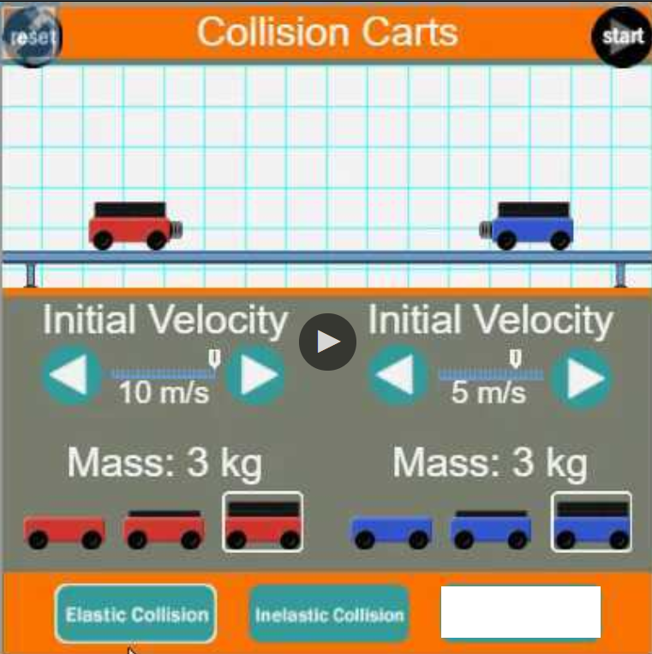

One can observe conservation of momentum experimentally by looking at:

∆ Momentum = (│Before – After│).

So, the momentum before a collision and after a collision should be the same if momentum is conserved.

In part 2, momentum will be observed for carts colliding from various parameters: elastic versus inelastic collisions, one cart colliding into a stationary cart, and both carts colliding into each other.

**Hypothesis**

If objects collide, then the momentum before a collision equals the momentum after a collision. In other words, the total momentum does not change in a system. m1v1 = m2v2

## **Materials**

## <https://www.physicsclassroom.com/Physics-Interactives/Momentum-and-Collisions/Collision-Carts/Collision-Carts-Interactive> .

[**http://somup.com/cr1VFbqrkH**](http://somup.com/cr1VFbqrkH) **Momentum & Collisions Lab Part 2 (4:45)**

**Procedures / Calculations and Data**

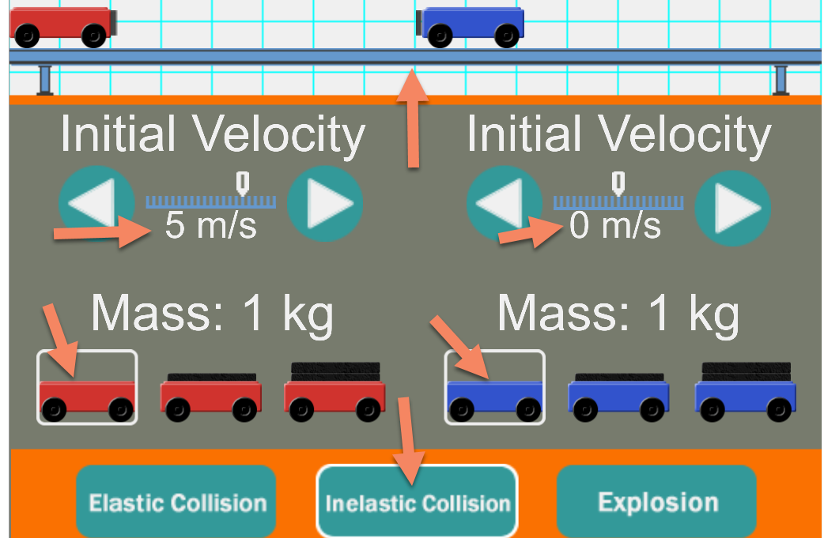

**Part 1 Inelastic Collisions** (*carts stick together*)

1. Set up the system as shown.

2. The red cart is to the left. The blue cart is at the center.

3. Use 5 m/s for the red cart and 0 m/s for the blue cart.

4. Use 1 kg masses for both carts.

5. Use “Inelastic Collision”.

6. Click on “Start”. Observe and record the velocities before and after collision.

**Inelastic Collision** *(Show units for all measurements)*

|  |  |  |  |  |  |
| --- | --- | --- | --- | --- | --- |
| Velocity  before | Mass Before | P = mv  before | Velocity  after | Mass  after | P = mv  after |
|  |  |  |  |  |  |

7. Calculate the momentum before and after collision. (Show work)

8. Repeat these procedures using 2 kg mass carts (both red and blue). Change the initial velocity to 10 m/s for the red cart.

|  |  |  |  |  |  |
| --- | --- | --- | --- | --- | --- |
| Velocity  before | Mass Before | P = mv  before | Velocity  after | Mass  after | P = mv  after |
|  |  |  |  |  |  |

9. Calculate the momentum before and after collision. (Show work)

10. Show a vector diagram of before and after the collision.

**Part 2 Inelastic Collisions** (*carts stick together*)

1. Set up the system so that the red cart is to the left & the blue cart is to the right.

2. Use the SAME velocity for BOTH carts, but in opposite directions. (e.g. 5 m/s for the red cart and -5 m/s for the blue cart).

4. Use the SAME mass for both carts (e.g. 1 kg or 2 kg or 3 kg).

5. Use “INELASTIC Collision”.

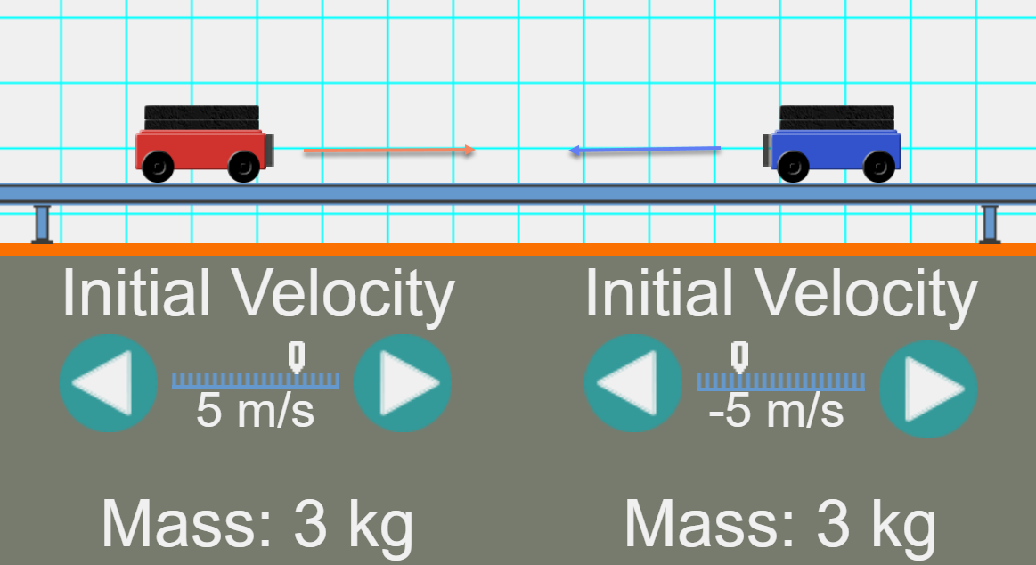

6. What happens after the collision?

7. Describe the momentum before and after the inelastic collision?

8. Show a vector diagram of before and after the collision.

**PART 3** Elastic Collisions (*carts bounce off each other*)

1. Set up the system as shown.

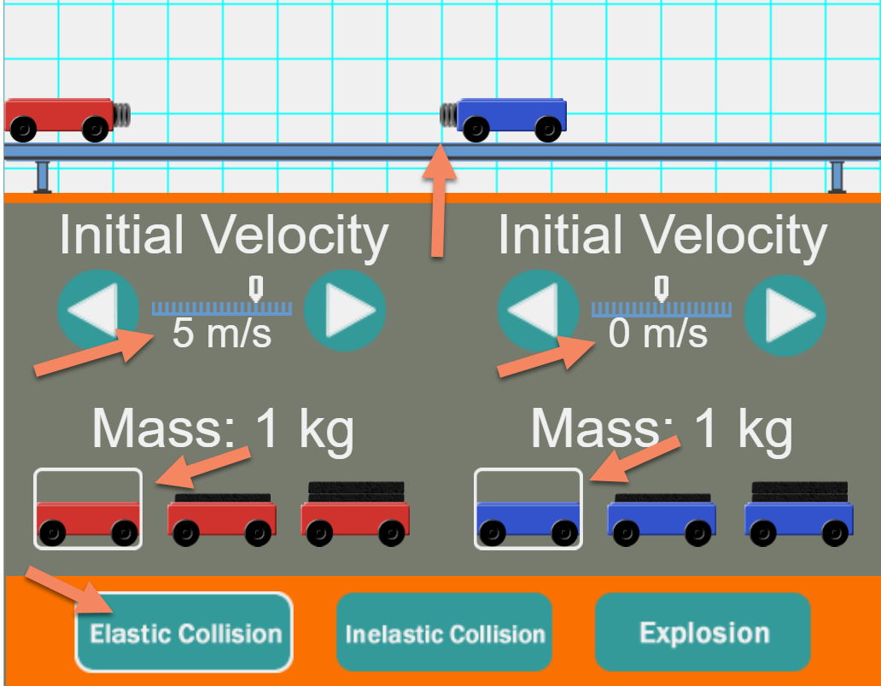

2. The red cart is to the left. The blue cart is at the center.

3. Use 5 m/s for the red cart and 0 m/s for the blue cart.

4. Use 1 kg masses for both carts.

5. Use “Elastic Collision”.

6. Click on “Start”. Observe and record the velocities before and after collision.

**Elastic Collision (Same Direction)** *(Show units for all measurements)*

|  |  |  |  |  |  |  |
| --- | --- | --- | --- | --- | --- | --- |
| Before Collision | | |  | After Collision | | |
| Mass  1st cart | Velocity  1st cart | P = mv  1st cart |  | Mass  1st cart | Velocity  1st cart | P = mv  1st cart |
|  |  |  |  |  |  |  |
|  |  |  |  |  |  |  |
| Mass  2nd cart | Velocity  2nd cart | P = mv  2nd cart |  | Mass  2nd cart | Velocity  2nd cart | P = mv  2nd cart |
|  |  |  |  |  |  |  |

7. Calculate the momentum before and after collision. (Show work)

8. Repeat these procedures using 2 kg mass carts (both red and blue). Change the initial velocity to 10 m/s for the red cart.

|  |  |  |  |  |  |  |
| --- | --- | --- | --- | --- | --- | --- |
| Before Collision | | |  | After Collision | | |
| Mass  1st cart | Velocity  1st cart | P = mv  1st cart |  | Mass  1st cart | Velocity  1st cart | P = mv  1st cart |
|  |  |  |  |  |  |  |
|  |  |  |  |  |  |  |
| Mass  2nd cart | Velocity  2nd cart | P = mv  2nd cart |  | Mass  2nd cart | Velocity  2nd cart | P = mv  2nd cart |
|  |  |  |  |  |  |  |

9. Calculate the momentum before and after collision. (Show work)

10. Show a vector diagram of before and after the collision.

**PART 4** Elastic Collisions (*carts bounce off each other*)

1. Set up the system as shown.

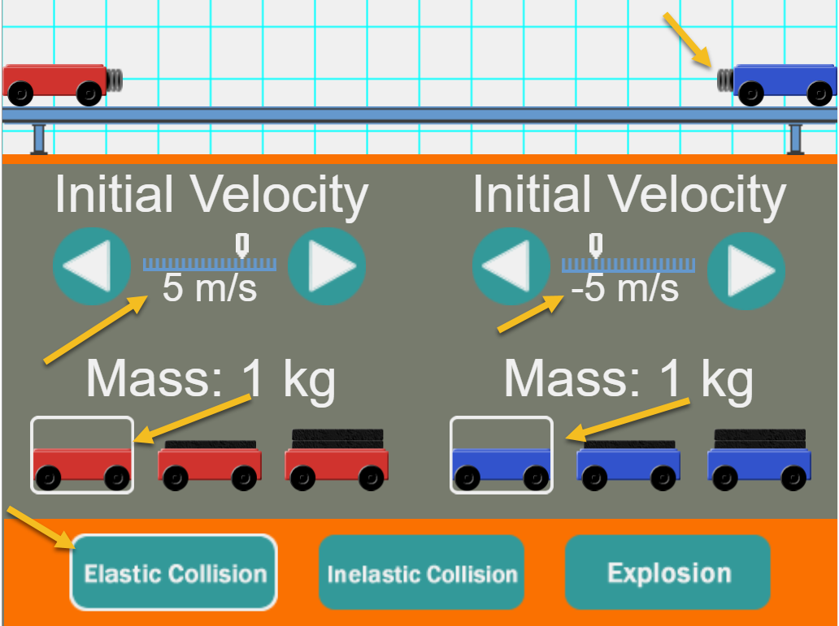

2. The red cart is to the left. The blue cart is at the center.

3. Use 5 m/s for the red cart and -5 m/s for the blue cart.

4. Use 1 kg masses for both carts.

5. Use “Elastic Collision”.

6. Click on “Start”. Observe and record the velocities before and after collision.

**Elastic Collision (Opposite Directions)**

*(Show units for all measurements)*

|  |  |  |  |  |  |  |
| --- | --- | --- | --- | --- | --- | --- |
| Before Collision | | |  | After Collision | | |
| Mass  1st cart | Velocity  1st cart | P = mv  1st cart |  | Mass  1st cart | Velocity  1st cart | P = mv  1st cart |
|  |  |  |  |  |  |  |
|  |  |  |  |  |  |  |
| Mass  2nd cart | Velocity  2nd cart | P = mv  2nd cart |  | Mass  2nd cart | Velocity  2nd cart | P = mv  2nd cart |
|  |  |  |  |  |  |  |

7. Calculate the momentum before and after collision. (Show work)

8. Repeat these procedures using 2 kg mass carts (both red and blue). Change the initial velocity to 10 m/s for the red cart.

|  |  |  |  |  |  |  |
| --- | --- | --- | --- | --- | --- | --- |
| Before Collision | | |  | After Collision | | |
| Mass  1st cart | Velocity  1st cart | P = mv  1st cart |  | Mass  1st cart | Velocity  1st cart | P = mv  1st cart |
|  |  |  |  |  |  |  |
|  |  |  |  |  |  |  |
| Mass  2nd cart | Velocity  2nd cart | P = mv  2nd cart |  | Mass  2nd cart | Velocity  2nd cart | P = mv  2nd cart |
|  |  |  |  |  |  |  |

9. Calculate the momentum before and after collision. (Show work)

10. Show a vector diagram of before and after the collision.

**Conclusions and Questions**

1. Do your results support conservation of momentum? Explain why or why not.

2. Identify and explain the types of collisions in this lab.

3. Was kinetic energy conserved in each collision? How do you know? What would explain any seeming “loss” in kinetic energy?

**Answers**

**Calculations and Data**

**Part 1 Inelastic Collision**

|  |  |  |  |  |  |
| --- | --- | --- | --- | --- | --- |
| Velocity  before | Mass Before | P = mv  before | Velocity  after | Mass  after | P = mv  after |
| 5 m/s | 1 kg | 5 kg∙m/s | 2.5 m/s | 2 kg | 5 kg∙m/s |

7. Calculate the momentum before and after collision. (Show work)

*p = mv for both cars*

8. Repeat these procedures using 2 kg mass carts (both red and blue). Change the initial velocity to 10 m/s for the red cart.

|  |  |  |  |  |  |
| --- | --- | --- | --- | --- | --- |
| Velocity  before | Mass Before | P = mv  before | Velocity  after | Mass  after | P = mv  after |
| 10 m/s | 2 kg | 20 kg∙m/s | 5 m/s | 4 kg | 20 kg∙m/s |

9. Calculate the momentum before and after collision. (Show work)

*p = mv for both cars*

10. Show a vector diagram of before and after the collision.

**Part 2 Inelastic Collisions** (*carts stick together*)

6. What happens after the collision (opposite direction, same velocities and mass)?

*Both carts stop.*

7. Describe the momentum before and after the inelastic collision?

*Momentum before collision: mRedvred + mblue(-v)blue = 0 because mass is the same and velocity is opposite (-v) for the blue car.*

*Momentum after collision is also zero: m(red + blue)v = 0 because V = 0.*

8. Show a vector diagram of before and after the collision.

**V = 0**

**PART 3** Elastic Collisions (*carts bounce off each other*)

**Elastic Collision (Same Direction)**

|  |  |  |  |  |  |  |
| --- | --- | --- | --- | --- | --- | --- |
| Before Collision | | |  | After Collision | | |
| Mass  1st cart | Velocity  1st cart | P = mv  1st cart |  | Mass  1st cart | Velocity  1st cart | P = mv  1st cart |
| 1 kg | 5 m/s | 5 kg∙m/s |  | 1 kg | 0 m/s | 0 kg∙m/s |
|  |  |  |  |  |  |  |
| Mass  2nd cart | Velocity  2nd cart | P = mv  2nd cart |  | Mass  2nd cart | Velocity  2nd cart | P = mv  2nd cart |
| 1 kg | 0 m/s | 0 kg∙m/s |  | 1 kg | 5 m/s | 5 kg∙m/s |

7. Calculate the momentum before and after collision. (Show work)

*p = mv for both cars*

8. Repeat these procedures using 2 kg mass carts (both red and blue). Change the initial velocity to 10 m/s for the red cart.

|  |  |  |  |  |  |  |
| --- | --- | --- | --- | --- | --- | --- |
| Before Collision | | |  | After Collision | | |
| Mass  1st cart | Velocity  1st cart | P = mv  1st cart |  | Mass  1st cart | Velocity  1st cart | P = mv  1st cart |
| 2 kg | 10 m/s | 20 kg∙m/s |  | 2 kg | 0 m/s | 0 kg∙m/s |
|  |  |  |  |  |  |  |
| Mass  2nd cart | Velocity  2nd cart | P = mv  2nd cart |  | Mass  2nd cart | Velocity  2nd cart | P = mv  2nd cart |
| 2 kg | 0 m/s | 0 kg∙m/s |  | 2 kg | 10 m/s | 20 kg∙m/s |

9. Calculate the momentum before and after collision. (Show work)

*p = mv for both cars*

10. Show a vector diagram of before and after the collision.

**PART 4** Elastic Collisions (*carts bounce off each other*)

**Elastic Collision (Opposite Directions)**

|  |  |  |  |  |  |  |
| --- | --- | --- | --- | --- | --- | --- |
| Before Collision | | |  | After Collision | | |
| Mass  1st cart | Velocity  1st cart | P = mv  1st cart |  | Mass  1st cart | Velocity  1st cart | P = mv  1st cart |
| 1 kg | 5 m/s | 5 kg∙m/s |  | 1 kg | -5 m/s | -5 kg∙m/s |
|  |  |  |  |  |  |  |
| Mass  2nd cart | Velocity  2nd cart | P = mv  2nd cart |  | Mass  2nd cart | Velocity  2nd cart | P = mv  2nd cart |
| 1 kg | -5 m/s | -5 kg∙m/s |  | 1 kg | 5 m/s | 5 kg∙m/s |

7. Calculate the momentum before and after collision. (Show work)

*p = mv for both cars*

8. Repeat these procedures using 2 kg mass carts (both red and blue). Change the initial velocity to 10 m/s for the red cart.

|  |  |  |  |  |  |  |
| --- | --- | --- | --- | --- | --- | --- |
| Before Collision | | |  | After Collision | | |
| Mass  1st cart | Velocity  1st cart | P = mv  1st cart |  | Mass  1st cart | Velocity  1st cart | P = mv  1st cart |
| 2 kg | 10 m/s | 20 kg∙m/s |  | 2 kg | -10 m/s | -20 kg∙m/s |
|  |  |  |  |  |  |  |
| Mass  2nd cart | Velocity  2nd cart | P = mv  2nd cart |  | Mass  2nd cart | Velocity  2nd cart | P = mv  2nd cart |
| 2 kg | -10 m/s | 0 kg∙m/s |  | 2 kg | 10 m/s | 20 kg∙m/s |

9. Calculate the momentum before and after collision. (Show work)

*p = mv for both cars*

10. Show a vector diagram of before and after the collision.

**Conclusions and Questions**

1. Do your results support conservation of momentum? Explain why or why not.

*The results should give an indication that the momentum before a collision equals the momentum after a collision. In other words, the total momentum does not change in a system. m1v1 = m2v2*

2. Identify and explain the types of collisions in this lab.

*There were three types of collisions in this lab:*

*1) inelastic collisions in which a moving cart collided with a stationary cart and the momentum was completely transferred from the moving cart to the formerly stationary cart.*

*2) Elastic collision in the same direction in which a moving cart collided with a stationary cart and the momentum transferred completely from the moving cart to the formerly stationary cart.*

*3) Elastic collision in opposite direction in which both carts were moving towards each other. Upon colliding, momentum was transferred so that both carts reversed direction and moved in the opposite direction from how they began.*

3. Was kinetic energy conserved in each collision? How do you know? What would explain any seeming “loss” in kinetic energy?

*Kinetic Energy changed at least a little due to friction between the track and wheels of the carts, but mainly from the collision itself. The seeming “loss” of kinetic energy is due to conversion (transformation) of energy into heat based on friction.*