# Chapter 25 – Kingdom Plantae

# GENERAL Biology students are only responsible for the notes in BLACK font type on this study guide.

# HONORS students are responsible for ALL the class notes (including yellow highlighted notes on this study guide).

I. Seed Plant Structure and Function

A. A_____ — the flowering plants — make up more than 90% of the plant kingdom.

B. Three Principal Organs of Seed Plants:

## _____, _____, _____

## They are linked together by systems that run the length of the plant.

## These systems produce, store, and transport _____, and provide physical _____ and protection.

## Most necessary _____ as as well as _____ are found deep in the ground in a steady supply (_____). Store food.

## _____ is required for roots to work: _____ (_____).

## Transport throughout the plant as well as photosynthesis (_____).

## _____ _____ and store energy.

II. R**_____**

A. Functions

1. **_____** the plant in the ground.
2. **_____** water and nutrients from soil.
3. **_____** absorbed substances to other parts of the plant.
4. **_____** Food (Ex. Carrots, Radishes, Beets, Potatoes).
5. Prevent **_____**.

B. Root Systems

1. **_____** Root
   1. Consists of **_____** large **_____** Root, with many smaller secondary roots.
   2. Most **_____** have this system.
2. **_____** Root
   1. Consists of **_____** roots without a dominant taproot.
   2. Most **_____** have this system.
3. **_____** Roots
4. Roots that arise from a part of the plant that is **_____** a root.
5. Gives **_____** to the plant.

#### C. Root Structure

##### Root **_____**:

###### Rounded tip containing **_____.**

###### **_____** of the root tip as it pushes through the soil.

##### Root Growth:

###### Zone of **_____ _____**

###### Above the root cap

###### Area where cells undergo **_____.**

##### Zone of **_____**

###### Area where cells formed in the meristematic region **_____**

##### Zone of **_____**

###### Area where cells differentiate into **_____**, **_____**, and **_____** tissue.

###### Label:

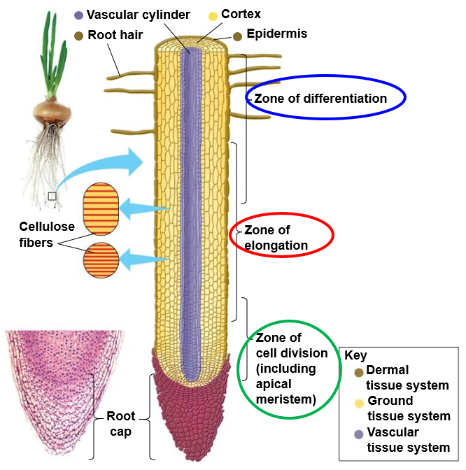

1. Cross Section of a Root
2. **_____** 🡪 transport water and minerals
3. **_____** 🡪 storage area (starch)
4. **_____** 🡪 transport food (glucose) from leaves
5. **_____** 🡪 cells originating from secondary roots
6. **_____** 🡪 confines the central cylinder
7. **_____** 🡪 outer layer of cells; absorption and protection
8. Root **_____** 🡪 epidermal cells to increase surface area for absorption.

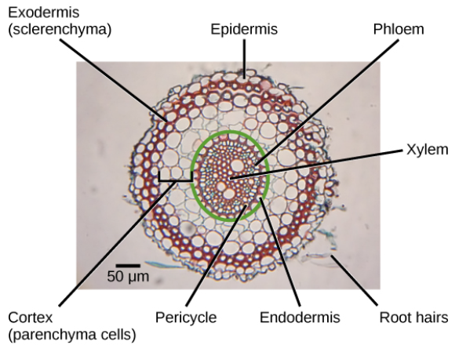

III. S**_____**

A. Functions

1. **_____**system for the plant body (leaves and branches)
2. **_____**System that carries **_____**and **_____**. throughout the plant
3. Stems contain cells from the 3 kinds of plant tissues: **_____**, **_____**, and **_____**.
4. Stems are surrounded by a layer of epidermal cells that have **_____** cell **_____** and a **_____** protective coat.

B. Structure

1. **_____**: where the leaf or branch is **_____** to the stem.
2. **_____**: contain **_____** that can produce new stems and leaves.
3. Stems can develop **_____** tissue that helps support leaves and flowers.

###### C. Vascular Bundle Patterns

1. Vascular Bundle: cluster of **_____** and **_____** tissue
2. M**_____** – Vascular bundles are **_____** throughout the stem.
3. H**_____** Dicots
   1. Vascular bundles form a **_____** near the **_____** part of the stem.
   2. **_____** 🡪 ground tissue cells **_____** the ring of vascular tissue.
   3. **_____** 🡪 ground tissue cells **_____** the ring of vascular tissue.
   4. Presence of **_____,** which forms new vascular tissue (**_____**/**_____**) as needed.

###### Herbaceous stems have little to no **_____** growth.

###### D. Stem Secondary Growth increases the diameter of woody plants

1. Secondary growth is an increase in thickness of stems and roots.

1. occurs at **_____ _____**.
2. **_____** ONLY … most deciduous trees.

2. Lateral Meristems are areas of active cell division that exist in two cylinders that extend along the length of roots and shoots.

1. Vascular **_____** is a lateral meristem that lies between **_____** xylem and primary **_____**.
2. **_____** Cambium is a lateral meristem that lies at the **_____** edge of the stem **_____**.

3. When secondary growth begins the **_____** appears as a thin, cylindrical layer of cells **_____** the xylem and the phloem of each bundle.

1. Divisions in the vascular cambium give rise to new layers of xylem and phloem.
2. Xylem toward the **_____** and Phloem toward the **_____** of the stem
3. As a result of secondary growth, the vascular **_____** gives rise to **_____** new tissues.
4. Secondary **_____** produces **_____** toward the **_____** of the stem.
5. Secondary **_____** produces the INNER **_____** toward the **_____** of the stem.
6. **_____** Cambium produces cells in one direction (outward).
7. The **_____** Bark is composed of **_____** cells.

4. As a result of secondary growth, the stem becomes wider.

5. Each year the cambium produces new layers of vascular tissue, causing the stem to become thicker and thicker.

E. Formation of wood and bark

1. **_____**

1. layers of **_____** xylem produced by vascular **_____**.
2. These cells build up year after year; layer upon layer.
3. As woody stems grow thicker, the **_____** xylem near the center of the stem no longer conducts **_____** and becomes **_____.**
4. **_____** is active in **_____** and **_____** transport.

##### 2. In a mature stem, all of the tissues found outside the **_____** make up the **_____.**

##### These tissues include **_____.**

##### As a tree expands in width, the **_____** layer grows as well

##### **_____** surrounds the cortex, and produces a thick, protective layer of waterproof **_____** that prevents loss of water from the stem.

##### As the stem increases in size, outer layers of dead bark often crack and flake off the tree

###### 3. Woody Stems: Tree **_____**

1. In most of the Temperate Zone, Tree Growth is seasonal
2. In **_____** when water is plentiful, a lot of **_____** is needed to transport it, so more xylem is formed in **_____** than any other time of the year
3. **_____** is larger and not as densely packed as the late **_____.**
4. When a tree is cut down, the spring xylem is **_____** in color, and the late summer xylem is **_____.**
5. During the **_____**, when **_____** xylem is made, a **_____** line forms between the late summer xylem of one season and the spring xylem of the new growing season.
6. The **_____** present indicate how **_____** the tree is.
7. The **_____** of the rings gives an idea of how harsh the **_____** was for any particular growing season (**_____**).
8. **_____** Xylem is wide and **_____** (grows rapidly)
9. **_____** Xylem is thin and **_____** (grow slower)
10. One **_____**’s Growth = Each pair of **_____** and **_____** rings
11. Ground Tissue in **_____** Stems
12. **_____** (photosynthesis in the **_____**).
13. **_____** (shoot support in areas of active **_____** & **_____** nutrients).
14. **_____** (support & **_____** shoot, transport water and nutrients).

IV. Leaves: Structure and Function

1. Main **_____** of the plant
2. Leaves must have a way of obtaining **_____** and **_____** as well as distributing end products
3. Structure of a leaf is optimized to **_____** and carry out **_____.**
4. Leaves appear **_____** because they **_____** green light.
5. Chlorophyll ABSORBS **_____** -violet and **_____** light.
6. **_____** ABSORB blue-violet and green (reflect orange).
7. Like roots and stems, leaves have an outer covering of **_____** tissue and inner regions of **_____** and **_____** tissues

###### Leaf Anatomy

1. Blade: **_____** of leaf (absorbs light – photosynthesis).
2. Petiole: **_____** that attaches the leaf to the stem
3. Epidermis: single layer of **_____** at the top and bottom of leaves (dermal tissue)
4. Cuticle: layer of **_____** over the epidermis that minimizes water loss (dermal tissue)
5. Veins (Vascular Tissue): **_____** and **_____** are bundled in leaf veins that run from the stem throughout the leaves
6. M**_____** (Parenchyma Ground Tissue): area between leaf veins where **_____** occurs.
7. **_____** produced here move to **_____** where they enter the **_____** for transport to the rest of the plant
8. Two subtypes of Mesophyll:
9. **_____** Mesophyll: directly underneath the epidermis; where **_____** occurs.
10. **_____** Mesophyll: beneath palisade layer; allows **_____** and**_____** to move in and out of the leaf.
11. Palisade and Spongy **_____** cells
12. **_____**
13. Growth; food storage
14. **_____** cells – Support, flexibility, photosynthesis
15. **_____** cells – Leaf veins; hard covering of seeds and nuts; found in fibers [cellulose]. Includes **_____** tissue.
16. **_____** Cells – regulate the opening and closing of the **_____**.
17. Stomates
18. Openings that permit **_____** to enter and **_____** to exit the leaf in **_____**.
19. Allows the release of **_____** produced in photosynthesis.
20. Small openings in the **_____** of most leaves
21. Allow **_____** and **_____** to diffuse into and out of the leaf, while helping to **_____.**
22. Each is surrounded by two “**_____**”.
23. Operation of the Guard Cells:
24. Close the stomata when there is **_____** water supply … e.g. at night (low temperature, low **_____**, low water).
25. At daylight, guard cells carry on **_____**, using up **_____** in the cell (hypo-osmotic).
26. Water from surrounding cells rush in (**_____**) to keep stomata **_____** and ensure that water is plentiful during for photosynthesis and due to build up of **_____**. [**_____**].
27. Plants keep their stomata open just enough to allow **_____** and **_____** to take place but not so much that they lose an excessive amount of water.
28. Turgor **_____**
29. Pressure exerted by fluid in a cell that presses the cell **_____** against the cell **_____**.
30. Turgor pressure is determined by the **_____** content of the vacuole, resulting from osmotic pressure.
31. Turgor is what makes living plant tissue **_____**.
32. Loss of turgor, resulting from the **_____** of water from plant cells, causes flowers and leaves to **_____**.

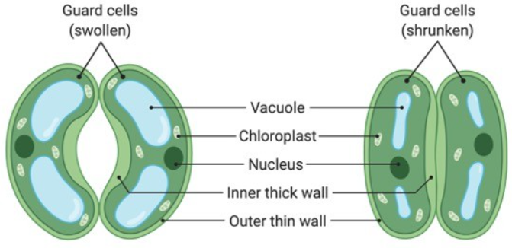

V. The Uptake and Transport of Plant Nutrients

A. Plants acquire nutrients from **_____**, **_____**, and **_____.**

1. Plant growth uses air, water, and soil.
2. Plants obtain water, minerals, and some oxygen from the soil.
3. The **_____** made by plants in **_____** use carbon and oxygen from the atmosphere and hydrogen from water
4. Plants use **_____ _____** to break down some of these **_____**, obtaining **_____** and consuming oxygen.

B. A plant must

1. move **_____** from its roots to its leaves.
2. deliver **_____** to specific areas of its plant body.
3. Water Transport in Plants
4. Plants require a constant supply of water and dissolved minerals from the soil.
5. This is provided as **_____** Sap, a solution of water and inorganic nutrients that flows from the roots through the shoot system to the tips of the leaves.
6. Xylem Sap flows through Xylem Tissue, pulled by **_____**, the loss of water from the **_____** by **_____**.
7. Xylem Sap Movement
8. is aided by the **_____** and **_____** of water molecules.
9. requires **_____** Energy expenditure by the plant.

#### Cohesion-Tension Theory

#### There are _____ that help transport Water in a Plant.

#### _____ Pressure - water entering the root pushes _____ upward in a plant stem.

#### _____ Action - water is pulled up the _____ _____ against gravity.

#### _____ Pull – loss of water from the leaves causes a negative pressure, pulling water up the tree.

#### Transpirational Pull

* **_____** molecules diffuse out of **_____**. This **_____**, called transpiration, creates tension on the chain of water molecules that run from the roots to the leaves.

1. Capillary Action

* The tension pulls the chain of water molecules upward through the xylem cells. Water molecules cling to the cells by **_____** and stick to each other by **_____**.

1. Root Pressure

* Continued **_____** and **_____** of Water and the tension created by Transpiration pulls water and minerals upward from the soil into the xylem cells of the roots.

1. Translocation Theory

* **_____** (glucose) move from the leaves to the rest of the plant through the **_____**.
* **_____** Process (requires energy)

1. Leaves perform photosynthesis and have high concentration of **_____** (glucose).
2. **_____** causes water to enter to accommodate.
3. Areas of the plant not involved in photosynthesis constantly use carbohydrates for energy; therefore, their sugar concentration is lower than in the **_____**.
4. Sugars move from leaves into the phloem,then toward areas of low carbohydrate concentration.
5. Sugar is “pushed” (through phloem) from **_____** Cells 🡪 **_____** Cells.

* Sugars (glucose) are used mainly for **_____**.

VI. Plant Hormones

1. **_____** that control development of cells, tissues, and organs.
2. They also coordinate responses to the environment.
3. 5 Known Plant Hormones:
   * + 1. **_____**
4. Plant hormone responsible for most **_____.**
5. Tropism: **_____** movement of a plant in response to an environmental stimulus.
6. **_____**tropism- directional growth of a plant toward a **_____.**
7. Auxin accumulates in the stem opposite the direction of the sun.
8. This causes the cells on the “dark side” of the stem to elongate and bend the top of the stem toward the light.
9. Other types of tropism
10. **_____**tropism- plant’s growth response to **_____** object.
11. **_____**tropism- directional growth of a plant directly **_____.**
12. **_____**tropism- directional growth of a plant toward a **_____** and away from a negative chemical stimulus.

2. **_____** – Controls various **_____** of a plant (Dormancy, Flowering, Germination, etc.)

3. **_____** – Promotes **_____** in plant roots and shoots. Affect lateral growth and apical dominance

4. **_____** Acid – slows plant metabolism, enhances plant response to environmental _____ (drought, salinity, pathogens); e.g. causing dormancy.

5. Ethylene – **_____** of fruit, opening of flowers, shedding of _____ in autumn.

VII. Pollination 🡪 Seeds 🡪 Fruit 🡪 Germination

1. Pollination
2. Seeds
3. After fertilization occurs, the _____ develops into a _____, and the _____ becomes a _____.
4. A Seed is an _____ of a plant that is encased in a Seed _____ (protective covering) and surrounded by _____ (food supply).
5. An Embryo is an organism in its **_____** stage of development.
6. Fruit
7. **_____** Ovary that contains the seeds.
8. Many different kinds of fruit.
9. Its purpose is to help **_____** seeds.
10. Germination
11. In order for germination to occur, 3 conditions must be met:
    1. Proper **_____**
    2. Proper **_____**
    3. Proper **_____**
12. Most seeds do **_____** require light for germination.
13. Once proper environmental conditions have been met, the following general steps happen:
    1. Water must **_____** the seed coat and penetrate into the seed.
    2. Water hydrates the **_____** and enzymes are activated that make the endosperm nutrients available to the growing embryo.
    3. Seed grows a **_____** to access water and nutrients underground.
    4. Seed grows **_____** that grow towards the sun.
    5. Seed leaves (**_____**) emerge from the seed and begin to perform Photosynthesis.

Optional (fill in the chart)

|  |  |  |
| --- | --- | --- |
| Characteristics of Monocots and Dicots | | |
|  | Monocots | Dicots |
| Seed |  |  |
| Leaves |  |  |
| Flowers |  |  |
| Stems |  |  |
| Roots |  |  |

HONORS ONLY (pp. 10-14)

Reproduction in Flowering Plants

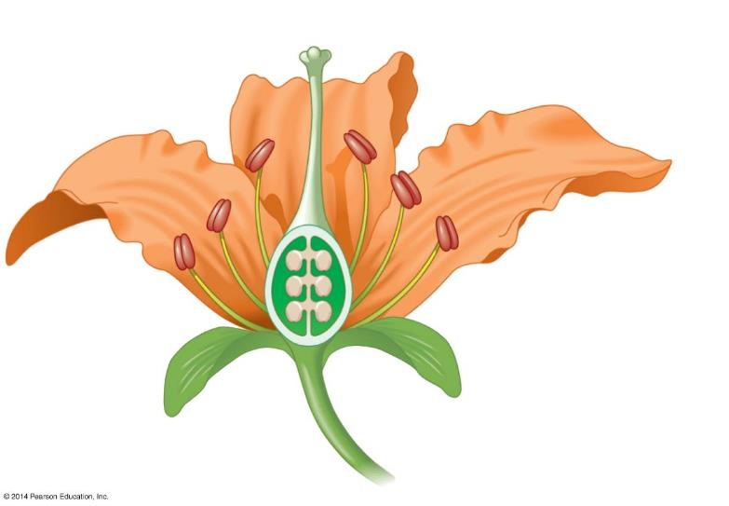

Life Cycle of a generalized Angiosperm

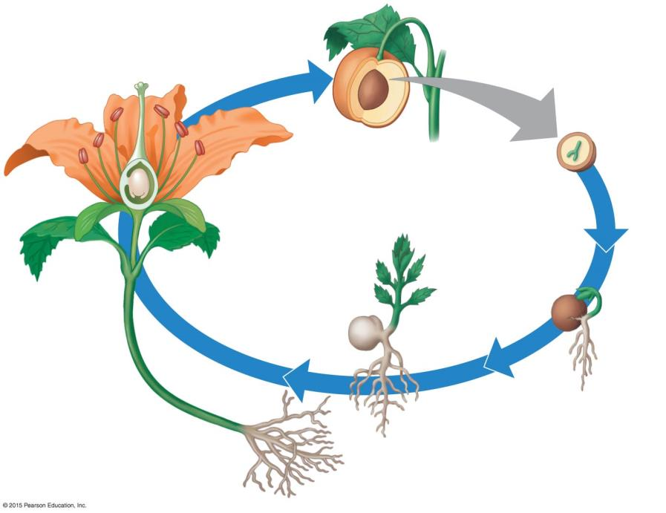

**5**

**4**

**3**

**2**

**1**

1.

2.

3.

4.

5.

**Alternation of Generations Summary**

1. Plant life cycles involve alternating _____ (2*n*) and _____ (*n*) generations.
   1. The diploid plant is called the _____.
      1. Specialized diploid cells in anthers and ovules undergo _____ to produce _____ spores.
      2. The haploid spores undergo _____ and produce the haploid generation.
   2. The haploid generation is called the _____, which produces haploid gametes via _____.
   3. At fertilization, gametes from male and female gametophytes _____ to produce a _____ Zygote.

