# Chapter 26-Animalia I

1. Overview of the Animal Kingdom

A. Branches of the Animal Kingdom

1. Invertebrates

1. Do NOT have a spinal column (_____)
2. Insects and sea creatures
3. _____ animals are invertebrates

2. Vertebrates

1. Have a _____ (backbone)
2. Mammals and Birds

3. _____: Study of Animals

B. Characteristics of Animals

1. M_____
2. E_____
3. No cell _____
4. Ingestive Heterotrophs (take in food and _____ digest it)
5. Go through _____ stage of development
6. Most adult animals are diploid and reproduce _____ by eggs and sperm
7. are produced by meiosis
8. are the only _____ cells
9. _____ fuse during _____ to form a _____.
10. The zygote divides into cells.
11. The zygote divides by _____ to form a _____ ball of cells called a _____.
12. One side of the blastula folds in and cells become rearranged to form a _____. The gastrula forms _____ Embryonic Layers
13. _____ – forms a lining of the future _____ tract.
14. _____ – forms an _____ layer that will give rise to the _____ and _____ system.
15. _____ – forms a middle layer that will give rise to _____ and most internal _____.
16. Maturation
17. After the gastrula stage, many vertebrate animals develop directly into _____.
18. Invertebrate and some vertebrate animals do NOT develop directly into adults.
19. Some animals, such as the sea star, develop into one or more _____ stages.
20. A Larva is an _____ individual that looks _____ from the _____ animal.
21. A larva undergoes a major change in body form, _____. It becomes a mature adult that can _____.
22. Animal Diversity

* 1. According to the Bible (Genesis 1:20-31)
  2. According to Evolution
     1. Animals are believed to have descended from an _____.
     2. Most of today’s phyla of animals are believe to have appeared for the first time in the geological column during a period called the “_____.”

1. Animal Body Plan
2. Presence of True _____
   * + 1. Presence or absence of true tissues separates animals into two groups:
          1. _____ (simplest animals): ___ true tissues
          2. Animals _____ true tissues
3. Tissues are an integrated group of cells that share a common _____ and a common _____.
   1. For example, epithelial, connective, nervous or muscle tissue).
4. Body Symmetry
5. _____ is the arrangement of body parts around a _____ or axis.
6. _____ occurs when the body can’t be divided into _____ parts (sponges).
7. _____ Symmetry:
8. Occurs when body parts are arranged around a _____ point lie spokes on a wheel (jellyfish, sea stars, sea urchins).
9. Most animals with radial symmetry are _____ (attached) or _____ (move very little).
10. _____ Symmetry
11. Occurs when animals can be divided into _____ along a single plane.
12. Organisms will have _____ and _____ sides that are mirror images of each other.
13. Animals with bilateral symmetry are usually _____ and have _____ and _____ ends.
14. Show _____ (tendency to concentrate _____ organs and a _____ at the head or anterior end)

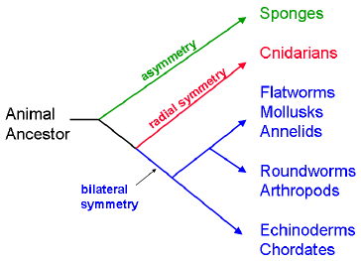

1. _____ Development
   * + 1. 2 or 3 Germ Layers
2. In animals with _____, the blastula folds in on itself to generate the _____.
3. Gastrulas of _____ (jellyfishes and their relatives) have two germ layers:
4. _____: outside
5. _____: inside
6. All other animals with true tissues have a third tissue layer: _____: Between the ectoderm and endoderm.

2. Germ layers: form all of the body’s tissues and organs. The gastrula forms three Embryonic Layers

1. endoderm – forms a lining of the future _____ tract.
2. _____ – forms an outer layer that will give rise to the _____ & _____ system.
3. mesoderm – forms a _____ layer that will give rise to _____ and most internal _____.
4. Animals with 3 tissue layers are divided into 2 groups: _____ and _____.
   1. Protostomes
5. If the Gastrula’s first indentation forms into a _____.
6. Example: _____, _____
   1. Deuterostomes

If the Gastrula’s first indentation forms into the _____.

Example: _____, _____

1. Body Cavity (_____)
   * + 1. Most animals with 3 tissue layers have a Body Cavity or Coelom:
2. Fluid-filled _____ between the outer body wall (ectoderm) and the digestive tube (endoderm) in which the internal _____ are suspended.
3. This body cavity helps protect the suspended organs from _____.
   * + 1. Embryonic development: body cavity (helps protect organs from injury).

3. Types of Organisms

1. _____ (No Coelom)

* Animals that have no internal, fluid-filled body cavity separating its body wall from its digestive tract. E.g. Platyhelminthes (_____)

1. _____

* Organisms with body cavity lined with patches of mesoderm, but not derived from the mesoderm, as in a true coelom, or body cavity. E.g. _____ (round worms)

1. _____

* Organisms with a body _____, (“True Coelom”) that is derived from and lined with _____.

1. Invertebrates
   1. Characteristics
      1. “Simplest” animals
      2. Contain the _____ number of different _____.
      3. Do ___ have a backbone.
      4. Includes _____, _____, _____, _____, _____, _____, _____, and _____.
   2. Phyla Chart Summary

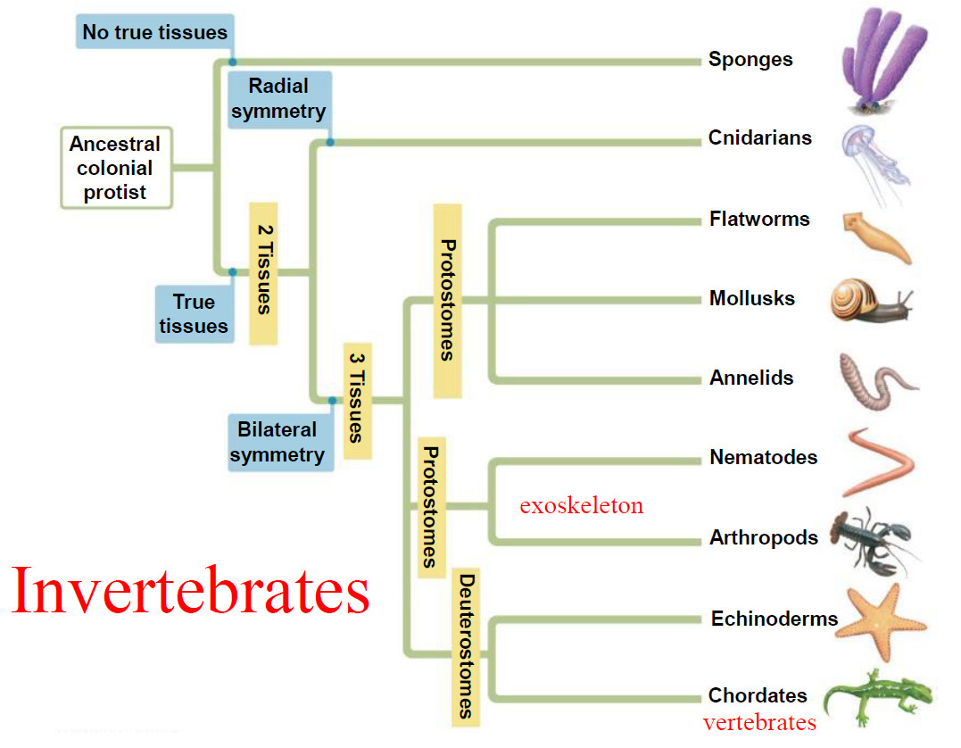

V. Phylum _____ (Sponges)

A. Characteristics

1. The Porifera may be defined as an _____ or somewhat radially symmetrical, multicellular organism with a cellular grade of an organization _____ true _____ and organs.
2. Simplest of all animals

* Lack true tissues and organs

1. _____, mostly marine
2. Lack body symmetry (_____)
3. Hollow, _____ bodies
4. _____: generally remain anchored to their substrate.

B. Anatomy & Features

1. Body wall has outer layer of flattened cells and inner layer of flagellated “_____ cells”.
2. Between these two layers is a jelly-like matrix that has many types of cells embedded in it (amoebocytes). These cells digest food, store and transport nutrients, etc.
3. Porifera do _____ have a _____ system.
4. Porifera have no coelom (_____).
5. Porifera have no real body layers but they do have 2 cell layers;
6. an outer layer that makes up the _____
7. an inner layer that makes the inner _____.
8. Porifera have specialized cells called choanocytes (_____ cells).  Collar cells with cytoplasm covered flagella that help to provide water’s flow.
9. _____ are cells that perform similar tasks of a circulatory system and store nutrients.
10. _____ Feeders
11. Movement of flagella on collar cells produces a current of water into the sponge’s central cavity.
12. Food particles are trapped and distributed to other cells.
13. _____ and _____ exit through a large hole at the top.
14. Porifera have both _____ and _____ reproduction.
15. _____
16. Possess & release _____ eggs and sperm into the water (_____ reproduction).
17. Sponges can reproduce asexually by _____ … the unique ability of regeneration, a form of _____ reproduction. E.g. injury
18. “_____”
19. _____ are microscopic crystalline structures that give _____ and form.
20. Some spicules have toxic _____ that help deter predators or catch _____.

VI. Phylum _____ (Includes hydras, jellyfish, coral, sea anemones)

A. Characteristics

1. Aquatic (mostly marine)
2. _____ symmetry
3. Body Plans: 2 Tissue Layers
4. _____ 🡪 protective & sensory
5. Endoderm 🡪 nutritive, glandular, _____
6. ___glea 🡪 nerve network
7. Gastrovascular cavity 🡪 2-way digestion
8. _____
9. _____ surrounded by tentacles.
10. _____: (stinging cells)

B. Feeding Habits

1. Food is grabbed by tentacles and paralyzed with _____ to sting predators and prey.
2. _____ (stinging cells) found in the Tentacles. Each has a Nematocyst that has a coiled, harpoon-like stinger that shoots out when triggered.

C. Life Forms

1. _____: mouth directed upward; hydra, Coral
2. _____: mouth directed downward; Jellyfish

D. Digestion

1. Cnidarians have an _____ digestive system with only ___ opening; the gastrovascular cavity serves as both a mouth and an anus.
2. Cnidarians carry out _____ digestion, where enzymes break down the food particles and cells lining the gastrovascular cavity absorb the nutrients.
3. An advantage of extracellular digestion is the capacity to eat _____ food particles.

E. Reproduction

1. Cnidarians reproduce both _____ and _____.
2. Some species can produce both eggs and sperm in the same organism. These organisms are called simultaneous _____ and release gametes into the ocean in egg-sperm bundles.
3. Some species are also either male or female and produce either eggs or sperm.