**Simple Graphing Lab**

*Use this worksheet as a guideline for the lab. Complete the warm up questions, graph plotting, and review questions. Once completed, go to Study Place and complete the Lab Test.*

**Learning Objective:**

Explain the components of a typical graph (data collection, axis intervals and units, plotting points, slope lines, dependent and independent variables).

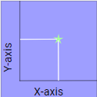

**Background Information**

Graphs provide a quick way to view a lot of data at once. Labs often include graphs. These graphs all have two axes, one up (the vertical axis or y-axis) and one across (the horizontal axis or x-axis).

The data you collect from experiments will show up on these graphs as x marks showing the values for the data. Each mark represents a value on the y-axis (directly across from the mark) and a value on the x-axis (directly under the mark).

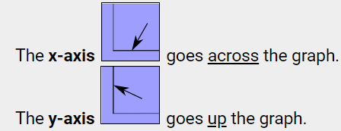

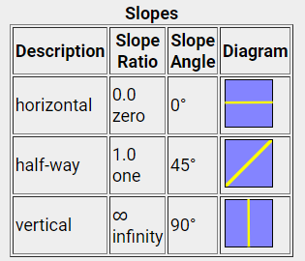

The slope of a line indicates how much it slants up or down, extending horizontally or diagonally. Slope is just another word for steepness. Usually slope is measured as an angle or a ratio.

**Warm Up Questions**

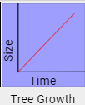

1. The graph to the right plots the size of a tree over time. How do you think the tree’s size changes with time?

a. it gets bigger ↑ b. it gets smaller ↓ c. it stays the same –

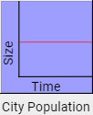

2. The graph to the right plots the growth of the population of a city over time. What do you think is happening to the city over time? How do you think the tree’s size changes with time?

a. it is growing ↑ b. it is shrinking ↓ c. it is not changing –

3. The graph to the right plots the amount of rice stored in a country over time. What do you think is happening to the rice storage in this country?

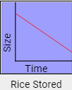

a. it is increasing ↑ b. it is decreasing ↓ c. it stays the same –

Use the graphs on the right to answer questions 4-6

4. Which of the following graphs most correctly shows the height of an average child from the age of one to five years old?



A

B

C

5. Which of the following graphs most correctly shows what happens to the volume of water in a bath tub after the drain is opened?

6. Which of the following graphs most correctly shows the elevation (height) of an airplane at cruising speed?

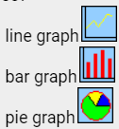

7. Suppose you were making a graph. Which of the types of graphs on the right would best represent the monthly price of gasoline?

Answers



1. The graph to the right plots the size of a tree over time. How do you think the tree’s size changes with time?

*Look along the x-axis (across). As you move to the right, time passes, and the height of the line above the x-axis increases. This line height represents the tree size.* ***It gets bigger****.*



2. The graph to the right plots the growth of the population of a city over time. What do you think is happening to the city over time? How do you think the tree’s size changes with time?

*Look along the x-axis (across). As you move to the right, time passes, and the height of the line above the x-axis stays the same. This line height represents the city population.* ***It's not changing****.*

3. The graph to the right plots the amount of rice stored in a country over time. What do you think is happening to the rice storage in this country?



*Look along the x-axis (across). As you move to the right, time passes, and the height of the line above the x-axis gets smaller. This line height represents the rice stored in the country.* ***It's declining.***

Use the graphs on the right to answer questions 4-6

4. Which of the following graphs most correctly shows the height of an average child from the age of one to five years old?



A

B

C

*The height of a young child increases as the years go by. The graph for something that gets bigger slopes up. (B)*

5. Which of the following graphs most correctly shows what happens to the volume of water in a bath tub after the drain is opened?

*After you open the drain in a tub full of water, the water drains out. The volume of water gets smaller. The graph for something that gets smaller slopes down. (A)*

6. Which of the following graphs most correctly shows the elevation (height) of an airplane at cruising speed?

*An airplane at cruising altitude stays at the same height. The graph for something that stays the same is a flat line. (C)*



7. Suppose you were making a graph. Which of the types of graphs on the right would best represent the monthly price of gasoline?

***Line graphs*** *would be best in this case, represented by plotted points of the price (y-axis) over time (x-axis).* ***Bar graphs*** *are best used to compare things between specific groups or tracking changes over a longer period of time.* ***Pie graphs*** *are best to use when comparing parts of a whole (e.g. percentages).*

Use the **Simple Graphing (Skateboarding) Video** to complete the data table below.

<http://somup.com/cqQrIpe5Fj>

|  |  |
| --- | --- |
| Time (seconds) | Distance (meters) |
|  |  |
|  |  |
|  |  |
|  |  |
|  |  |
|  |  |

What is the independent variable, time or distance? [Hint: not influenced by other variables or quantities.]

What is the dependent variable, time or distance? [Hint: depends on the other variable or quantity.]

1. Write a title for the graph in the box provided at the top.

2. Plot the points from the chart on the graph to the left. [Use the “X” text box below for the points. Copy and paste it.]

3. Draw a slope line (“insert” line) for the plotted points.

4. What is the slope of the line? (∆y / ∆x)

X

0

Distance

m

1 m

2 m

3 m

4 m

5 m

6 m

7 m

8 m

9 m

10 m

Time (seconds)

1 s

2 s

3 s

4 s

5 s

|  |  |  |  |  |  |
| --- | --- | --- | --- | --- | --- |
|  | | | | | |
|  |  |  |  |  |  |
|  |  |  |  |  |  |
|  |  |  |  |  |  |
|  |  |  |  |  |  |
|  |  |  |  |  |  |
|  |  |  |  |  |  |
|  |  |  |  |  |  |
|  |  |  |  |  |  |
|  |  |  |  |  |  |
|  |  |  |  |  |  |

|  |  |
| --- | --- |
| Time (seconds) | Distance (meters) |
| 0 s | 0 m |
| 1 s | 2.0 m |
| 2 s | 4.0 m |
| 3 s | 5.9 m |
| 4 s | 6.9 m |
| 5 s | 8.8 m |

What is the independent variable, time or distance? [Hint: not influenced by other variables or quantities.]

**Time (x-axis)**

What is the dependent variable, time or distance? [Hint: depends on the other variable or quantity.]

**Distance (y-axis)**

X

X

X

X

X

X

4. What is the slope of the line? (∆y / ∆x)

**∆y / ∆x = (8.8 m - 0) / (5 s – 0)**

**Slope = ~1.8**

**The skateboarder began to slow down due to friction.**

0

Distance

m

1 m

2 m

3 m

4 m

5 m

6 m

7 m

8 m

9 m

10 m

|  |  |  |  |  |  |
| --- | --- | --- | --- | --- | --- |
| Distance Over Time (Skateboarding) | | | | | |
|  |  |  |  |  |  |
|  |  |  |  |  |  |
|  |  |  |  |  |  |
|  |  |  |  |  |  |
|  |  |  |  |  |  |
|  |  |  |  |  |  |
|  |  |  |  |  |  |
|  |  |  |  |  |  |
|  |  |  |  |  |  |
|  |  |  |  |  |  |

Time (seconds)

1 s

2 s

3 s

4 s

5 s

Review Questions

A graph of distance against time is a straight line with a slope of 1. If one allows 2 time units to pass, how many distance units have been traveled?

1

2

3

Not enough information

For a graph representing cost against time, which variable is the dependent variable?

Cost

Time

Price

Can't be determined

If a graph is labeled as Cost vs. Time, then time is the variable on the ___.

y-axis

x-axis

vertical axis

the slope line

For a graph representing amount of garbage collected as a function of time passed, which variable is the independent variable?

Amount of garbage

Time

Landfill size

Can't be determined

The axes of a graph are labelled as dekameters on the y axis and hours on the x axis. Which of the following could be a slope value for this graph?

30 dekameters

12 hours

20 dekameters/hour

20 hours/dekameter