**Nuclear Energy (History & Half-Life)**

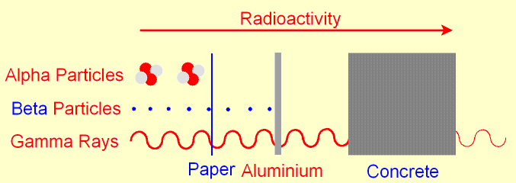 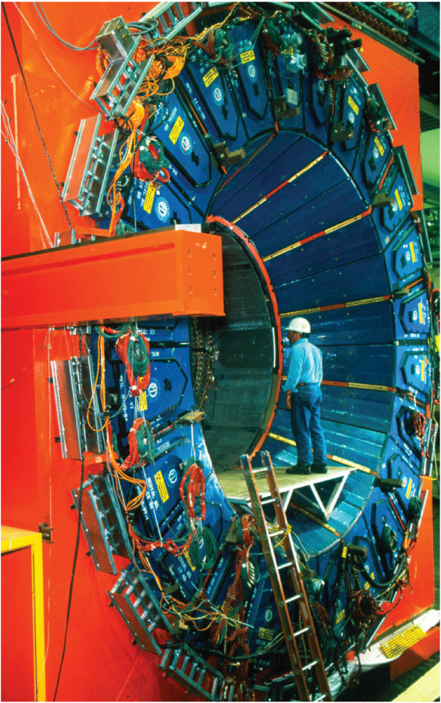

**E = mc2**

**See** [**https://www.learningctronline.com/courses**](https://www.learningctronline.com/courses) **for Materials and Resources.**

**Topics:**

1. Nuclear Energy

**Objectives:**

* Define "radioactivity"
* Describe the three types of nuclear radiation
* Summarize the history of the study of radioactivity
* Describe the effects of nuclear radiation
* Define "half-life" & solve problems involving the concept of half life
* Discuss the application of radioactive decay to dating methods
* Artificial Transmutation of Elements - Explain how one element can be changed into another by bombardment
* Define and describe subatomic particles (quarks, baryons, mesons)

TAKE NOTE

1. Reading (Hewitt Text)

1. Test Corrections (The Atom and Quantum)
2. Lab Revisions (Emission Spectra)
3. Notes Nuclear Energy (History, Half-Life, Transmutation)
4. Half-life Worksheet

1. Problem Set: Nuclear Energy (two weeks)
2. Radioactivity Basics Worksheet
3. Lab: Half-Life
4. Class Song: AGES
5. Week 19 Devotional (<https://www.learningctronline.com/devotional>)

**Text**: Chapters 39 – 40 Nuclear Energy (Hewitt)

**Class Notes: Use the Document provided**

**Homework**:

* Half-Life Worksheet
* HONORS 🡪 brief presentation on nuclear energy (in class next week).
* How much is it used in the world? Benefits? Dangers? Why or why not?

**Lab**: Half-Life

* Perform the lab as directed using the worksheet provided.
* Complete all calculations and data, showing work whenever appropriate.
* Conclusions should be answered in complete sentences that convey a complete thought.
* Save the documents into your LAB folder in the Physics folder on your desktop.

**TEST:** The test will be given after next week’s lesson.

Supplemental Resources (Optional)

1. **Radioactivity Basics Worksheet**

<http://somup.com/cFX20qnjnh> Nuclear Energy in the 1940 & 50's (4:48)