Knot Tying Activity

**Materials** Fishing line String #3 rubber stoppers

To practice making fishing knots, we use string because it is easy to see and maneuver. The teacher or a competent fisher student will demonstrate step by step how to tie each kind of knot.

Tying an Improved Clinch Knot (Tackle to line)

Any beginning fisherman should know certain basic knots. One of these is presented here, and others will be introduced later. The Clinch knot is used to tie the fishing line to a hook, swivel or lure. While it is not difficult to master, it is essential. Tying this knot requires only five easy steps:

1. Holding the hook securely, put the end of the line through the eye of the hook.

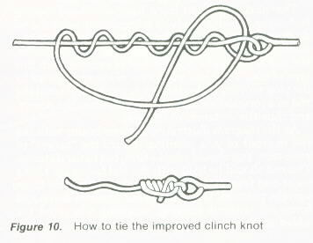

1. Still holding the hook, twist the free end of the line around the standing end of the line about six to eight times.
2. Put the free end through the loop formed between the eye of the hook and the first twist (*the one closest to the hook*).
3. Bring the free end under the loop just formed by it, between the last *twist (furthest from the hook*) and the hook eye.
4. Holding both the free end of the line and the hook in one hand and the fastened end of the line in the other, pull the knot tight.

[www.netknots.com/html/fishing_knots.html](http://www.netknots.com/html/fishing_knots.html) 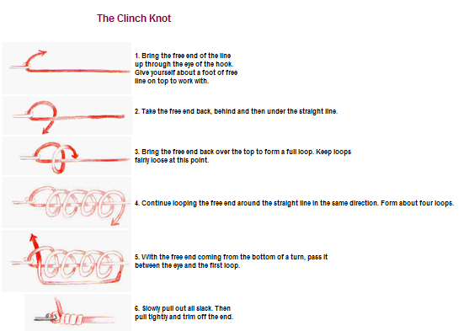

[www.netknots.com/html/fishing_knots.html](http://www.netknots.com/html/fishing_knots.html)Snell Knot (must be used with a leader)

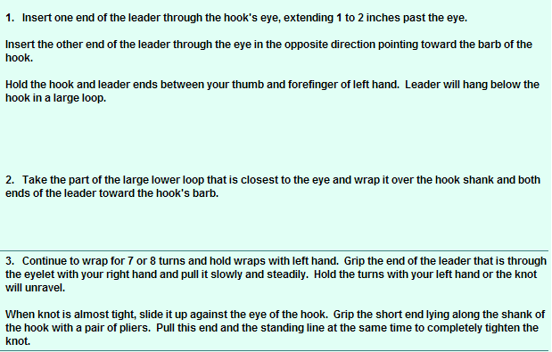

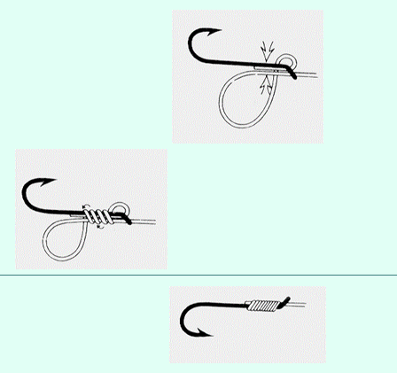

Palomer Knot (hook to line)

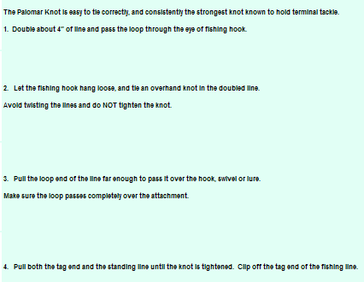

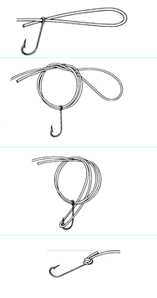Kramer Knot (Very strong)

 

Loop line & bring it back through hook eye

Run line through hook eye

  

Make 4 loops

Run line around FRONT of line and through the previous loop

Loop line BEHIND line

 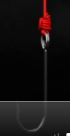Centauri Knot (oldie by a goodie)

Cinching the knot is the difficult part … take your time

Run line through the loop

 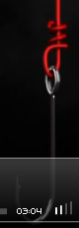 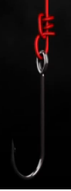

Put line through the hole between the hook eye and line

Loop line around “pole” line 3 times

Run line through hook eye in same direction has barb

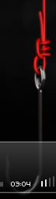 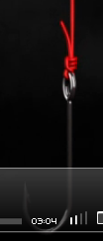

Cinch the line by pulling on hook end and pole end at the same time

Run line through the 3 loops made earlier and out the end

[www.netknots.com/html/fishing_knots.html](http://www.netknots.com/html/fishing_knots.html)Moore Knot (Very Strong)

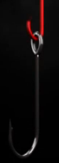 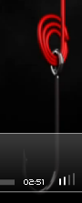

Loop the line through the hook eye 3 times

Run line through hook eye in same direction has barb

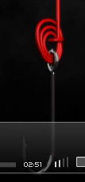 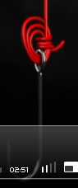

Run line through middle of the loops already made 3 times

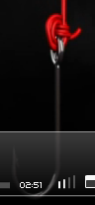

Cinch the line by pulling on MAIN line

[www.netknots.com/html/fishing_knots.html](http://www.netknots.com/html/fishing_knots.html)Tying a Blood Knot

The blood knot is useful when trying to tie two pieces of line together, provided they are of nearly equal diameters. This knot is not used as often as the improved Clinch knot, but it is one of the basics that should be learned.

1. To tie the blood knot overlap the two sections of fishing line about a foot.

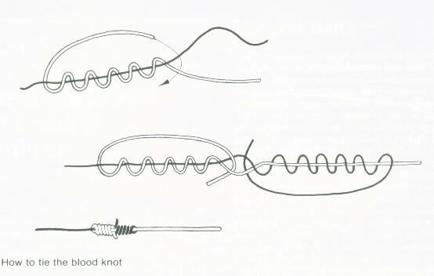

1. Grab the two lines at the middle of their overlap point between your thumb and forefinger.
2. Using one of the short ends of the overlap, you will now tie a modified Clinch knot on one side.
3. Take the short end and wrap it around the other fishing line’s attached portion at least 3 to 5 times.
4. Bring the remainder of the free end down and push it through the loop formed by the two pieces of line near your thumb and forefinger (*see the top diagram in the sketch*).
5. Carefully switch hands, using the thumb and forefinger of the previously free hand to hold the line overlap in place.
6. Twist the remaining free end around the remaining fastened end of the fishing line 5 times. Poke this free end through the loop formed by the two lines at your thumb and forefinger. Be sure that this end is pushed through that loop in the opposite direction of the first end.
7. Holding each free end between the thumb and forefinger of each hand, slowly draw all four sections of line together.
8. After they have been pulled tightly together, forming a neat knot, the excess portions of the two free ends may be trimmed close to the knot.

You should practice this knot several times to get the hand of it. Don’t be discouraged if you don’t tie it correctly the first time. By making mistakes yourself you will be in a better position to help members of your group avoid the same mistakes or to explain why they made mistakes.