Name _____ Teacher, Day, Time ____

Objective Describe the interior of the Earth (in terms of crust, mantle, and inner and outer cores) and where the magnetic field of the Earth is generated.

|  |  |
| --- | --- |
| Layer of the Earth | Thickness of Each Layer of the Earth |
|  | 36 km |
|  | 2900 km |
|  | 2250 km |
|  | 1300 km |

A. Information gained from the study of earthquake waves that pass through the earth’s interior has helped scientists to develop a picture of what it may be like inside the earth.

1. Fill in the table to the right with the proper layer. 🡪

2. On the drawing, label EACH layer with the following:

* Actual thickness of the layer (in km)

* Elemental composition of the layer

* State of matter of the layer (ex. solid, liquid, gas)



B. **Analysis Questions**

1. Many of the deepest earthquakes occur at approximately 700 kilometers below the surface of the earth. In which layer of the earth do these deep earthquakes occur?

2. What is the thickest layer of the earth?

3. What is the thinnest layer of the earth?

4. If you were to use an apple as a scale model of the earth, what part of the apple would represent the earth’s crust?

5. How Do We Know What We Know?

ANSWERS

|  |  |
| --- | --- |
| Layer of the Earth | Thickness of Each Layer of the Earth |
| Crust | 36 km |
| Mantle | 2900 km |
| Outer Core | 2250 km |
| Inner Core | 1300 km |

Objective Describe the interior of the Earth (in terms of crust, mantle, and inner and outer cores) and where the magnetic field of the Earth is generated.

A. Information gained from the study of earthquake waves that pass through the earth’s interior has helped scientists to develop a picture of what it may be like inside the earth.

1. Fill in the table to the right with the proper layer. 🡪

2. On the drawing, label EACH layer with the following:

* Actual thickness of the layer (in km)

* Elemental composition of the layer

* State of matter of the layer (ex. solid, liquid, gas)

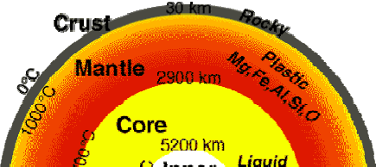



(*inner core*)

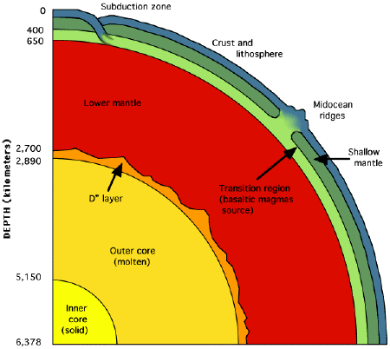

B. **Analysis Questions**

1. Many of the deepest earthquakes occur at approximately 700 kilometers below the surface of the earth. In which layer of the earth do these deep earthquakes occur?

*The mantle is the layer of the earth interior where most earthquakes occur. The earth’s crust is only 36 km thick and since most earthquakes occur ~700 km deep, that is the mantle layer (up to 2900 km deep into the earth’s interior).*

2. What is the thickest layer of the earth?

*The mantle is the thickest layer of the earth (2900 km).*

3. What is the thinnest layer of the earth?

*The crust is the thinnest layer of the earth (36 km).*

4. If you were to use an apple as a scale model of the earth, what part of the apple would represent the earth’s crust?

*The earth’s crust is very thin compared to the other layers of the earth. This would compare to the apple’s peal.*

5. How Do We Know What We Know?

* The Discovery that earth has layers was supported by evidence from earthquake waves.
* When an earthquake occurs energy is released in wave form in all directions from where the quake occurred.
* The seismic waves (earthquake waves) travel differently through different materials.
* As the waves travel through different materials they change speed and direction, this is known as Refraction
  + The waves are recorded by seismograph (earthquake recording stations) stations around the world.
  + Some regions of the earth do not have seismic waves