Name _____

1. Predict what would happen to the water table if…… (I = increase, D= decrease)

a. An area experienced a drought ____

b. An area experiences an unusually high amount of rain ____

c. A large farming corporation moves and uses groundwater to irrigate the crops ____

2. Concrete is _____ meaning it does not allow water to pass through.

3. Create a line graph that shows the relationship between the slope of a stream and the particle size it is able to move.

Slope (gradient)

4. Classify the following as point source pollution (P) or non-point solution (NP)

a. Acid rain ___

b. Oil spill ___

c. Runoff ____

d. Fertilizers that wash off into a stream ___

e. Factory outlet injects chemicals directly into a river ___

5. Put the following in order from highest permeability to lowest permeability: _____

a. Clay/silt b. sand c. gravel

6. Draw a cross section of land and label the water table, zone of aeration, zone of saturation, land surface, and surface water. Hint: Use your note packet from the PPT.

7. Describe how water circulates from an ocean to land. (Use the terms precipitation, runoff, condensation, and evaporation.)

8. Compare V-shaped valleys and U-shaped valleys. Which have a steeper gradient? Which are formed by glacial activity or river flowing?

9. Water is a _____ molecule (*opposite sides of the molecule has different charges*) and is known as the universal _____.

10. Berkley, Huntington Woods, and Oak Park are all in a _____.

11. The ability of water to flow through a given material is called _____ and the amount of open space in a given material is called _____ (Think sponge!)

12. A stream load refers to the material carried by a stream. Draw a picture of a stream and label the suspended load, dissolved load, and bed load.

Vocabulary (*Define each term*)

1. Gradient-

2. Plume-

3. Delta-

4. Discharge-

5. Aquifer-

6. Groundwater-

7. Infiltration-

8. Transpiration-

9. Discharge-

10. Tributary-

11. Meander-

ANSWERS

1. Predict what would happen to the water table if…… (I = increase, D= decrease)

a. An area experienced a drought ____**Decrease**

b. An area experiences an unusually high amount of rain ____**Increase**

c. A large farming corporation moves in and uses groundwater to irrigate the crops ____**Decrease**

2. Concrete is **Impermeable** meaning it does not allow water to pass through.

3. Create a line graph that shows the relationship between the slope of a stream and the particle size it is able to move.

Slope (gradient)

Particle Size

4. Classify the following as point source pollution (P) or non-point solution (NP)

a. Acid rain ___**NP**

b. Oil spill ___**P**

c. Runoff ____**NP**

d. Fertilizers that wash off into a stream ___**NP**

e. Factory outlet injects chemicals directly into a river ___**P**

5. Put the following in order from highest permeability to lowest permeability

a) Clay/silt b.) sand c.) gravel

Gravel 🡪 Sand 🡪 clay/silt

6. Draw a cross section of land and label the water table, zone of aeration, zone of saturation, land surface, and surface water. Hint: Use your note packet from the PPT.

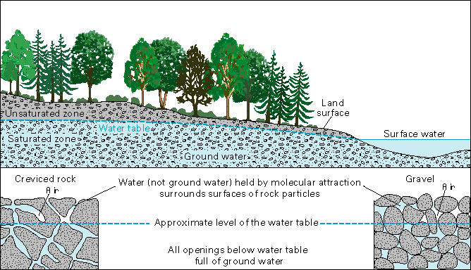

7. Describe how water circulates from an ocean to land. (Use the terms precipitation, runoff, condensation, and evaporation.) **A: Evaporation, Condensation, Precipitation, Runoff**

8. Compare V-shaped valleys and U-shaped valleys. Which have a steeper gradient? Which are formed by glacial activity or river flowing**? V-Shaped have a steeper gradient, formed by river flowing; and U shaped are formed by glacial activity**

9. Water is a **POLAR** molecule (opposite sides of the molecule has different charges) and is known as the universal **SOLVENT.**

10. Berkley, Huntington Woods, and Oak Park are all in a **Watershed**.

11. The ability of water to flow through a given material is called PERMEABILITY and the amount of open space in a given material is called **POROSITY**. (Think sponge!)

12. A stream load refers to the material carried by a stream. Draw a picture of a stream and label the suspended load, dissolved load, and bed load.

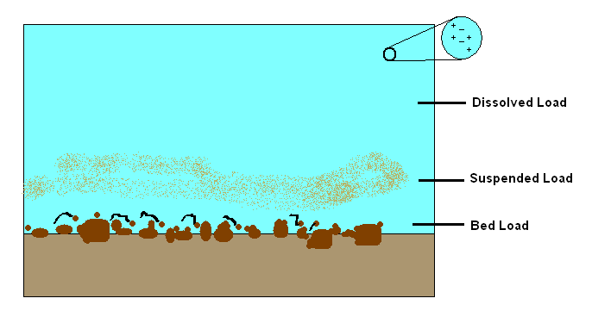

Vocabulary

Gradient - change in elevation of a stream over a distance

Plume - contaminated area of an aquifer

Delta - Triangular shaped deposit created when a stream enters a larger body of water

Discharge - volume of water moved by a stream in a gradient

Aquifer - body of water table

Groundwater - water locked beneath the earth’s surface in soil pore spaces and in the fractures

of rock formations

Infiltration - water soaking into the ground

Transpiration - when plants give off water vapor

Discharge - volume of water moved by a stream in a given period of time

Tributary - smaller feeder stream that flow into larger streams

Meander - bends or turns in a stream