# Name ____

1. A normal-visioned man marries a normal-visioned woman whose father was color-blind. They have two daughters who grow up and marry. The first daughter has five sons, all normal-visioned. The second daughter has two normal-visioned daughters and a color-blind son. Diagram the family pedigree (history), including the genotypes of all the individuals mentioned.

2. Suppose a young lady comes to you for advice in your capacity as a marriage counselor. She tells you that her brother has hemophilia, but both of her parents are normal. She wishes to marry a man who has no history of hemophilia in his family and wants to know the probability of her children having this disease. What would you tell her and how would you explain your conclusions? Diagram the family pedigree (history), including the genotypes of all the individuals mentioned.

3. A normal-visioned man marries a normal visioned wife whose father was color blind. They have a daughter and a son who grow and marry. The daughter has three sons and two daughters. The sons have normal vision and one of the daughters is color blind. The son of the original parents has one daughter who gives birth to a color-blind son. Show a pedigree chart of this family. Give the genotypes of all individuals.

4. Britain’s Queen Victoria is famous not only for being a monarch, but for having a hemophiliac pedigree as shown below. The present-day monarchy arose from George VI and none of his lineage has hemophilia. List the carrier females that are named, unaffected, and affected persons.

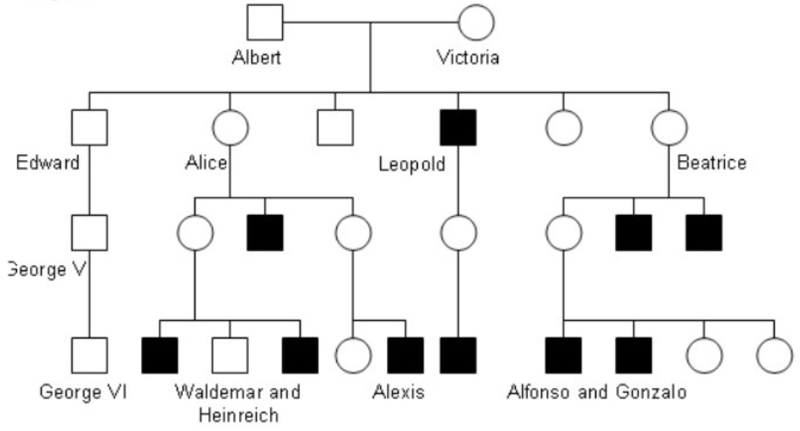

# ANSWERS

1. A normal-visioned man marries a normal-visioned woman whose father was color-blind. They have two daughters who grow up and marry. The first daughter has five sons, all normal-visioned. The second daughter has two normal-visioned daughters and a color-blind son. Diagram the family pedigree (history), including the genotypes of all the individuals mentioned.

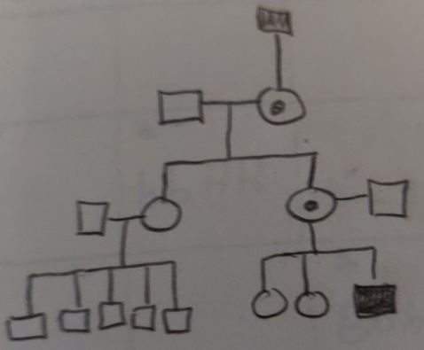

**Color Blind Male Xny Normal Male XNy**

**Carrier Female XNXn Normal Female XNXN**

**This is a sex-linked trait.**

2. Suppose a young lady comes to you for advice in your capacity as a marriage counselor. She tells you that her brother has hemophilia, but both of her parents are normal. She wishes to marry a man who has no history of hemophilia in his family and wants to know the probability of her children having this disease. What would you tell her and how would you explain your conclusions? Diagram the family pedigree (history), including the genotypes of all the individuals mentioned.

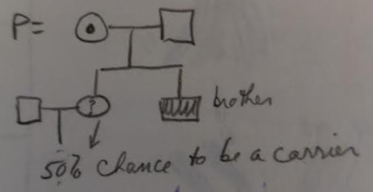

**Hemophiliac Male Xhy Normal Male XHy**

**Carrier Female XHXh Normal Female XHXH**

**This is a sex-linked trait.**

3. A normal-visioned man marries a normal visioned wife whose father was color blind. They have a daughter and a son who grow and marry. The daughter has three sons and two daughters. The sons have normal vision and one of the daughters is color blind. The son of the original parents has one daughter who gives birth to a color-blind son. Show a pedigree chart of this family. Give the genotypes of all individuals.

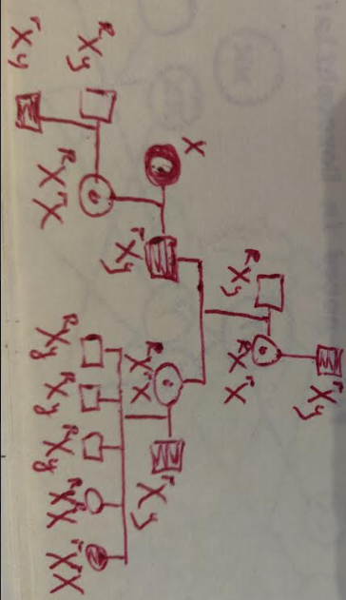

**Color Blind Male Xry Normal Male XRy**

**Carrier Female XRXr Normal Female XRXR**

**Color Blind Female XrXr This is a sex-linked trait.**

4. Britain’s Queen Victoria is famous not only for being a monarch, but for having a hemophiliac pedigree as shown below. The present-day monarchy arose from George VI and none of his lineage has hemophilia. List the carrier females that are named, unaffected, and affected persons.



**Hemophiliac Male Xhy Normal Male XHy**

**Carrier Female XHXh Normal Female XHXH**

**This is a sex-linked trait.**

**Carriers: Queen Victoria, Alice, Beatrice**

**Affected: Leopold, Beatrice’s sons, Alice’s son, Alfonso, Gonzalo, Alexis**

**Unaffected: Albert, Edward, George V and VI**