K_____ Theory – Model of a **Gas**

Properties of Gases (*Postulates or Assumptions*)

* A _____ is composed of individual PARTICLES which are in _____, _____, _____ -line motion

a. _____ may result in a transfer of energy [_____ ***collisions***], but the total net energy of the system remains constant.

b. The _____ of particles is _____ in comparison with the space in which they are *contained (i.e. earth’s volume compared to the volume of the solar system*)

1. Gas particles are considered as having _____ attraction for each other

* Gases take the _____ and _____ of whatever _____, room, or space they occupy.
* The particles change direction only when they rebound from collisions.

Gas Pressure

* If no _____ are present, no _____ can occur, meaning there is no _____. An empty space with no particles and no pressure is called a _____.
* The collisions of atoms and molecules in _____ with objects results in _____ pressure.
* REALITY: _____ in the gas laws

a. This model is not perfect especially under conditions of _____ temperature & pressure

b. Particles do have some _____

c. Particles do have some _____ forces toward each other (Van der Waals forces)

Gas Pressure

* The _____ exerted by the particles of a gas _____ with the surface of an object.
* _____ KE 🡪 _____ collision force 🡪 _____ pressure
* More _____ 🡪 greater collision force 🡪 higher _____

Atmospheric Pressure

* The _____ exerted on all objects [*force/area*]
* Gas pressure is actually the air molecules _____ with surfaces. The more molecules, the more _____ 🡪 the more _____.

Measuring Pressure of a Gas (_____)

* _____ 🡪 device used to measure _____ pressure
* Original barometers used mercury
  + _____
  + Low evaporation rate
  + Modern barometers use small cells of air
  + Expansion or contraction moves dial

Measuring Pressure

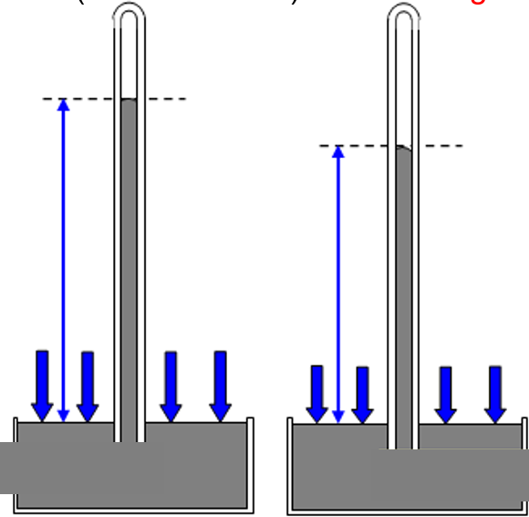

_____ pressure = _____ pressure

* *[left] Atmospheric* _____ *down much more than the “*_____*” inside the tube. So Patm > Pg*
* *[right] “gas”* _____ *the tube has greater pressure than before so the liquid in the tube is pushed down more than before.*

Reading a Barometer

Describe the atmospheric pressure in each manometer.

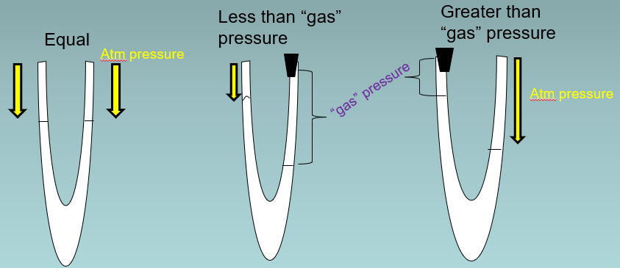

Standard _____ and _____

* Standard Temperature and Pressure (_____) standard conditions used to compare gas measurements; defined as an absolute temperature of _____ K and a pressure of _____ kPa
* Scientists use _____ temperature (K) in all gas calculations.
* One standard atmosphere (_____) is the pressure required to support 760 mm of mercury in a mercury barometer at 25°C.
* ___ atm = ___ mm Hg = ___ kPa

A pressure gauge records a pressure of 450 kPa. Convert this measurement to atmospheres and millimeters of mercury.

Temperature & _____ _____ Energy

* _____ Energy
  + As any substance is heated, its particles absorb energy, some of which is _____ within the particles. This stored portion of the energy is potential energy (___). PE is responsible for _____ changes (_____ *to* _____ *to* _____*, gas to liquid to solid, etc.*) but does _____ raise the _____ of the substance.
* _____ Energy
  + The remaining absorbed energy speeds up the _____ of particles, which is their kinetic energy (___). The particles in any collection of atoms or molecules at a given temperature have a wide range of kinetic energies. The _____ kinetic energy of particles in a system is called its _____.
  + The average kinetic energy of the particles in a substance is directly related to the substance’s temperature in _____ (K).
  + When average KE _____, K temperature also _____.
  + As a substance cools, the particles tend to move more _____, and their average kinetic energy _____.
  + _____ zero (___ K, or ___ oC) is a theoretical temperature at which there is NO _____ of particles; and there is NO _____ at 0 K.
  + No temperature can be lower than _____ zero.

Properties of **Liquids**

* _____ definite shape, but a definite _____
* Fluidity 🡪 Less tightly packed molecules that take the _____ of the container and flow readily
* Less dense than solids, but greater than gases (usually d ∞ 1/T)
* Relatively _____ -compressible except for extreme temperatures and pressures
* Diffusion 🡪 _____ concentration or pressure toward a _____ concentration or pressure
* _____ 🡪 _____ liquid changing to gas
* According to kinetic theory, there are _____ intermolecular attractions between the particles in the gas state.
* The particles in a liquid are attracted to each other. These intermolecular attractions keep the particles in a liquid close together, which is why liquids have a definite volume.

Intermolecular Forces and Condensation

* Intermolecular forces affect interactions between particles
* Stronger forces means more energy to overcome
* _____ (___ 🡪 ___): _____ < intermolecular forces … *Particles* _____ *together, forming* _____
* _____ & _____ (___ 🡪 ___): KE > intermolecular forces … *Particles* _____ *apart forming* _____

Intermolecular Forces and Freezing

* Liquid particles have _____, random motion
* Solid particles are _____ in place, but _____
* Freezing (___ 🡪 ___): KE < intermolecular forces … *Particles* _____ *together, forming* _____
* Melting (___ 🡪 ___): KE > intermolecular forces … *Particles break away, forming* _____

Evaporation

* The conversion of a _____ to a _____ or vapor is called vaporization.
* When this conversion occurs at the _____ of a liquid that is not boiling, the process is called evaporation*.*
* Evaporation is _____ related to _____ area, _____, _____, and moisture (humidity).

The Irony of Evaporation

* Evaporation is a liquid becoming a gas, meaning that heat must be absorbed by the liquid. YET, evaporation is a _____ process. How can this be?

1) The particles that evaporate (escape) from a liquid MUST have _____ KE that the particles left in the liquid.

In this case, the escaped (*vapor or gas*) particles are taking _____ (*in the form of heat*) _____ from the liquid, cooling it.

2) You can experience the effects of evaporation cooling you off on hot days. When you perspire, water molecules in your perspiration absorb heat from your body, gaining enough KE to evaporate from the skin’s _____ (*taking heat with it*). The perspiration (sweat) that remains cools you further by absorbing more body heat.

_____ Pressure

* In an open system, molecules that evaporate can escape from the system.
* In an _____ system, equilibrium is _____ established and various factors must be considered:

_____ 🡪 > T, > evaporation

_____ area 🡪 > SA, > evaporation

air currents 🡪 > AC, > evaporation

ESTABLISHING Equilibrium

* In a _____ system, the molecules collect as a vapor above the _____, increasing pressure of the air above the liquid. Some condense back into a liquid.
* These particles collide with the walls of the sealed container, producing _____. A measure of the force exerted by a gas above a liquid is called _____ pressure = the TENDENCY TO _____.
* Over time, liquid particles continue to evaporate and gas particles condense and return to the liquid state.
* In a CLOSED system, _____ is established.
* Dynamic Equilibrium is a state of balance in which _____ processes (s ↔ l … l ↔ g ... s ↔ g ) are proceeding at equal _____. Must be in a _____ system.

_____ + energy 🡪 vapor [_____] *– heat added*

Liquid + energy 🡨 vapor [condensation] *– heat* _____

Before equilibrium *… evaporation > condensation*

At equilibrium… evaporation RATE = condensation RATE

Dynamic Equilibrium l ↔ g

* In a closed system, eventually, the number of particles _____ will _____ the number of particles _____.
* The system is in equilibrium because the _____ of evaporation of liquid equals the _____ of condensation of the vapor.
* At equilibrium, the particles in the system continue to evaporate and condense, but no _____ change occurs in the number of particles in the liquid or vapor phases.
* The system is in equilibrium because the rate of evaporation of liquid equals the rate of condensation of the vapor.

Vapor Pressure

* Indicates how _____ a liquid will _____ or _____. This can be referred to as how volatile a given liquid is.
* Depends on the _____ of the liquid: liquids have characteristic forces of attraction between their molecules
  + _____ bonding
  + Van der Waals forces (*temporary dipoles that exist between virtually every molecule*)
* Depends on temperature (*avg KE*)

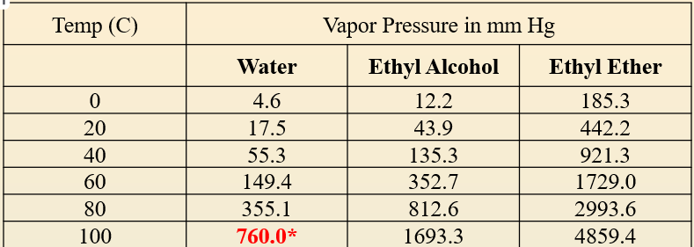

When does water “normally” boil?

When does Ethyl Alcohol “normally” boil?

When does Ethyl Ether “normally” boil?

Can Water boil at 0° C?

Which liquid is most volatile? Least volatile?

Boiling of Liquids

Atmospheric pressure acts on the surface of a vapor bubble, causing it to collapse.

* _____ only occurs at the _____ of an object or liquid
* _____ occurs _____ a liquid, beginning at the heat source
* Avg _____ increases so bubbles (vapor) form throughout the liquid, rise to the surface, and _____ into the air.

_____ Point (bp)

* The temperature at which the equilibrium _____ pressure of the _____ is equal to the prevailing _____ pressure
* Boiling points _____ at higher _____
* Atmospheric pressure _____ with altitude, so _____ vapor pressure is needed to bring a liquid to boiling.
* “_____” Boiling Point means at STP

Boiling & Pressure

* If atmospheric pressure _____, liquids will boil at _____ than expected temperatures (*e.g like doing push ups with people helping lift you*)
* If atmospheric pressure _____, liquids will boil at _____ than expected temperatures (e.g *like doing push ups with people sitting on you*)

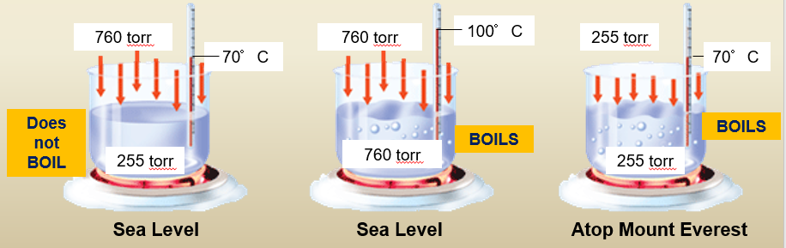

Properties of **Solids**

< Temperature < kinetic energy < particle motion

a. Definite _____

b. Definite _____

c. _____ packed molecules

d. _____ density than liquids or gases

e. Usually least compressible of phases

f. Molecules move _____ of all the phases

g. Particles vibrate about _____ points, and do _____ flow

Phase Changes for Solids

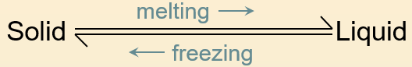

_____ point (mp)

* The temperature at which a _____ changes into a _____.
* The disruptive vibrations of the particles are strong enough to overcome the _____ that hold them in fixed positions.
* Melting: _____ energy > intermolecular _____

_____ point (fp)

* The temperature at which a _____ changes into a _____.
* _____: kinetic energy < intermolecular forces
* Tmp = Tfp

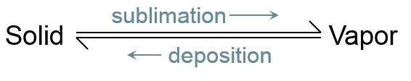

_____

* The change of a substance from a _____ to a _____ without passing through the liquid state is called sublimation. Sublimation occurs in solids with vapor pressures that exceed atmospheric pressure at or near room temperature.
* _____: KE > intermolecular forces
* _____: KE < intermolecular forces

Phase Diagrams

* Represent the relationships among the _____, _____, and _____ states (or phases) of a substance in a sealed container
* The phase diagram of water shows the relationship among _____, _____, and the physical states of water (s, l, g).
* The conditions of _____ and _____ at which two phases exist in _____ are indicated on the phase diagram by a line separating the phases.
* Each slope line represent the equilibrium conditions for one of the phase changes. Label each phase change on the phase diagram:

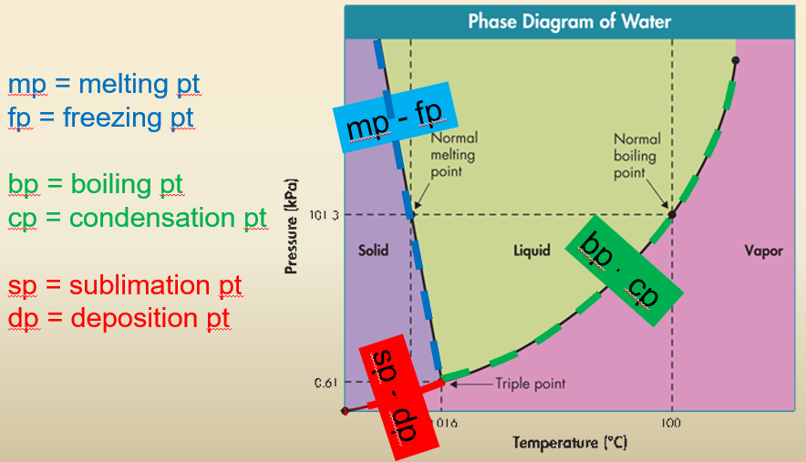

_____ Point

* The point on the diagram at which all _____ phases can exist in equilibrium with one another.
* Freezing, melting, boiling, condensation, sublimation, & deposition are _____ occurring at the _____ time.
* _____ is unique:
* As pressure increases on solid water (*move up the slope line for s ↔ l*), it will eventually melt into liquid water, _____ as it _____.
* For all other substances in creation solids _____ as they freeze, meaning that the *s ↔ l* line on the phase diagram will slope the opposite direction.
* *God is very cool, isn't He?*