**Wildlife Management:**

**Fishing**

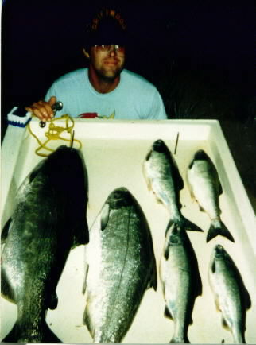 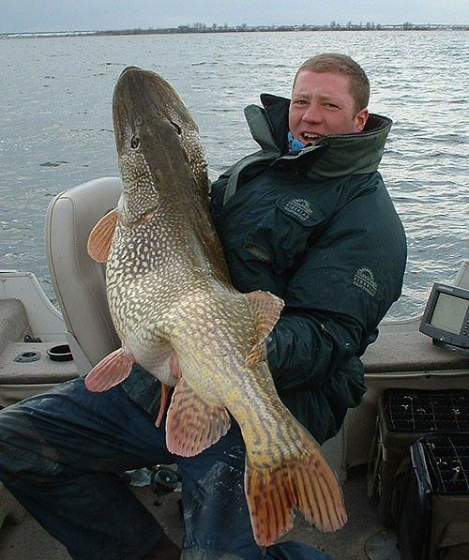

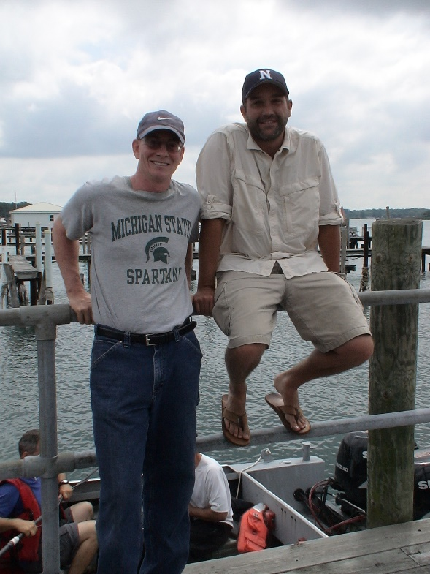

**See** [**https://www.learningctronline.com/courses**](https://www.learningctronline.com/courses) **for Materials and Resources.**

**Topics:**

1. Fishing

**Objectives:**

* + Understand basics of the sport of fishing
    - Bait
    - How to catch a fish
    - Casting techniques
  + Determine the estimated sample of fish in a region using sampling techniques.
  + Explain various knot tying strategies.
  + Observe examples of fishing expeditions.

TAKE NOTE

1. Reference Material: Fishing Basics Worksheet
2. Lab: Knot Tying
3. Lab: Sampling Activity – Fish Management
4. Bonus: Polar Bear Game OR Stream Invertebrate Activity
5. Quiz Fishing
6. Film Review “Blue Miracle” [2021] (Dennis Quaid)
7. Week 11 Devotional (<https://www.learningctronline.com/devotional>)

**Text**:

**Reference Material: Fishing Basics**

**Homework**:

* Fishing Reference Material Worksheet

**Lab**: Knot Tying

* Perform the activity as directed using the worksheet provided.
* Save the document into your LAB folder in the Projects in Science folder on your desktop.

**Lab**: Sampling Activity Fish Management

* Perform the lab as directed using the worksheet provided.
* Save the document into your LAB folder in the Projects in Science folder on your desktop.

**Lab**: Film Review

* Obtain the movie “Blue Miracle” [2021, Dennis Quaid]
  + Complete the **generic** film review in the course Resources folder.
* Save the document into your LAB folder in the Projects in Science folder on your desktop.

**TEST:** Quiz Fishing

1) the academic integrity policy

* Tests must be completed **WITHOUT** referring to books, notes, the internet, people, or any outside resources.
* Students **MAY** use the approved Periodic Tables, approved Reference Tables, or approved equation (formula) sheet (provided by the teacher) along with calculators and scratch paper.
* A guardian should be proctoring the test. Proctoring means to monitor the following:

2) Take the **"in one sitting"**, meaning that once you start the test, you must complete it without interruption.

3) There is a **40-minute time limit** on this test. Please have the proctor write the time taken at the top of your answer sheet with their signature or initials.

4) Proctors should NOT be reading the test or engaging students during the test.

5) Do NOT use RED font. Black font is best.

Supplemental Resources (Optional)

1. Polar Bear Game
2. Stream Invertebrates Activity