* *Scroll through the Periodic Table Notes to answer the following questions*

1. What is the general trend in **atomic radii** across a period? According to atomic theory what causes the trend?
2. What is the general trend in **atomic radii** down a group? According to atomic theory what causes the trend? Make a line graph, showing periodicity of atomic radii.

Atomic Number

1. What trend is observed between the **size** of an atom and the size of the atom’s cation? According to atomic theory what causes the trend?
2. What trend is observed between the **size** of an atom and the size of the atom’s anion? According to atomic theory what causes the trend?
3. What is **ionization energy**?
4. What is the general trend in **ionization energy** across a period? According to atomic theory what causes the trend?
5. What is the general trend in **ionization energy** down a group? According to atomic theory what causes the trend? Make a line graph, showing periodicity of ionization energy.

Atomic Number

1. What is **electronegativity**?
2. What is the general trend in **electronegativity** across a period? According to atomic theory what causes the trend?
3. What is the general trend in **electronegativity** down a group? According to atomic theory what causes the trend? Make a line graph, showing periodicity of electronegativity.

Atomic Number

**ANSWER KEY**

* *Scroll through the Periodic Table Notes to answer the following questions*

1. What is the general trend in **atomic radii** across a period? According to atomic theory what causes the trend?

***Atomic radii DECREASES going across a period (row). A period represents the SAME energy level for the valence electrons. As one goes from left to right across the same period, the nuclear charge (protons) INCREASES while the overall energy level is the same. Therefore, valence electrons are “pulled in” closer to the nucleus.***

1. What is the general trend in **atomic radii** down a group? According to atomic theory what causes the trend? Make a line graph, showing periodicity of atomic radii.

***Atomic radii INCREASES going down a group (family/column). A period represents the SAME energy level for the valence electrons. As one goes from left to right across the same period, the nuclear charge (protons) INCREASES while the overall energy level is the same. Therefore, valence electrons are “pulled in” closer to the nucleus.***

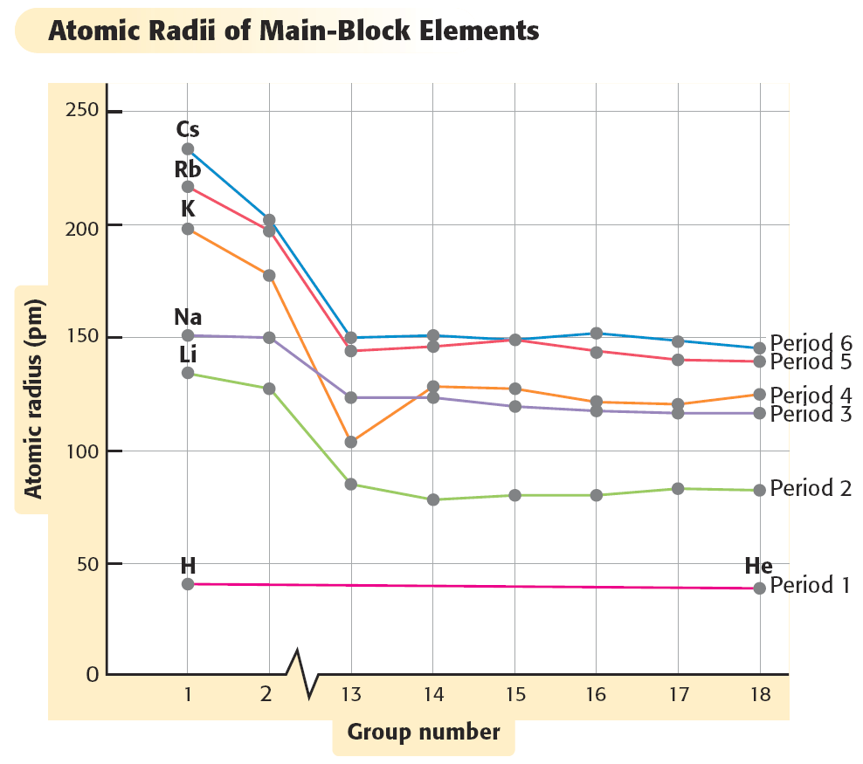

1. What trend is observed between the **size** of an atom and the size of the atom’s cation? According to atomic theory what causes the trend?

***Metals produce “cations” (positively charged ions) by LOSING electron(s). Therefore, the cation will be SMALLER than the neutral atom of any metallic element.***

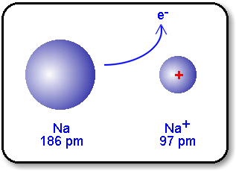

1. What trend is observed between the **size** of an atom and the size of the atom’s anion? According to atomic theory what causes the trend?

***Non-Metals produce “antions” (negatively charged ions) by GAINING electron(s). Therefore, the antion will be LARGER than the neutral atom of any non-metallic element.***

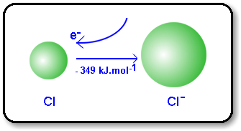

1. What is **ionization energy**?

***Ionization energy is the energy required to remove the most loosely bound electron in an atom. This is usually the valence electron(s).***

1. What is the general trend in **ionization energy** across a period? According to atomic theory what causes the trend?

***Ionization Energy tends to INCREASE along a period or row***

1. ***Due to a decrease in the atomic radii of the atom***
2. ***When electrons are lost by an atom, there is greater nuclear (positive) force than negative***
3. ***The electrons are pulled closer to the nucleus and held more tightly***
4. ***Due to an increase in atomic number***
5. ***the number of protons (positive charges) increases***
6. ***the increase in nuclear charge causes an increase in the attractive force of the nucleus toward the negative electrons and pulls them in***
7. What is the general trend in **ionization energy** down a group? According to atomic theory what causes the trend? Make a line graph, showing periodicity of ionization energy.

***Ionization Energy tends to DECREASE down a group or family***

1. ***Due to an increase in the separation of valence electrons and the nucleus***
2. ***Due to an increase in the SHEILDING EFFECT***
3. ***this is similar to the effect of a solar eclipse by the moon on the earth***
4. ***lower energy orbitals block the force of attraction between the nucleus and the outermost valence electrons***

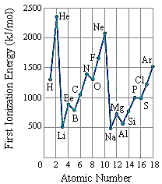

1. What is **electronegativity**?

***The measure of the electron attracting power (ELECTRON AFFINITY) of an atom when it bonds with another atom***

1. What is the general trend in **electronegativity** across a period? According to atomic theory what causes the trend?

***Electronegativity tends to INCREASE along a period or row***

* ***Going across a period, the nuclear attracting power usually increases***

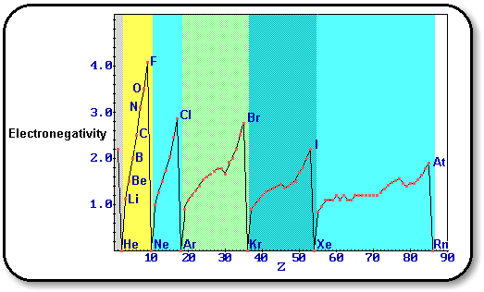

10. What is the general trend in **electronegativity** down a group? According to atomic theory what causes the trend? Make a line graph, showing periodicity of electronegativity.

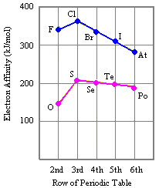

***Electronegativity tends to DECREASE down a group or family***

* ***The atoms get much larger going down a group, so the nuclear attracting power usually decreases***