In problems 1-3, the Woman supports a 100 N load with the friction-free pulley systems shown below. Find the spring-scale readings that show how much force she must exert.

1. _________ 2. _________ 3. _________

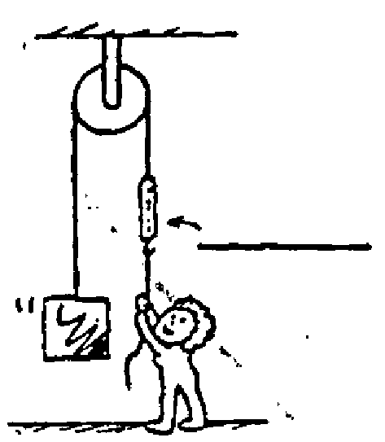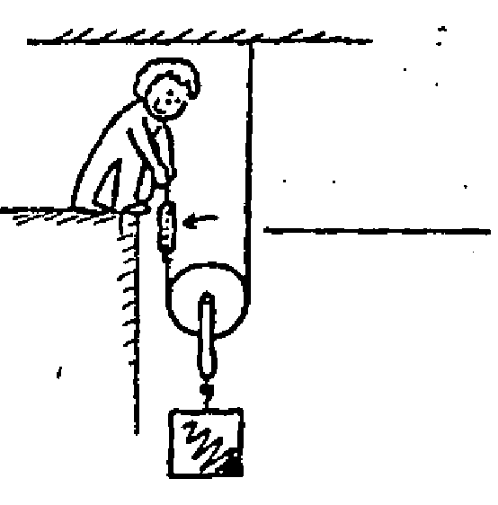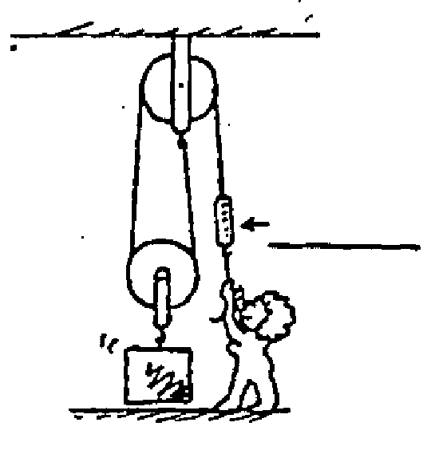

A 600 N block is lifted by the friction-free pulley system shown below.

4. How many strands of rope support the 600 N weight?

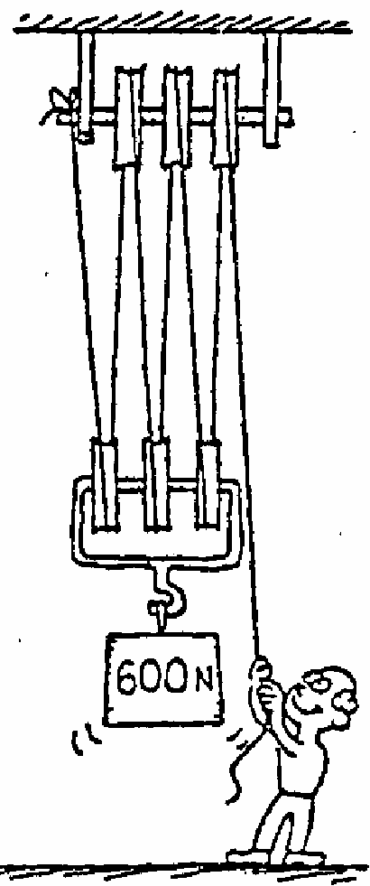5. What is the tension in each strand?

6. What is the tension in the end held by the man?

7. If the man pulls his end down 60 cm, how many cm will the weight rise?

8. What is the ideal mechanical advantage of the pulley system?

9. If the actual mechanical advantage is 5, what is the pulley system’s efficiency?

10. Why don’t balls bounce as high during the second bounce as they do in the first?

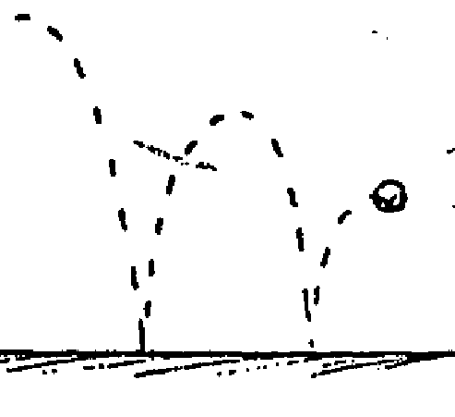

In problems 1-3, the Woman supports a 100 N load with the friction-free pulley systems shown below. Find the spring-scale readings that show how much force she must exert.

1. *100 N* 2. *50 N* 3. *50 N*

2 supporting ropes

*2 supporting ropes means that each support 1/2*



A 600 N block is lifted by the friction-free pulley system shown below.

4. How many strands of rope support the 600 N weight? *6*

5. What is the tension in each strand? *100 N for each supporting rope*

6. What is the tension in the end held by the man? *100 N*

7. If the man pulls his end down 60 cm, how many cm will the weight rise?

*10 cm … the mechanical advantage is 6.*

8. What is the ideal mechanical advantage of the pulley system?

*The mechanical advantage is 6. IMA = resistance force / effort force*

*IMA = # ropes supporting the load*

9. If the actual mechanical advantage is 5, what is the pulley system’s efficiency?

*Eff = AMA / IMA*

10. Why don’t balls bounce as high during the second bounce as they do in the first?

 *Friction (heat) reduces the efficiency of all work done. Elasticity.*