Quantum Theory of Light

### Nature of Light

*Context*

* *e- are the crucial particle in Chemistry*
* *e- are part of light / Electromagnetic Spectrum*

**DEMO** Radiometer

#### Electromagnetic Radiation

1. Form of Energy
2. Travels at the speed of light (c) in a vacuum: 3 X 108 m/s or 186,000 mps
3. Many characteristics can be explained by the “Wave Model” of light
4. Light is part of the Electromagnetic Spectrum

a. radio microwave infrared visible light ultraviolet x-ray gamma

b. visible light is less than 1% of all Electromagnetic radiation … This is tough on agnostic (“I won’t believe it unless I see it”)

## Wave Nature of Light

1. Properties of Waves
2. **Reflection**: the angle of incidence (i) equals the angle of reflection (r)

**DEMO** Optics Kit, Light Source, Flat Mirror

1. **Refraction**:
2. light will speed up or slow down when entering different media
3. **n**1 sin @1 = **n**2 sin @2 The index of refraction (**n**) is an intensive property
4. explain light behavior in transparent media, prisms and lenses

**DEMO** Optics Kit, Light Source, Glass Plate, Prisms (*normal refraction, dispersion, Total Internal Reflection)*

1. **Diffraction**: occurs with one wave OR interference with more than one wave

**DEMO** Pasco Single Slits & Multiple Slits with Optical Bench & Laser Diode

1. Components of Waves
2. Transverse Waves: sinusoidal; water waves; electromagnetic radiation
3. Longitudinal Waves: Compressional; sound
4. Wavelength (λ): crest to crest; trough to trough
5. Frequency (Hz): the number of waves per second
6. Velocity (v): distance travelled per unit time
7. all EM waves travel the same velocity 🡪 variables: f, v, and λ
8. f and λ are inversely proportional
9. c = f λ in a vacuum; v = f λ in any other medium

**DEMO** Long Spring (*show transverse vs. longitudinal; wavelength, frequency [# waves in a given time]; velocity [distance/time])*

#### Particle Nature of Light

**DEMO** Long Spring (*show that more energy produces more standing waves)*

1. Planck’s Constant
2. E = h f E α f
3. Blackbody Radiation – any “body” above 0 K radiates energy
4. Planck noticed that incorporating wavelength into an integral function of radiation yields a “Bell Curve” [ EM source vs. λ ]
5. Planck discovered the mathematical equation describing the bell curve which were different than classical studies by Newton and others involving PE [ mgh ] and KE [ 1/2 mv2 ]
6. Planck discovered distinct energy zones with no gradations in between
7. This relates the Energy of the EM wave to its frequency
8. An atom, when excited, can emit radiant energy only in the form of bursts or bundles, called “QUANTA” (*the classical explanation used a continuous emission spectrum*)

**DEMO**

Long Spring (*standing waves)*

1. When an atom absorbs radiant energy, it absorbs one or more QUANTA (bundles) of energy
2. The amount of energy in a QUANTUM is proportional to the frequency of the radiant energy [ E α f ] and therefore, can be expressed by E = h f [see **Reference Table A**]
3. The PhotoElectric Effect
4. Discovery due to many contributions from *scientists [Einstein, Maxwell, Hertz, Planck*]
5. Set up a circuit (*anode, cathode, high voltage source*) in a vacuum and use metals
6. Radiated electrons onto the cathode
7. below a THRESHOLD frequency of light, no electrons were given off (*e.g. solar calculators won’t work in the dark; e.g. flashlights requiring two batteries will not work with only one*)
8. above the THRESHOLD frequency or energy, electric current is immediately given off [*if classical wave theory was used, it could not explain the immediate emission of electrons from metals because in that case it would take years*]
9. The WORK FUNCTION is the property of the metal used … different metals have different THRESHOLD FREQUENCIES as incident light strikes it
10. The CATHODE received electrons in QUANTIZED amounts which were multiples of “hf” that Planck had calculated
11. The emitted *electrons (travelling towards the ANODE from the Cathode*) absorbed a specific WORK function and therefore, were emitted at a specific kinetic energy

hf = KEmax + W0 hf = [ 1/2 mv2 ] + @

1. Every metal exhibits a specific work function and the KEmax of the electron emitted is constant regardless of the intensity of incident light. However, the number of electrons emitted does increase with intensity of incident light (*e.g. dim light barely allows a solar calculator to work, whereas bright light yields a bright display*)
2. Exception: Na (sodium) metal which exceeds normal visible threshold frequencies
3. exception: Zn (zinc) requires UV radiation to reach threshold
4. **Examples** include “electric eye” solar calculators, garage door openers, photovoltaic cells

If the frequency is low, nothing happens.

e-

incident light

incident light

If the f is high enough, electrons are emitted from the surface.

1. The Bohr Theory
2. Bohr derived an orbital model of the atom in which electrons exist in specific energy orbits outside the nucleus
3. Bohr used the Rydberg/Ritz equation using classical wave mechanics (angular momentum, centripetal acceleration, electrostatic force of attraction) and the concept of the PHOTON.

1 / λ = R (Z2 ) ( 1 / n2 - 1 / m2 )

1. Electrons existed in ORBITS that did not radiate energy … this is theoretically possible at a specific angular momentum … otherwise the electrons would spiral into the nucleus or be tangented out of its orbit as in the planetary model of our solar system [*bound energy system*]

**DEMO** Straw with 30 cm thread and small weights

1. When electrons change energy levels, there is a specific energy change (QUANTUM) described by “hf” (Planck). There are NO intermediate energy gradations between orbits for electrons.

1H**1** 1) electron orbits have a specific diameter

p

2) energy orbits are separated by multiples

e-

of “hf” and are named “K, L, M, N, O, P

and Q shells in the Bohr Model

1. Bohr calculated the GROUND STATE of the HYDROGEN ATOM, and therefore, could calculate the energy levels associated with the Hydrogen atom [ *see handout p. 805* ]
2. Lyman series
3. Balmer series
4. Paschen series
5. Each energy level could only contain a specific number of electrons

* Shell number 1 2 3 4 5 6 7
* Shell letter K L M N O P Q
* # of electrons 2 8 8 32 32 18 8

###### Hydrogen Series of Energy Levels

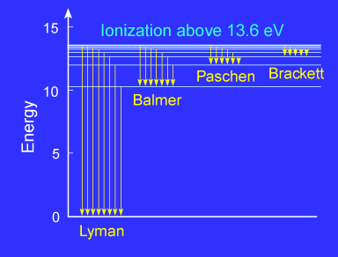

The Excited State of an Atom

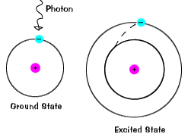

* An atom in the ground state is at equilibrium in terms of energy and particles
* When heat or light (photons) strike an atom and bring it to the “excited state” equilibrium is disturbed as electrons jump to higher energy levels
* The electron will return to the “ground state” to restore equilibrium … it must, therefore, give off the excess energy it gained
* The excess energy is given off as colors of light (wavelengths)

1. The Debroglie Wavelength & Momentum
2. Debroglie reasoned that if light had a particle nature and a wave nature, then matter must also have a wave nature as well as a particle nature
3. He used the concept of a **PHOTON’s energy** E = hf … substituting v = f λ and therefore f = v / λ , he came up with the following equation:

E = hv / λ

1. Using classical Momentum p = mv , he could substitute into the energy equation and end up with the **MOMENTUM of a PHOTON**

λ = h / mv

1. E.g. an automobile weighs 3000 lbs or 1. 36 x 104 newtons, travelling 60 mph, what wavelength is given off by the car?
2. 60 mph = 88 ft/s = 26.82 m / s
3. **λ = h / mv**
4. Weight = mass x gravity so **mass** = Weight / gravity = 1. 36 x 104 newtons / 9.8 m / s2 = 1.3 x 103 kg
5. h = 6.634 x 10-34 js
6. **λ =**  6.634 x 10-34 js **/** (1.3 x 103 kg ) ( 26.82 m / s) = 1.78 x 10-34 m
7. **Wavelengths below 10-16** are imperceptible

#### Spectroscopy

1. The radiation emitted or absorbed by a metal, a gas or a substance, revealing the PARTICLE nature of light
2. Emission Spectrum
3. When an atom receives (absorbs) energy from heat or electricity, the atom becomes “**excited**”. When it returns to the “**ground state**”, it gives off a characteristic light spectrum.
4. Continuous Spectrum
5. The light emitted forms a continuous, blended spectrum of color

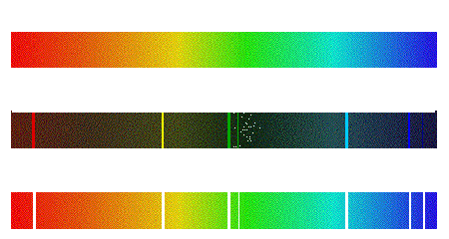

1. Color is produced as white light is dispersed by a prism (e.g. rainbow)

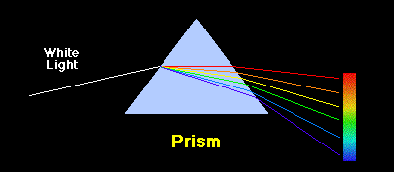

1. White light is produced by an incandescent bulb

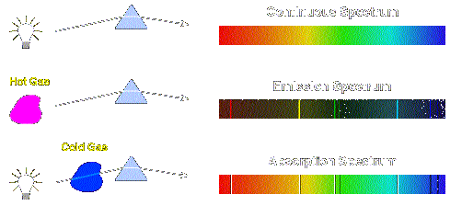

1. Bright-Line Spectrum
2. The light emitted forms sharp, individual bright lines of color, distinctly separated as part of the spectrum
3. Hot Gaseous elements exhibit bright-line spectra characteristic of that element when they release the energy they absorbed to reach an “excited state”
4. Bright-Line Spectra are like FINGERPRINTS for elements – each element has its own Bright-Line Spectra which is used for identification

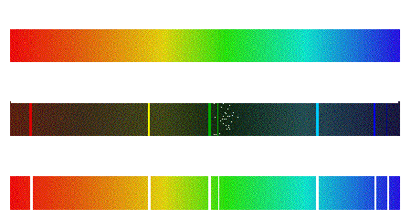

1. Absorption Spectrum (Dark Line Spectrum)
2. Represents the exact opposite of the Bright-Line Spectrum in which a dark line exists for absorption where the Bright-Line would exist in emission
3. This spectrum shows the energy (*color of light*) needed to raise an atom to a certain “excited” energy level (*colors represent specific light energies … ROYGBIV: from lower to higher energy*)



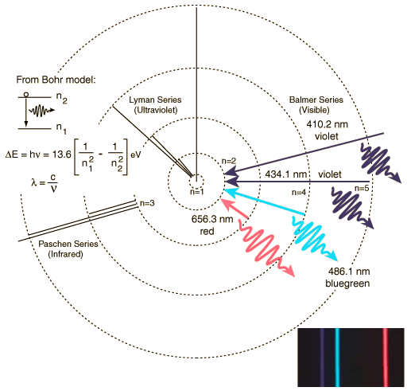

##### Modern Atomic Theory – Quantum Mechanics