Of the following, which is most crucial to science?

a. dependent variables

b. historic perspectives

c. supporting evidence

d. opinions by well-known scientists

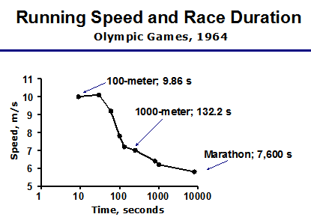

Time

a. represents the dependent variable.

b. represents the independent variable.

c. is shown on the y axis.

d. is always directly proportional to the control.

Collective insight and expertise that increase reliability of observations and conclusions, and the ability to solve scientific problems relates to

a. analytical chemistry

b. scientific variability

c. hypothesizing

d. collaboration

Physical properties of a substance include

a. color and odor.

b. melting and boiling points.

c. malleability and ductility.

d. all of the choices are valid.

Which of the following assumptions is NOT considered part of the kinetic theory of gases?

a. A gas is composed of individual PARTICLES which are in continuous, random, straight-line motion.

b. Collisions may result in a transfer of energy (assuming elastic collisions), but the total net energy of the system remains constant.

c. The volume of particles is ignored in comparison with the volume in which they are contained.

d. Gas particles have some attractive forces toward each other.

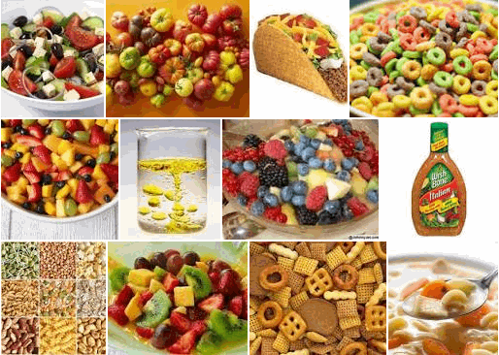

How would you classify the items in the image?

a. heterogeneous mixtures

b. heterogeneous substances

c. homogeneous substances

d. homogeneous mixtures

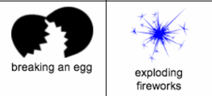

What kind of changes are inferred in the image?

a. Breaking an egg is a physical change; exploding fireworks is a chemical change.

b. Breaking an egg is a chemical change; exploding fireworks is a physical change.

c. Breaking an egg and exploding fireworks are physical changes.

d. Breaking an egg and exploding fireworks are chemical changes.

Which statement defines and gives an example of an intensive property?

a. used to identify; volume

b. used to determine amount; mass

c. used to identify; density

d. used to determine amount; volume

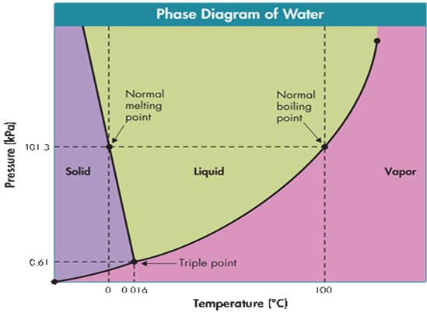

19. What phase exists at 102 kPa & 70 C?

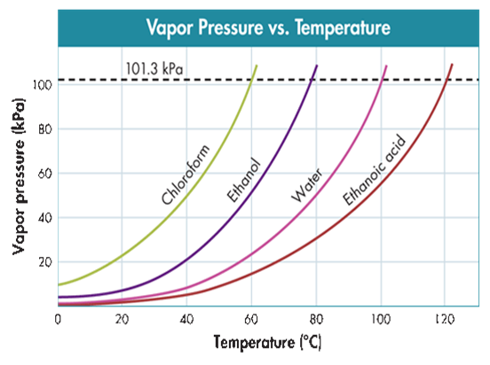

The normal boiling point of chloroform is closest to

Significant figures in a measurement comprise:

a. all the digits in any measurement (e.g. 0.01, 100, 1.0, etc.).

b. all the digits in a measurement except the last one.

c. all digits with certainty (graduations on the measuring tool) and the first digit that is uncertain.

d. all digits with certainty (graduations on the measuring tool) and two uncertain numbers beyond that.

The length and width of an index card are 12.79 cm and 7.60 cm respectively. What is the area of the index card (use significant figures)?

Which measurement expresses 0.0134 m in scientific notation and uses the correct number of significant figures?

What is the mass of a piece of lead that occupies 40.0 cm3 and has a density of 11.35 g/cm3?

Four different students measured the volume of a 20.0 liter gas tank using various measuring devices. Based on their measurements, answer questions 19 and 20.

Student A: 18 liters

Student B: 1.80 x 101 liters

Student C: 20 liters

Student D: 21.25 liters

Which student had the most precise measurement?

Which student had the most accurate measurement?

Convert 4.9 cm/ml to m/kl.

According to Schrödinger, the region of high probability of finding an electron in an atom is called a ___.

The electron configuration of the element, _____, is 1s22s22p63s23p1. What is this element's atomic number?

A neutral atom of an element with atomic number 48 and mass number 120 contains

Which statement is NOT true concerning wave-particle duality of light?

a. Light does not have mass and does not take up space.

b. Frequency and energy of photons are directly related.

c. Wavelength and frequency of photons are inversely related.

d. The photoelectric effect shows light (photons) emitting electrons automatically when striking a metal's surface.

Which scientist's contribution is MISREPRESENTED based on the history of atomic structure?

a. The positively charged subatomic particle, the proton or canal ray, was discovered by Goldstein.

b. Thomson discovered the electron, proton, and neutron using a Crookes tube (cathode ray tube).

c. Dalton: All elements are composed of indivisible particles called atoms. All atoms of the same element have the same chemical properties.

d. Millikan's oil drop experiment suspended electrons between charged plates to determine a charge to mass ratio.

e. Rutherford designed the initial planetary model of the atom with electrons outside the nucleus.

A sample of element "X" contains 90.0 percent X35 atoms, 8.0 percent X37 atoms, and 2.0 percent X38 atoms. Ignoring significant figures, the average isotopic mass is closest to:

As energy is ____ electrons get “excited” to a higher energy level. The wavelengths of light that cause this excitation make up the ___ spectrum.

Which statement does NOT represent one of Mendeleev's major contributions to the Modern Periodic Table?

a. He arranged the elements by increasing atomic mass.

b. He arranged the elements by similarities in physical and chemical properties of elements.

c. He arranged the elements by increasing atomic number.

d. He predicted the existence of elements that were not yet discovered.

The energy needed to remove an electron from an atom in the gaseous state is called ____ and is ____.

a. ionization energy and is less for metals than non-metals.

b. ionization energy and is greater for metals than non-metals.

c. electronegativity and is greater for metals than non-metals.

d. electronegativity and is less for metals than non-metals.

Oxygen forms compounds with metals by gaining electrons. In doing so, it becomes

a. a cation whose atomic size is less than the neutral atom.

b. a cation whose atomic size is greater than the neutral atom.

c. an anion whose atomic size is less than the neutral atom.

d. an anion whose atomic size is greater than the neutral atom.

Atomic size generally

a. increases from left to right across a period.

b. decreases going down a group.

c. remains constant within a period.

d. decreases from left to right across a period.

The subatomic particle that plays the greatest role in determining the physical and chemical properties of an element and can change within the same element is the

a. proton

b. electron

c. photon

d. neutron

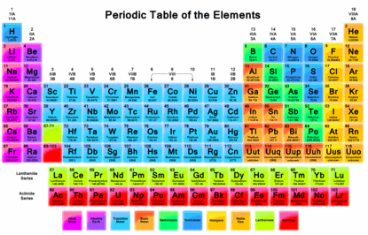

On the periodic table, there is a periodic pattern in the physical and chemical properties of elements based on

a. increasing atomic mass.

b. increasing electronegativity.

c. increasing atomic number.

d. increasing atomic radius.

Which term or phrase LEAST relates to an elements ability to attract electrons?

a. electronegativity

b. electron affinity

c. shielding effect

d. periodicity (periodic trends)

What is the net charge of the magnesium ion when it bonds ionically?

a. +12 p ... -10 e- = +2

b. +12 p ... -12 e- = 0

c. +10 p ... -12 e- = -2

d. +13 p ... -10 e- = +3

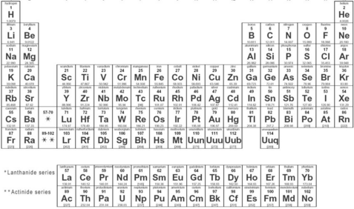

Which of the following elements is a metalloid?

a. As

b. Se

c. Br

e. Kr

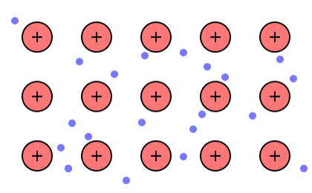

Which statement is NOT true concerning forces of attraction between free-floating valence electrons and positively charged metal ions?

a. The forces of attraction result in metals are malleable and ductile, instead of brittle.

b. The forces of attraction allow electrons to conduct current or thermal energy.

c. The forces of attraction involve a sea of drifting valence electrons, allowing metal cations to slide past each other like ball bearings immersed in oil.

d. The forces of attraction are metallic bonds resulting from the transfer of valence electrons.

The electron configuration of a fluoride ion, F-, is

a. 1s22s22p5.

b. the same as that of the neon atom.

c. 1s22s22p63s1.

d. the same as that of a potassium ion.

Sterling silver, brass, bronze, and stainless steel are all _____, meaning they are mixtures of two or more elements, at least one of which is a metal, producing superior properties to those of their component atoms.

When do Ionic compounds conduct electricity?

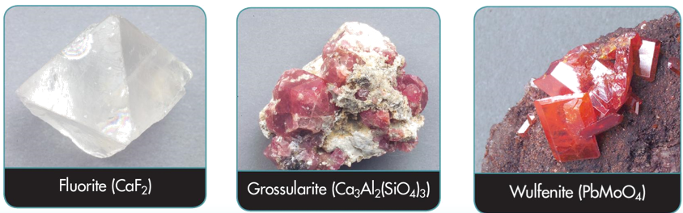

The image shows three substances at room temperature, which are

a. ionic compounds with high melting points.

b. covalent molecules with low melting points.

c. cations of metals with lower than expected melting points.

d. anions of nonmetals with higher than expected melting points.

Metals tend to have _____ ionization energies, while nonmetals tend to have _____ electronegativities. Therefore, Metals tend to _____ electrons to complete their valence, forming _____, while nonmetals tend to _____ electrons to complete their valence, forming _____.

Which substance does NOT have the correct geometric shape associated with it?

a. H2O has a bent shape.

b. CH4 has a trigonal planar shape.

c. NH3 has a pyramidal shape.

d. CO2 has a linear shape.

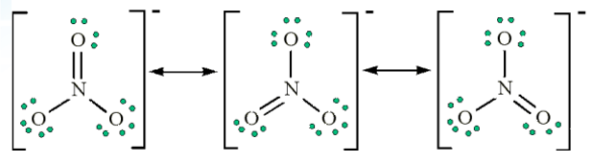

The image shows

a. resonance.

b. coordinate covalent bonds.

c. triple covalent bonds.

d. exception to the octet rule.

Which of these elements does NOT exist in nature as a diatomic molecule?

a. O

b. Cl

c. N

d. Si

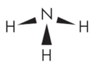

Ammonia (NH3) exhibits a pyramidal shape due to electron repulsion of the unshared pair of electrons in nitrogen. Which statement is true?

a. Ammonia has polar bonds and is a polar molecule.

b. Ammonia has nonpolar bonds and is a polar molecule.

c. Ammonia has nonpolar bonds and is a nonpolar molecule.

d. Ammonia has polar bonds and is a nonpolar molecule.

These temporary dipoles, caused by electrical attractions between oppositely charged regions of polar molecules, determine whether a molecular compound is a solid, liquid, or gas at room temperature.

a. hydrogen bonds

b. Van der Waal forces

c. network forces

d. ionic bonds

45. Which is NOT a common characteristic of network solids?

a. Melting points commonly reach 1000 C or higher.

b. Compounds are insoluble in most solvents and are poor conductors.

c. Compounds are very soft.

d. Compounds like diamond, graphite, silicon dioxide, possess strong covalent bonds, and the entire sample can be thought of as a single molecule.

A triple covalent bond is formed when two atoms share ___ valence electron(s).

Use the polyatomic ion chart to name them incorrectly.

What is the correct formula for dinitrogen tetroxide?

What would be the formula for copper(II) phosphate?

What is the ionic charge on the chromium ion in the ionic compound that has the formula Cr2O3?

What is the charge on the phosphorus atom in the polyatomic ion: PO4-3?

What is the formula for sulfuric acid?

Which law states, "When two elements combine to form more than one compound, the different masses of one element that combine with the same mass of the other element are in the ratio of small whole numbers"?

How many grams are there in 2.12 moles of C3H8?

What is the molecular mass of potassium bromide?

A compound composed of Nickel and fluorine contains 9.11 g Ni and 5.89 g F. What is the empirical formula of this compound?

What is the molecular mass of Ammonium Phosphate?

A compound has the empirical formula C2H3O and a molar mass of 172.0 g. What is its molecular formula?

How many atoms of carbon are in 3.27 mol of propane (C3H8)?

How many grams are in 4.00 x 1023 particles of AlCl3?

How many hydrogen atoms are in 4 molecules of isopropyl alcohol, C3H8O?

Calculate the mass of nitrogen in 125 g of NH3.

The chemical formula of aspirin is C9H8O4. What is the mass of 0.200 mol of aspirin?

How many moles of SO3 are in 2.4 x 1024 molecules of SO3?

What is the volume (in liters at STP) of 2.50 mol of carbon monoxide?

The mass of a mole of oxygen molecules:

The density of a gas is 3.21 g/L. What is the molar mass of this gas?

A large weather balloon filled with helium has a volume of 7.00 x 102 L at STP. Which expression should be used to find the mass of helium in the balloon?

a. 22.4 L/mol x 4.0 g/mol He

b. 7.00 x 102 L x 4.0 g/mol He

c. 22.4 L/mol x 7.00 x 102 L x 4.0 g/mol He

d. 7.00 x 102 L x 1 mol/22.4 L x 4.0 g/mol He

Determine the density of SO2 gas @ STP. [Do not use any reference table for this question EXCEPT the Periodic Table.]

What is the percent by mass of carbon in acetone, C3H6O?

What is the percent by mass of nitrogen in NH4NO3?

The mole ratio of elements in Ca3(PO4)2

Find the mass, in grams, of 5.00 x 1023 molecules of F2.

Which has more atoms, 58.2 g aluminum or 106.5 g silver?

a. Aluminum has more atoms than silver.

b. Silver has more atoms than aluminum.

c. Aluminum and silver have the same number of atoms.

d. There is not enough information to answer the question.

1,6 diaminohexane is used to make nylon. What is the empirical formula of this compound if its percent composition is 62.1 % C, 13.8 % H, and 24.1 % N?