**Creation / Evolution**

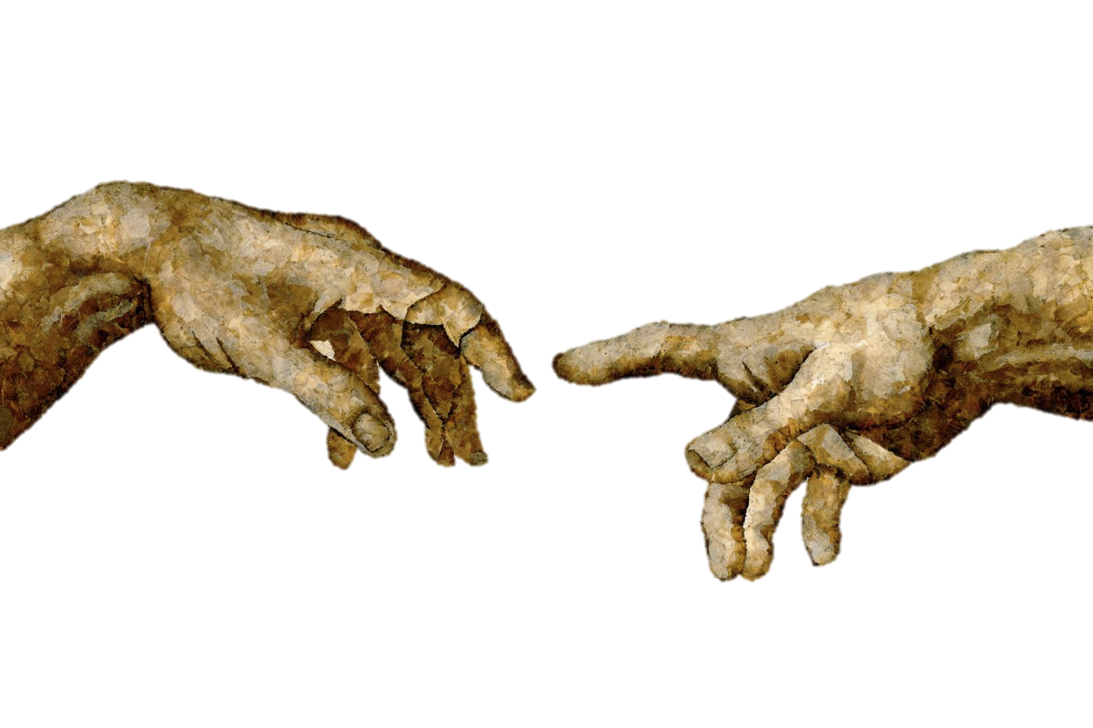

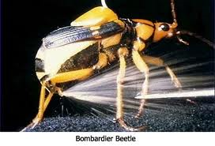 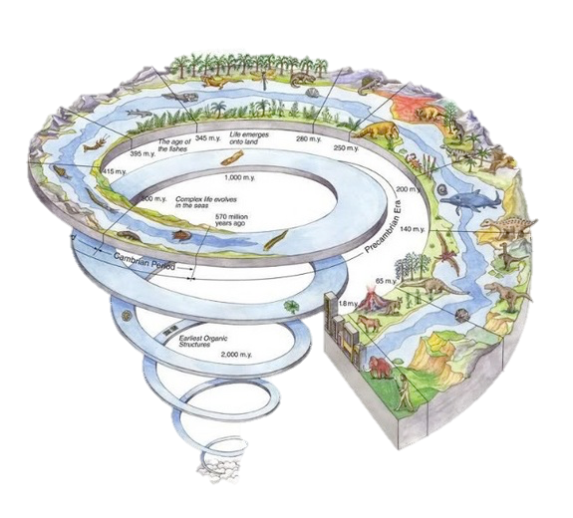

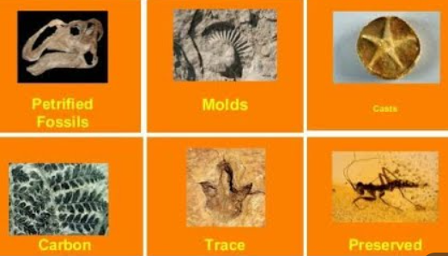

**See** [**https://www.learningctronline.com/courses**](https://www.learningctronline.com/courses) **for Materials and Resources.**

**Topics:**

1. Creation / Evolution

**Objectives:**

1. Establish the best way to deal with a potentially controversial and contentious issue.
2. Identify and dismantle misconceptions related to creation / evolution.
3. Learn and practice the appropriate questions to ask in a discussion of creation / evolution.
4. Understand the fossil record, its place in earth’s history, and the use of radioactive dating.

TAKE NOTE (1 week)

1. Creation / Evolution Notes / Study Guide.
2. Age of the Earth Summary Report (Steven Ball) Worksheet.
3. Lab Fossil Identification
4. Lab Radioactivity Simulation
5. Worksheet Fossils
6. Film Review “Inherit the Wind” [1988] (Kirk Douglas, Jason Robards, Darren McGavin) … 1h 36m
7. Quiz Fossils & Radioactive Dating
8. Week 18 Devotional (<https://www.learningctronline.com/devotional>)

**Text**:

**Reference Material: Creation/Evolution PowerPoint**

**Homework**:

* Creation / Evolution Notes / Study Guide
* Age of Earth Summary Report (Steven Ball)
  + PDF by Steven Ball
  + Worksheet to summarize article
* Worksheet Fossils

**Lab**: Fossils

* Perform the lab as directed using the worksheet provided.
* Save the document into your LAB folder in the Projects in Science folder on your desktop.

**Lab**: Radioactivity Simulation

* Perform the lab as directed using the worksheet provided.
* Save the document into your LAB folder in the Projects in Science folder on your desktop.

**Lab**: Film Review

* Obtain the movie “Inherit the Wind” [1988, Kirk Douglas, Jason Robards, Darrin McGavin] [1h 36m]. Youtube.com.
  + Complete the **Inherit the Wind** film review.
* Save the document into your LAB folder in the Projects in Science folder on your desktop.

**TEST:** Quiz Fossils & Radioactive Dating

1) the academic integrity policy

* Tests must be completed **WITHOUT** referring to books, notes, the internet, people, or any outside resources.
* Students **MAY** use the approved Periodic Tables, approved Reference Tables, or approved equation (formula) sheet (provided by the teacher) along with calculators and scratch paper.
* A guardian should be proctoring the test. Proctoring means to monitor the following:

2) Take the **"in one sitting"**, meaning that once you start the test, you must complete it without interruption.

3) There is a **30-minute time limit** on this test. Please have the proctor write the time taken at the top of your answer sheet with their signature or initials.

4) Proctors should NOT be reading the test or engaging students during the test.

5) Do NOT use RED font. Black font is best.

Supplemental Resources (Optional)

***<https://somup.com/c31vDmuc3J> Incredible Creatures that Defy Evolution 1 (9:04) Dr. Jobe Martin, former evolutionist, Bombardier Beetle and Giraffe***

[***https://somup.com/c31vbiucZy***](https://somup.com/c31vbiucZy) ***Incredible Creatures that Defy Evolution 2 (11:23) Woodpecker, Golden Plover***

<http://somup.com/cZVbFDkpHP> (6:58) Young Earth or Old Earth? [by Christians]