# Human Anatomy & Physiology – Nerves Circulation Respiration

I. N_____ System

1. Overview
2. Nervous and _____ systems work together to coordinate body functions.
3. _____ within this system relies on _____.
4. Neurons are nerve _____ that transmit information via _____ and _____ signals.
5. MAIN FUNCTIONS:
6. Receive _____ Information
7. Integrate the information
8. Coordinate a _____
9. Two Main Divisions
10. _____ Nervous System (CNS)

* _____ & _____ Cord

1. _____ Nervous System (PNS)

* Nerves which convey information between the CNS and the rest of the _____.

1. _____ receptor 🡪 sensory input 🡪 integration in Brain and spinal cord (CNS) 🡪 _____ output (peripheral NS) 🡪 _____ cells
2. Neurons

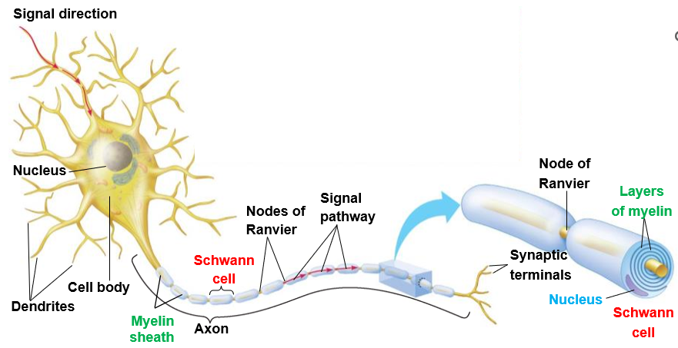

1. _____ _____ contains the nucleus and other cell organelles.
2. _____ *receive* signals from other neurons and convey this information toward the cell body.
3. _____: *transmit* signals to other cells.
4. Wrapped in fatty Myelin Sheaths.
5. _____ of Ranvier: _____ between cells that form Myelin Sheaths.

* _____ signal conduction along an axon.

1. A typical axon has hundreds of branches, each with a _____ Terminal at the very end.
2. _____ cells wrap around axons of motor and sensory neurons to form the myelin sheath.
3. S_____

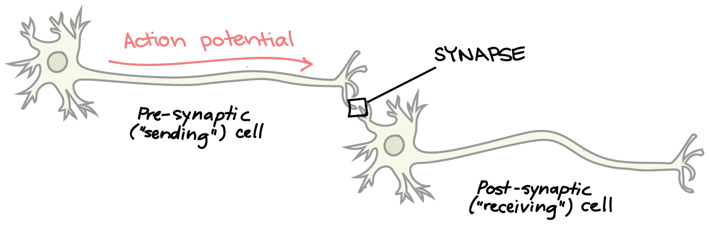

1. The _____ between a synaptic terminal and another cell is called a Synapse, or _____ point.
2. At a synapse, electrical or chemical signals are transmitted to other neurons or effector cells.
3. Synapses are relay points between a synaptic terminal of a sending neuron and a receiving cell, which could be another neuron.
4. The sending (_____) cell secretes a _____ *signal*, a _____, which crosses the Synaptic Cleft.
5. The neurotransmitter binds to a *specific receptor* on the surface of the _____ (_____) cell.

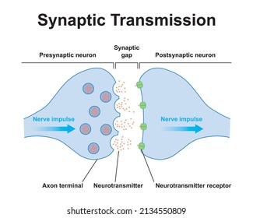

1. Membrane _____
2. Nerve function depends on charge differences across neuron membranes.
3. At _____, when a neuron is not transmitting a signal, a neuron’s plasma membrane has _____ _____ — the membrane potential, in which

* just _____ the cell is slightly _____.
* just _____ the cell is slightly _____.

1. The _____ Potential is the voltage across the _____ membrane of a resting neuron.

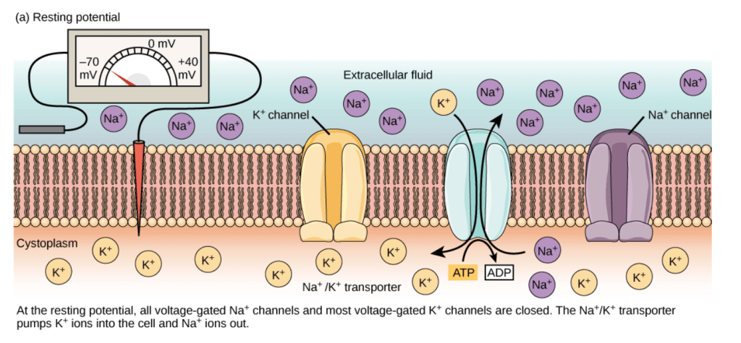

1. All voltage-gated Na+ channels and most voltage-gated K+ channels are closed.
2. _____ -_____ (Na+-K+) Pumps
3. use energy from _____ to actively move __+ out of the neuron and __+ into the neuron.
4. The resting potential exists because of differences in _____ concentration of the fluids _____ and _____ the neuron.
5. The _____ _____ membrane that surrounds a neuron is _____ to charged molecules or ions.
6. To enter or exit the neuron, ions must pass through special _____ called ion channels that span the membrane.
7. Ion channels have different configurations: open, closed, and inactive.
8. _____ Potential
9. A _____ _____, called an Action Potential,
10. is a _____ in the membrane voltage.
11. that transmits a nerve signal along an _____.
12. The rapid flip-flop of the membrane potential is
13. a result of the _____ movements of _____ across the membrane.
14. at Na+ and K+ *voltage-gated channels*,
15. that open and close in response to stimuli.
16. They propagate in a _____ chain reaction along a neuron.
17. They are _____ events.

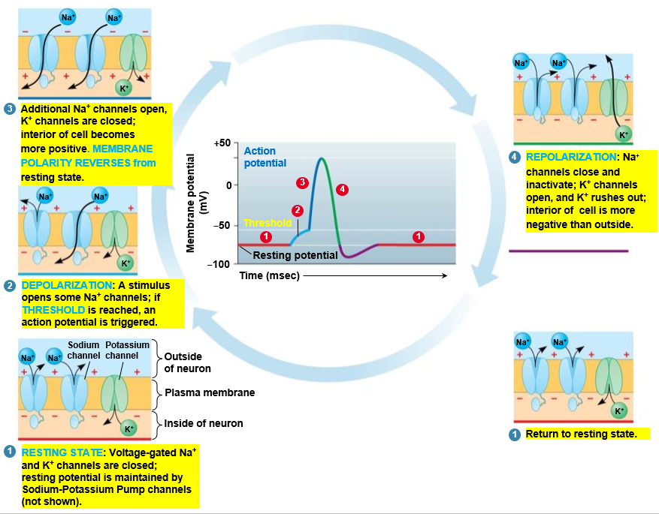

II. C_____ System

1. The Circulatory System facilitates exchange with all Body Tissues.
2. To sustain life, the body must
3. acquire _____
4. exchange _____
5. dispose of _____ products.
6. The Circulatory System facilitates these exchanges. It consists of:
7. a _____ pump (_____)
8. a circulatory _____ (_____)
9. a set of tubes (_____) to carry the circulatory fluid.
10. The vertebrate circulatory system is often called a _____ system, with three main types of vessels:
11. _____ carry blood _____ *from the heart* to body organs and tissues.
12. _____ *return blood* _____ *the heart*.
13. _____ convey blood _____ *arteries and veins* within each tissue.
14. Large _____ branch into _____, which give rise to _____, which branch into networks called Capillary _____, which infiltrate every organ and tissue in the body.
15. Capillaries converge into Venules, which in turn converge into larger _____ that _____ blood to the Heart.

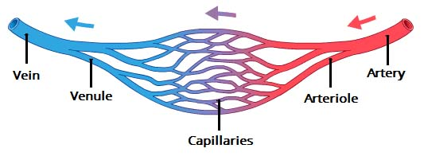

1. Land vertebrates have a Double Circulation:
2. The _____ circuit carries _____ -_____ blood between the heart and the lungs.
3. The _____ circuit carries _____ -_____ blood between the heart and the rest of the body.
4. In all Birds and Mammals, the heart has _____ chambers with two _____ and two _____.

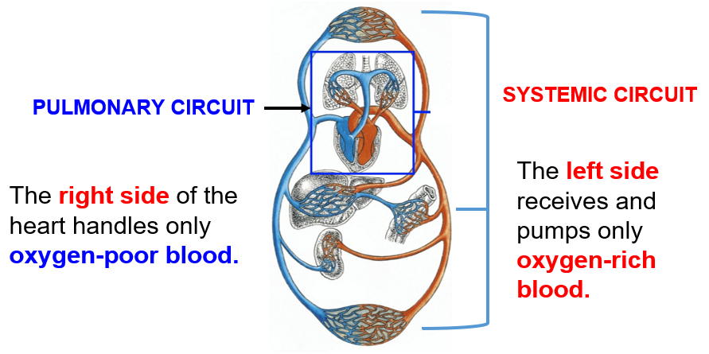

1. H_____
2. Main component of the circulatory system
3. Muscular Organ (_____) about the size of your fist that pumps the blood.
4. ___ chambers with ___ valves through which blood must pass on each trip around the body.
5. 70 beats per minute
6. Pumps _____ coming from the lungs to all parts of the body through a network of blood _____.
7. _____ 🡪 special tissue inside the heart that causes it to beat automatically
8. The heart has Four hollow spaces called Chambers.
9. _____: upper, _____ chambers

* Blood _____ the heart through the atria.

1. _____: lower, larger, _____ chambers

* Blood _____ the heart through the ventricles.

1. Four Valves in the heart direct the flow of blood.
2. _____ Valves (Mitral & Tricuspid Valves)
3. _____ valves separate the atrium and ventricle on each side of the heart.
4. Allow blood to flow in only one direction: from _____ to _____.
5. _____ Valves (Pulmonary & Aortic Valves)
   * One-way valves allow blood to leave the ventricles, but not return.
6. Each side of the heart pumps blood to a different part of the circulatory system.
7. _____ circulation
   1. _____ Side of Heart pumps _____ from the heart to the _____.
   2. Oxygen-_____ blood is pumped by the right side of the heart through the lungs.
   3. There it gives off _____ _____ and picks up _____.
   4. This oxygen-_____ blood is then returned to the _____ side of the heart by the _____ _____.
8. _____ circulation
   1. _____ Side of Heart pumps blood _____ the heart to the rest of the _____.
   2. Oxygen-_____ blood leaves the heart to supply the body with oxygenated blood.
   3. By the time blood returns from this systemic circulation, cells throughout the body have absorbed much of the blood’s oxygen, and exchanged carbon dioxide for it.
   4. This blood is now oxygen-_____ and ready for another trip to the _____ to become oxygen-rich again.
9. Blood flow through the heart:
10. Oxygen-poor blood from the body enters the _____ and _____ _____.
11. Vena Cava empty into the _____ _____.
12. Blood passes through the Right AV (Triscuspid) Valve into the Right Ventricle.
13. _____ Ventricle pumps oxygen-_____ blood into _____ artery through the semilunar valve (to the _____).
14. Pulmonary arteries transport blood _____ the lungs for gas exchange.

* Blood simultaneously picks up _____ and discharges _____ _____ and other wastes.

1. Pulmonary _____ carry _____ blood from the lungs to the _____ _____.
2. Blood passes through the Left AV Valve into the Left Ventricle.
3. Left Ventricle pumps oxygen-_____ blood into _____ (Largest artery in the body) through the semilunar valve (to the body).
4. As the blood passes through the capillaries, it delivers oxygen to the cells and absorbs carbon dioxide from them.
5. By the time the blood enters the _____, it is _____.
6. The veins collect the deoxygenated blood and _____ it to the _____.



1. The working of the heart
2. One drop may circulate through the body at the rate of once every _____.
3. The walls of the _____ Ventricle are about 3 times _____ than the walls of the _____ ventricle.
4. Right Ventricle has to pump blood only to the _____.
5. Left Ventricle has to push to the rest of the _____.
6. Nourishing the Heart
7. The muscle of the heart receives almost no nourishment from the blood that flows through its chambers.
8. The heart’s nourishment is supplied primarily by two _____ arteries.
9. These arteries branch from the _____ and enter the heart muscle.
10. Blood _____
11. When the heart contracts, both atria function together, and then both ventricles function together.
12. Both the right and left atria receive blood at the same time.
13. When atria contract, both AV valves open and blood flows into the ventricles (_____).
14. After a brief pause, both ventricles contract, the AV valves close, and the semilunar valves open. (_____).
15. The blood is then pumped into the _____ artery and _____ at the same time.
16. Heart _____
17. Each year more than 700,000 people in the United States die of a heart attack.
18. The most common warning sign of a heart attack is a dull _____, ache or “heaviness” in the center of the _____.
19. This sensation may spread to the neck, shoulders, and arms.
20. Person may feel weak, _____, short of _____ and _____.
21. Caused by a _____ supply of blood to the heart muscle – Occluded _____ Arteries
22. B_____
23. The average adult has about _____ _____ of blood inside of their body
24. Parts of Blood:
25. _____ – straw-colored part of blood that makes a little more than half the substance of blood.
26. _____ Blood Cells (WBC) Fight _____, infection.
27. _____ Blood Cells (RBC)
28. Deliver _____, _____ and others to body tissues.
29. Remove _____ and carbon dioxide from body tissues.
30. _____ _____ to prevent blood loss.

III. Respiratory System

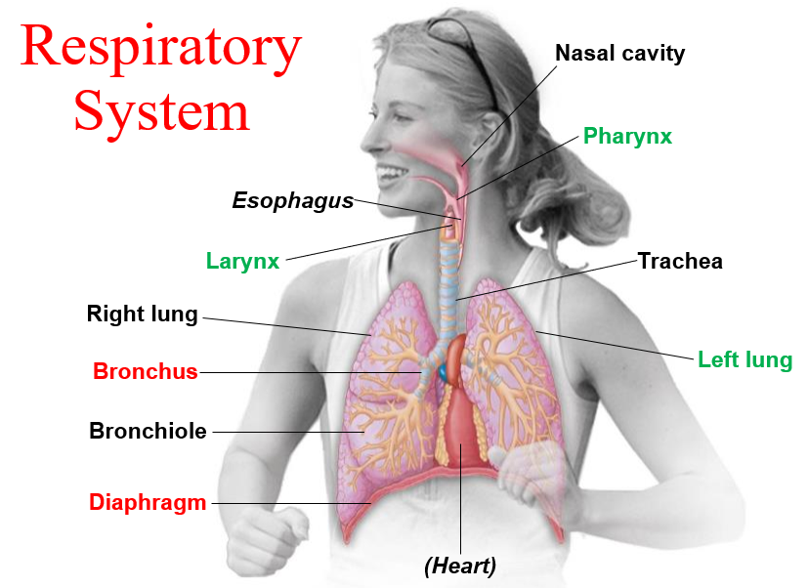

* + 1. _____ _____ involves the Respiratory and Circulatory systems in servicing your body’s cells.
    2. Three Phases of Gas Exchange occur in humans:
  1. Breathing.
  2. Transport of gases by the circulatory system.
  3. Exchange of gases with body cells:
     + Body tissues take up oxygen and release carbon dioxide.
     1. B_____
        1. _____ of the _____ through alternating inhalation and exhalation.
* Air is not moved by the lungs, but by the muscles surrounding the lungs: Diaphragm and Rib Cage Muscles.
  + - 1. I_____

1. The _____ separates the abdominal cavity from the thoracic cavity & helps ventilate the lungs.
2. Diaphragm _____,
3. _____ Cage moves up and out;
4. Lungs _____,
5. _____ rushes in.
   * + 1. E_____
6. Diaphragm _____ and moves up,
7. Rib Cage moves down and in;
8. _____ in the Lungs increases,
9. and air is _____ out of the lungs.
   * + 1. Pathway In. In humans, AIR is
10. _____ through the _____ into the _____ Cavity.
11. filtered by _____ and mucous surfaces.
12. _____ and _____.
13. sampled for odors.
    * + 1. Pathway to the lungs. From the Nasal Cavity, air next passes
14. to the _____,
15. then to the _____, past the Vocal Cords,
16. into the _____, held open by cartilage rings;
17. into the paired _____,
18. into _____,
19. to the _____, grapelike clusters of air sacs, where _____ _____ occurs.
    * 1. Gas Exchange
20. _____ walls are only _____ cell thick.
21. Many tiny Capillaries surround the alveoli; their walls are also one cell thick.
22. In alveoli,
23. O2 diffuses into the blood.
24. CO2 diffuses into the alveoli.
25. _____ in the air passes through the walls of both the alveoli and the capillaries to enter the blood.
26. _____ _____ in the blood can pass just as easily into the alveoli.
    * 1. _____ Phases of Gas Exchange occur in humans:

1. _____.

2. _____ of gases by the circulatory system.

3. _____ of gases with body cells:

