**Electromagnetic Spectrum & Light Chapter 18**



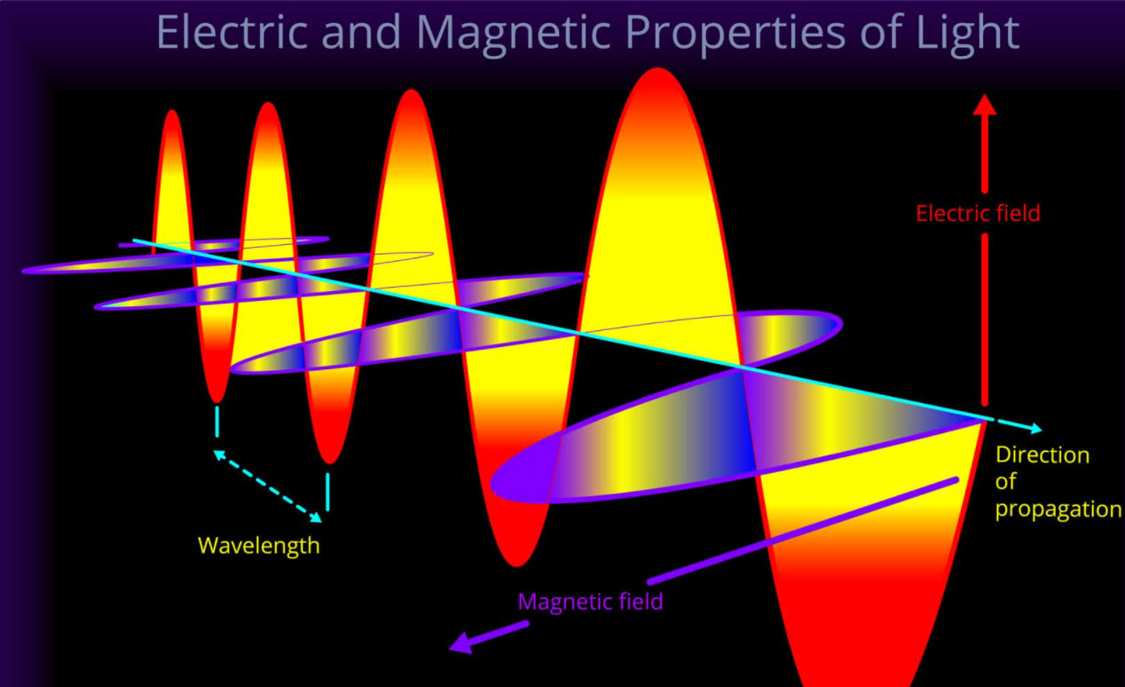

**See** [**https://www.learningctronline.com/courses**](https://www.learningctronline.com/courses) **for Materials and Resources.**

**Topics:**

1. Electromagnetic Spectrum & Light

**Objectives:**

* Define electromagnetic radiation and recognize the relationship between frequency, wavelength, and the speed of light.
* Describe wave-particle duality and classify associated properties of light (photoelectric effect, reflection, refraction, diffraction, and polarization).
* Recognize types of reflection of light, the law of reflection, and draw all components of light when it reflects off a reflective surface.
* Recognize refraction of light, optical density, index of refraction, identifying all components of light as it refracts while travelling through different media.

TAKE NOTE

1. Guided Reading Note-Taking Worksheet (Pearson Text) (1 week)
2. Pearson Concepts in Action Worksheet
3. Lab EM Radiation Virtual Lab
4. Lab Reflection & Refraction (Formal Lab Report) … procedures, calculations
5. Class Song: If I Had Reality (Scarecrow Song)
6. Week 29 Devotional (<https://www.learningctronline.com/devotional>)

**Text**: Chapter 18: Electromagnetic Spectrum & Light pp. 530-567

**Guided Reading Note-Taking Worksheet:**

Complete the worksheet for Chapter 18: EM Spectrum & Light (18.1 – 18.5).

**Class Notes: PowerPoint or PDF**

**Homework**:

* 18.3 Behavior of Light Worksheet (Pearson Concepts in Action)
* Assignments will be “spot checked” during class or submitted via email.

**Lab**: Electromagnetic Spectrum Virtual Lab

* Complete the activities using the worksheet provided.
* Save the documents into your LAB folder in the Physical Science folder on your desktop.
* *Assignments will be “spot checked” during class or submitted via email.*

**Lab**: Reflection & Refraction of Light (Formal Lab Report)

* Perform the lab as directed using the worksheet provided.
* This week do the Procedures and Calculations and Data sections.
* You will submit a Formal Lab Report (following the guidelines in the Lab Report Format Document) within 16 days.
* Save the documents into your LAB folder in the Physical Science folder on your desktop.

**TEST:** The test will be given after next week’s lesson.

Supplemental Resources (Optional)

1. Measuring Angles Worksheet
2. Electromagnetic Spectrum Powerpoint
3. Color of Light Simulation
4. 18.4 Color Worksheet (Pearson Concepts in Action)

[**https://screencast-o-matic.com/watch/cqVDYO3DUJ**](https://screencast-o-matic.com/watch/cqVDYO3DUJ) **Simulation on Reflection (0:22)**

[**http://somup.com/cFfeFEVp1h**](http://somup.com/cFfeFEVp1h) **Reflection (2:45) ... Specular vs Diffuse. Law of Reflection.**

[**http://somup.com/cqfXD9nU6Z**](http://somup.com/cqfXD9nU6Z) **Refraction ctr (3:52) Light "bending". Index of Refraction.**

[**http://somup.com/cFfeq2Vp1T**](http://somup.com/cFfeq2Vp1T) **Dispersion in Prisms ctr (2:40) Dispersion. Total Internal Reflection.**

------------------------------------------

<http://somup.com/cFXoqZnj6U> Mirror Cloaks (1:21)

<http://somup.com/cFXoqbnj6Y> Invisibility (Making a Drinking Straw Partially Disappear[/urlnew] (1:00)

<http://somup.com/cFXoqynj6y> Laser Maze (2:26)

<http://somup.com/cYhqbwjzUF> Eyes but Can't See, Ears but Can't Hear Matthew 13:14-15; Slow Fade (5:59)