Heading

Title

**Introduction**

**Purpose**

To construct biochemical molecules and demonstrate two common chemical reactions: dehydration synthesis and hydrolysis.

**Discussion**

Biochemical molecules (those found in living organisms) tend to be large. The first part of this lab involves building a few of the more common representative molecules. The second part involves demonstrating with the molecular models two of the more common chemical reactions that occur within living organisms.

1. **Dehydration synthesis** The construction of a larger molecule from smaller molecules by the removal of a water molecule.
2. **Hydrolysis** The breaking down of a larger molecule into smaller molecules by the addition of water molecule(s).
3. The following color code should be used for the various atoms:

C black (4 bonds) O red (2 bonds)

H white (1 bond) N blue (3 bonds)

1. Marshmallows will be used for “atoms”. It doesn’t matter whether they are the normal size (~1” cubes) or the mini-size.
2. The bonds between atoms are represented by toothpicks.

**Hypothesis**

If biochemical molecules are constructed, then one can observe dehydration synthesis and hydrolysis for understanding.

**Materials** Marsh Mellows Toothpicks Colored Markers Raisins

**Procedures PART I** – **Biochemical Molecules**

1. The atomic structure of molecules will be created using colored marshmallows (atoms) and toothpicks (bonds). Mark the marshmallows with the appropriate color.
2. **Build a molecule** for each of the molecules and **take a picture** and insert it into the lab.
   1. Right click your pictures to resize less than 600.
   2. Label the molecule (name).
3. HONORS ONLY … complete the data table at the end of the lab (follow instructions).
4. **Amino Acids**

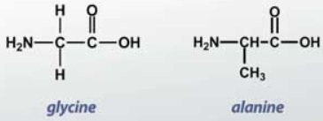

There are more than twenty different kinds of amino acids. They are all essential to the construction of more complex molecules known as proteins. Construct two of the simplest amino acids, glycine and alanine. If glycine and alanine are combined together, a peptide bond is formed by dehydration synthesis.

1. Glycine – NH2 CH2 COOH

2. Alanine – NH2 CH CH3 COOH

Image of Molecules

1. **Glycerol** – C3H5(OH)3

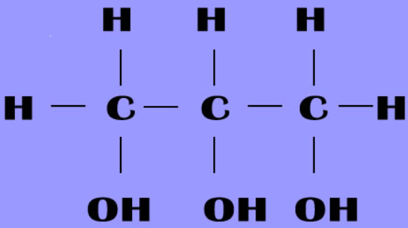

Glycerol belongs to a group of organic molecules known as the alcohols, all having as a common functional group, OH. Not all alcohols are inebriating and, in fact, many different kinds are found commonly in living organisms. Glycerol is normally used as a component of fats, oils, and waxes in our bodies.

Image of Molecule

1. **Fatty Acids**

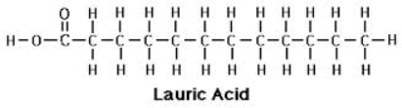

Fatty acids make up the other component of fats, oils and waxes. They are, in part, characterized by a long chain of carbon atoms on which hydrogen atoms are attached. It is this long chain of carbons and hydrogens that constitutes one of the basic characteristics of fats and oils – storage of energy. There are many different kinds of fatty acids. You will build two. Fats are categorized as saturated and unsaturated based on whether they contain single bonds (*saturated, unhealthy*) or double and triple bonds (*unsaturated, healthier*).

1. 1. Lauric Acid – C11H23 COOH

2. Stearic Acid – C17H35 COOH

Image of Molecules

1. **Glucose** – C6H12O6

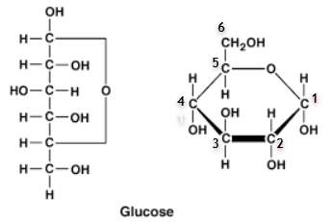

Glucose is one of the more important molecules found in living things. It belongs to a group of molecules called carbohydrates and is used to construct complex sugars, starches and cellulose (*the basic component of cell walls*).

The carbon atoms of glucose and any simple sugar are numbered in order to distinguish them. When constructing the glucose molecule, pay attention to the direction of the “OH” groups on each numbered carbon (C1 down, C2 down, C3 up, C4 down).

Image of Molecule

**PART II** – **Biochemical Reactions**

There are thousands of chemical reactions occurring in living organisms every second. Two common chemical reactions with which one must be familiar are dehydration synthesis and hydrolysis.

**A. Dehydration Synthesis**

Synthesis is the formation of a more complex molecule by the union of simpler molecules. Most of the chemical reactions in our body involve the removal of water (H2O) and the formation of a bond between two smaller molecules. This is called *dehydration (loss of water*) synthesis (*making something new and bigger*).

Glucose + Glucose 🡪 Maltose + Water

C6H12O6 C6H12O6. C12H22O11 H2O

Use the glucose molecule (A) you constructed in Part I and build another glucose molecule (B). Then, build the following disaccharide, maltose, by dehydration synthesis.

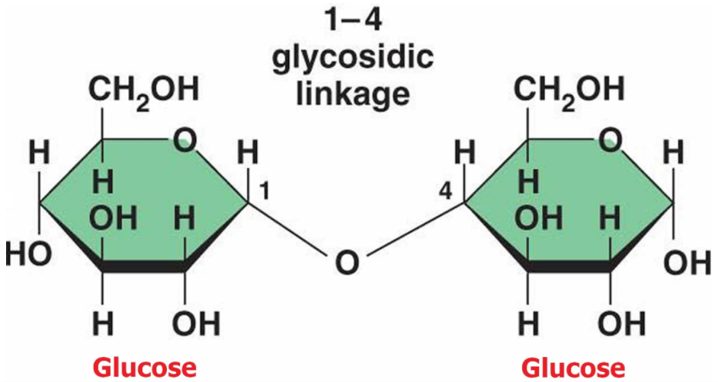

* + - 1. Remove the –OH group from carbon #1 of glucose A and the H of the –OH group from carbon #4 of glucose B.
      2. The removed atoms, H and OH, will combine together to form HOH or H2O. Do this.
      3. Note that carbon #1 of Glucose A has only three bonds. It needs four. Also note that the oxygen of carbon #4 of Glucose B has only one bond. It needs two.
      4. Join the carbon of Glucose A with the oxygen of Glucose B using a normal covalent bond. This forms the new molecule known as MALTOSE.
      5. Perform this dehydration synthesis reaction and take a picture to insert into the lab.

Image of Molecule

**B. Hydrolysis**

Hydrolysis is the reverse reaction of dehydration synthesis. It involves splitting the larger molecule into smaller molecules by the addition of water molecule(s).

Maltose + Water 🡪 Glucose + Glucose

C12H22O11 H2O C6H12O6 C6H12O6

Using the water molecule you previously removed in Part II A, split the maltose molecule into two glucose molecules. Use the directions given in Part II A for dehydration synthesis BACKWARDS.

Image of 2 Glucose Molecules

**Calculations and Data**

**Conclusions**

**Address Hypothesis**

The hypothesis that if biochemical molecules are constructed, then one can observe dehydration synthesis and hydrolysis for understanding was confirmed.

**Analysis**

Biochemical molecules (those found in living organisms) tend to be large. The first part of this lab involves building a few of the more common representative molecules. The second part involves demonstrating with the molecular models two of the more common chemical reactions that occur within living organisms.

1. **Dehydration synthesis** 🡪 The construction of a larger molecule from smaller molecules by the removal of a water molecule.
2. **Hydrolysis 🡪** The breaking down of a larger molecule into smaller molecules by the addition of water molecule(s).

**Questions**

1. What are the two similarities between all amino acids?

2. What is the difference between any two amino acids?

3. What are two common characteristics between the fatty acid molecules?

4. What is the basic difference between any two fatty acid molecules?

5. What are the names of two other simple sugars like glucose (monosaccharides).

6. What do the names monosaccharide, disaccharide and polysaccharide each imply?

7. Name and define each of the two general types of reversible reactions found in all living organisms.

8. What molecule is removed and inserted in the reactions for question 7?

**Errors**

Constructing the molecules using toothpicks and marshmallows does not give an accurate idea of proportions (atomic sizes). The arrangement of OH- groups on glucose is particular and easy to overlook. The error section can also afford the learner opportunity to offer any ideas for relevant further study/research of this topic or scientific principle (this is optional).

**Resources/Bibliography**

Acme Synthetic Chemicals. Lauric Acid 98%. @ 2022 Acme Synthetic Chemicals. n.d. Web. 1 Oct. 2022. <https://acmechem.com/lauric-acid-98/>

Biomolecules Lab. *Lab Worksheet*. Biology Course Site, Week 4. Learning CTR Online, n.d. Web. 1 Oct. 2022. <[www.learningctronline.com](http://www.learningctronline.com)/biology-course-site-s1>.

Quora. What is the Difference Between Glycine and Alanine, n.d. Web. 1 Oct. 2022. <https://www.quora.com/What-is-the-difference-between-glycine-and-alanine> .

Health Jade. Maltose. Image. © 2019 HealthJade.net. n.d. Web. 1 Oct. 2022. <https://healthjade.net/maltose/> .

HONORS ONLY

Complete the chart for the lab.

|  |  |  |  |
| --- | --- | --- | --- |
|  | **Name of Molecule** | **Molecular Formula** | **Structural Formula**  **(Type of Bonds)** |
| A1 |  |  |  |
| A2 |  |  |  |
| B |  |  |  |
| C1 |  |  |  |
| C2 |  |  |  |
| D |  |  |  |

On the next page, show the information (*name of molecules, molecular and structural formulas*) for the dehydration synthesis and hydrolysis of maltose.