**EM Waves & Properties of Light (Week 1)**

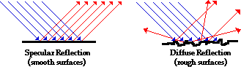

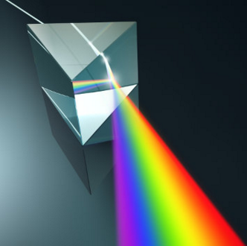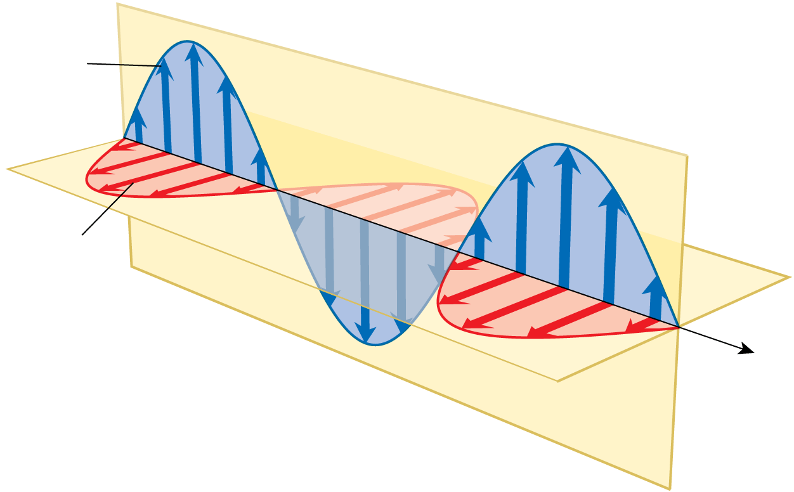

**See** [**https://www.learningctronline.com/courses**](https://www.learningctronline.com/courses) **for Materials and Resources.**

**Topics:**

1. Electromagnetic Radiation & Properties of Light (week 1 of 3)

**Objectives:**

* Identify and define the electromagnetic spectrum, giving practical applications of each range (wavelength, frequency, energy).
* Recognize, draw, measure and calculate using reflection of light, the law of reflection, and components of light when it reflects off a reflective surface.
* Recognize, draw, measure and calculate using refraction of light, optical density, index of refraction, identifying all components of light as it refracts while travelling through different media, including total internal reflection.

TAKE NOTE

1. Test Corrections (Sound) due by next class.
2. Reading (Hewitt Text)

1. Notes EM Waves & Light
2. EM Radiation Virtual Lab

1. Problem Set 1: Reflection & Refraction (2 weeks)
2. Lab: Reflection & Refraction (LAB REPORT) … due 4 days after week 29’s class
3. Lab: Prisms
4. Quiz: Reflection & Refraction
5. Class Song: You’re Welcome
6. Week 28 Devotional (<https://www.learningctronline.com/devotional>)

**Text**: Chapters 27 & 29 Light; Reflection & Refraction (Hewitt)

**Class Notes: Use the Document provided**

**Homework**:

* Problem Set 1: Reflection & Refraction

**Lab**: EM Radiation Virtual Lab

* Perform the lab as directed using the worksheet provided.
* Complete all calculations and data, showing work whenever appropriate.
* Conclusions should be answered in complete sentences that convey a complete thought.
* Save the documents into your LAB folder in the Physics folder on your desktop.

**Lab**: Reflection & Refraction LAB REPORT

* Perform the lab as directed using the worksheet provided.
* The Lab Report is due next week (Friday)
* Complete all calculations and data, showing work whenever appropriate.
  + Include images (e.g. screen shots) for reflection and refraction.
* Conclusions should be answered in complete sentences that convey a complete thought.
* Save the documents into your LAB folder in the Physics folder on your desktop.

**Lab**: Prisms

* Perform the lab as directed using the worksheet provided.
* Complete all calculations and data, showing work whenever appropriate.
* Conclusions should be answered in complete sentences that convey a complete thought.
* Save the documents into your LAB folder in the Physics folder on your desktop.

**TEST:** Reflection & RefractionQuiz.

There is a **20-minute time limit** on the quiz.

You MAY use notes on this quiz.

Supplemental Resources (Optional)

<https://screencast-o-matic.com/watch/cqVDYO3DUJ> Specular Reflection Simulation (0:22)

<http://somup.com/cFfeFEVp1h> (2:45) Reflection

<http://somup.com/cqfXD9nU6Z> (3:52) Light "bending". Index of Refraction.

<http://somup.com/cFfeq2Vp1T> (2:40) Dispersion. Total Internal Reflection.

<http://somup.com/cFXoqZnj6U> (1:21) Mirror Cloak

<http://somup.com/cFXoqbnj6Y> (1:00) Invisibility Cloak

<http://somup.com/cFXoqynj6y> (2:26) Laser Maze