**Properties of Water**

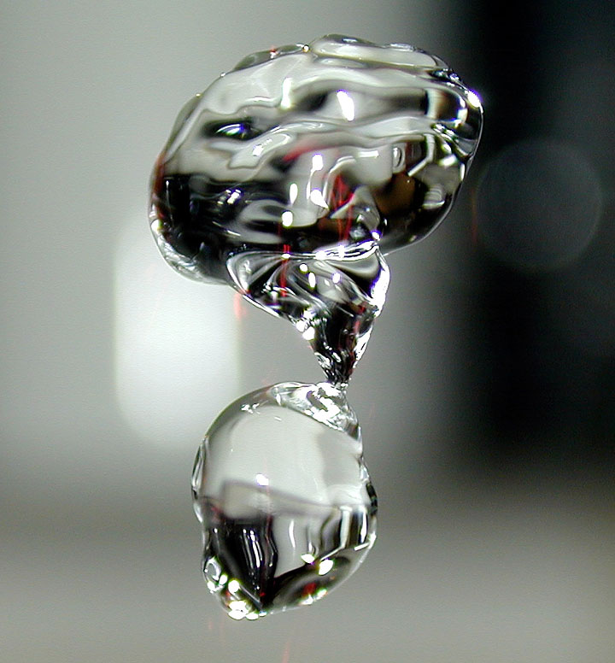

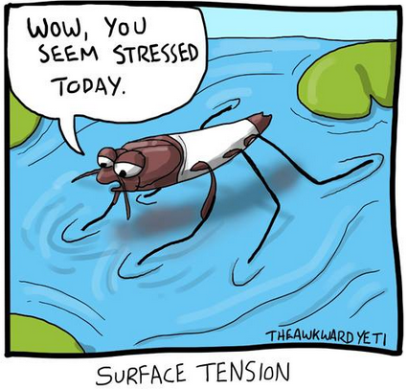

**See** [**https://www.learningctronline.com/courses**](https://www.learningctronline.com/courses) **for Materials and Resources.**

**Topics:**

1. Properties of Water

**Objectives:**

* What is water’s composition?
* What is water’s chemical formula?
* What is polarity in terms of molecules like water?
* What kinds of molecules can water dissolve?
* Why does water have so many special properties?
* What is hydrogen bonding?
* What kind of special properties does water exhibit?
* What is the difference between “hard” and “soft” water?

TAKE NOTE (All assignments are due by next week’s class.)

1. Properties of Water PowerPoint (class notes)
2. Class notes study guide (Properties of Water)
3. Labs: Properties of Water; videos & LAB QUIZ
4. Crossword review: Properties of Water
5. Week 29 Devotional (<https://www.learningctronline.com/devotional>)

**Text**:

**Reference Material:**

**Homework**:

* Class Notes Study Guide

**Lab**: Properties of Water with lab quiz (afterward)

* Perform experiments 1 – 6 as shown on the PowerPoint slides.
* The expected results are shown for each experiment (in case you fail!). ☺
* Create a WORD document.
* Take a picture of each experiment’s results.
* Label each image appropriately.
* Give the property of water shown by each image.
* Save the document into your LAB folder in the Projects in Science folder on your desktop.

**Lab**: Watch all the videos listed below.

* Once completed with the Properties of Water lab and watching all the videos, take the LAB QUIZ.

**TEST:** Lab Quiz

1) the academic integrity policy

* Tests must be completed **WITHOUT** referring to books, notes, the internet, people, or any outside resources.
* Students **MAY** use the approved Periodic Tables, approved Reference Tables, or approved equation (formula) sheet (provided by the teacher) along with calculators and scratch paper.

2) Take the **"in one sitting"**, meaning that once you start the test, you must complete it without interruption.

3) There is a **10-minute time limit** on this test.

4) Do NOT use RED font. Black font is best.

Supplemental Resources (Optional)

<https://screencast-o-matic.com/watch/cFQr2MqRa7> (2:29) Why Care About Water?

<https://screencast-o-matic.com/watch/cFQr29qRzl> (3:47) The Wonder of Water

<https://screencast-o-matic.com/watch/cFQrohqRzm> (0:31) Electrolysis of Water

<https://screencast-o-matic.com/watch/cF6elPYlbr> (2:59) Electrostatic Attractions (Polarity)

<https://screencast-o-matic.com/watch/cF6h2BYotW> (2:24) Like Dissolves Like

[Water’s Polarity:https://screencast-o-matic.com/watch/cFQUlaYixQ](https://screencast-o-matic.com/watch/cFQUlaYixQ) (0:39)

<http://somup.com/cFQU2CnVn2> Properties of Water (3:45)

<http://somup.com/cFQUoVnVnD> Surface Tension of Water [Bill Nye] (4:06)

<https://screencast-o-matic.com/watch/cFQropqRgE> (1:18) Hard Water Test