Projectile Motion Lab

**Purpose** To investigate projectile motion in terms of horizontal and vertical components.

**Discussion** Objects that are launched are called projectiles. The path they follow is called a **trajectory**. The motion of a projectile is described in terms of its position, velocity, and acceleration and exemplifies motion in accord with Newton’s laws, especially Newton’s second law.

Position, velocity, and acceleration are all vector quantities, and we have seen that the perpendicular components of vector quantities are independent, allowing separate analysis of the vertical and horizontal parts of the motion.

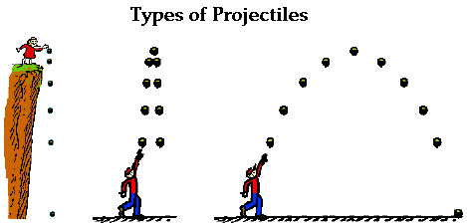

A projectile is an object upon which the only force acting is gravity. There are a variety of examples of projectiles: (1) an object dropped from rest is a projectile (*provided that the influence of air resistance is negligible*); (2) an object which is thrown vertically upwards is also a projectile (*provided that the influence of air resistance is negligible*); (3) an object which is thrown upwards at an angle is also a projectile (*provided that the influence of air resistance is negligible*); and

1

2

3

(4) an object which is launched horizontally off a cliff or table, etc. and falls due to gravity.

A projectile is any object which once projected continues in motion by its own inertia and is influenced **only** by the downward force of gravity.

Many students have difficulty with the concept that the only force acting upon an upwardly moving projectile is gravity. Their conception of motion prompts them to think that if an object is moving upwards, then there must be an upward net force. And if an object is moving upwards and rightwards, there must be both an upwards and rightwards net force. A common misconception is that an unbalanced net force (Fnet) is required to keep an object in motion. This idea is simply not true; a net force is not required to keep an object in motion.

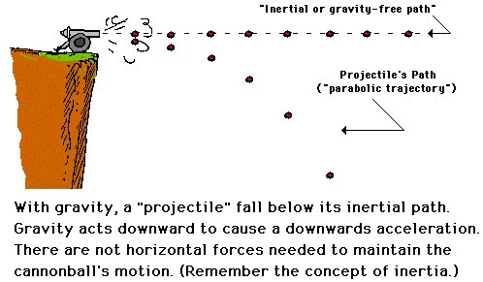

4

A net force is only required to produce acceleration. (*Balanced forces are involved with constant velocity or motion.)* And in the case of a projectile that is moving upwards, there is a downwards force and a downwards acceleration; that is, the object is slowing down.

Imagine observing a person drop a ball while walking at constant speed in a given direction. If you observe the ball (1) relative to the person’s body, the ball should land straight down by his/her foot. If you observe the projectile path of the ball (2) relative to the place the ball was released to the place it lands, the trajectory will be a “parabolic” curve downward. We will do this simple experiment for Newton’s first law of motion.

This same situation exists when a cannon ball is launched horizontally off a cliff and another cannonball is dropped vertically downward simultaneously. Both cannon balls should hit the ground at the same time proving that only gravity operates on the objects. The path of each canon ball is shown in the figure to the right.

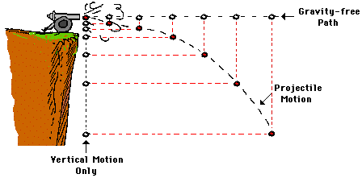

**Figure 3**

The equation for an object falling with constant acceleration (due to gravity) can be used to determine the “x” and “y” vector components of projectile motion such as vertical and horizontal displacements, and vertical and horizontal velocities: **d = vit + ½ gt2.**

In the case of velocity, the velocity of the canon ball will depend on the horizontal or vertical velocity component. (1) The horizontal component of velocity, **vx**, is determined by the equation **dx = vxt + ½ gt2**. Since there is no acceleration due to gravity in the horizontal component of velocity, the equation becomes: **dx = vxt**. To determine the maximum velocity at the launch, the equation is rearranged to:  **vmax = dx / t**.

(2) The vertical component of velocity, **vy**, is determined one of two ways: (a) If the trajectory begins horizontally as in figure 4 on page 1, the vertical component of velocity, **vy**, is zero [*in the equation dy = vyt + ½ gt2*] since the only vertical force on the canon ball is gravity. Therefore, the displacement of the canon ball can be determined by the equation: **dy = ½ gt2**. To determine the time, **t**, it takes for the object to fall the distance or height, **dy**, use: **t = √(2dy / g)**.

(b) If, however, the trajectory begins at an angle above horizontal (*as shown below*), one would need to find the vertical velocity component and use the equation: **dy = vyt + ½ gt2**. To find the vertical velocity component, **vy** on the diagram below, use **sin θ = vy / vi**. Therefore, **vy  = vi sin θ**.

For the canon ball trajectory shown below, if we know the horizontal velocity component, Vx, we can calculate the launch velocity of the canon using **cos θ = vx / vi**. Therefore, **vi  = vx / cos θ**.

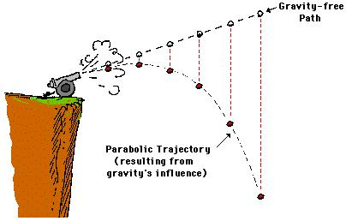

**θ**

**vx**

**Vy**

**vi**



5

**Vy**

**Materials** PHET Simulation <https://phet.colorado.edu/en/simulation/projectile-motion>

You can access simulations at: <https://phet.colorado.edu/en/simulations/browse>

Find the course you desire (Physics, Chemistry, Math, Earth Science, Biology). Go to the right to scroll each course for simulations.

**Procedures**

**Part 1 Sketch the five possible types of projectiles in the squares provided. Label them.**

Label (give a title) to each type of projectile.

|  |  |  |  |  |
| --- | --- | --- | --- | --- |
|  |  |  |  |  |
|  |  |  |  |  |

**Part 2A Measure the Horizontal Distance (dx) Component at Different Speeds**

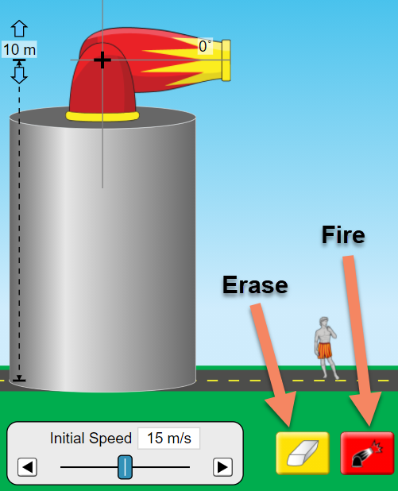

1. Use the “Intro” simulation with the cannon on top of a cylinder.

2. Set the angle of the mini-launcher to 0⁰ to shoot horizontally.

3. Click and drag the target to measure the horizontal distance.

4. Set the “initial speed” to 5 m/s and fire the cannon.

5. Measure and record the HORIZONTAL distance (**dx**) the ball travelled.

6. Fire the cannon at each “initial speed” in the data table.

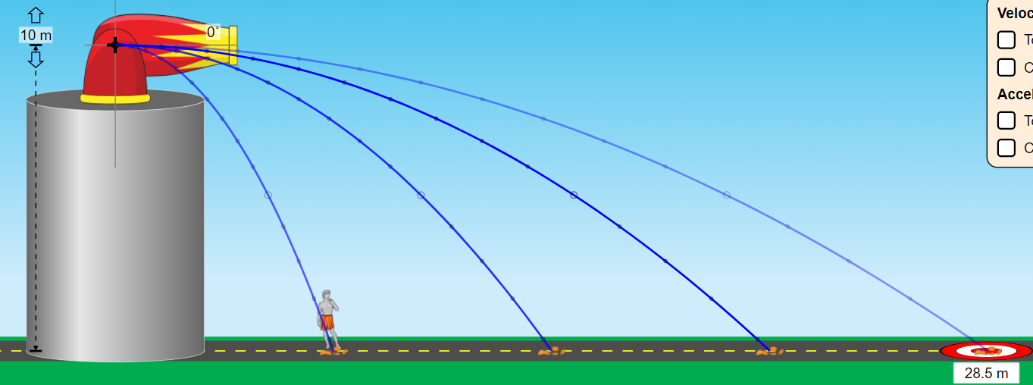

|  |  |
| --- | --- |
| Initial Speed | **dx** |
| 5 m/s |  |
| 10 m/s |  |
| 15 m/s |  |
| 20 m/s |  |

**Part 2B Calculate the Time of Fall**

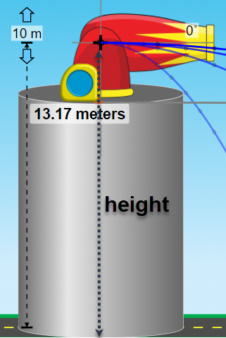

1. Launching an object from the cannon AND dropping another object vertically from the same height takes the SAME TIME. The two objects should hit the floor at the same time.

2. Measure the height (vertical distance, **dy**) from the “+” of the cannon to the ground.

3. Use the equation provided to calculate the time, t, for the objects to fall to the ground (*either from being dropped or from being launched*). [d = ½ gt2 … **t = √(2dy / g)**]

|  |  |
| --- | --- |
| Height, **dy** | Calculated Time, **t** |
|  | 1.4 s |

**Part 2C Calculating Horizontal Distance (dx) at the Different “Initial Speed”**

1. Use the calculated time and the initial speeds to calculate the horizontal distance, **dx**, of the launched object. [**vx  = dx** / **t**]

vx  = dx / t

**dx = vx x t**

|  |  |
| --- | --- |
| Initial Speed | Calculated Distance, **dx** |
| 5 m/s |  |
| 10 m/s |  |
| 15 m/s |  |
| 20 m/s |  |

**Part 3 Measure the Trajectory (Non-Horizontal projectiles)**

1. Change to the “Lab” simulation (click on the icon at the bottom of the screen).

2. Set the launcher to a 1 m height & the desired angle of trajectory (15°, 30°, 45°, 60° and 75°).

3. Begin at a 15° trajectory and launch the cannonball, using the 12 m/s initial speed.

4. Complete the data table. Use the target to measure horizontal distance (**dx**) and the tape measure to measure vertical distance (**dy**), placing the cross hairs on the white dot of the trajectory and the dotted line on the ground.

5. Calculate time using the equation provided.

|  |  |  |  |  |
| --- | --- | --- | --- | --- |
| Trajectory | **dx** | **dy** | **Calculated Vx** | **Calculated Time, t** |
| 15° |  |  |  |  |
| 30° |  |  |  |  |
| 45° |  |  |  |  |
| 60° |  |  |  |  |
| 75° |  |  |  |  |

**Vx  = Vi cos θ**.

vx  = dx / t

**t = dx / Vx**

Show at least two calculations for Vx and t.

30° 🡪Vx  = Vi cos θ = (? m/s)(cos 30°) = ? m/s

t = dx / Vx = ? m / ? m/s = ? s

?° 🡪Vx  = Vi cos θ = (? m/s)(cos ?°) = ? m/s

t = dx / Vx = ? m / ? m/s = ? s

**Conclusions and Questions**

1. What is the initial vertical velocity component for a horizontally launched projectile?

2. What did you notice about the time it took for the horizontally launched projectile to hit the floor when using various initial speeds?

3. How did the actual horizontal distances and calculated horizontal distances compare in Part 2A and 2C?

4. Which trajectory angle yielded the greatest vertical launch height (dy)?

5. Which trajectory angle yielded the greatest horizontal launch displacement (dx)?

6. Which two pairs of trajectory angles yielded the same horizontal launch displacement (dx)?

7. Label the trajectory angle, the estimated vertical height reached, and measured horizontal displacement for each projectile below (*based on the lab results*).



Answers

**Part 1 Sketch the five possible types of projectiles in the squares provided. Label them.**

Label (give a title) to each type of projectile.

|  |  |  |  |  |
| --- | --- | --- | --- | --- |
| **Free Fall** | **Vertical Free Fall** | **Parabolic** | **Horizontal Cliff fall** | **Trajectory Cliff Fall** |
|  | | |  |  |

**Part 2A Measuring the Horizontal Distance (dx) Component at Different Speeds**

|  |  |
| --- | --- |
| Initial Speed | **dx** |
| 5 m/s | 7.1 m |
| 10 m/s | 14.2 m |
| 15 m/s | 21.4 m |
| 20 m/s | 28.5 m |

**t = √(2dy / g)**

t = √(2(10.0 m) / 9.8 m/s2)

**Part 2B Calculating Time of Fall** [SHOW WORK]

|  |  |
| --- | --- |
| Height, **dy** | Calculated Time, **t** |
| 10.0 m | 1.4 s |

**Part 2C Calculating Horizontal Distance (dx) at the Different “Initial Speed”**

1. Use the calculated time and the initial speeds to calculate the horizontal distance, **dx**, of the launched object. [**vx  = dx** / **t**]

|  |  |
| --- | --- |
| Initial Speed | Calculated Distance, **dx** |
| 5 m/s | 7.0 m |
| 10 m/s | 14.0 m |
| 15 m/s | 21.0 m |
| 20 m/s | 28.0 m |

vx  = dx / t

**dx = vx x t**

**Part 3 Measuring Trajectory (Non-Horizontal projectiles)**

|  |  |  |  |  |
| --- | --- | --- | --- | --- |
| Trajectory | **dx** | **dy** | **Calculated Vx** | **Calculated Time, t** |
| 15° | 10.1 m | 1.5 m | 11.6 m/s | 0.6 s |
| 30° | 14.3 m | 2.8 m | 10.4 m/s | 1.2 s |
| 45° | 15.6 m | 4.7 m | 8.5 m/s | 1.7 s |
| 60° | 13.3 m | 6.5 m | 6.0 m/s | 2.1 s |
| 75° | 7.6 m | 7.8 m | 3.1 m/s | 2.4 s |

**Vx  = Vi cos θ**.

vx  = dx / t

**t = dx / Vx**

15° 🡪Vx = Vi cos θ = (12 m/s)(cos 15°) = 11.6 m/s

t = dx* / Vx = 10.1 m / 11.6 m/s = 0.9 s

30° 🡪Vx = Vi cos θ = (12 m/s)(cos 30°) = 10.4 m/s

t = dx / Vx = 14.3 m / 10.4 m/s = 1.4 s

45° 🡪Vx = Vi cos θ = (12 m/s)(cos 45°) = 8.5 m/s

t = dx / Vx = 15.6 m / 8.5 m/s = 1.8 s

60° 🡪Vx = Vi cos θ = (12 m/s)(cos 60°) = 6.0 m/s

t = dx / Vx = 13.3 m / 6.0 m/s = 2.2 s

75° 🡪Vx = Vi cos θ = (12 m/s)(cos 75°) = 3.1 m/s

t = dx* / Vx = 7.6 m / 3.1 m/s = 2.5 s

*dx for 15° and 75° will be the same based on projectiles.

**Conclusions and Questions**

1. What is the initial vertical velocity component for a horizontally launched projectile?

*zero*

2. What did you notice about the time it took for the horizontally launched projectile to hit the floor when using various initial speeds?

*The initial velocity did not matter, they all hit at the same time.*

3. How did the actual horizontal distances and calculated horizontal distances compare in Part 2A and 2C?

*There were the same.*

4. Which trajectory angle yielded the greatest vertical launch height (estimated dy ) ?

*75°*

5. Which trajectory angle yielded the greatest horizontal launch displacement (dx ) ?

*45°*

6. Which two pairs of trajectory angles yielded the same horizontal launch displacement (dx )?

*30° & 60° 15° & 75°*

7. Label the trajectory angle, the estimated vertical height reached, and measured horizontal displacement for each projectile below (*based on the lab results*).

75*°*

60*°*

30*°*

15*°*

7.3 m

12.7 m

14.6 m

45*°*