Heading

Title

**Introduction**

**Purpose**

To determine how heat energy is transferred from one object to the next. Given the materials listed below, how can heat energy transfer be measured?

**Background Information (***List and define three ways heat energy is transferred*.)

**Hypothesis**

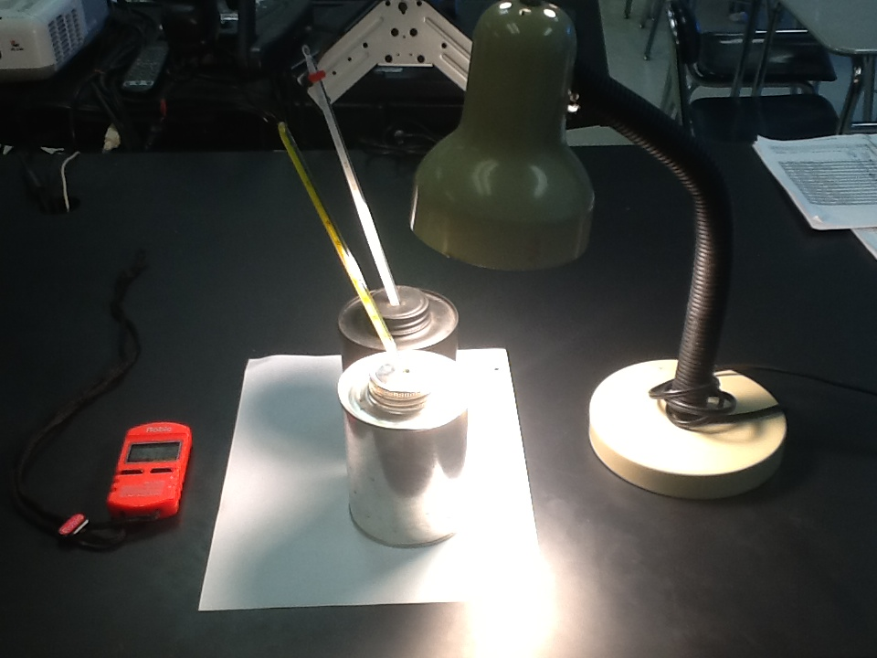

**Materials**

Black Radiation Can 2 Thermometers (°C) Timer

Silver Radiation Can 200-watt Light / Lamp

**Procedures**

Create a set of specific procedural steps that tests your hypothesis by setting up an experiment (*as shown in the picture*) that would allow you to measure the temperature change of the air inside two differently colored cans when equally exposed to radiant energy. [*The experiment is not focusing on which cans will absorb the most radiant energy from the lamp, but on how the heat energy is transferred, and how this energy transfer is measured*].

Heat Energy Transfer Pre-Lab Questions

1. Identify and define three ways that heat energy is transferred. Give an example of each.

2. Define the term “albedo” and state the relationship between albedo and amount of temperature increase in a material.

3. Give examples of two substances that would have a high albedo, and two substances that would have a low albedo.

4. How do alcohol thermometers work? How do they measure the temperature of an object?

During Lab Questions:

1. Identify how each type of energy transfer is occurring in this lab.

Post Lab Questions (*Answer in complete sentences with supporting data*):

1. How were you able to measure the temperature change of the two cans? Which of the two cans changed temperature the most?

2. What was the rate of temperature increase for each can (in °C/min.)?

Hint: Rate = change in temperature (∆ T in °C) over time (minutes).

3. What is the difference in the movement of the air molecules in the black can versus the movement of the air molecules in the silver can? How do you know this?

4. Draw a diagram, starting with the lamp, use arrows to show how energy flowed from the lamp to the can, to the air inside the can, to being measured in the thermometer. Label each part of the diagram, and the types of energy transfer in the diagram.

Lamp Color of Cans Movement in the Cans

1. Which can has the greatest albedo? How can you determine this from the experiment?

DATA TABLE

*Be sure to give units for each temperature measurement*

|  |  |  |
| --- | --- | --- |
| Time (Minutes) | Temperature  Black (°C) | Temperature  Silver (°C) |
| 0 |  |  |
| 3 |  |  |
| 6 |  |  |
| 9 |  |  |
| 12 |  |  |
| 15 |  |  |
| 18 |  |  |
| 21 |  |  |
| 24 |  |  |

Make a scatterplot graph of the time (in minutes) versus the temperature for each can. Use time as the independent variable.

Graphing Guidelines

1. Title your graph – (should be descriptive of data plotted).

2. Label axes with proper variable placement; leave space to label each axis; include units.

3. Always plot the independent variable (control) on the horizontal (x) axis.

4. Choose an appropriate scale – make sure that each box on each axis is given the same interval value, and that the data will fit on the graph according to your scale.

5. Draw a scatterplot (connect the points) for each can and label the slope line.

|  |  |  |  |  |  |  |  |  |  |  |  |  |  |  |  |  |  |  |  |  |  |  |  |  |
| --- | --- | --- | --- | --- | --- | --- | --- | --- | --- | --- | --- | --- | --- | --- | --- | --- | --- | --- | --- | --- | --- | --- | --- | --- |
|  |  |  |  |  |  |  |  |  |  |  |  |  |  |  |  |  |  |  |  |  |  |  |  |  |
|  |  |  |  |  |  |  |  |  |  |  |  |  |  |  |  |  |  |  |  |  |  |  |  |  |
|  |  |  |  |  |  |  |  |  |  |  |  |  |  |  |  |  |  |  |  |  |  |  |  |  |
|  |  |  |  |  |  |  |  |  |  |  |  |  |  |  |  |  |  |  |  |  |  |  |  |  |
|  |  |  |  |  |  |  |  |  |  |  |  |  |  |  |  |  |  |  |  |  |  |  |  |  |
|  |  |  |  |  |  |  |  |  |  |  |  |  |  |  |  |  |  |  |  |  |  |  |  |  |
|  |  |  |  |  |  |  |  |  |  |  |  |  |  |  |  |  |  |  |  |  |  |  |  |  |
|  |  |  |  |  |  |  |  |  |  |  |  |  |  |  |  |  |  |  |  |  |  |  |  |  |
|  |  |  |  |  |  |  |  |  |  |  |  |  |  |  |  |  |  |  |  |  |  |  |  |  |
|  |  |  |  |  |  |  |  |  |  |  |  |  |  |  |  |  |  |  |  |  |  |  |  |  |
|  |  |  |  |  |  |  |  |  |  |  |  |  |  |  |  |  |  |  |  |  |  |  |  |  |
|  |  |  |  |  |  |  |  |  |  |  |  |  |  |  |  |  |  |  |  |  |  |  |  |  |
|  |  |  |  |  |  |  |  |  |  |  |  |  |  |  |  |  |  |  |  |  |  |  |  |  |
|  |  |  |  |  |  |  |  |  |  |  |  |  |  |  |  |  |  |  |  |  |  |  |  |  |
|  |  |  |  |  |  |  |  |  |  |  |  |  |  |  |  |  |  |  |  |  |  |  |  |  |
|  |  |  |  |  |  |  |  |  |  |  |  |  |  |  |  |  |  |  |  |  |  |  |  |  |
|  |  |  |  |  |  |  |  |  |  |  |  |  |  |  |  |  |  |  |  |  |  |  |  |  |
|  |  |  |  |  |  |  |  |  |  |  |  |  |  |  |  |  |  |  |  |  |  |  |  |  |
|  |  |  |  |  |  |  |  |  |  |  |  |  |  |  |  |  |  |  |  |  |  |  |  |  |
|  |  |  |  |  |  |  |  |  |  |  |  |  |  |  |  |  |  |  |  |  |  |  |  |  |
|  |  |  |  |  |  |  |  |  |  |  |  |  |  |  |  |  |  |  |  |  |  |  |  |  |
|  |  |  |  |  |  |  |  |  |  |  |  |  |  |  |  |  |  |  |  |  |  |  |  |  |
|  |  |  |  |  |  |  |  |  |  |  |  |  |  |  |  |  |  |  |  |  |  |  |  |  |
|  |  |  |  |  |  |  |  |  |  |  |  |  |  |  |  |  |  |  |  |  |  |  |  |  |
|  |  |  |  |  |  |  |  |  |  |  |  |  |  |  |  |  |  |  |  |  |  |  |  |  |
|  |  |  |  |  |  |  |  |  |  |  |  |  |  |  |  |  |  |  |  |  |  |  |  |  |
|  |  |  |  |  |  |  |  |  |  |  |  |  |  |  |  |  |  |  |  |  |  |  |  |  |
|  |  |  |  |  |  |  |  |  |  |  |  |  |  |  |  |  |  |  |  |  |  |  |  |  |
|  |  |  |  |  |  |  |  |  |  |  |  |  |  |  |  |  |  |  |  |  |  |  |  |  |
|  |  |  |  |  |  |  |  |  |  |  |  |  |  |  |  |  |  |  |  |  |  |  |  |  |
|  |  |  |  |  |  |  |  |  |  |  |  |  |  |  |  |  |  |  |  |  |  |  |  |  |
|  |  |  |  |  |  |  |  |  |  |  |  |  |  |  |  |  |  |  |  |  |  |  |  |  |
|  |  |  |  |  |  |  |  |  |  |  |  |  |  |  |  |  |  |  |  |  |  |  |  |  |
|  |  |  |  |  |  |  |  |  |  |  |  |  |  |  |  |  |  |  |  |  |  |  |  |  |
|  |  |  |  |  |  |  |  |  |  |  |  |  |  |  |  |  |  |  |  |  |  |  |  |  |
|  |  |  |  |  |  |  |  |  |  |  |  |  |  |  |  |  |  |  |  |  |  |  |  |  |
|  |  |  |  |  |  |  |  |  |  |  |  |  |  |  |  |  |  |  |  |  |  |  |  |  |
|  |  |  |  |  |  |  |  |  |  |  |  |  |  |  |  |  |  |  |  |  |  |  |  |  |
|  |  |  |  |  |  |  |  |  |  |  |  |  |  |  |  |  |  |  |  |  |  |  |  |  |
|  |  |  |  |  |  |  |  |  |  |  |  |  |  |  |  |  |  |  |  |  |  |  |  |  |

ANSWERS

**Question** How is heat energy transferred from one object to the next? Given the materials listed below, how can heat energy transfer be measured?

**Background Information**: List and define three ways heat energy is transferred.

* *Radiation 🡪 heat is transferred without an particles*
* *Conduction 🡪 heat is transferred from particle to particle (hot to cold)*
* *Convection 🡪 heat is transferred by particles and forms currents*

**Hypothesis** (If then statement): Answers vary depending on student’s perspective

**Materials**

Black Radiation Can 2 Thermometers

Silver Radiation Can 200-Watt Light / Lamp

**Procedures**

Create a set of specific procedural steps that tests your hypothesis by setting up an experiment (*as shown in the picture*) that would allow you to measure the temperature change of the air inside two differently colored cans when equally exposed to radiant energy. [*The experiment is not focusing on which cans will absorb the most radiant energy from the lamp, but on how the heat energy is transferred, and how this energy transfer is measured*].

*1. Place a thermometer in the black can, and another in the white can as shown in the picture.*

*2. Set up the 200 Watt lamp above both cans so the radiant energy (light) is the same for both cans.*

*3. Measure the temperature (*°C*) in each can BEFORE turning on the lamp. Record this for time “zero” in the data table. Start the timer.*

*4. Turn on the lamp and measure the temperature (*°C*) inside the cans (based on the thermometer reading) every three minutes from 3 to 24 minutes.*

*5. Work on the lab report while waiting for the temperature readings. [Answer the pre-lab and during-lab questions while waiting.]*

*6. Put all the materials back where you obtained them.*

*7. Plot the temperature in the cans versus the time on a graph, using time as the independent variable. Follow all graphing guidelines.*

Heat Energy Transfer Pre-Lab Questions

1. Identify and define three ways that heat energy is transferred. Give an example of each.

* ***Radiation*** *🡪 e.g. sun warms the earth from 93 million miles away; heat is transferred without an particles;*
* ***Conduction*** *🡪 e.g. metals conduct heat / cold easily; heat is transferred from particle to particle (hot to cold)*
* ***Convection*** *🡪 e.g. wind; ocean currents; convection in asthenosphere; heat is transferred by particles and forms currents*

2. Define the term “albedo” and state the relationship between albedo and amount of temperature increase in a material.

*Albedo, also known as the reflection coefficient, derived from Latin albedo "whiteness" (or reflected sunlight) in turn from albus "white," is the reflecting power of a surface. Albedo depends on the frequency (color / heat content) of the radiation. The higher the albedo, the LESS the temperature of a material will increase because it reflects the heat/light/radiation.*

3. Give examples of two substances that would have a high albedo, and two substances that would have a low albedo.

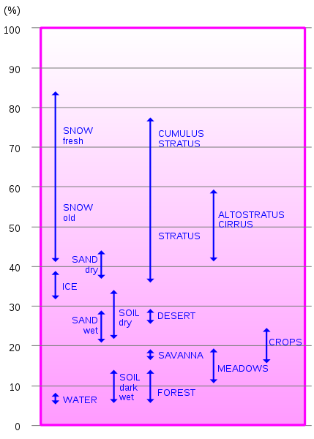

|  |  |
| --- | --- |
| Surface | Typical Albedo |
| Fresh asphalt | 0.04 |
| Worn Asphalt | 0.12 |
| Conifer Forest | 0.08 – 0.15 |
| Deciduous Trees | 0.15 – 0.18 |
| Bare soil | 0.17 |
| Green grass | 0.25 |
| Desert sand | 0.40 |
| New concrete | 0.55 |
| Ocean ice | 0.5 – 0.7 |
| Fresh snow | 0.8 – 0.90 |

*The table shows a surface type and its relative albedo. The numbers can be converted to percent by moving the decimal two places to the right. (e.g., 0.04 = 4%)*

*Snow and ocean ice have high albedo and therefore, would reflect most radiation off its surface (and not increase in temperature rapidly).*

*Asphalt and soil have low albedo and therefore, do not reflect radiation as easily. Therefore, they would increase in temperature faster than other materials.*

4. How do alcohol thermometers work? How do they measure the temperature of an object?

***Alcohol thermometers*** *or spirit thermometers are an alternative to the mercury thermometer, and functions in a similar way. But unlike mercury thermometer, the contents of an alcohol thermometer are less toxic and will evaporate away fairly quickly. An organic liquid is contained in a glass bulb which is connected to a capillary of the same glass and the end is sealed with an expansion bulb. The space above the liquid is a mixture of nitrogen and the vapor of the liquid. For the working temperature range, the meniscus or interface between the liquid is within the capillary. With increasing temperature, the volume of liquid expands and the meniscus moves up the capillary. The position of the meniscus shows the temperature against an inscribed scale.*

During Lab Questions:

1. Identify how each type of energy transfer is occurring in this lab.

*Radiation 🡪 Heat is radiated FROM the lamp (light source) TO the cans.*

*Conduction 🡪 Heat is absorbed by the cans on their surface (more by the black can than the white can) and is transferred by conduction from the particles on the outside of the can to the particles inside the can.*

*Convection 🡪 Heat inside the can will be transferred unevenly. The particles closest to the outside of the can (where heat is conducted in) will be warmer. Therefore, the particles at the center of the can are coolest. The difference in temperature will cause “currents” inside the can.*

Post Lab Questions:

1. How were you able to measure the temperature change of the two cans? Which of the two cans changed temperature the most?

*We measured the temperature change of the two cans by collecting temperature from a start point in a certain amount of time. We recorded the temperatures in our data table. By subtracting the temperatures at different times, we have the temperature change. We also will calculate the “rate” of temperature increase (question 2).*

*The black can temperature changed the most because the black surface on the can absorbs the radiant energy more than the white surface of the other can. Therefore, black can has a lower albedo than the white can.*

2. What was the rate of temperature increase for each can (in °C/min.)?

Hint: Rate = change in temperature (∆ T in °C) over time (minutes) 🡪 R = ∆ T / minutes

Black Can 🡪 (37.1 °C – 23.0 °C)/24 minutes = 0.6 *°C / min*

White Can 🡪 (30.0 °C – 22.0 °C)/24 minutes = 0.33 *°C / min*

3. What is the difference in the movement of the air molecules in the black can versus the movement of the air molecules in the silver can? How do you know this?

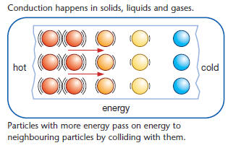

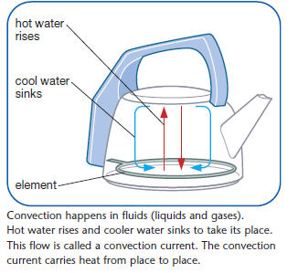

*The picture at the right shows how the particles will conduct heat from hot to colder particles. Since, the black can absorbs more heat than the white can, the particles in the black can will be moving faster.*

*Convection will occur more rapidly in the black can because the particles on the outer surface will warm up quicker and there will be a temperature difference from the particles in the inside of the can.*

4. Draw a diagram, starting with the lamp, use arrows to show how energy flowed from the lamp to the can, to the air inside the can, to being measured in the thermometer. Label each part of the diagram, and the types of energy transfer in the diagram.

Lamp Color of Cans Movement in the Cans

34 C 27 C

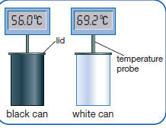

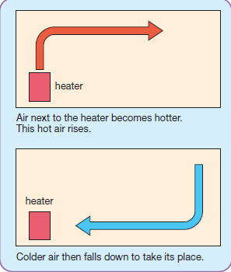

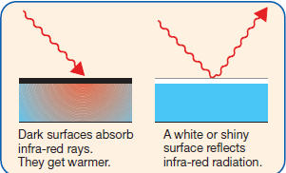

Black White



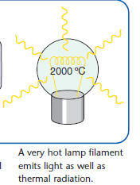

*Radiation*

*convection*

5. Which can has the greatest albedo? How can you determine this from the experiment?

*The white can has the greatest albedo, meaning its surface reflects light from the lamp the most. In the experiment, we observed that the temperature inside the black can increased the most because it absorbed the radiation rather than reflected it as in the white can.*DATA TABLE

*Be sure to give units for each temperature measurement*

|  |  |  |
| --- | --- | --- |
| Time (Minutes) | Temperature  Black (°C ) | Temperature  Silver (°C ) |
| 0 | 23.0 °C | 22.0 °C |
| 3 | 28.0 °C | 24.3 °C |
| 6 | 32.0 °C | 26.5 °C |
| 9 | 34.5 °C | 28.0 °C |
| 12 | 35.5 °C | 28.8 °C |
| 15 | 36.0 °C | 29.1 °C |
| 18 | 36.4 °C | 29.5 °C |
| 21 | 36.9 °C | 29.8 °C |
| 24 | 37.1 °C | 30.0 °C |

Make a scatterplot graph of the time (in minutes) versus the temperature. Use time as the independent variable.

Graphing Guidelines

1. Title your graph – (should be descriptive of data plotted).

2. Label axes with proper variable placement; leave space to label each axis; include units.

3. Always plot the independent variable (control) on the horizontal (x) axis.

4. Choose an appropriate scale – make sure that each box on each axis is given the same interval value, and that the data will fit on the graph according to your scale.

5. Draw a scatterplot (connect the points) for each can and label the slope line.Temperature (°C) in Cans Versus Time in Minutes

40

|  |  |  |  |  |  |  |  |  |  |  |  |  |  |  |  |  |  |  |  |  |  |  |  |  |
| --- | --- | --- | --- | --- | --- | --- | --- | --- | --- | --- | --- | --- | --- | --- | --- | --- | --- | --- | --- | --- | --- | --- | --- | --- |
|  |  |  |  |  |  |  |  |  |  |  |  |  |  |  |  |  |  |  |  |  |  |  |  |  |
|  |  |  |  |  |  |  |  |  |  |  |  |  |  |  |  |  |  |  |  |  |  |  |  |  |
|  |  |  |  |  |  |  |  |  |  |  |  |  |  |  |  |  |  |  |  |  |  |  |  |  |
|  |  |  |  |  |  |  |  |  |  |  |  |  |  |  |  |  |  |  |  |  |  |  |  |  |
|  |  |  |  |  |  |  |  |  |  |  |  |  |  |  |  |  |  |  |  |  |  |  |  |  |
|  |  |  |  |  |  |  |  |  |  |  |  |  |  |  |  |  |  |  |  |  |  |  |  |  |
| Temperature  °C |  |  |  |  |  |  |  |  |  |  |  |  |  |  |  |  |  |  |  |  |  |  |  |  |
|  |  |  |  |  |  |  |  |  |  |  |  |  |  |  |  |  |  |  |  |  |  |  |  |  |
|  |  |  |  |  |  |  |  |  |  |  |  |  |  |  |  |  |  |  |  |  |  |  |  |  |
| 30 |  |  |  |  |  |  |  |  |  |  |  |  |  |  |  |  |  |  |  |  |  |  |  |  |
|  |  |  |  |  |  |  |  |  |  |  |  |  |  |  |  |  |  |  |  |  |  |  |  |  |
|  |  |  |  |  |  |  |  |  |  |  |  |  |  |  |  |  |  |  |  |  |  |  |  |  |
|  |  |  |  |  |  |  |  |  |  |  |  |  |  |  |  |  |  |  |  |  |  |  |  |  |
|  |  |  |  |  |  |  |  |  |  |  |  |  |  |  |  |  |  |  |  |  |  |  |  |  |
|  |  |  |  |  |  |  |  |  |  |  |  |  |  |  |  |  |  |  |  |  |  |  |  |  |
|  |  |  |  |  |  |  |  |  |  |  |  |  |  |  |  |  |  |  |  |  |  |  |  |  |
|  |  |  |  |  |  |  |  |  |  |  |  |  |  |  |  |  |  |  |  |  |  |  |  |  |
|  |  |  |  |  |  |  |  |  |  |  |  |  |  |  |  |  |  |  |  |  |  |  |  |  |
|  |  |  |  |  |  |  |  |  |  |  |  |  |  |  |  |  |  |  |  |  |  |  |  |  |
| 20 |  |  |  |  |  |  |  |  |  |  |  |  |  |  |  |  |  |  |  |  |  |  |  |  |
|  |  |  |  |  |  |  |  |  |  |  |  |  |  |  |  |  |  |  |  |  |  |  |  |  |
|  |  |  |  |  |  |  |  |  |  |  |  |  |  |  |  |  |  |  |  |  |  |  |  |  |
|  |  |  |  |  |  |  |  |  |  |  |  |  |  |  |  |  |  |  |  |  |  |  |  |  |
|  |  |  |  |  |  |  |  |  |  |  |  |  |  |  |  |  |  |  |  |  |  |  |  |  |
|  |  |  |  |  |  |  |  |  |  |  |  |  |  |  |  |  |  |  |  |  |  |  |  |  |
|  |  |  |  |  |  |  |  |  |  |  |  |  |  |  |  |  |  |  |  |  |  |  |  |  |
|  |  |  |  |  |  |  |  |  |  |  |  |  |  |  |  |  |  |  |  |  |  |  |  |  |
|  |  |  |  |  |  |  |  |  |  |  |  |  |  |  |  |  |  |  |  |  |  |  |  |  |
|  |  |  |  |  |  |  |  |  |  |  |  |  |  |  |  |  |  |  |  |  |  |  |  |  |
| 10 |  |  |  |  |  |  |  |  |  |  |  |  |  |  |  |  |  |  |  |  |  |  |  |  |
|  |  |  |  |  |  |  |  |  |  |  |  |  |  |  |  |  |  |  |  |  |  |  |  |  |
|  |  |  |  |  |  |  |  |  |  |  |  |  |  |  |  |  |  |  |  |  |  |  |  |  |
|  |  |  |  |  |  |  |  |  |  |  |  |  |  |  |  |  |  |  |  |  |  |  |  |  |
|  |  |  |  |  |  |  |  |  |  |  |  |  |  |  |  |  |  |  |  |  |  |  |  |  |
|  |  |  |  |  |  |  |  |  |  |  |  |  |  |  |  |  |  |  |  |  |  |  |  |  |
|  |  |  |  |  |  |  |  |  |  |  |  |  |  |  |  |  |  |  |  |  |  |  |  |  |
|  |  |  |  |  |  |  |  |  |  |  |  |  |  |  |  |  |  |  |  |  |  |  |  |  |
|  |  |  |  |  |  |  |  |  |  |  |  |  |  |  |  |  |  |  |  |  |  |  |  |  |
|  |  |  |  |  |  |  |  |  |  |  |  |  |  |  |  |  |  |  |  |  |  |  |  |  |
| 0 |  |  |  |  |  |  |  |  |  |  |  |  |  |  |  |  |  |  |  |  |  |  |  |  |

20

15

10

5

0

Time (minutes)