Problem Set: The Atom (Chapter 28)

*Complete all the problems in this set in an organized fashion, showing ALL necessary WORK. Problems with only answers may be considered incorrect and lower your grade. Clearly indicate your answers by underlining or circling the final answer to each problem.*

Applying Concepts

1. The northern lights are the result of high energy particles coming from the sun striking atoms high in the Earth’s atmosphere. If you looked at the light through a spectrometer, would you expect to see a continuous spectrum or line spectrum? Explain.

2. If white light were emitted from the Earth’s surface and observed by someone in space, would its spectrum be continuous, dark line or bright line? Explain.

3. Suppose you wanted to explain quantization to a younger brother or sister. Would you use money or water as an example? Explain.

4. A photon with an energy of 6.2 eV enters a mercury atom in the ground state. Will the photon be absorbed by the atom? Explain.

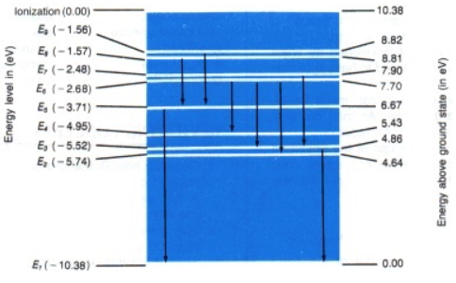

5. A certain atom has 4 possible energy levels as shown. If an electron can make transitions between any two levels, how many spectral lines can the atom emit? Which transition gives the photon the highest energy?

6. A photon is emitted when an electron drops through energy levels within an excited hydrogen atom. What is the maximum energy the photon can have? If this same amount of energy were given to an electron in the ground state of a hydrogen atom, what would happen?

7. When electrons fall from higher energy levels to the third energy level within hydrogen atoms, are the photons emitted infrared, visible, or ultraviolet? Explain.

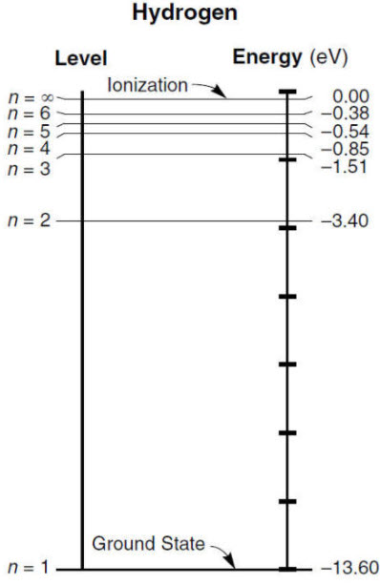

8. Compare the present quantum mechanical theory of the atom with the Bohr model.

9. Which color laser (*red light, green light, or blue light*) emits photons with the highest energy?

### Physics Principles and Problems

1. According to the Bohr model, how many times larger is the orbit of a hydrogen electron in the second level than in the first?

2. The energy level notes show how one can calculate the radius of the innermost orbit of the hydrogen atom. Note that all the factors in the equation are constants with the exception of n2. Find the radius of the orbit of the second, third, and fourth allowable energy levels in the hydrogen atom. (rn = n2k)

3. Calculate the energies (*in electron volts*) of the second, third and fourth energy levels of the hydrogen atom. [En = -13.6 eV(1/n2)]

1. Calculate the energy difference between E3 and E2 in the hydrogen atom using your results from #3. Then, find the wavelength of the light emitted using the equations from page 583 in your textbook. Which line in the diagram is the result of this transmission?

656 nm

434 nm

486 nm

410 nm

5. The diameter of the hydrogen nucleus is 2.5 x 10-15 m and the distance between the nucleus and the first electron is about 5 x 10-9 m. If you use a baseball with diameter of 7.5 cm to represent the nucleus, how far away would the electron be in meters and kilometers?

6. A mercury atom drops from 8.82 eV to 6.67 eV.

1. What is the energy of the photon emitted by the mercury atom?
2. What is the frequency of the photon emitted by the mercury atom?
3. What is the wavelength of the photon emitted by the mercury atom?

Chapter Review Problems

## Use the image to answer questions 21-23

 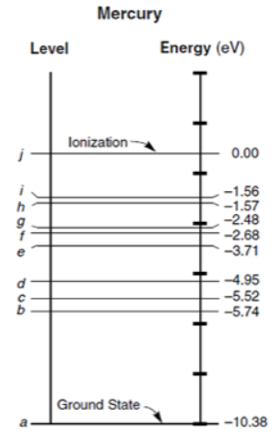

21. A mercury atom is in an excited state when its energy level is 6.67 eV above the ground state. A photon of energy 2.15 eV strikes the mercury atom and is absorbed by it. To what energy level is the mercury atom raised?

22. A mercury atom is in the excited state at the E6 energy level.

1. How much energy (*eV*) would be needed to ionize the atom?
2. How much energy (*eV*) would be released if the electron dropped down to the E2 energy level instead?

23. A mercury atom in an excited state has an energy of –4.95 eV. It absorbs a photon that raises it to the next higher energy level.

1. What is the energy (*eV*) of the photon?
2. What is the photon’s frequency?

24. A photon with the energy of 14.0 eV enters a hydrogen atom in the ground state and ionizes it. With what kinetic energy (*eV*) will the electron be ejected from the atom?

25. Honors only: calculate the radius of the orbital associated with the energy levels E5 and E6 of the hydrogen atom.

26. What energies are associated with a hydrogen atom’s energy levels E2 E3, E4 E5 E6?

27. Using the values that are calculated in question 26, calculate the following energy differences (*eV*) for a hydrogen atom.

1. E6 – E5
2. E6 – E3
3. E4 – E2
4. E5 – E2
5. E5 – E3

28. Use the values calculated from question 27 to determine the frequencies of the photons emitted when an electron in a hydrogen atom makes the level changes from:

1. E6 – E5
2. E6 – E3
3. E4 – E2
4. E5 – E2

29. Determine the wavelengths of the photons of the frequencies calculated in question 28.

1. E6 – E5
2. E6 – E3
3. E4 – E2
4. E5 – E2

30. Determine the frequency and wavelength of the photon emitted when an electron drops:

1. From E3 to E2 in an excited hydrogen atom
2. From E4 to E3 in an excited hydrogen atom

31. What is the difference between the energies (eV) of the E4 and E1 energy levels of the hydrogen atom?

32. From what energy level did an electron fall if it emits a photon of 94.3 nm wavelength when it reaches ground state within a hydrogen atom?

33. Honors only: For a hydrogen atom in the n = 3 Bohr orbital, find

a. the radius of the orbital

b. the electric force acting between the proton and the electron.

34. A hydrogen atom has its electron in the *n = 2* energy level.

1. If a photon with a wavelength of 332 nm strikes the atom, show that the atom will be ionized (the electron completely leaves the atom beyond the highest energy level).
2. When the atom is ionized, assume that the electron receives the excess energy from the ionization. What will be the kinetic energy of the electron in joules?

35. Honors only: Gallium arsenide lasers are used in CD players. If such a laser emits at 840 nm, what is the difference in eV between the two lasing energy levels?

36. A carbon dioxide laser emits very high-power infrared radiation. If such a laser emits at 10,600 x 10-9 m, what is the energy difference in eV between the two lasing energy levels?