**Projects in Science**

**Wild Edible Plants (in your yard) 1**

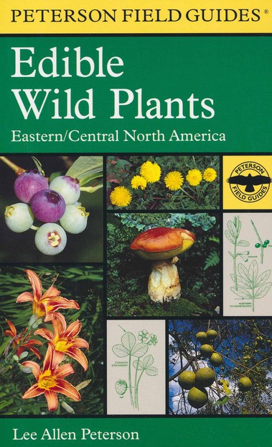

**See** [**https://www.learningctronline.com/courses**](https://www.learningctronline.com/courses) **for Materials and Resources.**

**Topics:**

1. Edible Wild Plants

**Objectives:**

* + Field Guides
  + Identify Wild Edible Plants
  + Field Specimen Activity
  + Cookbook Project

TAKE NOTE

1. Review Policies
   1. Late Policy
   2. Grading & Pedagogy – expect to spend 6-8 hrs/week on Projects in Science;
2. Create a Projects in Science folder on your Desktop with the following SUBfolders:
   1. Reference Materials
   2. Homework
   3. Lab
   4. Test
3. Technology
   1. Zoom
   2. Tablet
   3. Lab Supplies
   4. Microsoft Word, PowerPoint, Excel compatibility (especially MAC users)
   5. Access to Movies via Prime, YouTube, Apple TV, Hulu, etc.
4. Review Conduct, Integrity, Plagiarism policy (<https://www.learningctronline.com/policies-conduct-integrity-plagiari>)
5. Cookbook Project [due in 3 days after week 2’s class]
6. Reference Material: Field Guide Worksheet 1
7. Lab: Field Specimen Activity
8. Quiz Plant Identification (Practice with Powerpoint)
9. Class Song: “Do Your Best” (<https://www.learningctronline.com/class-songs>)
10. Week 1 Devotional (<https://www.learningctronline.com/devotional>)

**Text**: Peterson Field Guide to Edible Wild Plants

**Reference Material: Edible Wild Plants PowerPoint**

**Homework**:

* Field Guide Worksheet 1

**Lab**: Field Specimen Activity

* Perform the lab as directed using the worksheet provided.
* Save the document into your LAB folder in the Projects in Science folder on your desktop.

**TEST:** Quiz Plant Identification (Practice with PowerPoint)

1) Open the PPT Edible Wild Plants on Learning CTR Online.

2) Click on the “Slide Show” shade at the top of the PPT. Then, Click “Play from Beginning”.

3) Go through the slide to practice naming the various plants.

Supplemental Resources (Optional)

1. Website list