**Work, Power, Simple Machines Chapter 8**

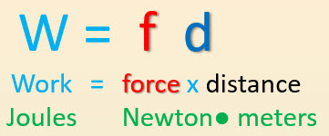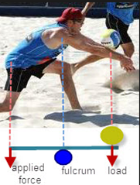

**See** [**https://www.learningctronline.com/courses**](https://www.learningctronline.com/courses) **for Materials and Resources.**

**Topics:**

1. Work, Power, Simple Machines

**Objectives:**

* Define and calculate Work as the force applied to an object over a specific distance (W = f d) in units of joules.
* Understand how work relates to Potential Energy (mgh) and Kinetic Energy (½ mv2).
* Define and calculate Power as the amount of work done per unit of time (P = W/t) in units of Watts.
* Classify the six simple machines.

TAKE NOTE

1. Reading (Hewitt Text)

1. Work Activity Worksheet
2. Classes of Levers Activity
3. Problem Set Work (Basics) [1 week]
4. Lab: Simple Machines (Part 1)
5. Upcoming: Semester Exam (due within 10 days after week 16’s class)

1. Week 13 Devotional (<https://www.learningctronline.com/devotional>)

**Text**: Chapter 8 Work / Energy (Hewitt)

**Class Notes: Use the Document provided**

**Homework**:

* Worksheet: Classes of Levers Activity
* Problem Set Work (Basics)

**Lab**: Work Activity

* Perform the lab as directed using the worksheet provided.
* Complete all calculations and data, showing work whenever appropriate.
* Conclusions should be answered in complete sentences that convey a complete thought.
* Save the documents into your LAB folder in the Physics folder on your desktop.

**Lab**: Simple Machines Part 1

* Perform the lab as directed using the worksheet provided.
* Complete all calculations and data, showing work whenever appropriate.
* Conclusions should be answered in complete sentences that convey a complete thought.
* Save the documents into your LAB folder in the Physics folder on your desktop.

**TEST:** No Quiz or Test

Supplemental Resources (Optional)

<http://somup.com/cFX2bhniR8> Work & Power Song (3:30)

<http://somup.com/cFX2bQniR9> Work & Power Hockey (5:03)

<http://somup.com/cFX2qNniWH> Simple Machines Overview (3:02)

<http://somup.com/cYfT2CiyTE> Bugs Bunny Barber of Seville Classes of Levers (Simple Machines) (6:03)

<http://somup.com/cFX2qRniWs> Wheel & Axle & Pulleys (2:16)