Trapping Furbearers

## **The Purpose of This Trapping Manual**

Beginning in 1980, successful completion of a trapper training course is required of all first time trappers. This requirement has come about in order to increase awareness of the trapper’s responsibilities, to introduce beginning trappers to acceptable trapping methods, ethics and responsibilities, law, natural history and basic wildlife management princi­ples. Skill in trapping must be developed through experience.

Through this course, one may learn more about the tradition and adventure of trapping, increase environ­mental awareness, gain new outdoor skills, and realize the potential economic gain of ecologically sound trap­ping. In addition, there is the opportunity for personal development through hard work, careful study, and better understanding of life and death. It is hoped the course will also encourage beginning trappers to learn more about trapping from personal experience and the experience of others.

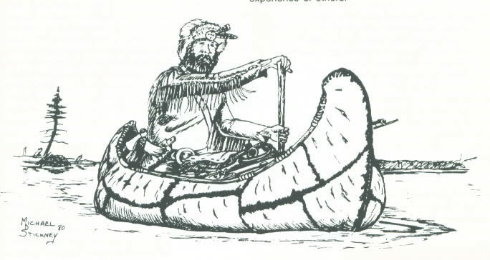

# A Brief History Of Trapping

Human beings since prehistoric times, including recent ­North American Indians and Eskimos, have used of various kinds to capture animals for food, trapping, or population control. The earliest forms of were probably pits, deadfalls or snares. The latter types are still legally used in some wilderness areas.

When Europeans first came to North America they also depended upon the plentiful furbearers for subsistence. The demand for fur in Europe created a large and thriving fur trade in North America from which Indians and some of the new immigrants derived a portion of their livelihood by trapping.

It was the lure of richer hunting and trapping, particularly for beaver, more than the lure of rich soil or even gold which prompted westward exploration and settlement. Along the paths opened by these pioneering beaver trappers, commerce, then agriculture spread across the nation.

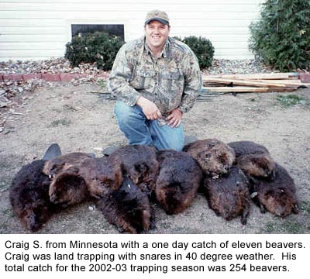

During the early 1800’s the mountain men, armed with their new Newhouse traps, journeyed up the Missouri River to explore the beaver meadows of the Rocky Mountains, from Canada south to New Mexico. The golden age of fur saw the native people befriended or exploited, the trappers surviving hardships to make or to lose fortunes, and many lives lost – all for the sake of fur.

Annual surpluses of furbearers still exist, and many people depend upon those surpluses to supplement their income. Well-regulated hunting and trapping provide pleasurable and profitable means of using a renewable natural resource.

# The Furbearer Resource

We are fortunate in having an abundant and varied supply of furbearers, including muskrat, mink, beaver, otter, opossum, skunk, raccoon, gray fox, red fox, coyote, weasel, fisher, bobcat and marten. They have a number of effects upon environmental conditions, economics, and the quality of human life in addition to their fur value and their value in controlling agricultural pests. With the exception of beaver and muskrat, most furbearers are also predators, which are important in maintaining ecological balance in natural systems.

Any discussion of the value of furbearers must take both their beneficial and their harmful effects into consideration. Beaver may flood valuable agricultural lands, roadways, woodland, and in some instances, have detrimental effects on trout. Their ponds are also valuable habitat for such animals as muskrat, and waterfowl such as wood ducks and black ducks. Muskrat eat aquatic vegetation, often opening portions of marshes for fish and wildlife habitat. However, muskrat can be extremely destructive to pond banks, dikes, and similar structures. Predators kill to eat. Some of their prey may be domestic stock, game animals or other valued wildlife. In some areas, for example, coyote may cause serious losses to free ranging sheep or other domestic stock. These losses are often more than offset by their role in controlling mice, rabbits, and other agricultural pests. The corn and songbird depredations of skunk and raccoon must be balance against their controlling effect on insects and rodents. To their discredit, furbearers serve as carriers of diseases like rabies and tularemia, and of parasites like mange mites and ticks.

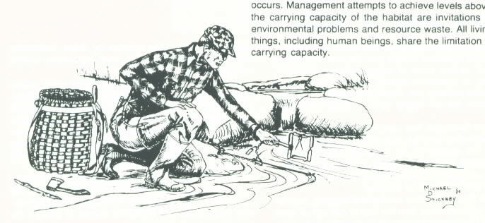

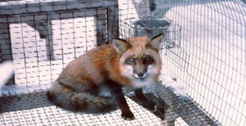

These are some of the tangible positive and negative values of the resource. The pleasure of seeing and studying these animals is probably the greatest of the intangible values. When both positive and negative aspects are considered, the importance of scientifically based wildlife management becomes apparent.

# Wildlife Management Principles

Wise management of renewable natural resources includes the use of a harvestable surplus, coupled with the preservation of the basic resource. The goal of management is to provide the maximum harvestable surplus consistent with other factors such as habitat quality, disease carriers, wildlife damage, and reproductive biology. Drawing upon the best available knowledge of ecology, behavior, current populations and habitat conditions, all are integrated into a management plan using the principles of wildlife management.

Within certain limits, all of the living components of the natural resource base are renewable. Forage plants are renewable; wildlife is renewable. Entire communities are dynamic and renewable as long as their requirements for life and reproduction are met.

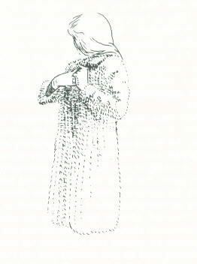

Every organism has a set of requirements (food, cover, and breeding sites, for example) which must be supplied by its environment. Each required resource exists in some limited amount. Any resource that exists in an inadequate amount is called a limiting factor, because it limits the population of the organism in that time and place. For example, an area may have enough of everything to support 1000 muskrat during the spring, summer and fall. During the winter months the food supply may only support 300 muskrat. Though all other things are sufficient, the remaining 700 must either avoid the shortage by moving elsewhere, or they die.

The entire set of requirements, including all limiting factors, determine the carrying capacity of a particular area for each species. The carrying capacity is similar to the volume of a bucket. When the bucket has been filled, adding more to it only wastes what is added. Sometimes the best management plan dictates that a population be held below its carrying capacity for some reason – such as when excessive wildlife damage occurs. Management attempts to achieve levels above the carrying capacity of the habitat are invitations to environmental problems and resource waste. All living things, including human beings, share the limitation of carrying capacity.

Most organisms produce more offspring than the habitat can support. The excess individuals are lost through predation, starvation, disease, or some other means. The natural order of thins is violence, and loss rates are quite high in most organisms. Muskrats, for example, frequently lose 70 percent of their population from one breeding season to the next. The attrition (loss) rate is found whether humans influence it or not. Increases in mortality caused by one factor, such as predation, are often compensated by decreases in other factors, such as starvation or disease. Thus, the total loss rate remains fairly constant.

Wildlife cannot be stockpiled; it is dynamic resource with high and low populations each year. Surplus animals die until the range that they occupy is able to support the survivors. Each year’s wildlife population consists of two parts. Capital stock is that portion of the population the habitat can support. Surplus stock is the part the habitat cannot support, and that will die by some means before the next year’s young are produced. Use of the surplus provides recreation, products, food and employment without depleting the capital stock. That stock remains to produce another surplus and to provide the other wildlife benefits that many consider essential.

If the resource is to be maintained for the use and enjoyment of future generations, management decisions cannot be based on whim, political expediency, or emotionalism. In some instances, such as disease epidemics, good management dictates drastic reductions in populations. In others, such as the bald eagle in New York, complete protection is the best management plan.

# The Rationale for Trapping

Furbearers are a part of the wildlife resource. The harvest of surplus furbearing animals results mainly in the production of durable, warm and beautiful fur clothing. Recent criticisms of trapping and the fur industry have implied vanity demands furs instead of readily available synthetic fibers. Beauty is only part of he usefulness of fur. One of its greatest advantages is the renewability of the resource and the relatively low fossil fuel cost of its production. Synthetic fibers come either from nonrenewable resources (coal or petroleum) or from energy intensive resources (wood fiber). Most of the energy involved in the production of fur garments is biological energy, the energy of growth and of human labor.

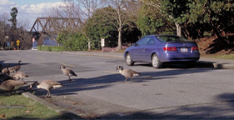

The major emotional argument against trapping is the cruelty to the captured animals. The amount of damage caused by traps has been greatly exaggerated by some of the anti-trapping groups. Most of the remainder is the result of irresponsibility on there part of a small number of trappers. A responsible trapper uses selective sets and minimizes the time a trapped animal is held. When possible, he uses sets, which kill target animals quickly. Although pain may be inflicted in trapping it is slight compared with the violence and brutality of the natural order where animals live and die violently. Their daily lives are a constant struggle for survival, and those that die far outnumber the survivors. Anthropomorphism (attributing human characteristics to animals) cannot change the realities of their existence.

Death is a necessary part of the use of furbearing animals; but taking of animal life is a part of human existence. Even our vegetable food stuffs are produced at the cost of animal life, either or fertilizer production, for insect and disease control, or through habitat destruction. All human beings directly or indirectly contribute to the loss of animal life.

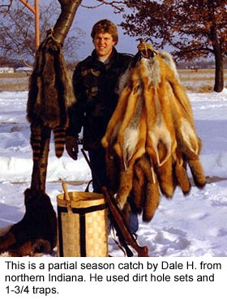

Trappers have spent a great deal of time designing traps and types of sets that will kill their catch as quickly and humanely as possible. Body-gripping traps are designed to kill the trapped animal r3elatively quickly, but they do not always do so. Unfortunately, body-gripping traps are not adaptable to all types of furbearers or all types of sets. For example, they can not effectively capture foxes or coyotes and these traps are not effective at dirt hole sets. No responsible trapper will use them where catching other animals such as protected wildlife, domestic stock, or house pets is possible. These traps have excellent but limited utility.

Box traps, including cage-like wire traps which catch only one animal at a time, have limited utility for they are heavy, expensive, bulky, and useful in only certain types of sets. Box traps are not effective for fox or coyote. They do have some advantages, for they seldom harm their catch. They are an excellent choice for areas where domestic animals or other non-target species are frequently encountered, such as urban or suburban trapping for problem raccoons, skunks, and opossums. Although their usefulness is limited, box traps are appropriate and effective in some trapping situations.

Leg-hold traps (steel traps) are the primary types of trap used. Animals taken in these are commonly caught by the foot or lower leg. When properly set and of appropriate size, the trap seldom does permanent damage to the leg or foot. Since the trapped limb soon becomes numb, the major impact of the trap lies with restricting the animal’s movements. Some animals resist being so restricted, others may lie down or even sleep. Unwanted animals can usually be released without permanent damage. Desired animals are killed by the trapper as quickly and humanely as possible. When trapping semi-aquatic animals sets are made so that the animal quickly drowns. Reports of animals spending days or weeks in a trap are either pure invention or cases of irresponsibility and violations of the law. By law, trappers must visit their traps at least every 24 hours (except 48 in some areas).

Some people have strong aversions to the killing of wildlife. There certainly is room for such personal attitudes. However, this concept should not be forced on others by legislation. Such action would strip resource managers of a powerful, effective, and legally controlled management tool. All of us must realize that our wildlife resource must be wisely used. Preservationist movements are as grossly in error as are those that would reduce or eliminate capital stocks. Sound wildlife management can attain the double goal of wisely using surplus stocks while preserving capital stocks for future productivity and use. In that way benefits of both consumptive and nonconsumptive use of the resource can be realized.

Even the best management plan has a weak link. If preservationists prevent management by political pressure, or if consumptive users act irresponsibly or unlawfully, the management of furbearers becomes difficult at best and impossible at worst. All of humanity loses when the wildlife resource suffers.

Before placing his first trap, a trapper must learn all he can about trapping and furbearers. Furbearers represent a resource, which cannot be stockpiled. Harvesting wisely, legally, efficiently, selectively, and humanely, trappers can manage for a continued yield of wildlife, and ensure the resource is preserved for future generations.

# Trapping Law

As stated previously, conservation laws are designed to insure a continuing population of furbearers. They also aid in permitting all citizens to share the common resource. Usually, open seasons are set to include the period when the fur is at its best. Both the regulations on trapping and the open season for various species of furbearers are listed in the annual Trapping Guide. These are available wherever licenses are sold. When in doubt about some point on seasons or regulations, check with your local Environmental Conservation Officer. Remember that the law requires you to visit your traps at least once in every 24 hours (except 48 hours in some areas), and to tag all traps with your name and address.

Keep your trapping license with you when you are trapping. Be sure that you comply with all licensing and tagging regulations.

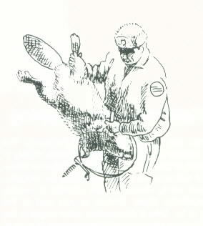

Note that the law specifically prohibits disturbing lawfully placed traps or removing lawfully trapped animals from the traps of another person. Securing the permission of landowners before setting traps is the trapper’s responsibility. Responsible trapping also requires that traps be set so that the risk of taking domestic animals and protected wildlife is kept to a minimum. All trappers must adhere strictly to the law, and recognize their responsibilities to ensure wise use of the resource.

# Trapping Ethics

The use of a public resource demands the exercise of both courtesy and personal responsibility. Respect for oneself, landowners, other people, and the furbearer resource summarizes this expression of that courtesy and responsibility. It is delineated in a personal code of ethics that goes beyond legal requirements and is set forth on the cover of this manual. It is **your responsibility** to adhere to this code.

Trappers must know and obey trapping laws and be willing to report violations of these laws to their local Environmental Conservation Officer. Failure to do so will result in the increased criticism of trapping and perhaps to the lack of proper management of our furbearers.

The proper use of legal traps will avoid mush of the criticism of trapping. Using the proper size and type of trap for the species desired limits any physical damage to the trapped animal. Using selective sets and baits reduces the chances of catching unwanted animals. Securing a trap in a manner to hold any animal captured eliminates the possibility of animals escaping with the trap still attached. An empty or bent trap is better than an animal escaping with the trap. Cover all leghold traps set on land. This will increase your catch and reduce any damage caused to the animal. Check traps daily and as early in the day as possible to keep the time an animal spends in the trap to a minimum. This in turn can keep the amount of physical damage and stress to the captured animal at a minimum and reduce its chance to escape.

When trapping in the water for semi-aquatic species, all traps should be placed in a manner to drown the captured animal which is a quick and humane form of death. Setting the trap in the water also reduces the chance of catching many non-target animals. The use of guarded leghold traps or small body-gripping traps is necessary wherever there is a possibility that the trapped muskrat will not drown. [*An animal actually asphyxiates, or dies from a lack of oxygen. Aquatic furbearers cannot intake water underwater, so they cannot drown. However, since the term “drowning” is commonly used to describe the manner in which they die, its use will be employed in this manual.*]

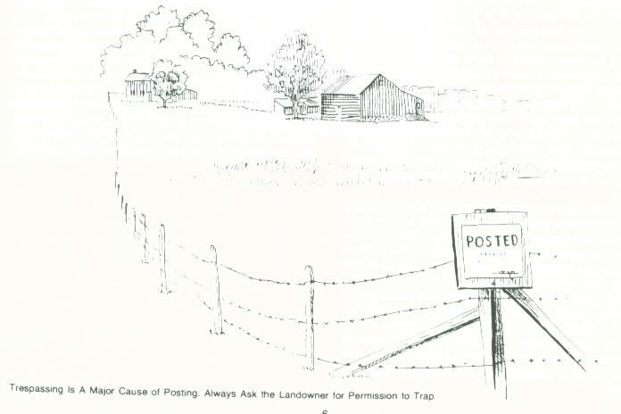

A good trapper is a good citizen who respects the rights and property of others. Get permission to trap on private land; a trapping license does not entitle the trapper to free access to private land. If a landowner has problems with some animals, such as muskrats removing these problem animals whenever legal. Remember not to cut stakes, drive on farm lands or set traps in standing crops (such as corn) without specific permission from the landowner.

Considering the activities of others, whether they are hunting, watching birds, or harvesting crops, is an essential part of the trapping ethic. Use caution when setting in areas where there is a risk of capturing a cat or dog. If a domestic animal is captured, immediately release it and if at all possible inform its owner about any injuries.

New traps and trapping techniques are constantly being developed. A good trapper stays up to date with these changes in order to be as humane and selective as possible. Completion of a trapper training course does not mean that you are an accomplished trapper who knows all there is to know. A good trapper realizes this and is always willing to learn. Keeping abreast of new developments is your responsibility.

A good trapper respects the resource being used. Respect in this instance includes making full use of the animal once removed from the wild. Proper pelt preparation ensures that the fur will not be wasted. Using carcasses for food, dog food, or in lure preparation is also very important. When the carcass cannot be used, dispose of it in a manner, which will not offend other people.

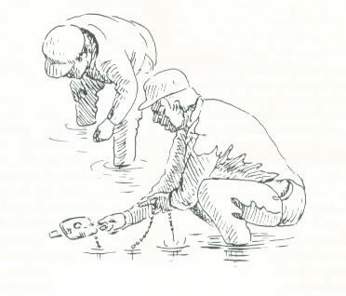

The trap sets and other information in this manual are presented to guide you in becoming a good trapper. Over the years, these sets have proven to be the most selective and humane sets available. The tools of trappers are important, but the proper use of these tools is what twill make you become a responsible trapper. You have a choice; you can support trapping and the future of the resource by abiding by both the law and the standards set for an ethical trapper, or by ignoring this information you can help stop trapping and possibly damage the resource. Let’s work together for the future of trapping and our valuable furbearing animals.

# Success in Trapping

Some beginning trappers don’t understand the idea of successful trapping. They may think that a successful trapper catches a furbearer in almost every trap, every night, which just doesn’t happen. Many professional trappers only average one fox for each twenty traps checked. A trapper’s catch depends on many things such as the area trapped, weather and furbearer populations. Trappers should not be judged by their catch volume but rater by how ethical and responsible they are. An important part of that responsibility is to continue checking traps as long as they are set even though a large volume of animals are not being caught.

Before You Go Trapping

What do you need to learn and do before your go trapping? You will need to learn trapping laws, gather equipment, and buy traps. You must prepare the traps, make or buy baits and lures, and study the furbearers. A wise trapper will practice making certain kinds of sets and thoroughly scout the area he or she plans to trap. With trap locations picked out in advance, a working knowledge of furbearers and the sets to take them, and equipment completely ready, the enjoyment of trapping and the chances of success are both much greater.

Trapping Equipment

To do anything well, one must have the right equipment. In trapping, as in so many other activities, quality equipment is the best investment in the long run. By being prepared for the most wary and difficult-to-trap animals, the trapper can take advantage of all trapping opportunities. Listed below are the contents of a typical fox trapper’s pack basket.

Traps pan covers stakes digging tool hatchet

Wire pliers gloves dirt sifter bait jar

Lure kneeling pad urine

## Pack Basket

The trapper must have something in which to carry all the equipment needed. Most trappers use a pack basket rather than a canvas pack because the basket is less likely to hold odors, more rigid and more convenient to use. Lure and bait are usually carried in a separate pouch or in the trappers’ coat pocket.

## Gloves

If only dry-land sets are made, a pair of clean, odor-free cotton gloves may be sufficient. Many trappers prefer to use rubberized gloves to reduce the amount of human scent left at the set. Either the short rubber gloves or arm-length gauntlets are very useful to water trappers. They will more than pay for themselves in comfort and preventing chapped skin or frost bite. No bait or lure or other odors should be permitted on the gloves. Keep them clean.

## Digging Tool

Many sets call for a bit of digging. Most trappers use some type of long, sturdy trowel for that purpose. Many special trapping trowels are available, although even a large spoon can work. A trowel is a good investment in the long run.

## Traps

Traps of the right size and type should be tagged and thoroughly prepared for use. Some examples of various types of traps, and the names of the basic trap parts are illustrated next to each sample.

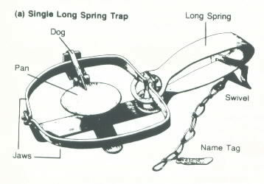

**Long-spring traps**

(*figure a*) are generally the least expensive. Having more metal in their construction, they are also heavier. Where easy concealment is not a problem and the extra weight might be an asset (as in beaver trapping), either single or double long-spring traps may be the best choice.

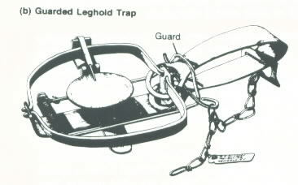

**Guarded traps**

(*figure b*) are available in several styles from several manufacturers. They employ an additional spring-loaded jaw or bail that prevents the muskrat or mink from escaping. Many muskrat trappers use these types of traps almost exclusively.

**Under-spring or jump traps**

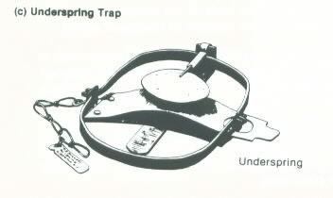

(*figure c*) are most compact and therefore easier to conceal than are long-spring traps. While they are a little more difficult to set than long-spring traps, jump traps are a bit faster and frequently stronger for a given size. They are also a little lighter to carry than the long-spring traps. Some manufacturers produce double as well as single under-spring traps.

**Coil-spring traps**

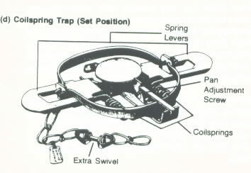

(*figure d*) are the fastest of the foothold traps. Available in sizes 1 through 4 from a variety of manufacturers, coil springs are often used in trapping predators. They have all the advantage of under-spring traps with the addition of increased speed.

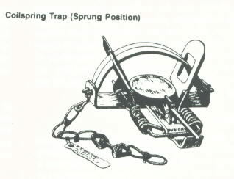

**Body-grip traps**

(*figure e*) are the result of many years of research and design efforts. These traps are designed to catch the animal about the neck or the chest. When properly set, these traps usually kill the trapped animal quickly. If a chest hold occurs, the animal may be killed by heart stoppage or strangulation, with death coming quite rapidly. In order to be most effective body-gripping traps must be set with careful attention to trigger placement.

These traps are very popular with water trappers, and quite useful in some kinds of land sets. **CAUTION: Body-gripping traps should not be used where or in ways they may take non-target animals.** Body-gripping traps are not adaptable to all types of furbearers, such as canines, or to a full range of sets. Canines instinctively avoid entering body-gripping traps.

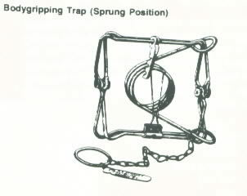

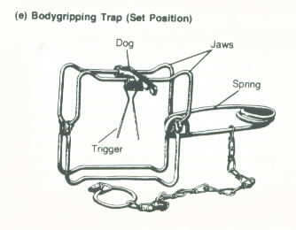

## **Box traps**

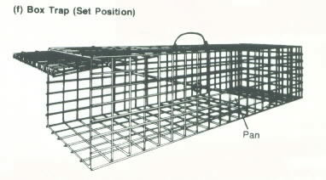

## (*figure f*) of various descriptions may be useful in trapping some species where the danger of taking domestic animals is high. Like the killer traps, however, their use is rather limited especially for canines. Their cost and size are also disadvantages to their use on trap lines.

**Snares**

While available, snares are illegal to use in New York.