**Food Additives**

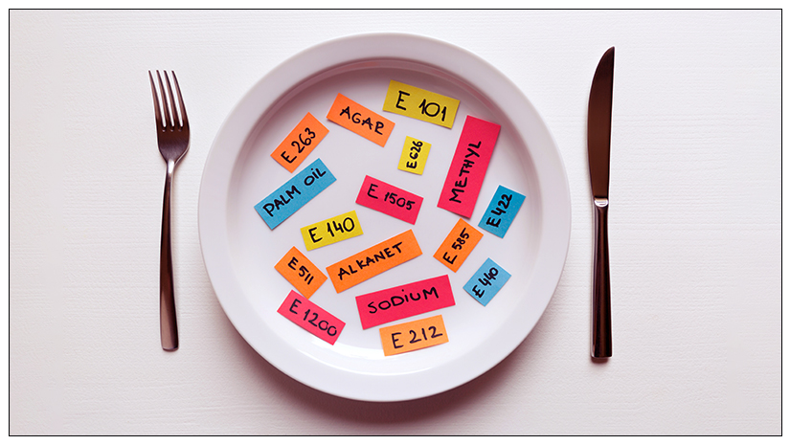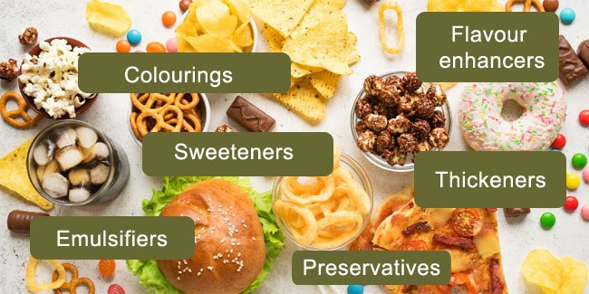

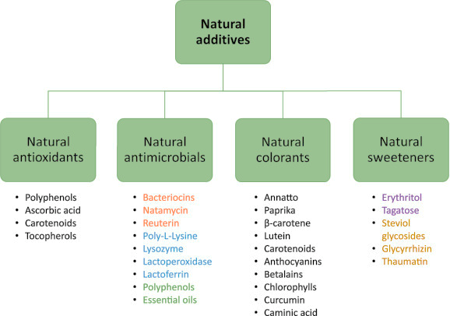

**See** [**https://www.learningctronline.com/courses**](https://www.learningctronline.com/courses) **for Materials and Resources.**

**Topics:**

1. Food Additives

**Objectives:**

* + Identify food types (organic, natural, processed).
  + Recognize types of food additives (natural, intentional, incidental).
  + Understand the establishment of safety standards (GRAS, Delaney, FDA).
  + Discuss FDA standards of identity, quality and fill.
  + Explain food labels (nutritional information) and compare foods.

TAKE NOTE

1. Reference Material Worksheet: Food Additives
2. Lab: How to Spot a Fat Hamburger
3. Lab: Surface Area versus Volume of Foods
4. Project: Food Labels (2 weeks)
5. Film Review “Big Year” [2011] (Steve Martin, Jack Black, Owen Wilson)
6. Week 12 Devotional (<https://www.learningctronline.com/devotional>)

**Text**:

**Reference Material: Food Additives**

**Homework**:

* Food Additives Reference Material Worksheet
* Food Labels Project (2 weeks)
* Film Review: “Big Year”

**Lab**: How to Spot a Fat Hamburger

* Complete the lab: “How to Spot a Fat Hamburger” using the worksheet provided.
* Save the document into your LAB folder in the Projects in Science folder on your desktop.

**Lab**: Surface Area versus Volume of Foods

* Complete the lab: “Surface Area versus Volume of Foods” using the worksheet provided.
* Save the document into your LAB folder in the Projects in Science folder on your desktop.

**Lab**: Film Review: Big Year (follow up of Wildlife Management)

* Obtain the movie “Big Year” [2011, Owen Wilson, Steve Martin, Jack Black]
  + Complete the **specific** film review from the website.
* Save the document into your LAB folder in the Projects in Science folder on your desktop.

**TEST: none**

Supplemental Resources (Optional)

1. Think about the upcoming project: Food Additives Letter