*Take the quiz without notes or outside resources.*

Name _____

Date _____

A. Label the major layers of the Earth’s interior from the diagram:

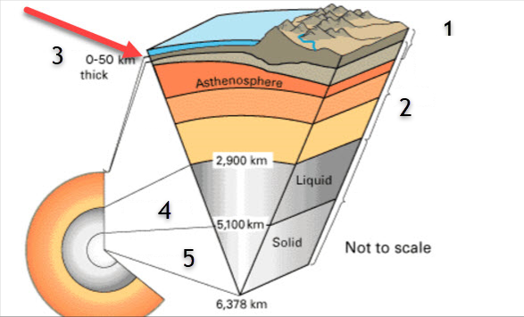

1)

2)

3)

4)

5)

B. We know about the earth’s interior layers by studying _____ waves.

C. Distinguish “magma” from “lava”.

D. Name and describe or define the three types of rocks.

1)

2)

3)

E. Earth’s lithosphere moves due to _____, based on differences in temperature and density.