Name _____

Build a Body

**Introduction**

**Purpose** To investigate incomplete dominance traits.

**Discussion**

Inheritance patterns are ways in which traits (genes) are inherited from generation to generation. There are many relationships which alleles can exhibit in nature that are NOT of a dominant/recessive nature. These are exceptions to Mendel’s principles. Not all genes show a pattern of dominance and recessiveness, in which one allele (gene) masks another. For some genes, there are more than two alleles. Many times, traits are controlled by more than one gene.

Incomplete dominance occurs when there are no forms of the gene that are dominant. F1 hybrids have an appearance somewhat in- between the phenotypes of the two parental varieties. The resulting trait is a BLEND of the two parental traits. The phenotype ratios and genotype ratios are always the same.

One can always tell that blending is involved if there are TWO EXTREMES and a “BLENDING” intermediate of these two extremes to make up the third characteristics. If a phenotype shows 3 traits, it involves blending. This type of inheritance exists in which the HETEROZYGOUS individuals show the effects of both alleles.

Many characters result from Polygenic Inheritance, in which a single phenotypic characteristic results from the additive effects of two or more genes scattered on various homologous chromosomes, but in different loci. Many genes affect one individual trait, showing a gradation or gradient of small differences in expression. This is known as CONTINUOUS VARIATION in the phenotype. There is no clear-cut distinction in the genes – the number of genes involved is not known. Examples: Human Skin Color and Height.

**Hypothesis**

If traits exhibit incomplete dominance, then the phenotype ratios and genotype ratios will be the same and the traits will appear to be blended (dominant, intermediate, recessive).

**Materials** Build a Body Traits Quarter (large coin)

Build a Body Trait Sheet

1. Body Build (weight)

Heavy (obese) (WW) Medium (Ww) Light (slim) (ww)

 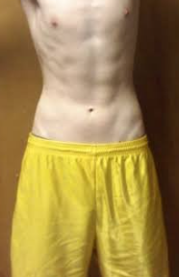

2. Face Shape

Round (SS) Oblong (Ss) Square (ss)

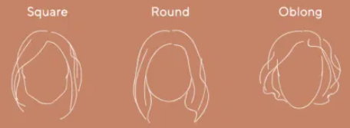  

3. Top of Head

Peaked (TT) Rounded (Tt) Flat (tt)

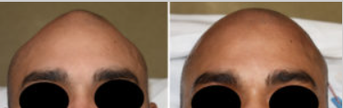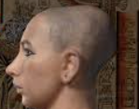

4. Hair Type

Curly (GG) Wavy (Gg) Straight (gg)

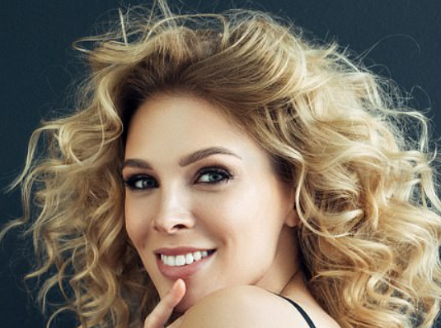 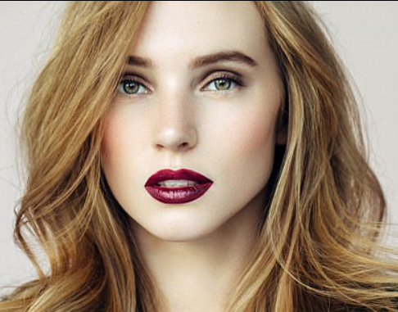 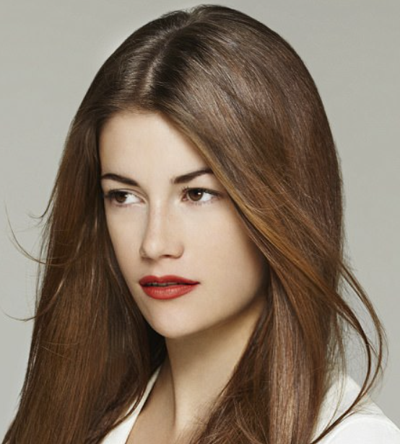

5. Skin Color – assume that there are two pairs of genes involved: Aa, Bb, and Cc.

Flip Aa Mom ____ Dad ____ 5-6 Capitals 🡪 Black

Flip Bb Mom ____ Dad ____ 4 Capitals 🡪 Brown

Flip Cc Mom ____ Dad ____ 3 Capitals 🡪 Yellow

2 Capitals 🡪 Reddish

0-1 Capitals 🡪 White

6. Hair Color – assume that there are two pairs of genes involved: Dd, Ee, and Ff.

Flip Dd Mom ____ Dad ____ 5-6 Capitals 🡪 Black

Flip Ee Mom ____ Dad ____ 4 Capitals 🡪 Brown

Flip Ff Mom ____ Dad ____ 3 Capitals 🡪 Yellow

2 Capitals 🡪 Red

0-1 Capitals 🡪 White

7. Eyebrow Color

Very Dark (JJ) Medium (Jj) Light (jj)

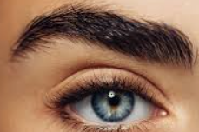 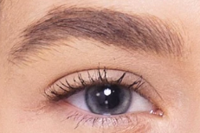 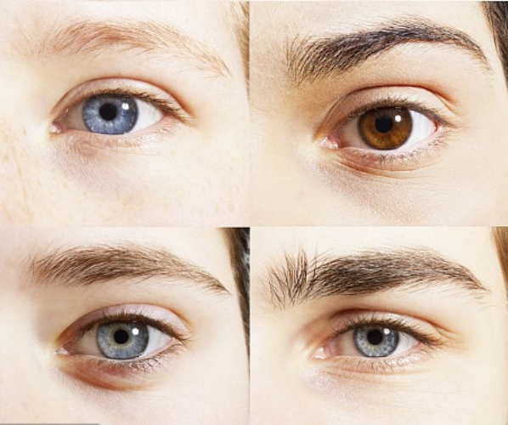

8. Eyebrow Thickness

Full (KK) Moderate (Kk) Fine (kk)

 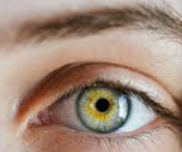 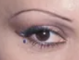

9. Eyebrow Placement

Not Connected (LL) Connected (Ll)

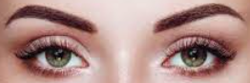 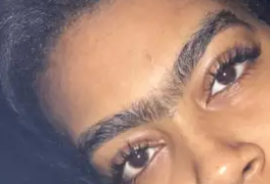

10. Eye Color – assume that there are two pairs of genes involved: Mm, Nn, Oo.

Flip Mm Mom ____ Dad ____ 5-6 Capitals 🡪 Black

Flip Nn Mom ____ Dad ____ 4 Capitals 🡪 Green

Flip Oo Mom ____ Dad ____ 3 Capitals 🡪 Blue-Green

2 Capitals 🡪 Dark Blue

0-1 Capitals 🡪 Light Blue

11. Eye Distance

Close Together (PP) Moderate (Pp) Far Apart (pp)

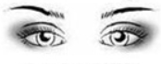 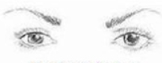

12. Eye Size

Large (QQ) Medium (Qq) Small (qq)

13. Eye Shape

Tapering (RR) Almond (Rr) Round (rr)

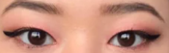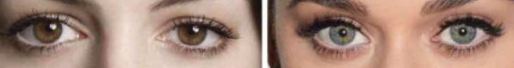

14. Eye Slant

Horizontal (UU or Uu) Upward (uu)

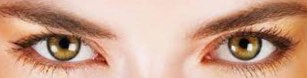 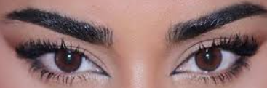

15. Eye Lashes

Long (VV) Medium (Vv) Short (vv)

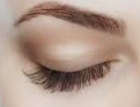 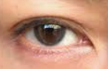

16. Mouth Size

Long (ZZ) Medium (Zz) Short (zz)

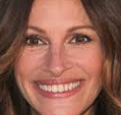 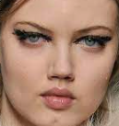

17. Lips

Thick (AA or Aa) Thin (aa)

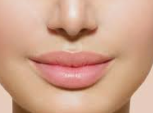 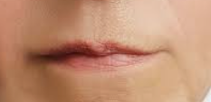

18. Dimples

Present (DD or Dd) Absent (dd)

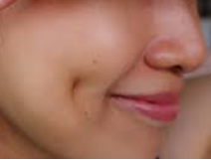

19. Nose Size

Big (BB) Medium (Bb) Small (bb)

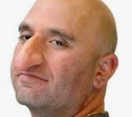 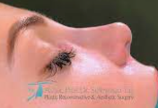

20. Nose Shape

Rounded (SS) Medium Pointed (Ss) Very Pointed (ss)

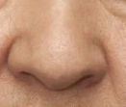 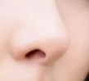

21. Nostril Shape

Rounded (RR or Rr) Narrow (rr)

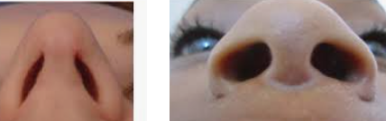

22. Earlobe Attachment

Free (FF or Ff) Attached (ff)

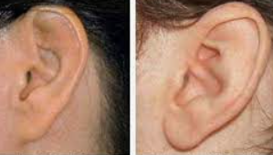 

23. Ear Size

Large (SS) Medium (Ss) Small (ss)

24. Freckles on Cheeks

Present (FF or Ff) Absent (ff)

25. Freckles on Forehead

Present (NN or Nn) Absent (nn)

26. Arm Length

Long (LL) Medium (Ll) Short (ll)

27. Hand Size

Large (HH) Medium (Hh) Small (hh)

28. Leg Length (Inseam)

Long (LL) Medium (Ll) Short (ll)

29. Foot (Shoe) Size

Large (HH) Medium (Hh) Small (hh)

**Procedures**

1. Obtain a large coin (*quarter*).
2. Consider the parents as **heterozygous** for all the Build a Body traits (e.g. Tt x Tt).
3. Start with the first trait listed in the “Build a Body Traits” section (*1. Body Build*).
   1. Flip the coin for the mother to determine the allele for each trait that the mother passed on to her offspring. *Note: the coin represents the offspring allele from the mother*.
   2. If the coin lands HEADS up, it represents the dominant allele (CAPITAL letter).
   3. If the coin lands TAILS up, it represents the recessive allele (lower case letter).
   4. Using the same process, flip the coin for the father to determine the allele for each trait that the father passed on to his offspring. *Note: the coin represents the offspring allele from the father*.
4. Record the results for each coin toss in the data table.
5. After both coins are flipped for a trait, use **these results** and the **Build a Body Traits** (*previous pages*) to determine and record the genotype and resulting phenotype in the data table for each trait.

**Calculations and Data**

1. Complete the data table on the next page.

2. For each trait, flip the coin as the “mother” first. If it is “heads” use the dominant (CAPITAL letter) trait. For example, T (tall).

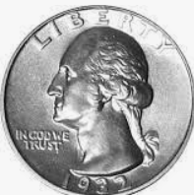 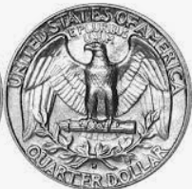

3. Flip the coin as the “father” second. If it is “tails” use the recessive (lowercase letter) trait. For example, t (short).

4. Complete the data table below by flipping the coin to represent the parents’ gene (allele) for each trait. HEADS represents the dominant allele (*use CAPITAL letter*) and TAILS represents the recessive allele (*use lowercase letter*).

|  |  |  |  |  |  |
| --- | --- | --- | --- | --- | --- |
|  | Trait | Gene from Mom | Gene From Dad | Genotype of Child | Phenotype of Child |
| 1 | Body Build (Weight) – Ww |  |  |  |  |
| 2 | Face Shape – Ss |  |  |  |  |
| 3 | Top of Head – Tt |  |  |  |  |
| 4 | Hair Type – Gg |  |  |  |  |
| 5 | Skin Color – Aa Bb Cc |  |  |  |  |
| 6 | Hair Color – Dd Ee Ff |  |  |  |  |
| 7 | Eyebrow Color – Jj |  |  |  |  |
| 8 | Eyebrow Thickness – Kk |  |  |  |  |
| 9 | Eyebrow Placement – Ll |  |  |  |  |
| 10 | Eye Color Mm – Nn Oo |  |  |  |  |
| 11 | Eye Distance – Pp |  |  |  |  |
| 12 | Eye Size – Qq |  |  |  |  |
| 13 | Eye Shape – Rr |  |  |  |  |
| 14 | Eye Slant – Uu |  |  |  |  |
| 15 | Eyelashes – Vv |  |  |  |  |
| 16 | Mouth Size – Zz |  |  |  |  |
| 17 | Lips – Aa |  |  |  |  |
| 18 | Dimples – Dd |  |  |  |  |
| 19 | Nose Size – Bb |  |  |  |  |
| 20 | Nose Shape – Ss |  |  |  |  |
| 21 | Nostril Shape – Rr |  |  |  |  |
| 22 | Earlobe Attachment – Ff |  |  |  |  |
| 23 | Ear Size – Ss |  |  |  |  |
| 24 | Freckles on Cheeks – Ff |  |  |  |  |
| 25 | Freckles (Forehead) – Nn |  |  |  |  |
| 26 | Arm Length – Ll |  |  |  |  |
| 27 | Hand Size – Hh |  |  |  |  |
| 28 | Leg Length – Ll |  |  |  |  |
| 29 | Foot/Shoe Size – Hh |  |  |  |  |
|  |  |  |  |  |  |

*BONUS: (HONORS STUDENTS) Make a drawing, sketch, or image of the “body” from the data table and insert it into this worksheet.*

5. Which traits showed the typical, Mendelian dominance and recessive genes?

6. Which traits showed incomplete dominance?

7. Which traits showed polygenic inheritance or continuous variation?

8. Which type of genetic trait was most prevalent (law of dominance, incomplete dominance, polygenic inheritance) in this lab?

**Conclusions**

1. Which type of genetic trait is most easily recognized and why?

2. Which type of genetic trait is most complex and why?

3. What type of genetic trait is shown by the graph? Explain the distribution of the trait.

