**Temperature, Heat, Expansion**

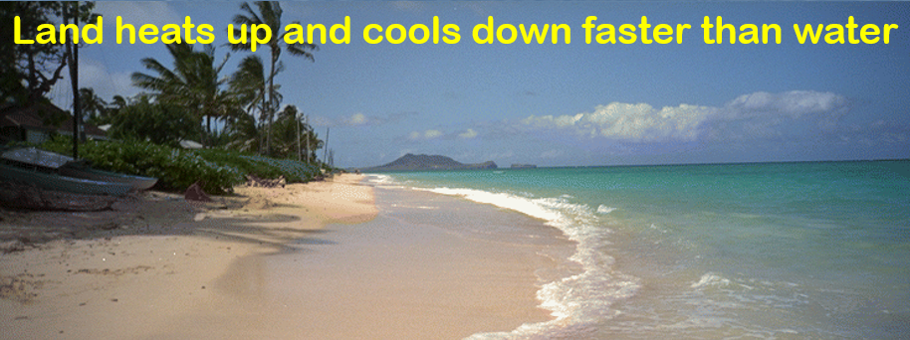

**See** [**https://www.learningctronline.com/courses**](https://www.learningctronline.com/courses) **for Materials and Resources.**

**Topics:**

1. Heat

**Objectives:**

1. Distinguish aspects of heat flow (endothermic, exothermic, potential energy, kinetic energy, heat and temperature).
2. Identify heat flow, potential and kinetic energy, phase changes, and heating or cooling for phase diagrams of a substance.
3. Define temperature, heat flow direction, thermal expansion, and specific heat.
4. Calculate / measure heat changes in a system using a calorimeter.
5. Understand thermal expansion and its importance regarding water.

TAKE NOTE

1. Reading (Hewitt Text) PDF

1. Note Taking & Questions from Text PDF Worksheet (2 weeks)
2. Heat Reference Material
3. Lab: Heating Curve of Water (1 week)
4. Lab: Specific Heat (1 week)
5. Semester Exam after this unit (due within 10 days after week 16’s class)

1. Class Song: Hello, My Students
2. Week 15 Devotional (<https://www.learningctronline.com/devotional>)

**Text**: Chapter 21 Temperature, Heat, Expansion (Hewitt)

**Class Notes: Use the PDF provided**

**Homework**:

* Worksheet: Note Taking & Questions from Text (first half)
* Heat Reference Material

**Lab**: Heating Curve of Water

* Perform the lab as directed using the worksheet provided.
* Complete all calculations and data, showing work whenever appropriate.
* Conclusions should be answered in complete sentences that convey a complete thought.
* Save the documents into your LAB folder in the Physics folder on your desktop.

**Lab**: Specific Heat

* Perform the lab as directed using the worksheet provided.
* Complete all calculations and data, showing work whenever appropriate.
* Conclusions should be answered in complete sentences that convey a complete thought.
* Save the documents into your LAB folder in the Physics folder on your desktop.

**TEST:** No Quiz or Test

Supplemental Resources (Optional)

[Heating Curve of Water (Time Lapse)](http://somup.com/cFX6DGni0X) (1:12)

<http://somup.com/cFX609niZa> Specific Heat of a Metal (3:04) The metal's temperature decreased drastically while water's temperature increased a little.

<https://screencast-o-matic.com/watch/crlFl8V2mSK> Burning Money (1:08)