The Cell & Cell Membrane

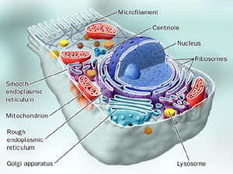 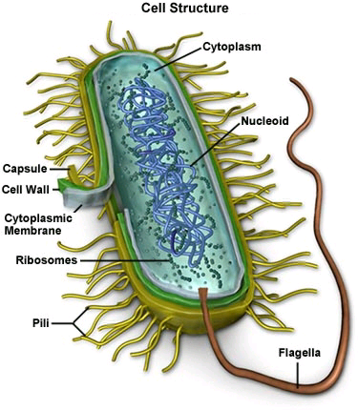



**See** [**https://www.learningctronline.com/courses**](https://www.learningctronline.com/courses) **for Materials and Resources.**

**Topics:**

1. The Cell & Cell Membrane

**Objectives:**

1. Describe basic structures in all cells and state the cell theory.
2. Compare and contrast prokaryotic and eukaryotic cells.
3. Describe the anatomy and function of the cell membrane.
4. Differentiate between diffusion, osmosis, passive transport, and active transport.

TAKE NOTE

1. Test Corrections (due before next week’s class)
2. Notes/Study Guide (1 week)
3. Homework from Text (1 week)
4. Lab Osmosis in an Egg (two weeks – procedures and data collection)
5. Honors 🡪 Cytology Notes & Modern Tools Worksheet
6. Week 5 Devotional (<https://www.learningctronline.com/devotional>)

**Text**: Chapter 4: The Cell & Cell Membrane pp. 60 – 80

Read the assigned pages in the text.

**Class Notes: PowerPoint or PDF**

**Notes/Study Guide:** Fill in the Chapter 4 Study Guide worksheet to understand the class notes.

**Homework**: (1 week)

* Study Questions (at the end of the chapter 4 in the text) #1, 3, 5-7, 9-10, 14-19 (explain the true/false)
* Use a Word document format as follows:
  + Heading: Your name, Chapter in Text, Study Questions
  + Number the appropriate questions you are to answer
  + Write the answer in a complete sentence use the question as the template (do not copy the question, but reword it into a statement that answers the question).
* Use the same document each week by starting a new “Study Question” for a different chapter on the next page.
* Assignments will be “spot checked” during class or submitted via email.

**Lab**: Osmosis in an Egg

* Begin the " Osmosis in an Egg " using the lab worksheet provided.
* This lab will take FOUR (4) days for just the procedures. So, get started this week!
* Work on the procedures and data collection this week.
* Be sure to include pictures in the lab report (as described in the instructions).
  + Make sure the pictures are not too large … right click / edit / resize / 600 or smaller resolution.
* Save document into your LAB folder in the Biology folder on your desktop.

**TEST:** No Quiz this week

Supplemental Resources (Optional)

<http://somup.com/c3eir7Tv0j> (1:28) **How Diffusion Works**

<http://somup.com/c3eir8Tv0z> (1:17) **How Facilitated Diffusion Works**

<http://somup.com/c3ei3cTv08> (1:40) **How Endocytosis & Exocytosis Work**

<https://youtu.be/Pxujitlv8wc> (5:27) The Amoeba Sisters Channel – **Prokaryotic vs. Eukaryotic Cells**

<https://youtu.be/8IlzKri08kk> (9:37) The Amoeba Sisters Channel – **Introduction to Cells**

<https://youtu.be/qBCVVszQQNs> (9:08) The Amoeba Sisters Channel – **Inside the Cell Membrane**

<https://youtu.be/jhszFBtBPoI> (7:40) The Amoeba Sisters Channel – **Diffusion**

<https://youtu.be/L-osEc07vMs> (9:57) The Amoeba Sisters Channel – **Osmosis & Water Potential**

<https://youtu.be/Ptmlvtei8hw> (7:49) The Amoeba Sisters Channel – **Cell Transport**