**Current, Circuits, Electromagnetic Induction**

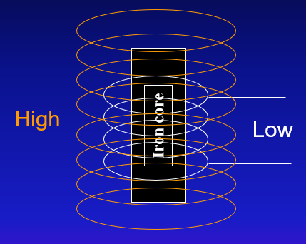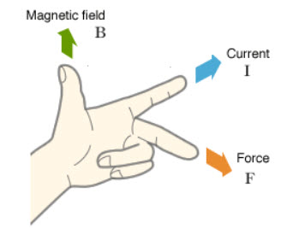

**[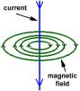](http://www.school-for-champions.com/science/images/electromagnetism2.gif)** 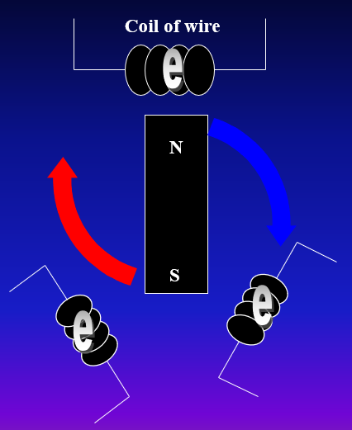

**See** [**https://www.learningctronline.com/courses**](https://www.learningctronline.com/courses) **for Materials and Resources.**

**Topics:**

1. *Electric Fields, Current, Circuits*, Magnetic Fields, Electromagnetic Induction

**Objectives:**

* *Define & calculate components of electric fields (energy, charge, & force).*
* *Understand voltage related to force and distance (work).*
* *Explain components of electric current in relation to Ohm’s law.*
* *Distinguish direct current from alternating current.*
* *Differentiate series circuits and parallel circuits and calculate electrical power, voltage, current, and resistance for each.*
* Define & calculate components of magnetic fields (right/left hand rules, flux, charge & force).
* Explain electromagnetic induction and give practical applications (Faraday’s Law, electrical usage).
* Distinguish motors from generators.
* Describe electrical transmission in terms of voltage, current, and transformers.

TAKE NOTE

1. Reading (Hewitt Text)

2. Notes *Electric Fields, Current, Circuits,* Magnetic Fields, Electromagnetic Induction

3. Lab Ohm’s Law

4. Lab Electromagnetism Lab

5. Electricity & Transmission PPT Worksheet

6. Problem Set: Electric Fields, Current, Circuits, Magnetic Fields, EM Induction

7. Test Electric Fields, Current, Circuits, Magnetic Fields, EM Induction

8. Class Song: Just for Learning

9. Week 25 Devotional (<https://www.learningctronline.com/devotional>)

**Text**: Chapters 33 – 37 Electric Fields, Current, Circuits, Magnetism, EM Induction (Hewitt)

**Class Notes: Use the Documents provided**

**Homework**:

* Problem Set: Electric Fields, Current, Circuits, Magnetic Fields, EM Induction
* Electricity & Transmission PPT Worksheet
* HONORS: Edison v. Tesla Project OR Electric Cars Debate (Pros and Cons)

**Lab**: Ohm’s Law

* Perform the lab as directed using the worksheet provided.
* Complete all calculations and data, showing work whenever appropriate.
* Conclusions should be answered in complete sentences that convey a complete thought.
* Save the documents into your LAB folder in the Physics folder on your desktop.

**Lab**: Electromagnetism Lab

* Perform the lab as directed using the worksheet provided.
* Complete all calculations and data, showing work whenever appropriate.
* Conclusions should be answered in complete sentences that convey a complete thought.
* Save the documents into your LAB folder in the Physics folder on your desktop.

**TEST:** Electric Fields, Current, Circuits, Magnetic Fields, Electromagnetic Induction

1) the academic integrity policy

* Tests must be completed **WITHOUT** referring to books, notes, the internet, people, or any outside resources for the first 60 minutes.
* Students **MAY** use the approved Periodic Tables, approved Reference Tables, or approved equation (formula) sheet (provided by the teacher) along with calculators and scratch paper.
* A guardian should be proctoring the test. Proctoring means to monitor the following:

2) The test is composed of multiple-choice, true/false, and compare/contrast questions as well as problems.

3) There is a **75-minute time limit** on this test. The final 15 minutes, students may use notes on the test. Honors students may take 90 minutes.

4) Please have the proctor write the time taken at the top of your answer sheet with their signature or initials.

5) Proctors should NOT be reading the test or engaging students during the test.

6) Do NOT use RED font. Black font is best.

7) NOTE There are additional questions for the HONORS students.

Supplemental Resources (Optional)

<http://somup.com/crinIwYVRg> Electromagnetism Lab (4:45).

<https://phet.colorado.edu/en/simulation/ohms-law>

<https://phet.colorado.edu/en/simulation/resistance-in-a-wire>

<http://somup.com/c3eebNTTr3> Magnetic Fields (6:36)