Newton’s Third Law Lab

**Introduction**

**Purpose**  To investigate Newton's Third Law using linear motion.

**Discussion**

Newton’s third law of motion states that forces always occur in pairs between two interacting objects. Every action has an equal and opposite reaction.

For example, push down on your desk real hard (*using your hands “palm down”*) for 10 seconds. The desk pushes back up with the SAME amount of force that you push down! You know this because there is a mark left on your hand

 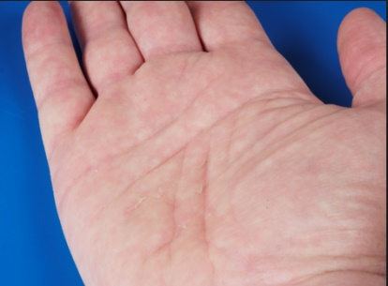

**Hypothesis**

If the motion cart moves forward, then the road must move backwards.

**Materials** Mini race car (reverse friction car)

1/2” - 1” Piece of masking tape

8 ½ by 11” piece of flat paper (not wrinkled at all)

**Procedures**

1. Wipe off an area on your desk or lab counter so that it is clean and smooth.

2. Place the unwrinkled piece of paper down. (The paper is the **road** for the car.)

1. Place a small piece of masking tape at the front end of the piece of paper, but off to the side so the paper does not touch the tape if the paper moves.
2. Hold the mini race car near the back wheels and on the desk. Gently pull back on the car so the back wheels “wind up.” Then hold the rear wheels of the car. DO NOT pull back on the car more than 4 inches.
3. Place the car on top of the piece of paper in the center, back part of the paper as shown.

paper

Race car

tape

paper

tape

Race car

1. Release the car and observe what happens.
2. Measure the distance the PAPER moved from the tape for three trials and complete the chart below. Be sure to include units for your measurements.

**Calculations and Data Sheet**

**Linear Motion** (*Mini Race Car*)

6. Describe what happens to the car and the piece of paper when you release the car?

7. Record the measurements for the distance the PAPER moved from the tape for three trials and complete the chart below. Be sure to include units for your measurements.

|  |  |  |  |  |
| --- | --- | --- | --- | --- |
|  | Trial 1 | Trial 2 | Trial 3 | Average |
| Distance paper moved |  |  |  |  |

**Conclusions and Questions**

A. Does the car or the road (paper) move? Draw a diagram showing the **action** of the car versus the **reaction** of the piece of paper.

B. Why don't you see the road moving away from you when you are in a real car?

C. Would you be able to drive forward if you were not attached to the Earth?

D. You are in a canoe on the lake one meter from the dock. You stand up and take a step to get onto the dock. Will you reach the dock or fall in the water? Make a diagram to explain your answer.

Answer Key

**Calculations and Data Sheet**

**Linear Motion** (*Mini Race Car*)

[**http://somup.com/cFXQqpniFy**](http://somup.com/cFXQqpniFy) **Newton's Laws & Momentum Demonstrations (2:47 – 3:53)**

6. Describe what happens to the car and the piece of paper when you release the car?

**The car moves forward while the paper moves backward**

7. Record the measurements for the distance the PAPER moved from the tape for three trials and complete the chart below. Be sure to include units for your measurements.

|  |  |  |  |  |
| --- | --- | --- | --- | --- |
|  | Trial 1 | Trial 2 | Trial 3 | Average |
| Distance paper moved |  |  |  | **10-20 mm** |

**Conclusions and Questions**

A. Does the car or the road (paper) move? Draw a diagram showing the **action** of the car versus the **reaction** of the piece of paper.

B. Why don't you see the road moving away from you when you are in a real car?

**The earth is so much larger than a car**

C. Would you be able to drive forward if you were not attached to the Earth?

**No. You need friction to provide the “opposing” force for motion**

D. You are in a canoe on the lake one meter from the dock. You stand up and take a step to get onto the dock. Will you reach the dock or fall in the water? Make a diagram to explain your answer.

# Dock

**The boat would move AWAY the exact amount one steps TOWARDS the dock. Therefore, one would fall in the water.**