Open the “Voltaic Cell” simulation by clicking on:

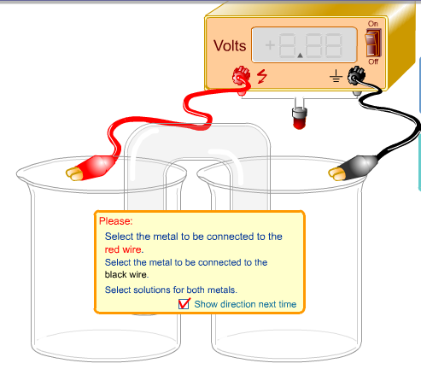

<https://screencast-o-matic.com/watch/cFeqocDuUt>

1. On the left side of the screen, select the metal to be used: Cu (copper).

2. On the left side of the screen, select the metal solution to be used: Cu(NO3)2 (aq) .

3. On the right side of the screen, select the metal to be used: Ag (silver).

4. On the right side of the screen, select the metal solution to be used: AgNO3 (aq) .

5. Click on the POWER switch (top right of the voltmeter box) and allow the reaction to proceed.

a. What is the voltage of this battery? _________ V

b. Which cell is being oxidized (loses electrons)? _____________

c. Which cell is being reduced (gains electrons)? _____________

d. What happens as the electrons appear on the Cu electrode?

e. What happens to the electrons that appear on the Ag electrode?

f. Which direction does the current flow (clockwise / counterclockwise)?

g. What is the function of the upside “U” shaped tube in the middle of the beakers?

6. Click the POWER switch to OFF to reset the system.

7. On the left side of the screen, select the metal to be used: Cu (copper).

8. On the left side of the screen, select the metal solution to be used: Cu(NO3)2 (aq) .

9. On the right side of the screen, select the metal to be used: Zn (zinc).

10. On the right side of the screen, select the metal solution to be used: Zn(NO3)2 (aq) .

11. Click on the POWER switch (top right of the voltmeter box) and allow the reaction to proceed.

a. What is the voltage of this battery? _________ V

b. Which cell is being oxidized (loses electrons)? _____________

c. Which cell is being reduced (gains electrons)? _____________

d. What happens as the electrons appear on the Cu electrode?

e. What happens to the electrons that appear on the Zn electrode?

f. Which direction does the current flow (clockwise / counterclockwise)?

12. Click the POWER switch to OFF to reset the system.

13. Complete the chart below by setting up the metal electrodes and solutions to test ALL combinations. RECORD the voltage for each combination. Click “off” to reset.

* NOTE: be sure the metal solution is matched with the metal electrode as before.

|  |  |  |  |  |
| --- | --- | --- | --- | --- |
| Metal Electrode | Ag | Cu | Zn | H |
| Ag |  |  |  |  |
| Cu |  |  |  |  |
| Zn |  |  |  |  |
| H |  |  |  |  |

14. What additional molecule is produced when the Hydrogen electrode is used?

15. Click on the “experiment” tab. Set up the electrolysis by choosing metals. On the left side, choose copper metal. On the right side choose silver metal. Choose the Copper metal solution to go with the copper metal.

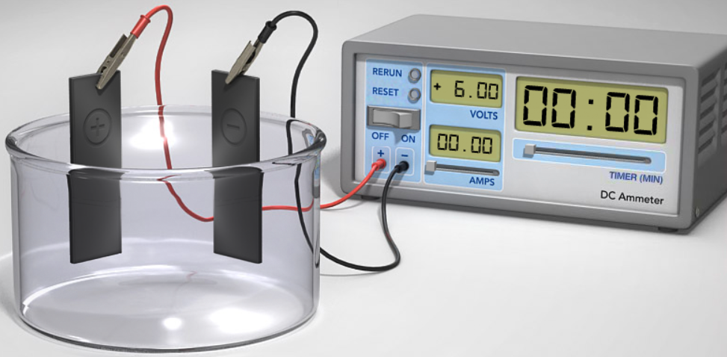

16. Go to the ammeter and set the timer to 5.0 minutes. Set the “amps” to 6.0 amps. Click the “on” toggle. If nothing happens add more amps until it works.

17. What voltage is shown on the ammeter? ________ V

18. Both metals started at 10 grams of mass. Record their new masses:

Copper ________ g Silver _________ g

19. Based on the change in mass, which metal was plated? ___________

Click “rerun” on the ammeter. Set the ammeter to 6.00 amps, and the time all the way to the right (40.0 minutes). Click run and then “Microscopic view” (at the bottom). Click just below the copper electrode and view for 30 seconds. Then, click below the silver electrode and view for 30 seconds. This should confirm which metal was plated.

On the ammeter, click “reset”. Repeat the procedures using Iron metal on the left and Nickel metal on the right along with the Iron metal solution.

20. Both metals started at 10 grams of mass. Record their new masses:

Iron _______ g Nickel ________ g

21. Based on the change in mass, which metal was plated? ____________

22. What is the major difference between electrolysis and the previous voltaic cell?

**ANSWER KEY**

1. On the left side of the screen, select the metal to be used: Cu (copper).

2. On the left side of the screen, select the metal solution to be used: Cu(NO3)2 (aq) .

3. On the right side of the screen, select the metal to be used: Ag (silver).

4. On the right side of the screen, select the metal solution to be used: AgNO3 (aq) .

5. Click on the POWER switch (top right of the voltmeter box) and allow the reaction to proceed.

a. What is the voltage of this battery? **-0.46 V**

b. Which cell is being oxidized (loses electrons)? **Copper**

c. Which cell is being reduced (gains electrons)? **Silver**

d. What happens as the electrons appear on the Cu electrode?

**Copper gives off electrons to form Cu+2**

e. What happens to the electrons that appear on the Ag electrode?

**Silver ions Ag+1 gain electrons to form Ag solid**

f. Which direction does the current flow (**clockwise**)? **From copper to silver**

g. What is the function of the upside “U” shaped tube in the middle of the beakers?

***This is the “salt bridge” allowing ions to complete the electrical circuit.***

7. On the left side of the screen, select the metal to be used: Cu (copper).

8. On the left side of the screen, select the metal solution to be used: Cu(NO3)2 (aq) .

9. On the right side of the screen, select the metal to be used: Zn (zinc).

10. On the right side of the screen, select the metal solution to be used: Zn(NO3)2 (aq) .

11. Click on the POWER switch (top right of the voltmeter box) and allow the reaction to proceed.

a. What is the voltage of this battery? **+1.10 V**

b. Which cell is being oxidized (loses electrons)? **Zinc**

c. Which cell is being reduced (gains electrons)? **Copper**

d. What happens as the electrons appear on the Cu electrode?

C**opper ions Cu+2 gain electrons to form Cu solid**

e. What happens to the electrons that appear on the Zn electrode?

**Zinc gives off electrons to form Zn+2**

f. Which direction does the current flow (**counterclockwise**)? **From zinc to copper**

13. Complete the chart below by setting up the metal electrodes and solutions to test ALL combinations. RECORD the voltage for each combination.

* NOTE: be sure the metal solution is matched with the metal electrode as before.

|  |  |  |  |  |
| --- | --- | --- | --- | --- |
| On left | Ag  on right | Cu  on right | Zn  on right | H  on right |
| Ag | --- | +0.46 V | +1.56 V | +0.80 V |
| Cu | -0.46 V | --- | +1.10 V | +0.34 V |
| Zn | -1.56 V | -1.10 V | --- | +0.76 V |
| H | -0.80 V | +0.34 V | -0.76 V | --- |

14. What addition molecule is produced when the Hydrogen electrode is used?

**H2 (g) bubbles around the electrode**

15. Click on the “experiment” tab. Set up the electrolysis by choosing metals. On the left side, choose copper metal. On the right side choose silver metal. Choose the Copper metal solution to go with the copper metal.

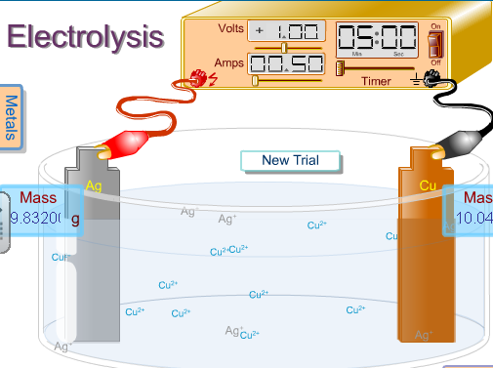

16. Go to the ammeter and set the timer to 5.0 minutes. Set the “amps” to 6.0 amps. Click the “on” toggle. If nothing happens add more amps until it works.

17. What voltage is shown on the ammeter? **+6.00 V**

18. Both metals started at 10 grams of mass. Record their new masses:

Copper **9.41** g Silver **10.59** g

19. Based on the change in mass, which metal was plated? Silver

Click “rerun” on the ammeter. Set the ammeter to 6.00 amps, and the time all the way to the right (40.0 minutes). Click run and then “Microscopic view” (at the bottom). Click just below the copper electrode and view for 30 seconds. Then, click below the silver electrode and view for 30 seconds. This should confirm which metal was plated.

On the ammeter, click “reset”. Repeat the procedures using Iron metal on the left and Nickel metal on the right along with the Iron metal solution.

20. Both metals started at 10 grams of mass. Record their new masses:

Iron **9.48** g Nickel **10.52** g

21. Based on the change in mass, which metal was plated? Nickel

22. What is the major difference between electrolysis and the previous voltaic cell?

**Electrolysis literally means, “Splitting” by using electricity/voltage. It is a NON-spontaneous reaction, meaning one must ADD energy into the system to get it to work. The voltaic/galvanic cell (battery) is a spontaneous reaction, meaning that it works by itself without outside forces/energy.**