Use the PDF link or video to complete the worksheet:

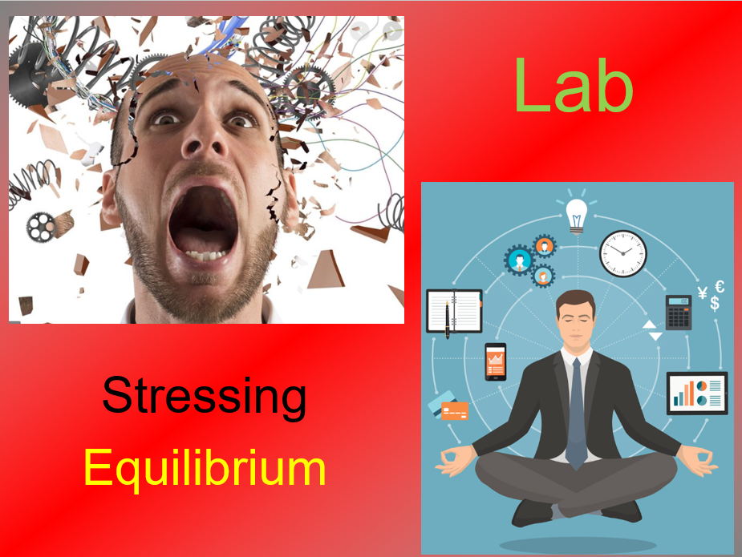

<http://somup.com/cYhhY3jcmo>

**Cobalt System**



This chemical equation has “____” on the ____ side of the arrows, meaning that heat is given off or released as a ____. This is an ____thermic reaction.

**Predict what will happen if you add HEAT to the system.**

This reaction is ____thermic (heat is a product). Therefore, adding heat will ____ the system.

To ____ the stress, the reaction will go toward the ____ to ____ the heat.

**Predict what will happen if you click on the COLD.**

This reaction is ____thermic (taking heat away from the product side) and STRESSing the system.

To relieve the stress, the reaction will go toward the ____ to ____ the heat.

**Predict what will happen if you click on the water.**

Adding water (____) will STRESS the system with too much reactant.

To relieve the stress the reaction will go towards more ____ to remove the ____ water.

**Predict what will happen if you click on the KCl.**

KCl ____ (splits up) into K+ and Cl- ions, making ____ ____ ions available on the product side, and STRESSING the system.

Adding KCl will, therefore, push the reaction towards the ____ to ____ the excess Cl- ions.

**Predict what will happen if you click on the Silver Nitrate.**

Silver Nitrate dissociates (____ up) into cations/anions. The Silver (Ag+) cations bond with the Cl- ions, ____ them from solution. The STRESS is that now there are ____ ____ Cl- ions on the product side of the reaction.

Adding silver nitrate removes the Cl- ions from the product side. To remove the STRESS, the reaction ____ to make ____ Cl- ions (____).

**Iron Thiocyanate system**

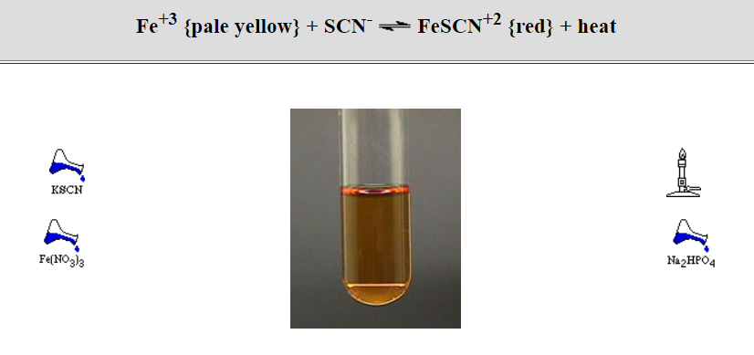

**Predict what will happen if you add HEAT to the system.**

This reaction is ____thermic (heat is a ____). Therefore, adding heat will push the reaction toward the ____ to ____ the heat.

**Predict what will happen if you click on the KSCN.**

KSCN dissociates (____ up) into cations/anions. Potassium (K+) cations form and ____ anions also form, meaning there is MORE SCN- ____ in solution. This stresses the system.

To relieve the stress, the reaction will go toward the ____ to remove the ____ SCN- anions.

**Predict what will happen if you click on the Fe(NO3)3.**

Fe(NO3)3 ____ (splits up) into cations/anions. Iron (Fe+3) cations form, meaning there are MORE Fe+3 ____ in solution. This stresses the system.

To relieve the stress, the reaction will go toward the ____ to ____ the excess Fe+3 anions.

**Predict what will happen if you click on the Na2(HPO4).**

Na2(HPO4) dissociates (splits up) into ____/____. HPO4 bonds with the Iron (Fe+3) cations, removing the (Fe+3) cations from the reactant side. This stresses the system.

To relieve the stress, the reaction will go toward the ____ to ____ the Fe+3 anions.

GAS Pressure

How does pressure affect a solid?

How does pressure affect a liquid?

How does pressure affect a gas?