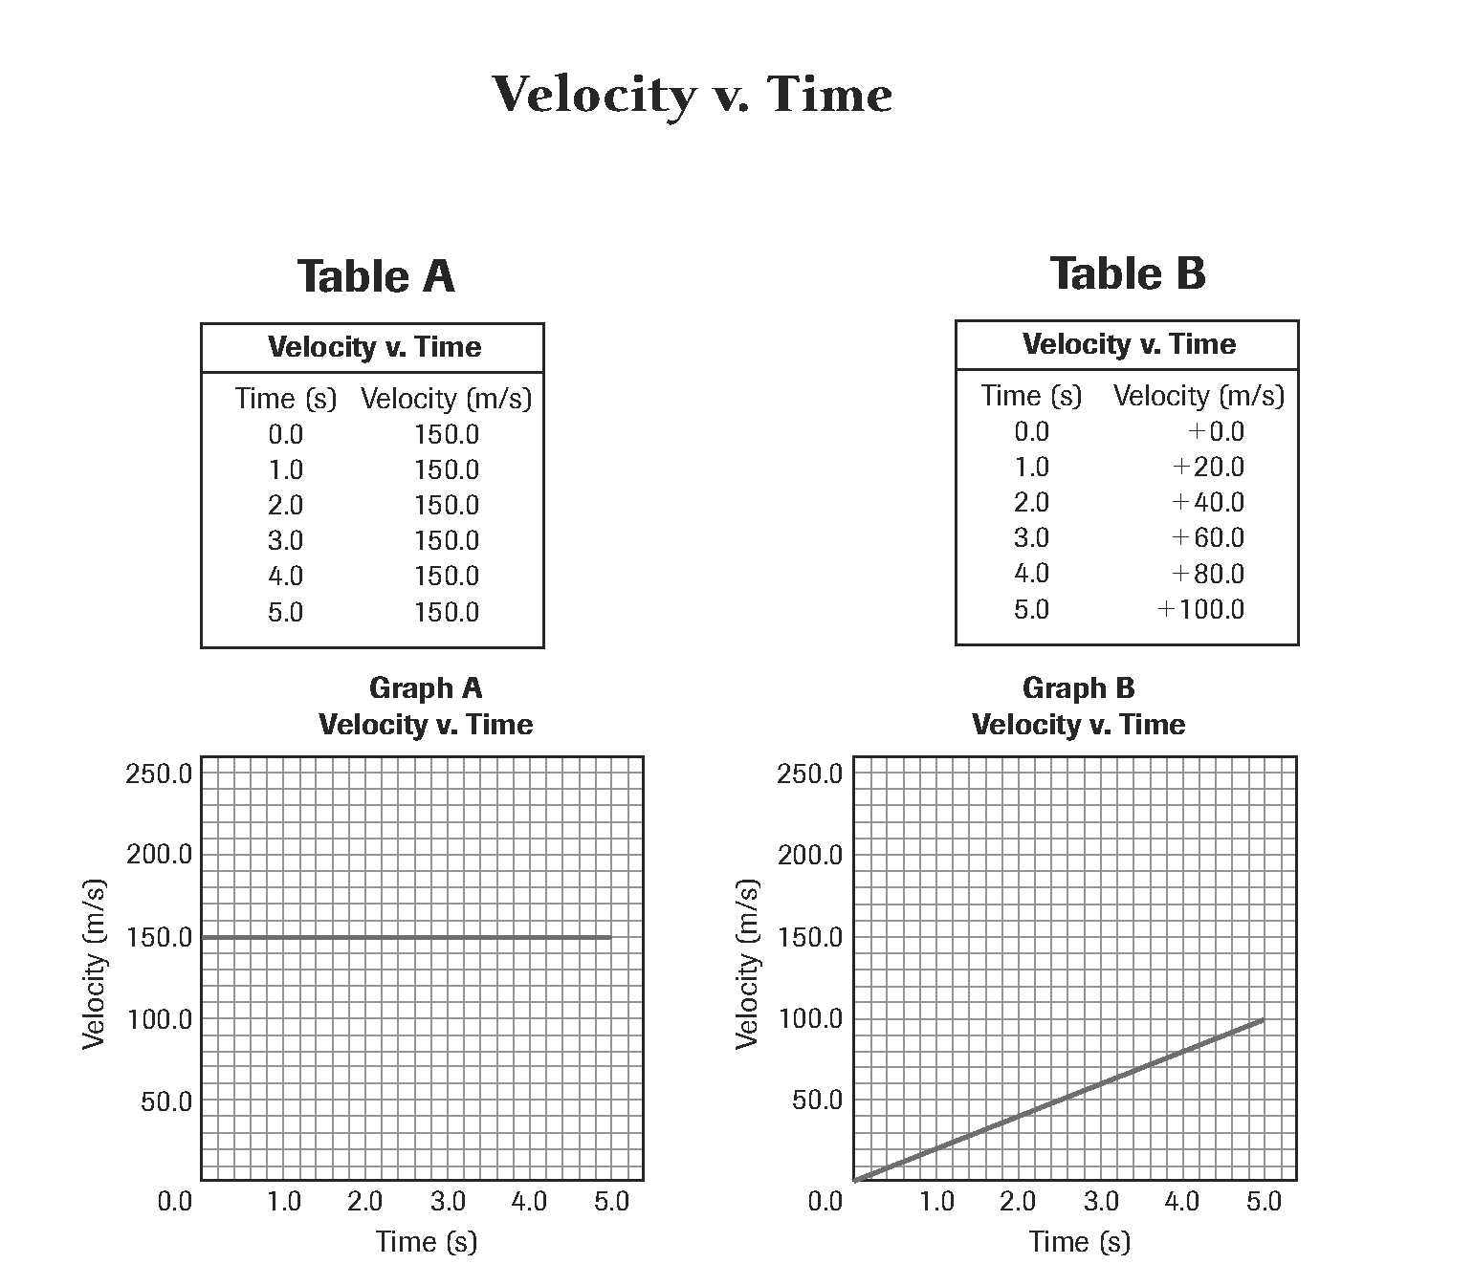

1. Which graph represents a linear relationship? Explain.

2. In which graph is the object moving at a constant velocity? What is the velocity?

3. What is the slope of the line in graph B? What value does the slope represent?

4. For graph A, express the graph line as an equation.

5. In graph A, determine the object’s displacement after 4.5 s.



6. For graph B, state the relationship between the variables as an equation.

7. In graph B, determine the object’s displacement between 2 s and 5 s.

8. Compare the velocity of the objects in the two graphs at 3 s.

9. How long will it take the object in graph B to reach the same velocity as the object in graph A?

10. What is the difference in velocity between the two objects at 2 s?

ANSWERS

1. Which graph represents a linear relationship? Explain.

*Graph B shows a linear relationship, meaning that as time increases, velocity also increases. This is a direct relationship. Graph A also shows a linear relationship with a zero slope, meaning there is a constant velocity (dependent variable).*

2. In which graph is the object moving at a constant velocity? What is the velocity?

*Graph A shows a constant velocity of 150 m/s.*

3. What is the slope of the line in graph B? What value does the slope represent?

*Slope is the area under the curve and can be calculated using ∆y/ ∆x. The slope of the line in Graph B is ~20.*

4. For graph A, express the graph line as an equation.

*Graph A also shows a linear relationship with a zero slope, meaning there is a constant velocity (dependent variable). The equation for linear graphs is: y = kx + B. Since slope is zero, the equation is y = B, where B is the y intercept.*

5. In graph A, determine the object’s displacement after 4.5 s.

*In Graph A, the object is moving at constant velocity (150 m/s) for 4.5 s. Since v = d/t, displacement can be calculated using d = vt or (150 m/s) x 4.5 s = 675 m.*

6. For graph B, state the relationship between the variables as an equation.

*Direct, linear, constant velocity*

7. In graph B, determine the object’s displacement between 2 s and 5 s.

*Displacement at 2 s is 40 m (20 m/s for 2 s) and at 5 s is 100 m (20 m/s for 5 s). Therefore the displacement between 2 x and 54 s is 60 m.*

8. Compare the velocity of the objects in the two graphs at 3 s.

*In Graph A, the object is moving at constant velocity (150 m/s). So at each second, the velocity is the same, 150 m/s. On Graph B, the velocity is 60 m/s. The object in Graph A is moving much faster than the object in Graph B at 3 s.*

9. How long will it take the object in graph B to reach the same velocity as the object in graph A?

*The time would have to be extrapolated because Graph A shows a velocity of 150 m/s, whereas, Graph B only shows up to 100 m/s. Since the slope is 20, the velocity will increase by 20 m/s each second. To reach 150 m/s would take an additional 2.5 seconds beyond what is shown on Graph B.*

10. What is the difference in velocity between the two objects at 2 s?

*At 2 s the velocity on Graph A is 150 m/s while on Graph B, the velocity is 40 m/s. This accounts for a difference of 110 m/s.*