**Ionic & Metallic Bonding Chapter 7B**

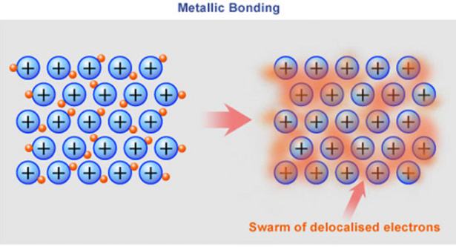

**See** [**https://www.learningctronline.com/courses**](https://www.learningctronline.com/courses) **for Materials and Resources.**

**Topics:**

1. Ionic & Metallic Bonding

**Objectives:**

1. Learn the properties of ionic compounds.
2. Understand Metallic Bonds and properties, including alloys.
3. Understand the conditions of stability for atoms related to bonding.
4. Explain and show how elements become ions (cations and anions).
5. Explain the ionic compounds in terms of formation, electrical charge, structure and Electronegativity Difference.

TAKE NOTE

1. Lesson Check/Sample problems or Alternative Worksheets
2. Lab Solutions Containing Ions
3. HONORS 🡪 Ionization Energy Activity OR practical application of Electrolytes.
4. Ionic & Metallic Bonding Test
5. Week 10 Devotional (<https://www.learningctronline.com/devotional>)

**Text**: Chapter 7: Ionic & Metallic Bonding pp. 209-219

Read the assigned pages in the text. Omit crystalline structures of metals (pp. 209-210).

**Class Notes: PowerPoint or PDF**

**Notes/Study Guide:** Fill in the Ionic Bonding Study Guide worksheet to understand the class notes.

**Homework**: TEXT

(1) Answer the KEYED **"Lesson Check"** questions at the end of each of the chapter.

(2) Answer the **"Sample problems"** found in the "Sample Problem" boxes throughout the chapter. An answer KEY is provided for you to use to self-correct your homework problems.

* Put your answers into complete thoughts in a Word document. Do NOT just put the answer, but write a phrase or sentence that you can study from for your tests. Save your work in a WORD document and SAVE into your HOMEWORK folder in the Chemistry folder on the desktop.
* Assignments will be “spot checked” during class or submitted via email.

**Alternate Homework**:

1. Ionic Bonding Study Guide
2. Practice Test Ionic & Metallic Bonding

HONORS (research a practical application for Electrolytes) … [no less than 1 hour, no more than 2 hours] OR Ionization Energy Activity.

**Lab**: Solutions Containing Ions

Complete "Solutions Containing Ions" Lab Worksheet.

* Perform the Lab: Solutions Containing Ions, using the worksheet provided (based on the experiment on p. 207 of your textbook).
* Answer the questions on the Solutions Containing Ions lab worksheet and explain how this experiment can allow you to classify compounds into two different categories.
* Include a picture of your set-up.
* Answers are provided at the end of the link for guidance, but you must use your own words (do not copy and paste my answers).
* If you do NOT have the necessary materials (battery, wires, etc.), I have provided two videos to watch (on the worksheet and the links are above) showing the conductivity of various substances (solids, liquid, solution).
* Save the document into your LAB folder in the Chemistry folder on your desktop.
* Assignments will be “spot checked” during class or submitted via email.

**TEST:** Ionic & Metallic Bonding

1) the academic integrity policy

* Tests must be completed **WITHOUT** referring to books, notes, the internet, people, or any outside resources.
* Students **MAY** use the approved Periodic Tables, approved Reference Tables, or approved equation (formula) sheet (provided by the teacher) along with calculators and scratch paper.
* A guardian should be proctoring the test. Proctoring means to monitor the following:

2) The test is composed of 20 multiple choice questions and some written problems.

* The **multiple-choice test must be taken "in one sitting"**, meaning that once you start the test, you must complete it without interruption. (40 minutes)
* Take a short break (5-10 minutes)
* The **written portion of the test must be taken "in one sitting"**, meaning that once you start the test, you must complete it without interruption. (30 minutes)

3) There is a **70-minute time limit** on this test. Please have the proctor write the time taken at the top of your answer sheet with their signature or initials.

4) Proctors should NOT be reading the test or engaging students during the test.

5) Do NOT use RED font. Black font is best.

Supplemental Resources (Optional)

1. Ionization Energy Activity
2. Chapter 7 Study Guide Pearson

Ionic Solids (1:13) <https://screencast-o-matic.com/watch/cF6eq5YlsI>

Solutions: (1:31) <https://screencast-o-matic.com/watch/cF6eq8YlMI>

<https://screencast-o-matic.com/watch/cq6wIju9ON> Metallic Properties and Bonds (3:03)