Plants Introduction

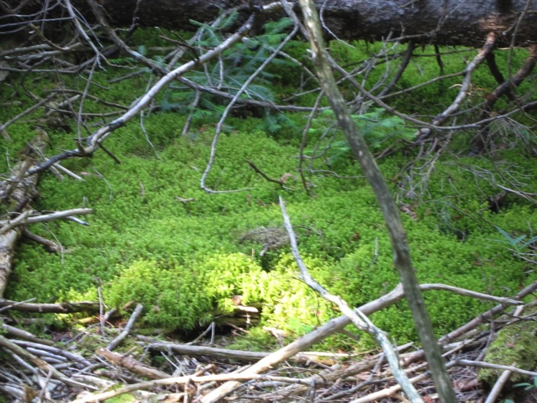 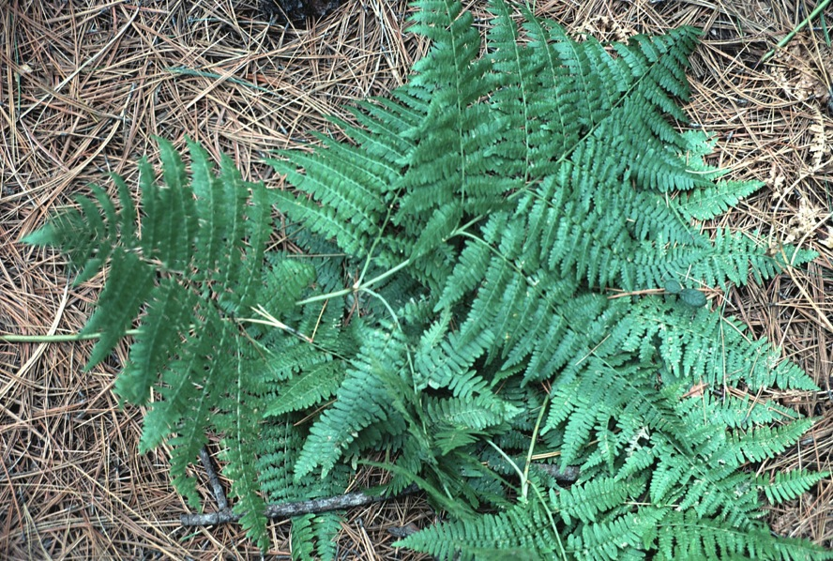

**Mosses Ferns**

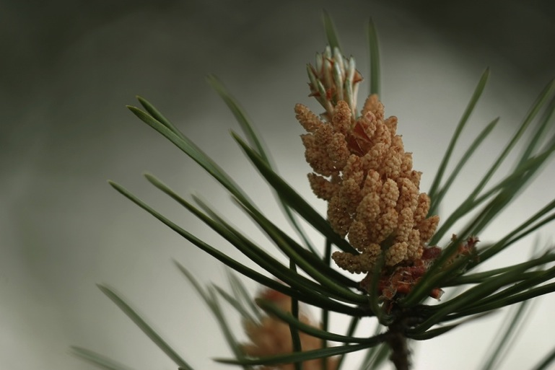 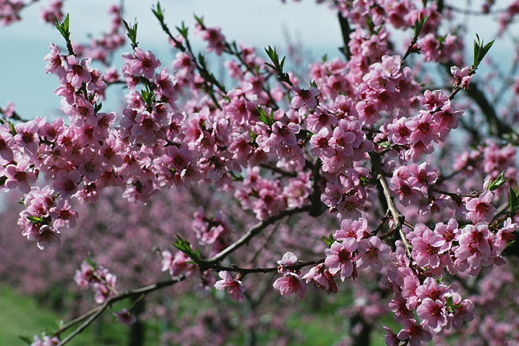

**Gymnosperms Angiosperms**

**See** [**https://www.learningctronline.com/courses**](https://www.learningctronline.com/courses) **for Materials and Resources.**

**Topics:**

1. Plants

**Objectives:**

1. Explain the importance of plants and their general life cycle?
2. Describe the taxonomic diversity of plants (bryophytes and tracheophytes).
3. Distinguish characteristics of bryophytes (gametophytes, rhizoids, etc.) and tracheophytes (seedless, seeds, cones, flowers, cotyledons).
4. Understand the basic tissues found in all tracheophytes and how plants grow.
5. Learn to use a dichotomous key to identify plants (trees).

TAKE NOTE

1. Test Corrections (due before next week’s class)
2. Notes/Study Guide (1 week)

* Honors 🡪 Should create a personalized study guide for the exam (2 weeks).

1. Homework from Text (1 week)
2. Lab Keying Out Trees Worksheet (page 1)
3. Honors 🡪 Lab Keying Out Trees (pages 1-2)
4. Week 23 Devotional (<https://www.learningctronline.com/devotional>)

**Text**: Chapter 24: Plants Introduction pp. 506 – 528

Read the assigned pages in the text.

**Class Notes: PowerPoint or PDF**

**Notes/Study Guide:** Fill in the Chapter 24 Study Guide worksheet to understand the class notes.

**Homework**: (1 week)

* Study Questions (end of the chapter in the text) #1-4, 6, 8-11, 14, 17-19, 22 (explain true/false)
* Use a Word document format as follows:
  + Heading: Your name, Chapter in Text, Study Questions
  + Number the appropriate questions you are to answer
  + Write the answer in a complete sentence use the question as the template (do not copy the question, but reword it into a statement that answers the question).
* Use the same document each week by starting a new “Study Question” for a different chapter on the next page.
* Assignments will be “spot checked” during class or submitted via email.

**Lab**: Keying Out Trees Lab

* Complete the "Keying Out Trees Lab" lab using

1. the “Tree ID Lab” PowerPoint,
2. the “Keying Out Trees” lab worksheet
3. and the “Dichotomous Tree Key”.

* All students must complete page 1.
* Honors students must do pages 1-2.
* After completing the Lab worksheet, email it to [learningctronline@gmail.com](mailto:learningctronline@gmail.com) for grading.
* Save document into your LAB folder in the Biology folder on your desktop.

**TEST:** No Quiz this week

Supplemental Resources (Optional)

1. Plant Introduction Vocabulary Review Crossword

<https://youtu.be/DGpPHrLF-5M> (8:26) The Amoeba Sisters Channel – **Plant Structure and Adaptations**

<https://youtu.be/wpKulkADzBk> (6:37) The Amoeba Sisters Channel – **Dichotomous Keys: Identification**