1. In a solution, litmus is blue. The pH of the solution could be

a. 10 b. 2 c. 3 d. 4

2. If 50.0 milliliters of a 1.0 M NaOH solution is needed to exactly neutralize 10. milliliters of an HCl solution, the molarity of the HCl solution is:

a. 1.0 M b. 2.0 M c. 5.0 M d. 10. M

3. What is the kw of water at 1 atm and 298 K?

a. 1.0 x 10-14 c. 1.0 x 1014

b. 1.0 x 10-7 d. 1.0 x 107

4. What is the conjugate acid-base pair in the reaction: H2O + HI H3O+ + I - ?

a. H2O and HI c. HI and I-

b. H2O and I- d. HI and H3O+

5. If a solution has a hydronium ion concentration of 1 x 10-9 M, the solution is

a. basic and has a pH of 9 c. acidic and has a pH of 9

b. basic and has a pH of 5 d. acidic and has a pH of 5

6. Which of the following acids has the weakest conjugate base?

a. HCl b. H3PO4 c. HF d. H2S

7. Phenolphthalein has a pink color in a solution which has a pH of

a. 1 b. 5 c. 7 d. 11

8. According to your reference table on relative strengths of acids, which ion is amphoteric?

a. Br - (aq) c. S-2 (aq)

b. HS- (aq) d. CO3-2 (aq)

9. In the reaction: NH2 - + H2O NH3 + OH-, two bronsted acids are

a. NH2–and H2O c. H2O and NH3

b. NH2–and NH3 d. H2O and OH-

10. What is the pH of a 0.001 M solution of HCl ?

a. 1 b. 7 c. 3 d. 11

11. In the reaction: H3PO4 + H2O H2PO4 - + H3O+, two Brönsted bases are

a. H3PO4 and H2O c. H2PO4 - and H2O

b. H3PO4 and H3O+ d. H2PO4 - and H3PO4 -

12. According to the reference table on relative strengths of acids, which Brönsted acid has the strongest conjugate base?

a. HS - b. H2S c. NH4 + d. HCl

13. Which Brönsted base can also act as an acid?

a. Cl – b. H2O c. S–2  d. SO4 -2

14. In any water solution at 25º C, the product of the H3O+ ion concentration times the hydroxide ion concentration is equal to

a. 1.0 x 101 c. 1.0 x 10-9

b. 1.0 x 10-7 d. 1.0 x 10-14

15. What is the hydroxide ion concentration in moles per liter of a solution whose [H3O+] is equal to 1 x 10-5?

a. 1 x 10-5 c. 1 x 10-9

b. 5 x 10-1 d. 9 x 10-1

16. Which 0.1 M solution is the best conductor of electricity?

a. HCl  (aq) b. HF (aq) c. C6H12O6 (aq) d. CH3OH (aq)

17. How many moles of NaOH (1 liter) are required to neutralize 0.50 liters of 2.0 M H2SO4 ?

a. 1.0 b. 2.0 c. 0.50 d. 4.0

18. According to the Arrhenius theory, a substance that yields hydrogen ions as the only positive ion in an aqueous solution is

a. a salt b. a base c. an acid d. a non-electrolyte

19. Which compound is a strong electrolyte?

a. CH3COOH c. C12H22O11

b. H2S d. HNO3

20. In the reaction H2O + H2O H3O+ + OH -, water is acting as

a. a proton acceptor only c. both a proton acceptor and donor

b. a proton donor only d. neither a proton acceptor nor donor

21. Which solution will turn litmus from red to blue?

a. H2S (aq) c. SO2 (aq)

b. NH3 (aq) d. CO2 (aq)

22. The [OH -] of a solution is 1 x 10-6. At 1 atmosphere and 298 K, the product of the [H3O+] [OH -] is

a. 1 x 10-2 b. 1 x 10-6 c. 1 x 10-8 d. 1 x 10-14

23. According to the reference table on relative strengths of acids, which is an amphoteric ion?

a. HSO4 - b. NH4 + c. NO3 -d. Cl -

24. A strong acid is titrated with a weak base to the equivalence point. What salt solution is produced?

a. acidic b. neutral c. basic d. no salt is produced

25. Pure water at 25º C has a pH of

a. 1 x 10-7 b. 1 x 10-14 c. 7 d. 14

26. What is the ionization constant, Ka of: HNO2 (aq) H+ + NO2- (aq) ?

a. [ HNO2 ] c. [ NO2- ]

[H+][ NO2-] [H+][ NO2-]

b. [H+] [ NO2-] d. [H+] [ NO2-]

[HNO2] [HNO2][ H2O]

27. According to the reference table on relative strengths of acids, which is the strongest Brönsted acid?

a. HNO2 c. CH3COOH

b. H2S d. H3PO4

28. Given the titration data in the table, the concentration of HCl required for the acid to neutralize the base is

|  |  |
| --- | --- |
| Volume of base (KOH) | 40 ml |
| Molarity of base | 0.20 M |
| Volume of acid (HCl) added | 20 ml |

1. 1.0 M
2. 0.20 M
3. 0.10 M
4. 0.40 M

29. Classify the salt, NaNO3, according to the bases and acids from which it was derived.

a. strong base and strong acid c. weak base and strong acid

b. strong base and weak acid d. weak base and weak acid

30. What is the pH of a solution with [OH-] of 3.1 x 10-12 M?

a. 3.5 c. 3.2 x 10-3 M

b. 11.5 d. 2.5

31. 4.0 grams of NaOH (0.10 mole) is dissolved in water to make a solution whose volume is 1.0 liter. What is the molar concentration of the hydrogen ions in this solution?

a. 1 x 10-11 M c. 1.0 x 10-7 M

b. 1 x 10-13 M d. 13 M

32. Which characteristic refers only to an acid and not a base?

a. lower pH c. turns red litmus blue

b. strong electrolyte d. poor electrolyte

33. Which statement is true concerning a 1.0 M KOH solution at 25º C?

a. [H+] = 1.0 M c. [H+] = 1.0 x 10-14 M

b. [OH-] = 1 x 10-14 M d. [OH-] = 1.0 x 10-7 M

34. The solution produced when equal volumes of weak acid and strong base are mixed is

a. acidic b. basic c. neutral d. salt

35. The salt LiCl dissociates in water based on what acid & base derivatives?

a. strong acid, strong base c. weak acid, strong base

b. strong acid, weak base d. weak acid, weak base

36. Which of the following is not a characteristic property of all Arrhenius acids?

a. furnishes hydrogen ions in water solution

b. reacts with water to release large amounts of heat

c. reacts with active metal to release hydrogen gas

d. has a sour taste

37. The common substance in the list below that is most basic is

a. vinegar (pH 2.8) c. milk (pH 6.5)

b. rainwater (pH 6.2) d. seawater (pH 8.5)

38. If 30 ml of a 0.20 molar solution of Mg(OH)2 neutralizes a 0.40 molar solution of HCl, the volume of HCl solution that is neutralized is

a. 7.5 ml b. 20 ml c. 15 ml d. 30 ml

39. A water solution of table salt is a good conductor of electricity. Because of this property, dissolved table salt is considered as a

a. strong electrolyte c. semi-electrolyte

b. weak electrolyte d. non-electrolyte

40. One property of bases is their ___ taste.

a. sour b. lack of c. neutral d. bitter

41. Given the reaction at equilibrium: Mg(OH)2 (s) Mg+2 (aq) + 2OH - (aq) , which shows a correct expression?

a. Kb = [Mg+2][2OH -]/[ Mg(OH)2] c. Kb = [Mg+2][OH -]2/[ Mg(OH)2]

b. Kb = [ Mg(OH)2]/[Mg+2][OH -]2 d. Ka = [Mg+2][OH -]2/[ Mg(OH)2]

42. If Kb is 1.1 x 10-5

a. the base will be more abundant than the ions in solution

b. the ions will be more abundant than the base in solution

c. this is considered a strong base

d. there will be an equal number of ions and base particles in solution

43. Which method would be LEAST effective to find the pH of any solution?

a. indicator strips (hydrion paper) c. use several different indicators

b. pH meter d. litmus paper

44. Given the buffer system: HCO3−(*aq*) + (H+)(*aq*) ↔ H2CO3(*aq*) . If an acid is added to the buffer system, what is true?

a. the HCO3− reacts with the hydrogen ions of the added acid to produce carbonic acid

b. the reaction favors the reverse reaction

c. the pH of the system will drop significantly

d. the H2CO3 dissociates to produce H+ ions that neutralize the added base

45. In a buffer system, when the pH is too high

a. the buffer generates H3O+

b. a base was added to the system

c. the system will shift to favor the forward reaction

d. all of the choices are valid

46. According to the diagram, what is true? 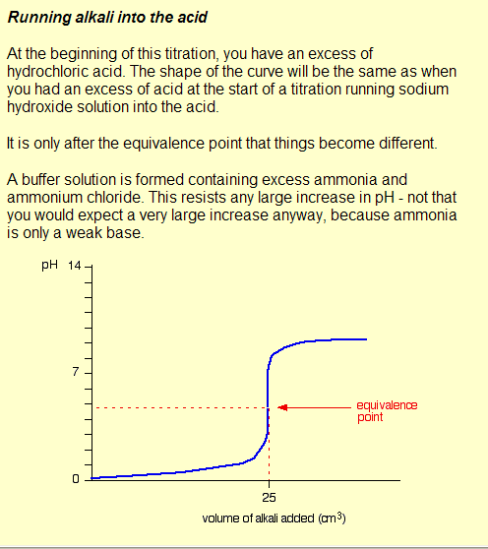

a. a weak acid is titrated with a strong base

b. a strong acid is titrated with a weak base

c. the resulting pH of the salt is neutral

d. neutralization never occurs

47. Which graph has a “basic” equivalence point? 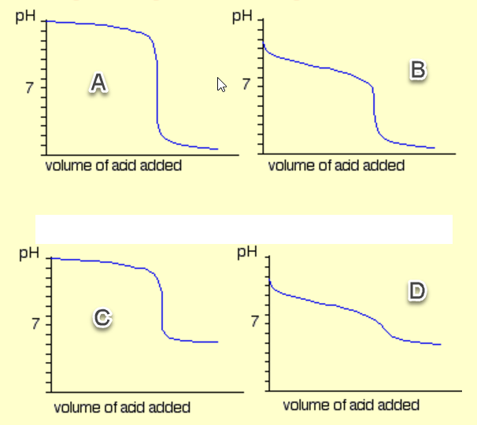

D. None of the graphs apply

### ANSWER KEY

1. A basic sol’n 24. A strong acid dominates

2. C NaOH + HCl 🡪 NaCl + HOH 1MaVa = 1MbVb 25. C

1:1 mol ratio of acid: base

3. A by definition 26. B [ ] of products / [ ] reactants

4. C proton donor & acceptor 27. D Phosphoric acid is highest on Ref tbl

5. A - log [H3O+] = - log 10-9 = 9 28. D 1MaVa = 1MbVb KOH + HCl 🡪 KCl + HOH

1:1 mol ratio of acid: base

6. A strong acid 🡪 weak conj. base 29. A NaOH (strong base), HNO3 (strong acid)

*Ref. table L*

7. D Phenolphthn turns color in base 30. D pH = -log10(3.2 x 10-3) = -0.5 – (-3)

[OH-1] [**H+**] = 10-14 = 3.2 x 10-3 M

8. B can donate or accept H+ ions31. B [OH] = 10-1 M … [H] = 10-13 M

pOH + pH = 14

9. C both can donate H+ ions 32. A

10. C -log1010-3 = pH of 3 33. C [OH] = 100 M … [H] = 10-14 M

*0.001 M = 10-3 1.0 M = 1 x 100 M;* [OH-1] [**H+**] = 10-14

11. C both can accept H+ ions 34. B strong base dominates

12. A weak acid 🡪 strong conj. Base 35. A LiOH (base) & HCl (acid): both strong

13. B OH can donate H to be acid 36. B weak acids do not react much

14. D [OH-1] [H+] = 10-14 37. D pH greater than 7 is basic

15. C [OH-1] [H+] = 10-14 38. A *MbVb = 2MaVa mole ratio of 1:2

Mg(OH)2 + 2HCl 🡪 MgCl2 + 2HOH

16. A strongest acid (ref table) 39. A by definition

17. C *2MbVb = MaVa mole ratio of 2:1 40. D by definition

18. C by definition 41. C [ ] of products / [ ] reactants … base

19. D strongest acid (ref table) 42. A K < 1, means reverse rxn is favored

20. C amphoteric 43. D litmus indicates a general pH range

21. B basic sol’n turns litmus blue 44. A favors forward rxn … reduce acid

22. D kw = [OH-1] [H+] = 10-14 45. D high pH = basic … need acid

23. A can donate or accept H+ ions 46. B notice the values on the diagram

47. C Strong base; weak acid

#17* 2NaOH(aq) + H2SO4(aq) 🡪 Na2SO4(aq) + 2HOH(aq)

#38* Mg(OH)2(aq) + 2HCl(aq) 🡪 MgCl2(aq) + 2HOH(aq)