**Astronomy: Sun & Stars**

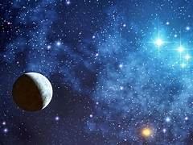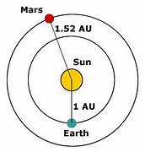

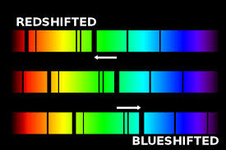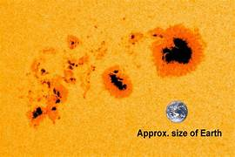

**See** [**https://www.learningctronline.com/courses**](https://www.learningctronline.com/courses) **for Materials and Resources.**

**Topics:**

1. Astronomy: Sun & Stars

**Objectives:**

1. Describe the structure and composition of the sun.
2. Understand the production of sunspots, sunspot cycles, and what sunspots produce related to outer space.
3. Explain the Hertzsprung-Russell diagram in relation to the fate of the sun and other stars.
4. Define constellations and distinguish seasonal versus circumpolar constellations.
5. Identify and describe eclipses, their frequency, & Earth’s shadows & the moon phases associated with them.
6. Define astronomical distances (e.g. light years).
7. Understand the Big Bang & its implications.

TAKE NOTE (All assignments are due by next week’s class.)

1. Notes / Study Guide Sun & Stars (PPT)
2. Lab: Sunspot Graphing Activity
3. Lab: Eclipses & Stars Activity
4. Review Notes: Sun & Stars
5. Review Notes: Tides, Eclipses, Distance, Big Bang
6. Test Astronomy Earth, Moon, Sun & Stars
7. Week 19 Devotional (<https://www.learningctronline.com/devotional>)

**Text**: PowerPoint

**Reference Material: PowerPoint Sun & Stars**

**Homework**:

* Notes / Study Guide from PPT Sun & Stars
* Review Notes: Sun & Stars
* Review Notes: Tides, Eclipses, Distance, Big Bang

**Lab**: Sunspot Graphing Activity

* Perform the lab using the links and worksheet provided.
* Save the document into your LAB folder in the Projects in Science folder on your desktop.

**Lab**: Eclipses & Stars Activity

* Perform the lab using the link and worksheet provided.
* You will need to download the SkyView Lite app on a cell phone for part of this lab.
* Save the document into your LAB folder in the Projects in Science folder on your desktop.

**TEST:** Test Astronomy Earth, Moon, Sun & Stars

1) the academic integrity policy

* Tests must be completed **WITHOUT** referring to books, notes, the internet, people, or any outside resources.
* Students **MAY** use the approved Periodic Tables, approved Reference Tables, or approved equation (formula) sheet (provided by the teacher) along with calculators and scratch paper.
* A guardian should be proctoring the test. Proctoring means to monitor the following:

2) Take the **"in one sitting"**, meaning that once you start the test, you must complete it without interruption.

3) There is a **40-minute time limit** on this test. Please have the proctor write the time taken at the top of your answer sheet with their signature or initials.

4) Proctors should NOT be reading the test or engaging students during the test.

5) Do NOT use RED font. Black font is best.

Supplemental Resources (Optional)

<https://go.screenpal.com/watch/cZjrYkV9dvo> Seasonal Constellations (2:05)

<http://somup.com/cZ6TrOHdRP> Red Shift (3:10)

<http://somup.com/cZjrYRGNd7> Doppler Effect with the Big Bang (4:18)

<http://somup.com/cZ6ZqKHHdX> (7:50) Solar & Lunar Eclipses Animation