Polar Bear Game

# **Purpose** To investigate the ecology of “competition” and “limited resources”

# **Materials** Dice Instruction Sheet

## Procedures

1. “Polar bears, they come in pairs.”
2. “Polar Bears, they sit around the holes in the ice.”
3. Polar Bear Oath: “I do solemnly swear that I will never divulge the secret of the polar bears around the hole in the ice. If I do, may the fleas of a thousand camels infest my body.”
4. Obtain five (5) dice.
5. Roll the dice and look at the numbers that are “up” on the dice. Ignore all the numbers on the sides.
6. From the roll determine how many polar bears there are and how many fish they can eat.
7. Two samples have been provided. You may need several rolls to figure out the “puzzle” before you can understand the “ecology” involved.

## Calculations and Data

**Sample 1**

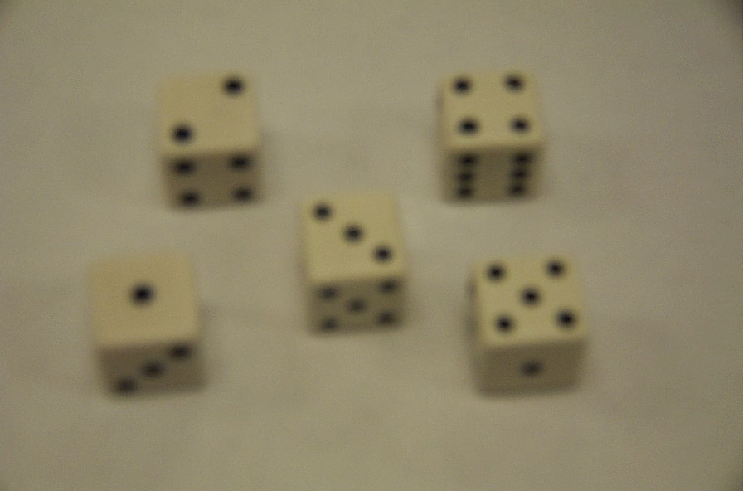

**6 bears**

**12 fish**

**Sample 2**

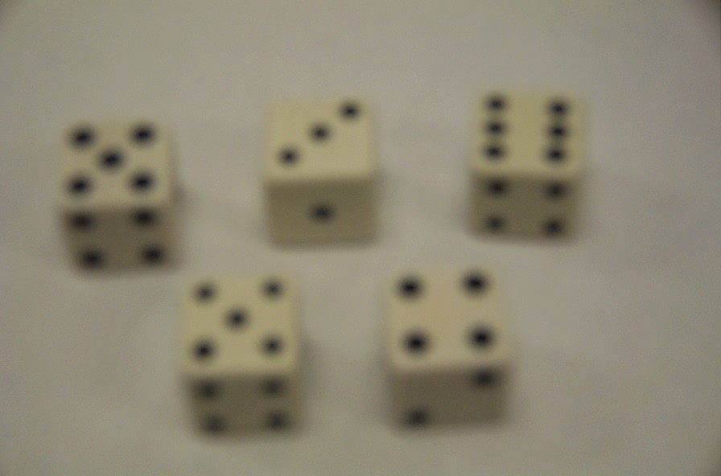

**10 bears**

**8 fish**

### Conclusions and Questions

1. Using the analogy of “polar bears, they come in pairs,” what ecological strategy do bears use for real life existence?
2. Using the analogy of “Polar bears sit around the holes in the ice,” what ecological strategy do bears use for real life existence?
3. Notice the pattern of fish and bears on the dice … the more bears there are, the less fish and the less bears there are, the more fish,” what ecological strategy do bears use for real life existence?