**Sound Waves Chapter 17B**

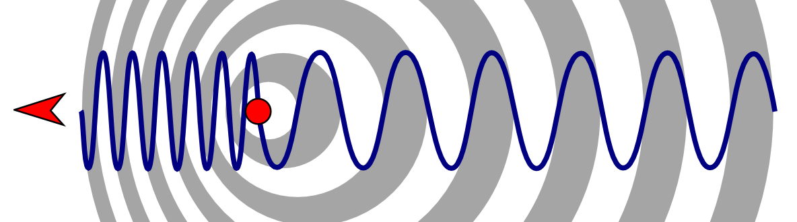

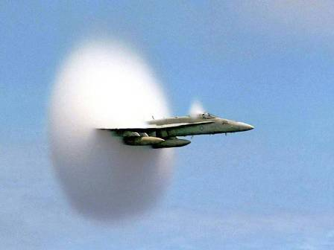

**See** [**https://www.learningctronline.com/courses**](https://www.learningctronline.com/courses) **for Materials and Resources.**

**Topics:**

1. Sound Waves

**Objectives:**

* *How are mechanical waves like sound produced, transmitted, and heard?*
* *Define the properties of mechanical waves like sound waves (longitudinal, wavelength, amplitude, frequency, speed) and calculate variables.*
* Identify and describe the function of the human ear related to sound.
* Explain and recognize behaviors of sound waves (Doppler Effect, refraction, reflection, resonance, and diffraction).
* Distinguish between pure sound, noise, and music. How do musical instruments work? What aspects of sound are involved in music?

TAKE NOTE

1. Guided Reading Note-Taking Worksheet (Pearson Text)

1. Pearson Concepts in Action Worksheets
2. Lab Sound Waves
3. Test Mechanical Waves & Sound
4. Class Song: You’re Welcome!
5. Week 28 Devotional (<https://www.learningctronline.com/devotional>)

Pearson Text Chapter 17: Mechanical Waves & Sound pp. 508-529

**Guided Reading Note-Taking Worksheet:**

Complete the worksheet for Chapter 17: Mechanical Waves & Sound (17.3 – 17.4).

**Class Notes: PowerPoint or PDF**

**Homework**:

* 17.3 Behavior of Waves Worksheet (Pearson Concepts in Action)
* 17.4 Sound & Hearing Worksheet (Pearson Concepts in Action)
* *Assignments will be “spot checked” during class or submitted via email.*

**Lab**: Sound Waves Lab

* Complete the lab using the worksheet provided.
* Save the documents into your LAB folder in the Physical Science folder on your desktop.
* *Assignments will be “spot checked” during class or submitted via email.*

**TEST:** Mechanical Waves & Sound

1) the academic integrity policy

* Tests must be completed **WITHOUT** referring to books, notes, the internet, people, or any outside resources.
* Students **MAY** use the approved Periodic Tables, approved Reference Tables, or approved equation (formula) sheet (provided by the teacher) along with calculators and scratch paper.
* A guardian should be proctoring the test. Proctoring means to monitor the following:

2) The test is composed of 20 multiple choice questions and some written problems.

* The **multiple-choice test must be taken "in one sitting"**, meaning that once you start the test, you must complete it without interruption. (40 minutes)
* Take a short break (5-10 minutes)
* The **written portion of the test must be taken "in one sitting"**, meaning that once you start the test, you must complete it without interruption. (30 minutes)

3) There is a **90-minute time limit** on this test. Please have the proctor write the time taken at the top of your answer sheet with their signature or initials.

4) Proctors should NOT be reading the test or engaging students during the test.

5) Do NOT use RED font. Black font is best.

Supplemental Resources (Optional)

1. Vocabulary Crossword Chapter 17
2. Sound & Light Activities

<https://screencast-o-matic.com/watch/cFX20vrh6t> Sound Moving Air (2:32)

[**http://somup.com/cbeD3hRA7**](http://somup.com/cbeD3hRA7) **PHET Simulation of Transmitting Sound (1:12) Class Demonstration**

<http://somup.com/crnDrkDrtb> Single & Double-Point Source Ripple Tank (0:49)

<http://somup.com/criibpYiqf> Sound Tubes (1:39)

<http://somup.com/crnDrxDrOk> Resonance Boxes with Tuning Forks (1:41)

<http://somup.com/criiFBYi00> C Scale & Single Tuning Fork Demonstration (0:42)

<https://screencast-o-matic.com/watch/cFXoqlr13x> Blowing Across Bottles (0:35)

[**http://somup.com/cFXoIEnji1**](http://somup.com/cFXoIEnji1) **Sonic Boom (2:07)**

[**http://somup.com/cFXoIHnji6**](http://somup.com/cFXoIHnji6) **Examples of Sonic Booms (1:36)**

[**http://somup.com/cYf3F9iTXa**](http://somup.com/cYf3F9iTXa) **Standing Waves & Resonance (1:51)**

<http://somup.com/cYf3q0iTDy> **Sound Waves: Diffraction & Interference (7:21)**

<http://somup.com/c3Vu2cZBWU> Michigan J. Frog (3:06)

<http://somup.com/cYhqoMjzX0> Being Weak Makes Us Strong 2 Corinthians 12:9-10; The Warrior is a Child (5:24)