**Mountains, Earthquakes, Volcanoes**



 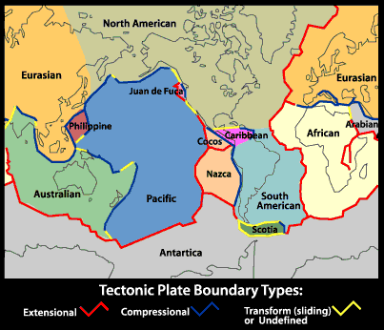

**See** [**https://www.learningctronline.com/courses**](https://www.learningctronline.com/courses) **for Materials and Resources.**

**Topics:**

1. Mountains, Earthquakes, Volcanoes

**Objectives:**

1. Explain the theory of plate tectonics.
2. List and describe the type of motion at the different tectonic plate boundaries.
3. List the type of fault and type of stress associated with the 3 boundary types.
4. List and define the types of mountains that form at the earth’s plates.
5. Explain various aspects of earthquakes (*faults, elastic rebound, focus & epicenter, measurement*).
6. Explain how scientists determine the location of an earthquake.
7. List and define the 3 types of volcanoes.

TAKE NOTE (All assignments are due by next week’s class.)

1. Mountains, Earthquakes, Volcanoes PowerPoint (class notes)
2. Class notes study guide (Mountains, Earthquakes, Volcanoes)
3. Lab: An Inquiry into Plate Boundaries
4. Lab: Virtual Earthquake
5. Film Review: “The Day the Earth Shook”
6. Review WS: Earth & Lithosphere, Mountains, Earthquakes, Volcanoes
7. TEST: Lithosphere (Earth’s Interior, Plate Tectonics)
8. Week 32 Devotional (<https://www.learningctronline.com/devotional>)

**Text**:

**Reference Material:**

**Homework**:

* Class Notes Study Guide
* Review Worksheet (Earth & Lithosphere, Mountains, Earthquakes, Volcanoes

**Lab**: Film Review

* Open the worksheet for the film review: “The Day the Earth Shook”.
  + Complete the film review worksheet using the link provided..
* Save the document into your LAB folder in the Projects in Science folder on your desktop.

**Lab**: An Inquiry into Plate Boundaries

* Perform the lab “An Inquiry into Plate Boundaries” using the worksheet provided.
* Save the document into your LAB folder in the Projects in Science folder on your desktop.

**Lab**: Virtual Earthquake

* Perform the lab “Virtual Earthquake” using the worksheet and simulation provided.
* Save the document into your LAB folder in the Projects in Science folder on your desktop.

**TEST:** Lithosphere (Earth’s Interior, Plate Tectonics, Mountains, Earthquakes, Volcanoes)

1) the academic integrity policy

* Tests must be completed **WITHOUT** referring to books, notes, the internet, people, or any outside resources.
* Students **MAY** use the approved Periodic Tables, approved Reference Tables, or approved equation (formula) sheet (provided by the teacher) along with calculators and scratch paper.
* A guardian should be proctoring the test. Proctoring means to monitor the following:

2) Take the **"in one sitting"**, meaning that once you start the test, you must complete it without interruption.

3) There is a **40-minute time limit** on this test. Please have the proctor write the time taken at the top of your answer sheet with their signature or initials.

4) Proctors should NOT be reading the test or engaging students during the test.

5) Do NOT use RED font. Black font is best.

Supplemental Resources (Optional)

1. Crossword Vocabulary Earth & Lithosphere, Mountains, Earthquakes, Volcanoes
2. Jeopardy Review

<http://somup.com/cFQrrlVW9R> Types of Plate Boundaries (1:22)

<http://somup.com/cFQ3XmVWWZ> Normal Fault (Simulation)

<http://somup.com/cFQ3XJVWWO> Reverse Fault (Simulation)

<http://somup.com/cFQ3XdVWWt> Strike Slip Fault (Simulation)

<http://somup.com/cZiDoQERRB> (2:39) Ring of Fire (Johnny Cash)

<http://somup.com/cbfjnkWPT> Earthquake Simulations (8:46)

<http://somup.com/cZjVorG08L> The Day the Earth Shook (43:31)