The Properties of Water

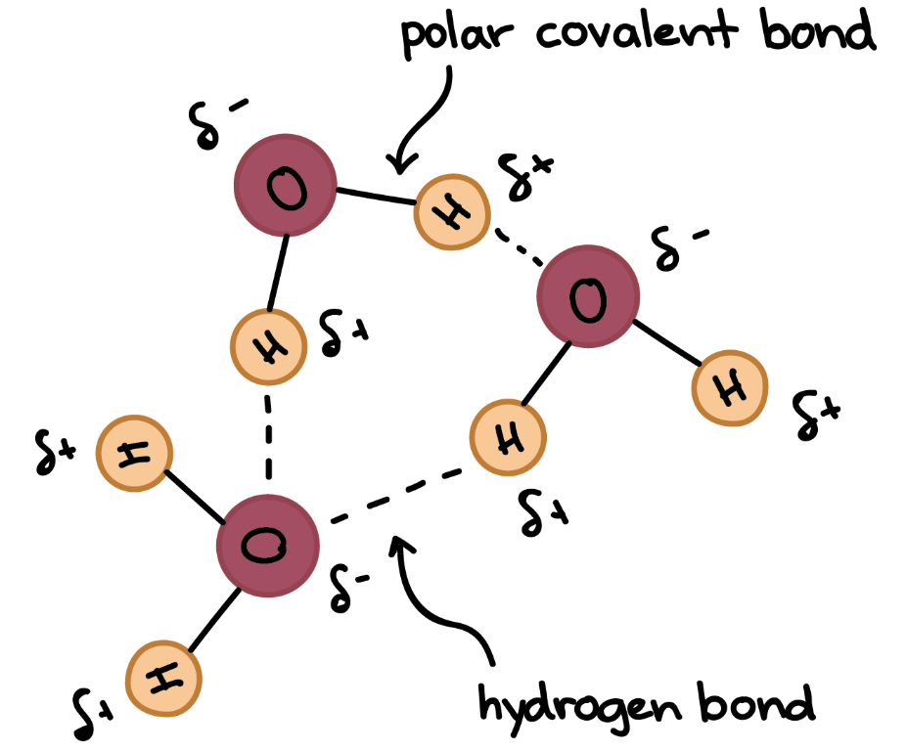

Water’s _______ gives it the ability to form _______ bonds and thereby giving water many unique and special properties.

_______ Bonds

* Water is a _______ molecule and therefore, is attracted to other water molecules (_______ interactions).
* The _______ end of one water molecule attracts the _______ end of another water molecule.
* Hydrogen bonds arise when a hydrogen atom (_______) is covalently bonded to a highly _______ larger atom.

Hydrogen bonding produces many of water’s properties:

* Water's _______ and _______ points are higher than expected.
* Water exhibits strong _______ _______ and capillary action due to _______ & _______.
* Water’s _______ _______ is second highest of all liquids. As a result, it can store large amounts of _______ energy. This allows it to moderate climate.
* Water is the one of the few substances whose _______ state is _______ dense than its liquid state. Ice is less dense than liquid water because when water reaches 4 ⁰C, it _______.

High Boiling & Melting Point of Water

_______ (covalent) compounds of low molecular mass are usually _______ or _______ with low boiling points at normal atmospheric pressure.

Water has a molar mass of 18.0 g/mol, but it has a _______ boiling point of 100˚C. Ammonia (NH3) has a molar mass of 17.0 g/mol and boils at about –33˚C. Look at the graph for a comparison. This is due to _______ bonding.

_______ Tension

* + The property of the surface of a liquid that allows it to resist an external force.
  + Strong _______ forces produce higher surface tension (_______ bonding).

Adhesion & Cohesion produce Surface Tension

_______ 🡪 attraction of molecules of _______ substances

* + - _______ in glass tubes
    - capillary action

_______ 🡪 attraction of molecules _______ a substance (e.g. formation of droplets)

Specific Heat

* Resistance to _______ in _______
* Higher specific heat means a substance can _______ more heat or release more heat depending on temperature.
* _______ bonds increase the amount of energy required for the average _______ (temperature) to change.
* _______ change in temperature
* Water takes a long _______ to heat up and a long time to cool down.
* Water’s high specific heat produces _______ climates in places with a lot of water : warmer winters and cooler summers.

_______ of Ice

* As water temperature drops below __˚C, it no longer behaves like a typical liquid, but _______. Ice at 0˚C, has about a 10% lower density than water at 0˚C.
* 99% of chemical substances are _______ dense as _______.
* Ice is _______ dense. Ice is one of only a few solids that _______ in its own liquid due to _______ bonding.

Solutions

Solutions are _______ mixtures of two or more _______ substances (elements and/or compounds).

* A solution is made of a _______ (*the substance being* _______) and a _______ *(the substance* _______ *the dissolving*).
* Air, a solution composed of 78% nitrogen and 21% oxygen. _______: O2 _______: N2
* In a solution, the solvent is present in a _______ amount. In a solution, the _______ dissolves in a _______.

Water is considered a _______ solvent for _______ (no C-H bonds) substances, meaning that it dissolves _______ non-organic matter ... due to _______.

How Does a Solution Form?

The _______ attraction between _______ and _______ particles become _______ than the attraction between solute particles themselves or between solvent particles themselves.

_______ (dissolution)

* As a solution forms, the _______ pulls solute particles apart at the _______ of the solute. This dissolving process is called _______. Then, water _______ the “broken apart” particles. This process is called _______.
* Involves a _______ Change 🡪 You can get back the original solute by evaporating the solvent. In other words, NO new substance is produced.
* _______ particles are “pulled apart” by the _______. NON ionic molecules break apart from each other remaining whole molecules.
* _______ is a form of dissolving in which _______ compounds break apart into its _______.

Solutions & Energy Changes

Solvent particles engage undissolved solute particles at their surface and _______ them. This is always _______ … _______ *some heat/energy to be added*).

The solvent particles surround the solute particles (_______), forming solute / solvent interactions & is always _______ … _______ *heat/energy into the solution).*

In a solution, the solute is dispersed _______ throughout the solvent. Therefore, we say it is _______.

Solutes: Electrolytes & Nonelectrolytes

* An _______ is a compound that conducts an electric current when it is in an aqueous solution or in the molten state.
* All _______ compounds are electrolytes because they _______ into ions when aqueous or molten.
* A _______ is a compound that does ____ conduct an electric current when it is in an aqueous solution, but its non-dissociated particles are surrounded by the solvent.

Nonelectrolyte 🡪 Dissolving particles are not _______ (Example: glucose).

_______ 🡪 Dissolving particles are _______ & _______ to move (e.g. Na+Cl-).

Factors Affecting Solubility & Rate of Dissolving

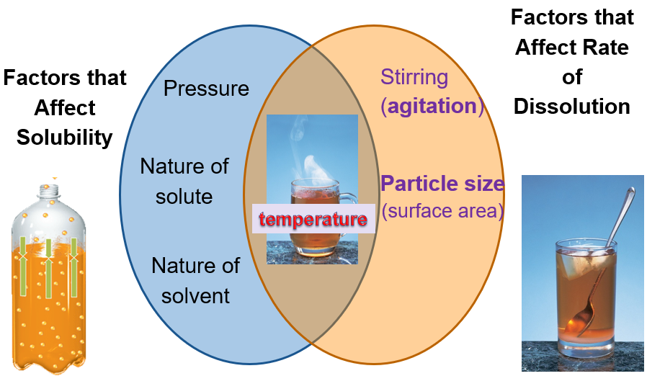

_______ Law: Solubility & Pressure

* The solubility (*S*) of a gas in a liquid is _______ proportional to the pressure (*P*) of the gas above the liquid at a given temperature.
* As the pressure of the gas above the liquid _______, the solubility of the gas _______.
* As the _______ of the gas decreases, the _______ of the gas decreases.
* Carbonated beverages contain large amounts of carbon dioxide (CO2 (g)) dissolved in water.
* The drinks are bottled under a high pressure of CO2 gas, which _______ solubility of the gas in solution.
* When the container is opened, the _______ of CO2 above the liquid decreases.
* Immediately, bubbles of CO2 form in the liquid & _______ from the bottle [Solubility _______].

_______ CANS

* The "head space" of the aerosol can is filled with highly _______ gas _______ in the product. When the nozzle is depressed, the pressure _______ so solubility of the gas also _______ and sprays out.

_______ Divers & the “Bends”

* The air scuba divers breathe is ~78% nitrogen. As one dives deeper pressure _______, meaning the solubility of nitrogen _______. _______ causes pressure to decrease, making nitrogen _______ soluble (i.e. “boils out”). If the divers surface too quickly, nitrogen bubbles just as in carbonated soda pop (the Bends). Helium is added to oxygen tanks, reducing this affect.

Solubility

The _______ amount of a _______ that can be _______ in a solvent is called that substance’s solubility. Solubility also describes the _______ of solutions by using three terms:

_______, _______, & _______ Solutions.

_______ solution 🡪 the concentration of solute is _______ than the maximum concentration the solvent can dissolve at a given temperature.

_______ solution 🡪 the concentration of solute is _______ to the maximum concentration the solvent can dissolve at a given temperature. Notice particles have settled out in solution.

_______ solution 🡪 the concentration of solute is _______ than the maximum concentration the solvent was expected to dissolve at a given temperature. No particles have settled out.

_______ a Super Saturated Solution 🡪 These solutions are _______; crystallization can usually be stimulated by adding a “_______ crystal” or scratching the side of the flask or _______.

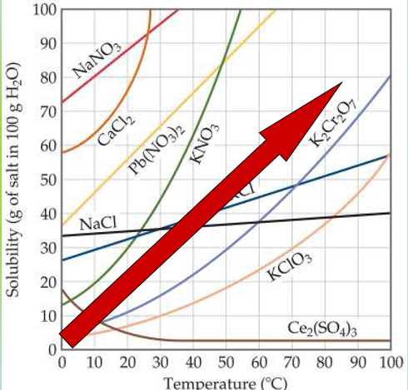 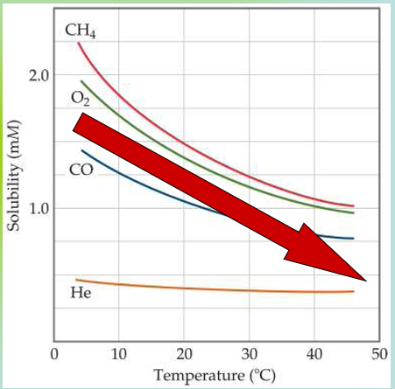

Solubility of _______ exhibits a _______ relationship with temperature.

Generally, the solubility of _______ solutes in liquid solvents _______ with increasing temperature.

Label the graphs as “solids” or “gases” 🡪

16B

Solute Concentration is helpful to know in order to describe solutions and is an important “real life” variable.

Molarity

The number of moles of solute in 1 liter of solution.

This term is the most used when describing _______ (symbolized by “___”) in a general chemistry lab.

 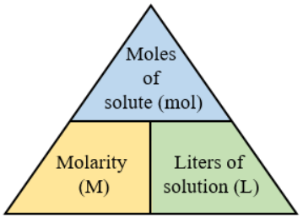

M =

Moles =

L =

Volume of a liquid is more easily measured than mass, therefore, laboratory reagents are usually made up of a specific _______ to give us a standard.

Molarity Calculations

What is the molarity of a solution that contains 25 g of HCl in 150. mL of solution? (The molar mass of HCl is 36.45 g/mol.)

What should you find first? _______

What set up is correct to find moles? _______ x 1 mol HCl / 36.45 g HCl

What set up is correct to find liters? _______ x 1 L / 1000 ml

How would you prepare 25 liters of 0.10 M BaCl2 solution, starting with solid BaCl2?

_______ = # _______ of solute / # _______ of solution

Find moles   _______ = _______ / _______ OR X moles = 0.1 M x 25 L

X = _______ BaCl2

Convert Moles to Grams GFM of BaCl2 = 137.3 + (2)(35.5) = _______ g / mole

2.5 moles x _______ / 1 mole = _______

*Place the* _______  *BaCl2 in an appropriate container and add sufficient water to give a final* _______ *of* _______*.*

Using Concentrated Solutions (_____)

(_______) (_______) = (Molarity) (Volume)

solution 1 solution 2

Usually one starts with a _______ concentrated solution and _______ it with water to obtain the desired volume. This is more convenient than using molarity or moles.

Making Dilutions

How would you prepare 100. ml (V1) of a 2.00 M HCl (M1) solution, starting with concentrated hydrochloric acid (12.0 M) (M2)?

_______ = _______

Find Volume

V2 = M1V1 / M2 V2 = (_______) (_______) / (_______) X = _______ = 0.0167 L

Make the Dilution:

Place _______ of 12.0 M HCl in the container (flask) & add enough water to get a FINAL _______ of _______.

Colligative Properties of Solutions

_______ properties of solutions are properties that depend upon the _______ of _______ molecules or ions, but not upon the identity of the solute.

Colligative properties include: _______ Point _______, _______ Point _______, Vapor Pressure Lowering, Osmotic Pressure.

Since colligative properties deal with the _______ of particles in a solution, we need to learn a new way to calculate concentration.

_______ (*___*) 🡪 the number of moles of solute dissolved in 1 kilogram (1000 grams) of solvent. Molality is also known as molal concentration and is calculated by:

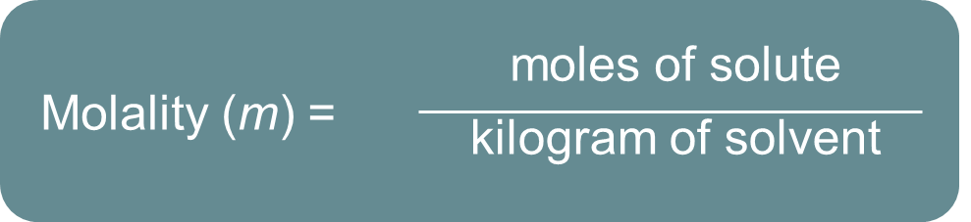

Calculating Molality

What is the molality (m) of a solution obtained by dissolving 45.0 grams of glucose (C6H12O6) in 2000. grams of water?

_______ = _______ of solute / _______ of solvent

Find moles

GMM of C6H12O6 = (6 x 12.0 g/mol) + (12 x 1.00 g/mol) + (6 x 16.0 g/mol) = ___ g / mole

45.0 g x 1 mole / 180 g = ____ moles

Find molality

2000. g x 1 kg/1000 g = 2.00 kg

m = _______ moles / _______ kg = ____ m

Boiling Point _______

* The change in boiling point is proportional to the _______ of the solution:

∆__b = Kb x ___

where Kb is the molal boiling point elevation constant, a property of the solvent.

* Boiling Point Elevation 🡪 A 1 _______ solution of water will _______ at _______ C rather than 100.00 C.

Freezing Point _______

* The change in freezing point can be found similarly: ∆__f = Kf x ___ where Kf is the molal freezing point depression constant of the solvent.
* A 1 _______ solution of water will _______ at _______ C rather than 0 C.

Colligative Properties of Electrolytes

* _______ are ionic compounds that dissociate to form _______ in solution and therefore, can conduct _______.
* _______ is a ___-electrolyte and has ___ ions in solution.
  + 1 __ of sugar 🡪 __ mol particles
* Salt is an electrolyte and has _______ in solution. 1 ___ of salt 🡪 __ mol ions.
* Since colligative properties *(vapor pressure, boiling point elevation, freezing point depression)* depend on the _______ of particles _______, solutions of electrolytes (which dissociate in solution) should show _______ changes than those of non-electrolytes.
* Notice the difference in moles produced when 3 moles of each substances is made into solutions of equal volume.

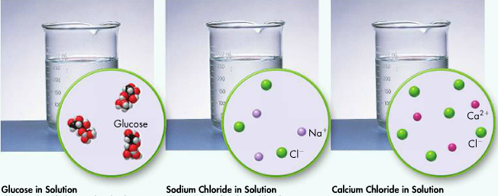

* Glucose produces ___ moles of solute in solution (no ions)
* NaCl produces ___ moles of solute in solution (TWICE as much)

… NaCl (aq) 🡪 Na+ + Cl- ___ moles of ions / NaCl (aq)

* CaCl2 produces ___ moles of solute in solution (3 times as much)

… CaCl2(aq) 🡪 Ca+2 + 2Cl- ___ moles of ions / CaCl2 (aq)

Calculating fp depression & bp elevation

Find the boiling point elevation and the freezing point depression of Nickel II Bromide (electrolyte) if 0.121 mol are dissolved in 224 grams of water (0.224 kg).

Find molality [*m = mol solute/Kg solvent*]

M = ____ moles / ____ kg = ____ m

Find molality of particles (ions)

NiBr2 (aq) 🡪 Ni+2 + ____ Br-1 = ____ moles of ions x ____ m = _______ m

Calculate fp depression and bp elevation

∆Tf = kf x ____ ∆Tb = kb x ____

= (____ C)( ____ m) = (____ C)( ____ m)

= ____ C + ____ C = ____ C + ____ C

Fp = ____ C Bp = ____ C