Heading

Title

# **Introduction** This lab deals with determining stoichiometry and percent yield.

**Purpose** To predict the amount of sodium acetate that should be produced in a chemical reaction and to calculate the percent yield.

**Background Information**

Quantitative analysis is a branch of stoichiometry dealing with limiting reactants and yields. Many chemical reactions do not go to completion, meaning they do not form the expected amount of product (theoretical yield). Often, one of the reactants is a limiting reactant, meaning that no matter how much of the other reactant(s) are involved, the limiting reactant determines how much product will form.

Limiting Reactant

Theoretical yield

Actual yield

Percent yield

The percent yield is a measure of the efficiency of a reaction carried out in the laboratory.

Reactions do not always go to completion. In other words, when a reaction is incomplete, less than the calculated amount of product is formed. Impure reactants and competing side reactions may cause unwanted products to form and the actual yield can be lower than the theoretical yield due to a loss of product during filtration or in transferring between containers, and other factors.

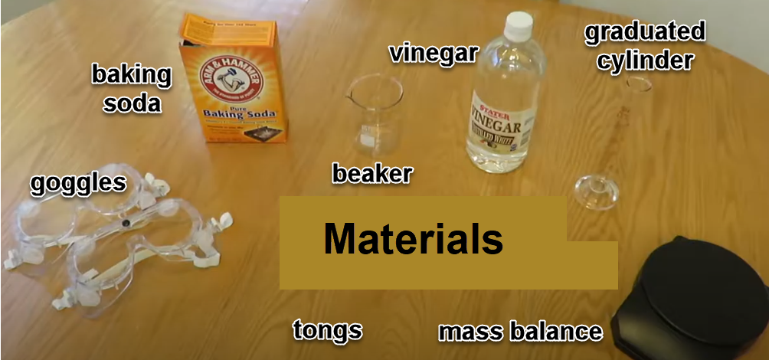

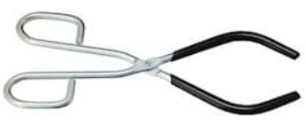

In this lab, two household chemicals will be used as reactants: baking soda and vinegar. Vinegar is an aqueous solution of acetic acid. Vinegar typically contains 5–8% acetic acid by volume. Usually the acetic acid is produced by the fermentation of ethanol or sugars by acetic acid bacteria. Common white vinegar or apple cider vinegar can be used to determine the amount of a product generated from a chemical reaction.

Sodium bicarbonate, NaHCO3, a.k.a. baking soda, will be mixed with “acetic acid,” HC2H3O2, a.k.a. vinegar, to generate sodium acetate, NaC2H3O2, and carbonic acid, H2CO2 (aq). The carbonic acid rapidly decomposes to generate gaseous carbon dioxide and liquid water. The carbon dioxide will appear as bubbles when the reaction occurs. Sodium bicarbonate will be the limiting reactant determining how much sodium acetate (product) will form.

Vinegar is not equivalent to acetic acid, it is only ~5% acetic acid. Therefore, excess vinegar will be used to ensure the reaction goes to completion as much as possible. However, the amount of vinegar will not be used to determine theoretical or percent yield.

**Hypothesis**

**Materials** Baking Soda (NaHCO3) Vinegar (CH3COOH) Beaker & Tongs

Mass Balance Graduated Cylinder Heat Source

## Procedures and Initial Calculations

1. Use the following balanced equation for this lab:

NaHCO3 (s) + CH3COOH (aq) 🡪 NaC2H3O2 (s) + CO2 (g) + H2O

Sodium bicarbonate + acetic acid 🡪 sodium acetate + carbon dioxide + water

2. Complete the data tables below using gram atomic masses (periodic table) to determine the molar mass of the reactants and sodium acetate.

|  |  |  |  |
| --- | --- | --- | --- |
| NaHCO3 (s) | | | |
| Element | Atoms/compound | g/mol | Total |
| Na |  |  |  |
| H |  |  |  |
| C |  |  |  |
| O |  |  |  |
|  | | |  |

|  |  |  |  |
| --- | --- | --- | --- |
| CH3COOH (aq) | | | |
| Element | Atoms/compound | g/mol | Total |
| C |  |  |  |
| H |  |  |  |
| O |  |  |  |
|  | | |  |

|  |  |  |  |
| --- | --- | --- | --- |
| NaC2H3O2 (s) | | | |
| Element | Atoms/compound | g/mol | Total |
| Na |  |  |  |
| C |  |  |  |
| H |  |  |  |
| O |  |  |  |
|  | | |  |

3. Measure and record the mass of the empty beaker.

4. Leave the beaker on the mass balance and carefully measure out 10.0 grams of sodium bicarbonate, NaHCO3 (s). (The mass does not have to be exactly 10.0 g, as long as you record the mass accurately.) Note: Do NOT use baking powder.

5. Take a picture of the beaker with the sodium bicarbonate and include that in the calculations and data section with an explanation.

|  |  |
| --- | --- |
| NaHCO3 (s) | |
| Mass of empty beaker |  |
| Mass of beaker with baking soda |  |
| Mass of baking soda alone |  |

6. Measure the mass of the empty graduated cylinder.

7. Add 50 ml of vinegar, CH3COOH (aq), to the graduated cylinder. Measure and record the mass. (The mass does not have to be exactly 50.0 g, but record the mass accurately.)

|  |  |
| --- | --- |
| CH3COOH (aq) | |
| Mass of empty graduated cylinder |  |
| Mass of grad cyl with vinegar |  |
| Mass of vinegar alone |  |

8. Slowly and gently pour ~10 ml of the vinegar (from the graduated cylinder) into the beaker containing the sodium bicarbonate. It should begin to bubble.

a. Take a picture of the reaction and include that in the calculations and data section with an explanation.

b. Wait for the bubbling to subside and add ~10 ml more vinegar, but make sure that the reaction does not cause the liquid to overflow the beaker.

9. Continue to add increments of vinegar to the sodium bicarbonate beaker until all the vinegar has been added.

10. Swirl the reaction beaker gently (do not allow spillage). Stir the mixture for two minutes with a glass stirring rod until there is no noticeable reaction left (no more bubbles).

11. When the product solution is completely calm, place the beaker on a heat source and bring it to boiling. You will observe bubbles again, but these are not the same as before.

a. Be careful that the liquid does not overflow, as this will hurt your calculations.

b. Once the liquid is bubbling significantly, either turn off the heat source, leaving the beaker on the heat source, or if the boiling is too vigorous, use tongs to lift the beaker off the heat source.

c. Repeat the boiling process until all the liquid is boiled away or evaporated.

d. This process may take 15 minutes or more.

12. When all the liquid has boiled away, remove the beaker from the heat source and place it on an oven mitt or on a surface that won’t be burned or marked. Allow everything to cool to room temperature.

13. When the beaker and product has completely cooled, take a picture and include that in the calculations and data section with an explanation. Describe the product in the beaker.

14. Find the mass of the beaker with product and record it in the data table. Remember, the salt formed in the beaker is sodium acetate, NaC2H3O2 (s), the product of the reaction.

*Actual yield

|  |  |
| --- | --- |
| NaC2H3O2 (s) Product | |
| Mass of beaker + product |  |
| Mass of empty beaker (procedure 4) |  |
| Mass of sodium acetate alone | **\*** |

15. Clean the beakers and workstation thoroughly. All waste can be washed down the sink. Make momma proud!

**Calculations and Data**

1. Calculate the moles of sodium bicarbonate used in this experiment. (Hint: use the mass of the sodium bicarbonate and it molar mass.)

NaHCO3 (s) + CH3COOH (aq) 🡪 NaC2H3O2 (s) + CO2 (g) + H2O

Sodium bicarbonate + acetic acid 🡪 sodium acetate + carbon dioxide + water

2. Insert the pictures and explanations of (a) the sodium bicarbonate mass and (b) the initial reaction of sodium bicarbonate with vinegar (from the procedures).

3. Calculate the mass of sodium acetate produced in this experiment using the moles of sodium bicarbonate (mole ratio is 1:1). (Hint: This is the theoretical yield.)

NaHCO3 (s) + CH3COOH (aq) 🡪 NaC2H3O2 (s) + CO2 (g) + H2O

Sodium bicarbonate + acetic acid 🡪 sodium acetate + carbon dioxide + water

4. Insert the picture and explanation of the product, sodium acetate, in the beaker (from the procedures).

5. Calculate the percent yield of sodium acetate produced in this experiment using the actual yield (mass recorded) to the nearest 0.1%.

**Conclusions**

**Address Hypothesis**

**Analysis**

**Questions**

1. Why were the moles of sodium bicarbonate calculated and used to find the theoretical yield, but not the moles of vinegar?

2. Distinguish theoretical yield from actual yield in this experiment?

3. What were the bubbles formed in the reaction of sodium bicarbonate and vinegar?

4. What would be the theoretical yield of carbon dioxide released in this experiment to the nearest 0.1 g? (Show all work)

5. If 3.6 g of carbon dioxide were produced in this lab, what is the percent yield to the nearest 0.1%? (Show all work)

**Errors**

**Bibliography**